
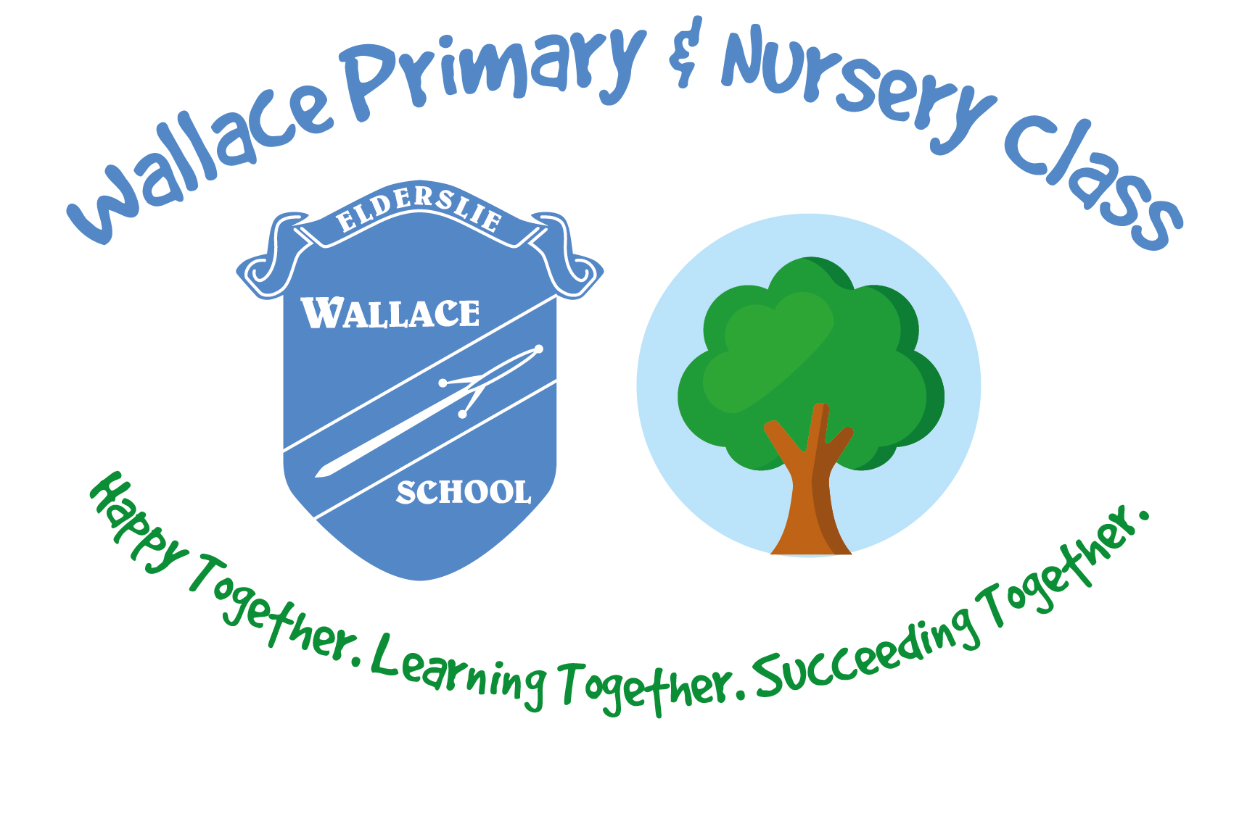
Wallace Primary School and Nursery Children’s Services
Greenhill Crescent
Elderslie
PA5 9AW

Head Teacher: Mrs Susan Dalrymple

Dear Parent / Carer,

I am delighted to share with you our plans for ‘Book Week Scotland’. During this week beginning 19th November we will have a focus on reading across the school and nursery. Our focus for this year is ‘Reading Together’ and we plan to engage pupils across the school and nursery in activities where we read together. There will also be homework tasks linked to Book Week.

Part of the week will include a Parental Workshop which we would be delighted for you to attend. This will be held on Thursday 22nd November from 3.15pm – 4.15pm. Drop in activities include: parent and pupil reading café, visit our new AR library, workshop on book banding, reading strategies and read, write, count bags. Activities with set times running twice at 3.15pm and 3.45pm are:
- Accelerated Reading
- New Spelling and Phonics Programme
- Nursery / P1 Family Book Bug Session (held in nursery & spaces limited)
Please note children attending nursery on this afternoon should be collected from Primary 1.

Thursday 22nd will be a non-uniform day and Friday 23rd will be a ‘Pyjama Day’ for school and nursery. Both are in return for Parent Council donations (see Parent Council letter for details). On Friday pupils can bring in a blanket or pillow and their favourite book to enjoy reading circles at assembly and a ‘Big ERIC’ time in class.

Finally, to reinforce our ‘Reading Together’ theme, we would love you to come into school or nursery to read a story to a class. We would welcome any family members or members of our local community. Please complete the return slip attached. *please note nursery reading together can include next week beg 19th and 26th.

Yours sincerely,

Susan Dalrymple
Head Teacher

Reading Together – Return Slip to Read to a Class
Name _____________________ Pupil Name _______________________

My availability for week beginning 19th November is:

My preferred time to read to a class would be:

I would like to read to (insert class):

I will bring my own book. OR Please provide me with a book to read. (please delete as appropriate)

