Dear Parents and Carers,

Wallace Nursery Class

**Welcome Back Newsletter**

**August 2018**

**Message from the Head Teacher**

A very warm welcome back to the [](http://clipartix.com/school-clipart-image-50464/)session 2018-2019, I hope everyone had a wonderful summer and has returned looking forward to the year ahead as we aim to make our vision a reality for ALL pupils, staff, parents and partners at Wallace.

***Happy Together. Learning Together. Succeeding Together***

**Staffing**

The staff team in the nursery work together to support your child to reach his/her full potential.

Staff in the nursery are as follows:

Head Teacher

Mrs Susan Dalrymple

Depute Head Teacher:

Mrs Diana Brooker

Senior Early Learning and Childcare Officer:

Mrs Lynne Anderson (Pink Group)

Early Learning and Childcare Officers:

Mrs Sharon Moncrieff (Blue Group)  
Mrs Karen Fletcher (Red Group)

Miss Natalie Morris (Yellow Group)

Mrs Cheryl Wilson (currently on maternity leave)

Early Years Transition Teacher**:**

Mrs Caryn Young

Mrs Dalrymple has overall responsibility for Wallace Primary and Nursery Class. Mrs Brooker is responsible for the management of the nursery class and staff. Mrs Anderson manages the day to day running of the nursery and is supported by Mrs Fletcher, Mrs Moncrieff, Miss Morris and Mrs Wilson. Mrs Caryn Young is the Early Years Teacher who will work alongside nursery staff to support targeted developments at different times throughout the year. ***Happy Together***

**Nursery Information and Reminders**

Indoor Shoes

On arrival at nursery all children should change from their outdoor shoes before entering the playroom. Previously this had been a pair of slippers however these are not ideal for outdoor play or physical education activities. It would be preferred if your child could wear light weight sand shoes which can be put on and taken off independently (no laces).

Spare Clothes

A spare set of clothes and underwear should be left in a bag on your child’s coat peg (please ensure these are fully labelled).

Voluntary Donation

The voluntary activity donation is £2.00 per week if attending for full five sessions or 50p per day if part time. This can be paid at the start of the week or termly if preferred. This donation is used to purchase valuable resources, equipment and snack.

Uniforms   
The nursery has an optional uniform which consists of a polo shirt, sweat shirt and zipper top. The uniforms can be purchased from Schoolwear Made Easy and Set Schoolwear in Paisley.

Outdoor Play

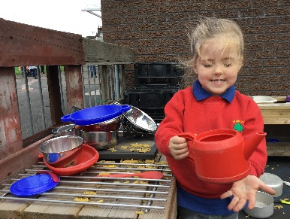The children will have access to outdoor play on a daily basis. Please ensure they are prepared for appropriate weather. On sunny days please apply sun cream before arriving at nursery and on wet days wear appropriate waterproof footwear and jackets.

Physical Education

Children will have access to play in the gym hall every week. Sessions will take place on a Wednesday morning and afternoon. Please ensure your child wears suitable, comfortable clothing on a Wednesday.

Nut Free Zone

Wallace Primary and Nursery is a nut free zone as there are children with severe nut allergies. For children who stay for lunch please ensure that no nuts or nut products are brought to nursery.

Parking

We kindly request that parents don’t park in the staff car park and are considerate of local residents when using surrounding areas. Please make full use of the car park at Kings Crescent.

Dogs

Along with Renfrewshire Guidelines no dogs are allowed within the school and nursery grounds.

**Funding Update**

There has been some wonderful news over the last few months about funding applications for the school and nursery. The wonderful grants sub-committee of the Parent Council have secured the following:

* £4,000 from Foyle Foundation for reading resources and the school and nursery library.
* £2104.35 from the Flight Path funding for cooking equipment.
* £2635.65 from Food for Thought for a STEM and Food Technology project.
* £500 from local shop Nisa for the school football team.
* Sponsorship from local business Eastons Solicitors for the school football team.

Also the grants committee organsied volunteers from Intu Braehead to upgrade the atrium area. The volunteers worked with staff from Cardwell Garden Centre for two days to paint, clean, clear and plant. The area looks great and the school and nursery can access this area throughout the day.

Thank you to the parents in this group for their hard work in securing this funding, these grants and sponsorship will make a massive difference to all pupils at Wallace.

***Succeeding Together***

**Parental Engagement**

Last year we made excellent progress in improving parental engagement across the school and nursery through a variety of events, support from parent helpers and developed methods of communication. We hope to continue this as we move into this new session.

***Happy Together***

**Communication with Families**

We have a variety of ways to communicate with parents.

* Download our school app –

‘My School App’

* Check out our website and class blogs
* Follow us on twitter @WallacePrimary
* Sign up for our email subscriptions which will send you any blog updates.
* Read monthly newsletters.

We are always looking for ways to improve this and would value your opinion on how we communicate through Social Media. The staff are currently considering the use of Facebook as a method of communication. We are keen to know whether family preference is Facebook or Twitter. Please see the voting station in the nursery cloakroom to indicate your preference.

***Learning Together***

**Curriculum**

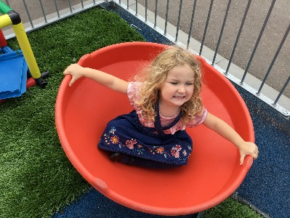Over the next few weeks the nursery staff will be working with the pupils to determine what they would like to learn and investigate. In addition, pupils will be asked to contribute their ideas for developing the outdoor area. This is a focus for the nursery as part of the Improvement Plan and we would welcome any support or resources anyone can offer. The children have been talking about celebrations which are taking place at home and the children will be sharing their learning with others at nursery.

***Learning Together. Succeeding Together***

**Pupil Comments**

What I would like to learn about in nursery this year:

I would like to build a dinosaur and get better at playing.

**Layla R**

I want to go to the forest.

**Adam O**

I would like to learn about going to school.

**Zoe R**

Some thoughts from our new starts in nursery:

I have been having fun in the house corner and on the round chair.

**Sophia A**

I have fun at nursery and have met new friends.

**Lexi R**

**Diary Dates**

September

5th iPad Workshop

10th – 14th Maths Week

20th Charity Fundraiser – Wear Pyjamas

21st & 24th September Weekend

26th European Day of Languages

October

15th – 21st October Break

22nd In-service Day

23rd Pupils Return

31st Halloween Party

November

1st Open Evening – Informal Meet the Staff

19th- 23rd Book Week

29th Charity Fundraiser – Wear Fancy Dress

30th Holiday

December

19th Nativity

20th Christmas Party

21st 2.30pm Close

Along with the nursery staff I am very excited about the year ahead. Together, we look forward to working with families to support your child as they grow and thrive in Wallace Nursery Class.

Yours sincerely,

Mrs Diana Brooker

Depute Head Teacher