 | TRINITY HIGH SCHOOL  RENFREW  Mental Health & Wellbeing Policy |   Achieving Excellence Together

Mental Health and Wellbeing Policy for Educational Establishments

Rationale
This policy is in response to the Scottish Government's Mental Health Strategy 2017-27. The policy will focus on:
- Our policy statement
- Lead members of staff
- Universal Support
- Signposting
- Working with parents/carers
- Targeted Support
- Training
- Policy Review
- Links to further information

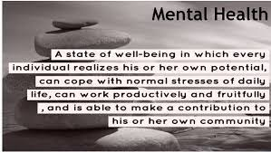

Policy Statement
At Trinity High School, we aim to promote positive mental health and wellbeing for every member of our staff and children/young people though nurturing relationships and the promotion of a positive establishment ethos.. We will pursue this aim using both universal, whole establishment approaches and specialised targeted approaches aimed at vulnerable children/young people.
In addition to promoting positive mental health and wellbeing, we aim to recognise and respond to mental ill health. By developing and implementing a practical, relevant and effective mental health and wellbeing framework, our policies and procedures will promote a safe and stable environment for the many children and young people affected both directly, and indirectly by mental ill health.
This policy is linked to the United Nations Convention on the Rights of the Child (UNCRC) articles 3, 12, 13, 17, 24 and 29 and the Charter for Catholic Schools in Scotland which aims to honour the life, dignity and voice of each person, made in the image of God.

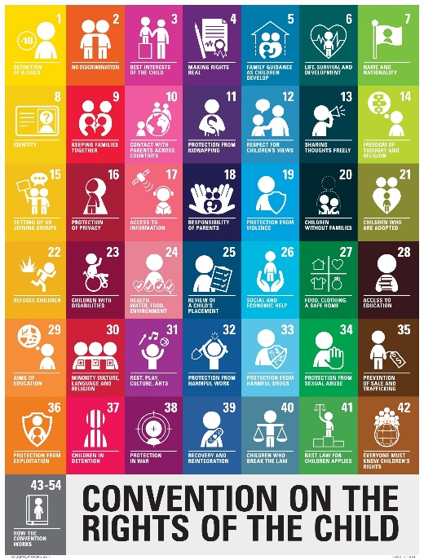

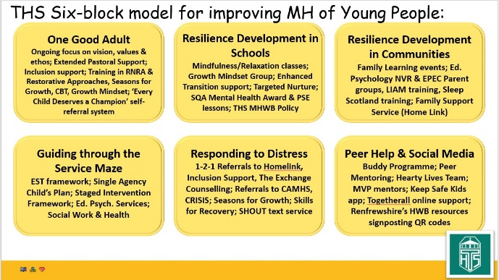
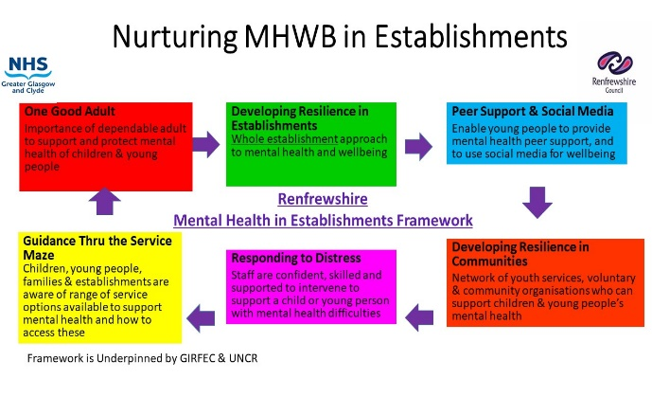
This document describes Trinity High School's approach to promoting positive mental health and wellbeing. This policy is intended to provide a framework for effective mental health and wellbeing in our establishment through the NHSGGC Mental Health Improvement & Early Intervention Framework for Children and Young People (6 Box Framework) and should be used as whole establishment guidance for all staff . The 6 box Framework is an evidence-based approach which sits under GIRFEC and the UNCRC (UN Convention of the Rights of the Child).
This policy will provide you with information around our universal and targeted approaches to mental health and wellbeing and also direct you to relevant training opportunities available online and through Renfrewshire Council, other partners and the new Scottish Government Children and Young People's Mental Health Learning Resource in order for staff to meet baseline skills requirement. We will also use Renfrewshire's Council's Health and Wellbeing monthly newsletter, blog and Twitter to share information of upcoming training.

The Policy and 6 Box Framework will:
- Provide a toolkit for all staff supporting children and young people in establishments to identify good practice and areas for development
- Promote positive mental health and wellbeing in all children, young people and staff through prevention and early intervention
- Increase understanding and awareness of common mental health issues
- Alert staff to early warning signs of mental distress and ill health
- Provide support to staff working with children/young people with mental health issues through a model of training to enhance professional knowledge
- Provide support to children/young people experiencing mental ill health, their peers and parents/carers through effective universal supports, effective liaison with partners and appropriate signposting to supports within establishments and the community.
For examples of good practice within each box, see Appendix E.
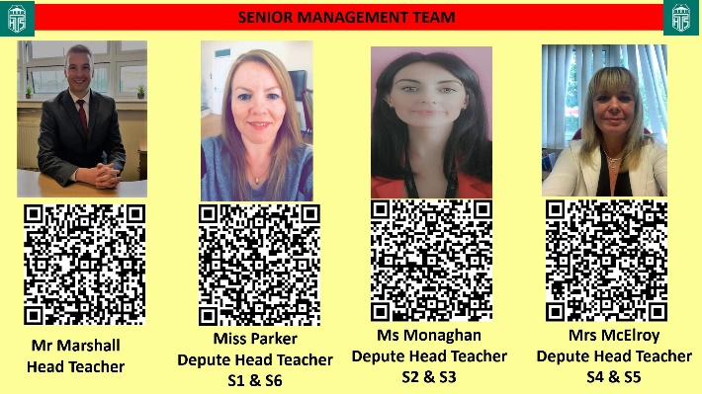
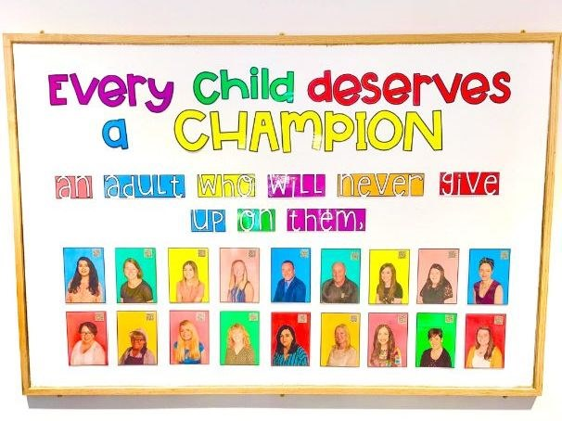

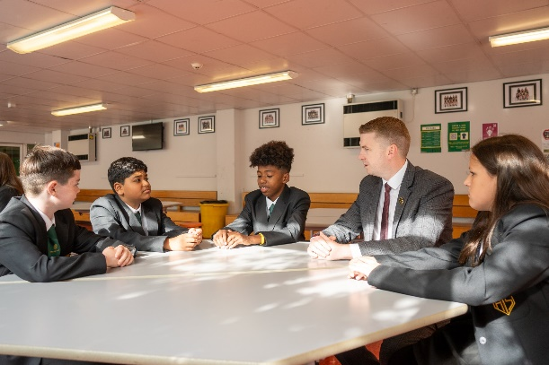

Lead Members of Staff
Whilst all staff have a responsibility to promote the mental health of children and young people, staff with a specific, relevant remit or training include:
- Child Protection & PREVENT Strategy Coordinator - Karen Parker, DHT
- CLPL Lead - Collette McElroy, DHT
- Health & Wellbeing Coordinator - Karen Parker, DHT
- 'Leadership of Child Protection' trained staff -
Name | Role
Paul Marshall | Head Teacher
Collette McElroy | DHT
Morag Monaghan | DHT
Karen Parker | DHT
Alan McEwan | DHT
Vicki Waddell | PT Inclusive Support
Martin McInnes | PT Pastoral Support
Bridet Graham | PT Pastoral Support
Alison Thomson | PT Pastoral Support
Ruth McGuire | PT Pastoral Support




- 'ASIST' (Applied Suicide Intervention Skills Training) trained staff -
Name | Role
Karen Parker | DHT
Alan McEwan | DHT
Collette McElroy | DHT
Vicki Waddell | PT Inclusive Support
Martin McInnes | PT Pastoral Support
Bridget Graham | PT Pastoral Support
Alison Thomson | PT Pastoral Support
Ruth McGuire | PT Pastoral Support
Roisin Quigley | Inclusive Support Teacher
Cheryl O’Neill | Nurture Keyworker
Kirsty Fry | Family Wellbeing Assistant

- 'What's The Harm?' & Self-harm Awareness training trained staff -
Name | Role
Karen Parker | DHT
Alan McEwan | DHT
Vicki Waddell | PT Inclusive Support
Martin McInnes | PT Pastoral Support
Bridget Graham | PT Pastoral Support
Ruth McGuire | PT Pastoral Support
Alison Thomson | PT Pastoral Support
Roisin Quigley | Inclusive Support Teacher
Freya Reid | Inclusive Support Teacher
Kirsty Fry | Family Wellbeing Assistant

- 'LIAM' (Let's Introduce Anxiety Management) or LILA (Let’s Introduce Learning About) trained staff -
Name | Role
Alan McEwan | DHT
Vicki Waddell | PT Inclusive Support
Martin McInnes | PT Pastoral Support
Roisin Quigley | Inclusive Support Teacher
Freya Reid | Inclusive Support Teacher
Cheryl O’Neill | Nurture Keyworker
Freya Reid | Family Wellbeing Assistant

- Cognitive Behavioural Therapy (CBT) trained staff -
Name | Role
Martin McInnes | PT Pastoral Support
Ruth McGuire | PT Pastoral Support
Freya Reid | Inclusive Support Teacher
Roisin Quigley | Inclusive Support Teacher

- 'Seasons for Growth' trained staff -
Name | Role
Cheryl O’Neill | Nurture Keyworker
Kirsty Fry | Family Wellbeing Assistant

- First Aiders - Alan McEwan, DHT; Sheena Downie, ASNA, Katie McGhee (ASNA), Izzy Morrison (ASNA)

Universal Support
We aim to look after the mental health and wellbeing of all of our children/young people by:
- Promoting nurturing relationships and health and wellbeing as the responsibility of all within our own establishment and the wider community through Renfrewshire's Nurturing Relationships Approach (RNRA) (one good adult and developing resilience in the community)
- Ensuring that children/young people learn how to look after their mental health and wellbeing (developing resilience in our establishment/community)
- Ensuring that children/young people know and can recognise mental health conditions (developing resilience in our establishment/community)
- Ensuring that children/young people understand and know where to go if they require more targeted support (one good adult/peer support and social media/responding to distress/guiding thru the service maze)
- Using the wellbeing indicators to track wellbeing and as a basis for discussion with a key adult using the Glasgow Motivation and Wellbeing Profiling Tool (one good adult/developing resilience in the community)
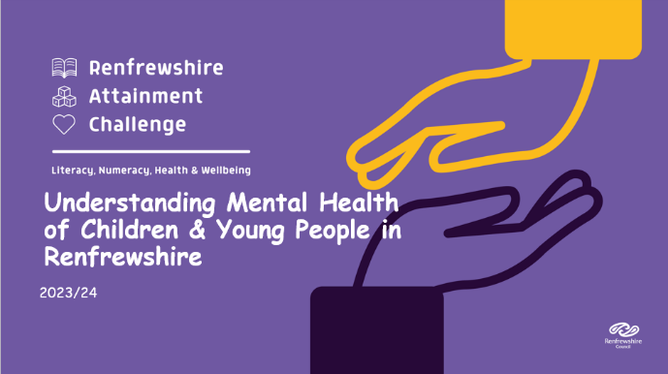
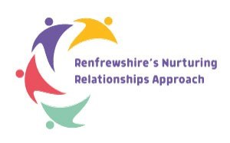

All Renfrewshire establishment staff working with children/young people will access the annual update of Understanding the Mental Health of Children and Young People in Renfrewshire and Child Protection to enable them to keep pupils in their care safe.
Our counselling service, The-Exchange, is a universal service and is available to all of our pupils. This will complement the range of whole-school and targeted approaches already available in schools to help support the mental, emotional, social and physical wellbeing of children and young people. Access to this resource is by self-referral on The-Exchange website, or through Pupil Support.
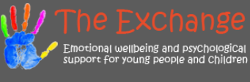

Teaching About Mental Health
Our aim is to enable children/young people to develop the skills, knowledge, understanding, language and confidence to seek help, as needed, for themselves or others. We offer universal supports in a variety of ways; as part of our Personal and Social Education programme, accredited courses, pupil leadership opportunities, wider achievement and extra-curricular opportunities.

We also offer the SQA Mental Health Award to pupils in S4 in order to support the accreditation journey of our pupils. The award aims to:
- Reduce stigma surrounding mental health
- Arm young people with healthy coping strategies
- Promote knowledge of the impact of mental health on behaviour
- Dispel myths surrounding mental health
- Promote understanding of positive and negative impacts on mental health
- Help individuals to make the right choices
- Promote understanding of the potential uses and impact of social media and the internet
- Create resilience
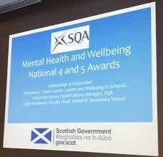
Understanding and promoting positive Mental Health are core elements of our whole school Personal and Social Education curriculum at all stages. As such children and young people will have the opportunity to learn and explore their understanding of relationships, emotional literacy, growth mindset and resilience development, and the impact of physical health and wellbeing on our mental wellness at various stages from S1-6. Within Trinity High School, we also develop key messages and peer support of mental health and wellbeing at whole school level via our Buddy Programme, Mentors in Violence Project (MVP) and Hearty Lives Project.

Targeted Support
When it is identified that a child/young person requires a more targeted support tailored to their individual needs, the Pupil Support team will work in partnership with the child/young person, their parents/carers, staff within the establishment and any other relevant partners. It may be that information regarding their support needs are shared with staff if the needs of the child/young person are impacting on their learning.
If you have any concerns regarding the wellbeing of a child/young person that you feel require more specialised or targeted support, you should speak to the relevant member of the Pupil Support team. You can find out more about warning signs, managing disclosures, protocol and confidentiality by clicking here.
If the wellbeing concern you have is in relation to self-harm and suicide, you can find out more about supporting children/young people at risk by clicking here. This link will take you to Renfrewshire Council's Supporting Children and Young People at Risk of Self-Harm and Suicide.

Signposting


We will ensure that children/young people, staff and parents/carers are aware of sources of support within our establishment and in the local community, who it is aimed at and how to access it. This will be done by sharing digital resources on our website and other digital platforms such as Twitter, Microsoft Teams, Show My Homework and Glow. Our digital resources include signposting for children/young people, parents/carers and staff. (See Appendices F, G and H)
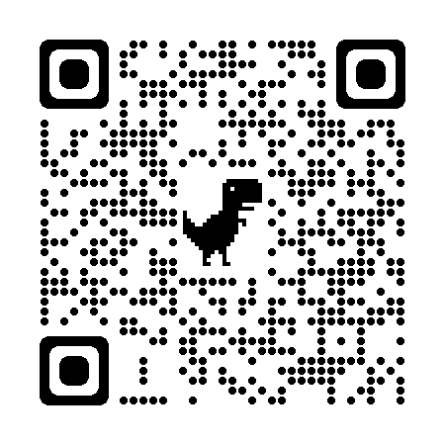
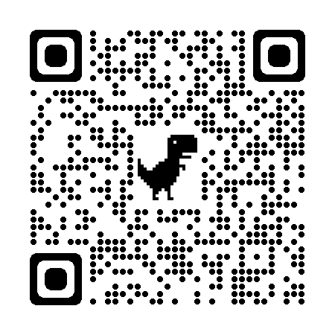
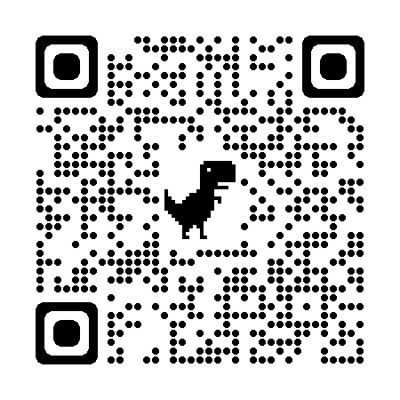
We will display relevant sources of support in communal areas such as the staff base areas and the Pupil Support corridor, and will regularly highlight sources of support to young people within relevant parts of the curriculum.
1 - Resources for children and young people. 2 - Resources for parents and carers. 3 - Resources for staff.

Working in Partnership with Parents/Carers
Parents/Carers are often very welcoming of support and information from the establishment about supporting their child/young person’s emotional and mental health. To support parents/carers, we will:
- Highlight sources of information and support about common mental health issues on our establishment website and other social media platforms
- Ensure that all parents are aware of who to talk to if they have concerns about their child or a friend of their child/young person
- Make our ‘Mental Health Policy’ easily accessible to parents/carers
- Share ideas about how parents/carers can support positive mental health in their children through our regular information events
- Keep parents/carers informed about the mental health topics their children/young people are learning about in HWB/PSE lessons and share ideas for extending and exploring this learning at home.



Staff Skills and Professional Learning
Renfrewshire's Nurturing Relationships Approach delivers a universal approach to supporting mental health and wellbeing and promoting resilience and as health and wellbeing is the responsibility of all staff, we must ensure that we all have an awareness of the warning signs to look for and also how to manage disclosures safely. For more information around this, see Appendix A.

Renfrewshire Council have provided suggestions for baseline training for all staff with specific training for staff interested or involved with pupil support. This document is listed as Appendix I.
Suggestions for individual, group or whole school Career Long Professional Learning (CLPL) should be discussed with Collette McElroy, DHT, our CLPL Coordinator who can also highlight sources of relevant training and support for individuals as needed.
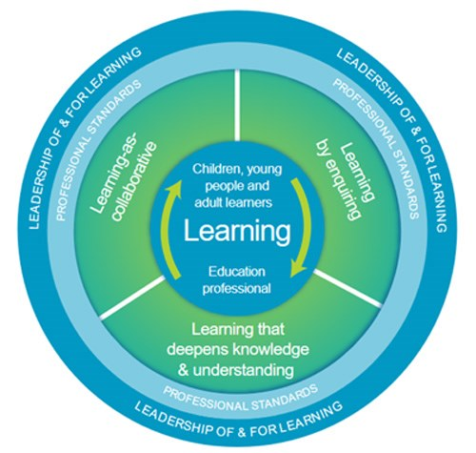

Policy Review
This policy will be reviewed every 3 years as a minimum. It is next due for review in June 2029. Additionally, this policy will be reviewed and updated as appropriate on a needs basis. If you have a question or suggestion about improving this policy, please contact Karen Parker, DHT.
This policy will always be immediately updated to reflect personnel changes.

Appendices
A - Warning signs and managing disclosures
B - Further information and sources of support about common mental health issues
C - Guidance and advice documents
D - Talking to students when they make a mental health disclosure
E - Renfrewshire Mental Health and Wellbeing Policy - self-evaluation tool and examples of good practice
F - Mental Health and Wellbeing Signposts for Children and Young People
G - Mental Health and Wellbeing Signposts for Parents/Carers
H - Mental Health and Wellbeing Signposts for Staff
I - Mental Health and Wellbeing Training for Staff (this includes links to the Scottish Government's new Professional Learning Resource)
J- Supporting Children & Young People at Risk of Self Harm and Suicide - Guidance for Staff

