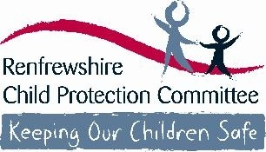

Trinity High School

Safeguarding and Protecting Children and Young People

Guidance for Session 2026/2027

- Child Protection refers to the processes involved in consideration, assessment and planning of required action, together with the actions themselves, where there are concerns that a child may be at risk of harm.
(National Guidance for Child Protection in Scotland 2021 updated 2023

The difference between child protection and child abuse could be you

Safeguarding and protecting children and young people is the responsibility of all staff

All Renfrewshire Children’s Services staff and those working in establishments and/or with children and young people must be:

- Aware of, and must follow, child protection procedures
- Alert to children’s needs
- Clear about their own role in ensuring the safety and wellbeing of all children

Our responsibility is to keep children and safe to support and promote their wellbeing by:

- Providing education to children and young people to help them to protect themselves
- Ensuring all staff play a part in the prevention of child abuse and neglect via the curriculum by:
- Raising pupil awareness of risks;
- Developing skills which will help them to keep themselves safe;
- Helping them recognise behaviours in others which may place them at risk; and
- Teaching them how to respond in order to keep themselves safe.

Abuse and child neglect

Abuse and neglect are forms of maltreatment. Abuse or neglect may involve inflicting harm or failing to act to prevent harm. Children may be maltreated at home; within a family or peer network; in care placements; institutions or community settings; and in the online and digital environment.
- Physical abuse – may involve hitting, shaking, throwing, poisoning, burning or scalding, drowning or suffocating.
- Emotional Abuse – conveying that the child is worthless or unloved, imposition of demands inappropriate for their age or stage of development, repeated silencing, ridiculing or intimidation, seeing or hearing the abuse of another (Domestic Abuse (Scotland) Act 2018)
- Sexual Abuse – forcing or enticing a child to take part in sexual activities, whether or not the child is aware of what is happening.
- Neglect – persistent failure to meet a child’s basic physical and / or psychological needs, which is likely to result in serious impairment of the child’s health or development.

All staff should be alert to:

- Unexplained but significant changes to patterns of attendance, presentation or behaviours
- Something the child or young person says, discloses or chooses to confide. Children and young people often take time to build trust and seek out adults to whom they wish to disclose abuse/neglect
- Concerns raised by other children or a third party
Additional areas of concern which you should ensure you are aware of and know the signs to look for:

- Exposure to Domestic Abuse
- Children displaying sexually harmful or problematic behaviours
- Female Genital Mutilation
- Honour based or forced marriages
- Child Trafficking
- Children affected by their parents’ drug or alcohol misuse or mental health issues
- Child Sexual Exploitation
- Child Criminal Exploitation
- Children who are at risk through internet use and online behaviour
- Radicalisation – that a young person may be vulnerable to extreme behaviour

What to do if you have a concern:

- Alert the head of establishment or manager designated as responsible for child protection immediately
- Confirm your concern in writing by completing Appendix 3 record of concern alert for staff as soon as possible and give to head or manager. Appendix 3 is attached to this information and additional copies are available (from the School Office)
- Follow the guidance from head or manager in supporting the child or young person

Responding to Disclosure/Allegations:
- If a child or young person chooses to disclose information about a potential child protection issue to you it is important that you:
- Listen carefully and with your full attention
- Do not guarantee confidentiality – explain that you will have to share this information with the relevant person to keep the child or young person safe
- Do not show disbelief or panic
- Take the allegation seriously and provide reassurance
- Avoid expressing personal views on the matter
- Never seek to investigate by asking leading questions – this is not your role

There should always be a manager responsible for child protection available for you to report your concerns to. In the unlikely event that there is no one available you can contact a local authority manager whose details are at the back of this guidance

CHILD PROTECTION CONTACT LIST
If you have any concerns about a pupil please contact Head Teacher or Child Protection Co-ordinator. If unavailable, the following staff are also responsible for child protection

ê
Head Teacher
Paul Marshall
Child Protection Co-ordinator
Karen Parker, DHT

Other school staff with designated responsibility for child protection:
Collette McElroy, DHT
Alan McEwan, DHT
Morag Monaghan, DHT

Children’s Services Staff

Clair McCrossan Education Manager 07811052460
Emma Henry Head of Education 07811 053963
Gerard McLaughlin Head of Education 0300 300 0278

Ensuring wellbeing for all

The Getting it Right for Every Child (GIRFEC) agenda is about ensuring that the wellbeing of all children and young people is the focus for all. It is everyone’s responsibility to understand the wellbeing indicators and to ensure that all our children & young people are:
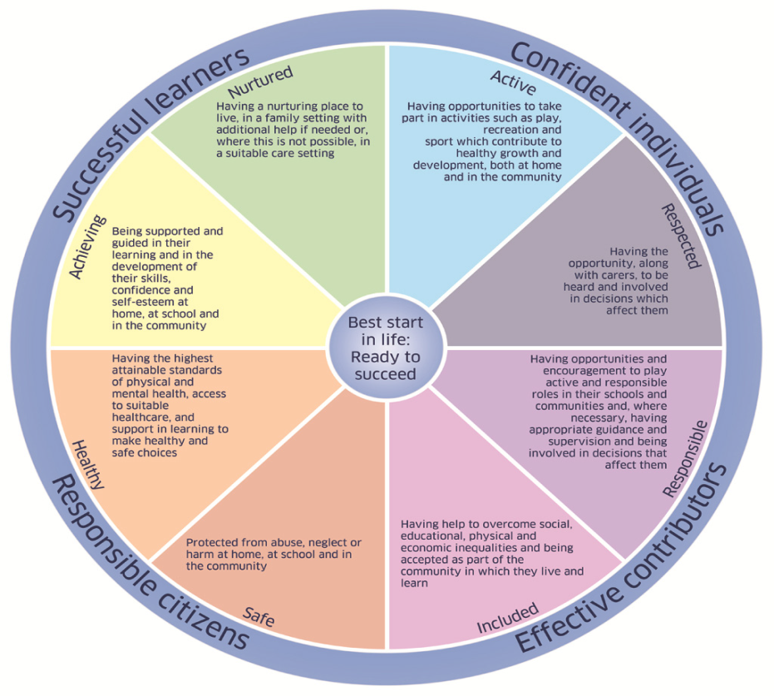
- SAFE
- HEALTHY
- ACTIVE
- NURTURED
- ACHIEVING
- RESPECTED
- RESPONSIBLE
- INCLUDED

Keeping the Promise
GIRFEC, The Promise, and children’s rights are indivisible components in our delivery of Scotland’s vision for all children, young people and families. Rights, Reviews and The Promise provides an overview of the inclusion connections across the recommendations and requirements of The Additional Support for Learning Implementation Plan (Morgan Review), The Promise and the Rights of the Child (UNCRC).
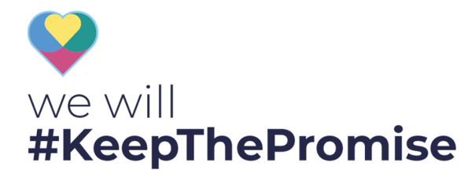
More information can be found at:
National Guidance for Child Protection in Scotland 2021 updated 2023 https://www.gov.scot/publications/national-guidance-child-protection-scotland-2021-updated-2023/
Getting it Right for Every Child
www.gov.scot/Topics/People/Young-People/gettingitright

Children’s Services
Appendix 3
Record of Concern Alert

Please use black ink (or type) and CAPITAL letters.
When you have a concern about a child or young person you must report it immediately to the head or manager. Once you have reported the concern to the head or manager you are required to complete this form on the same day.
Day and date
Head or manager to whom it was reported
Name of child/young person
Establishment/service
Source of Concern (please circle):
Personal Observation | Yes | No
Reported by child | Yes | No
Reported by another source | Yes | No
Please give details of source
Phone call | Yes | No
Please give details of call
Please give details. If a disclosure has been made, record on the back of this form using the child’s own words. SIGN AND DATE DIRECTLY UNDER STATEMENT
Print name
Date and Time
Job Title

