Todholm Primary School

Home Learning Pack

Primary 5

Literacy

Your Literacy learning will include;

- Writing
- Comprehension
- Grammar
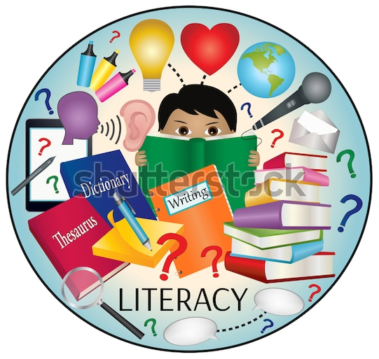
- Handwriting
- Spelling

Writing – Creative/Imaginative

Creative or Imaginative Writing focus on thinking up your own characters, settings and stories from your imagination. Choose one of these pictures and use it help to create your own story.
What has happened here?

Who was involved?

How is this going to impact the people who live here?

How long ago did the sand get there?

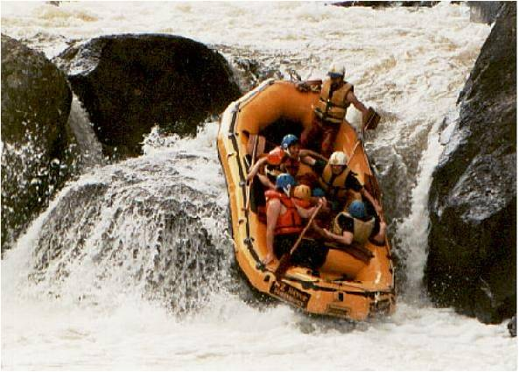
What is happening here?

Who is there? Are you there? Are you with others?

Is this dangerous or fun?

How will this end?

Remember in our imaginative writing we should include;
- An introduction.
- A build up to an event.
- A climax (the main event of the story).
- Some kind of resolution (how we bring things back to normal).
- A conclusion.

There also must be lots of detail and description in creative writing because the audience need to use your words to paint a picture in their mind.
Writing – Descriptive Writing

Descriptive Writing focuses on using the five senses to help bring an image or thought to life. For this writing we must include lots of adjectives all linked to the senses. When the audience is reading your writing, they should be able to see what you’re describing all together and not only parts of it. Choose one of these to describe in your writing.
Describe the happiest place in the world for you.

Describe the best food you have ever eaten.

Remember when you are describing one of these to make sure you have included each of the five senses. Depending on what you’re describing some senses will be stronger than others, however all five should still be there.

Use your adjectives to add extra description by writing about colours, sizes, shapes etc.

You can also describe the experience of seeing this place or eating this food for the first time and include your thoughts and feelings.

Comprehension

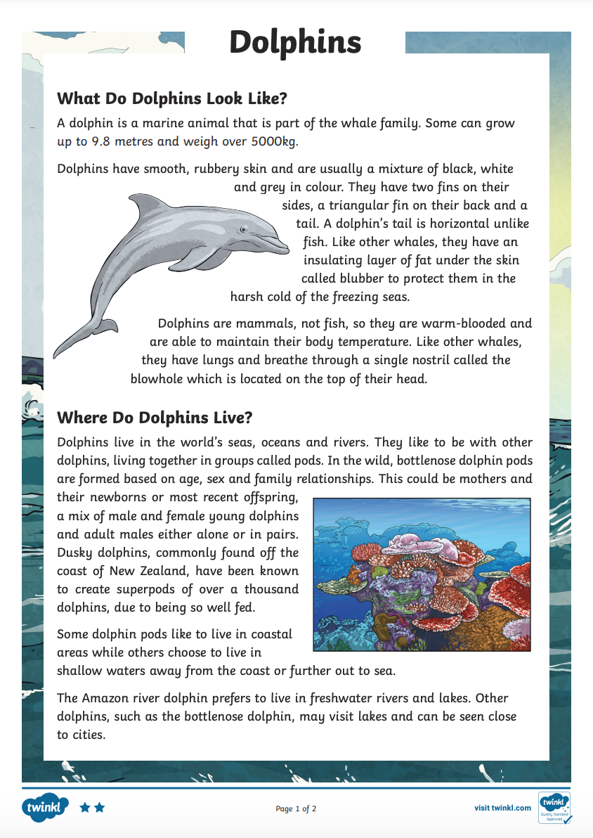
Complete this comprehension by reading the passage and answering the questions in full sentences.
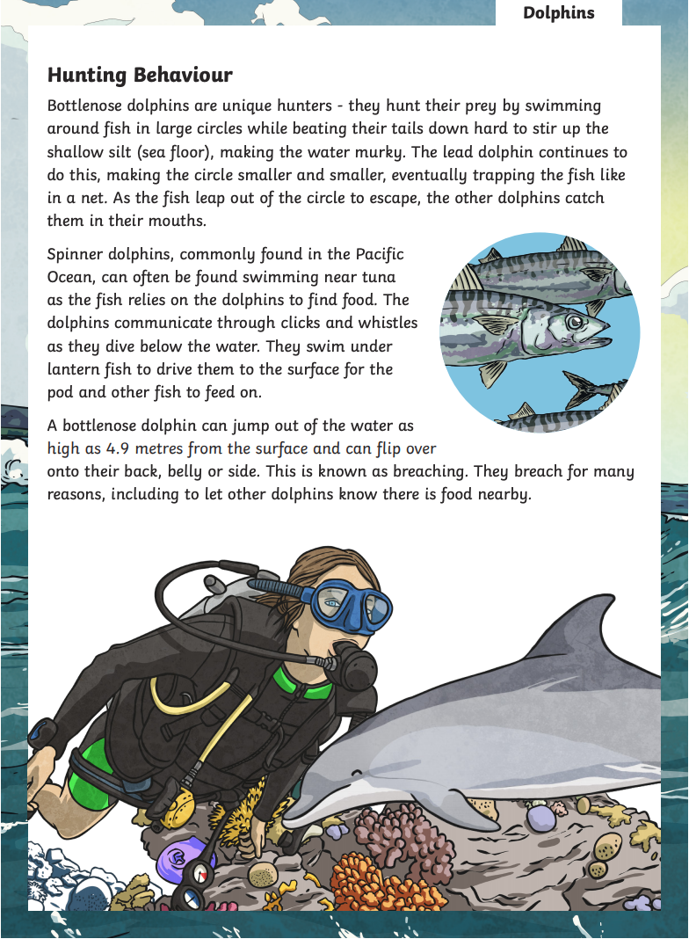
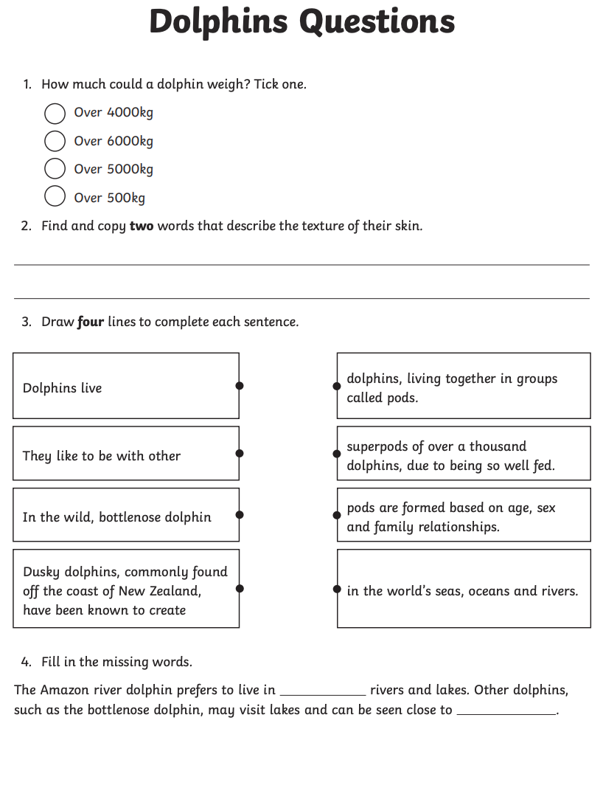
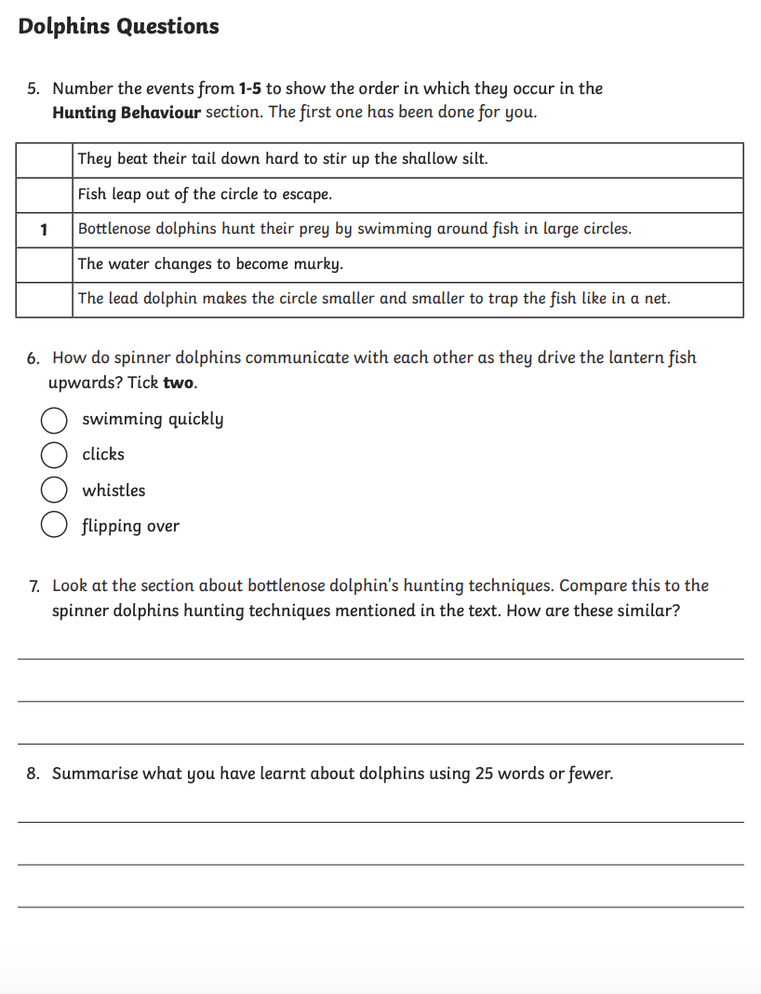
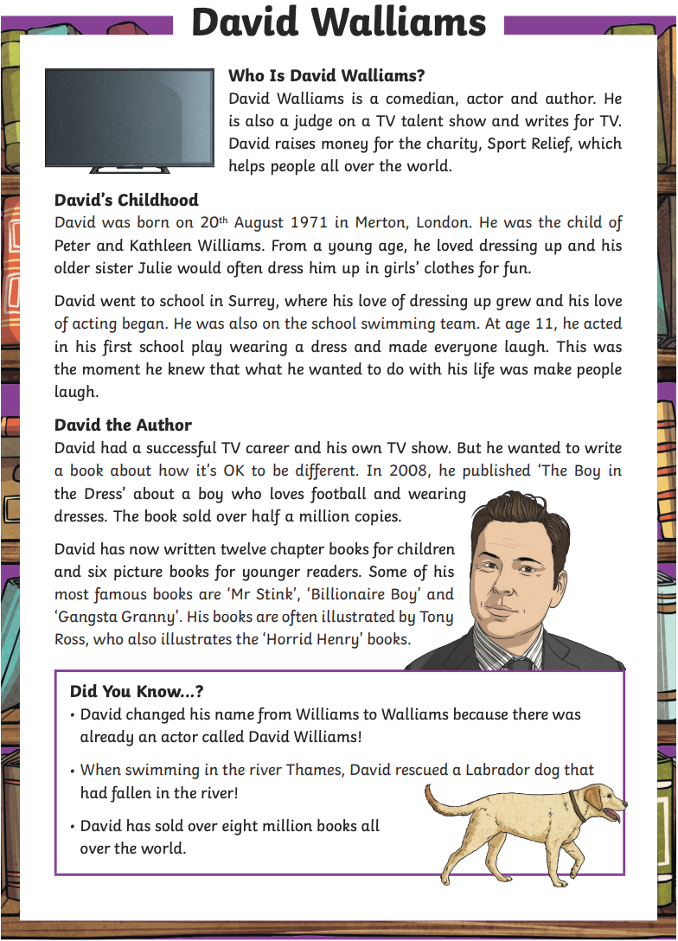
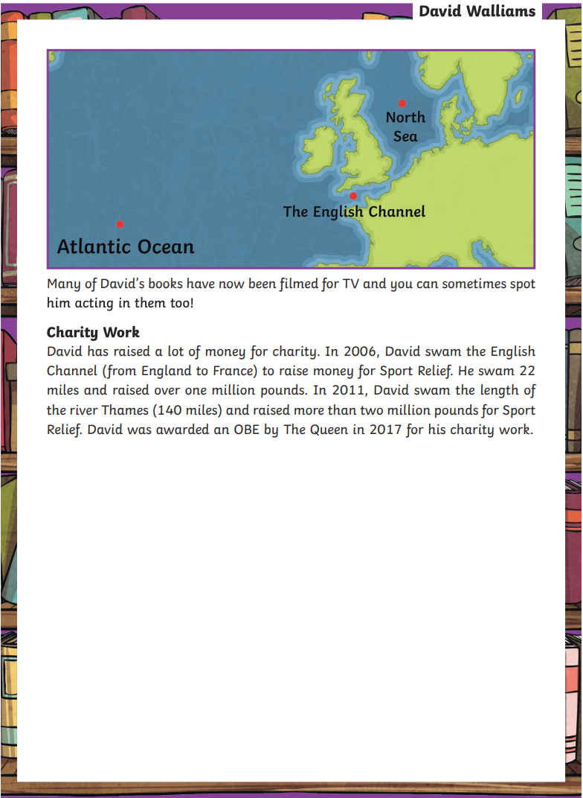
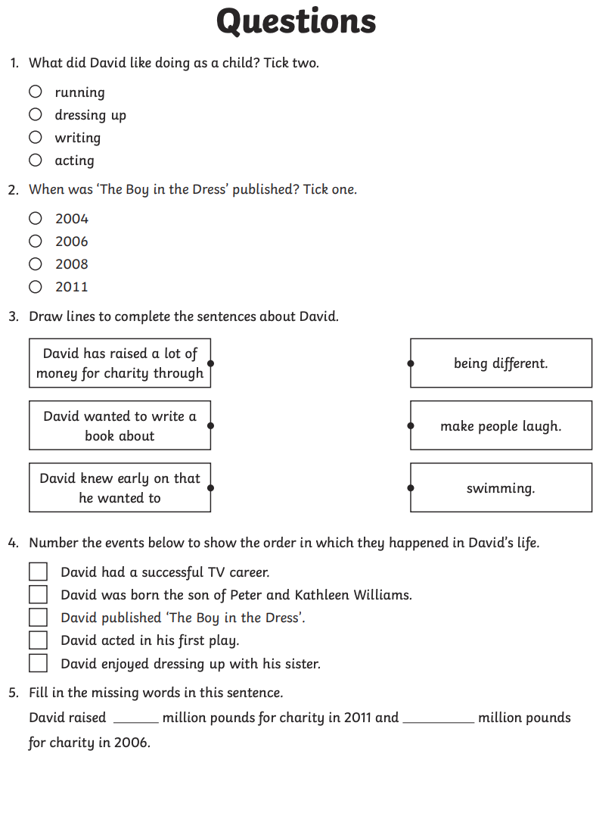
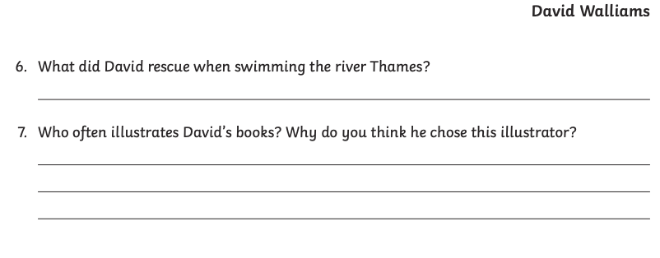

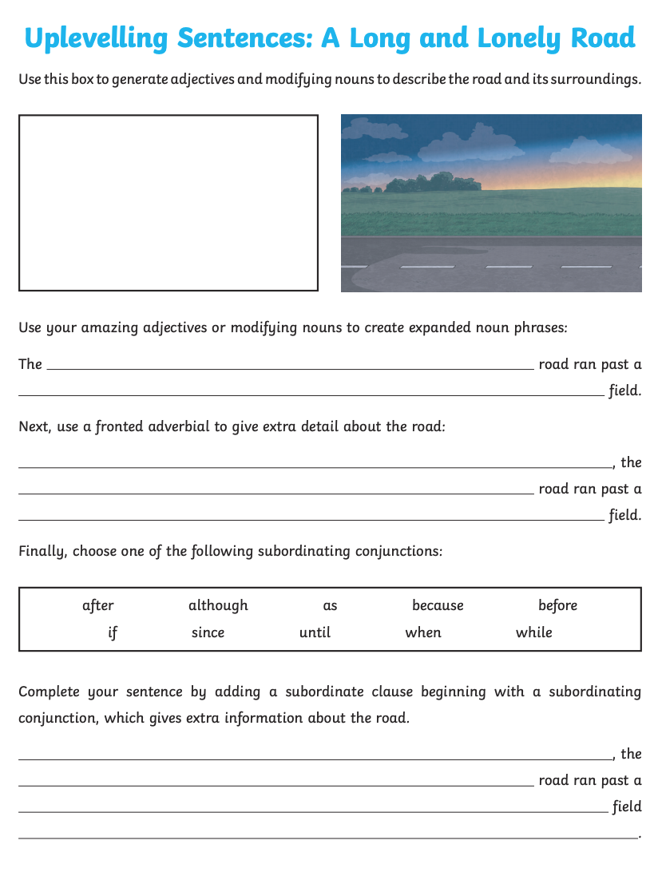
Grammar – Uplevelling Sentences
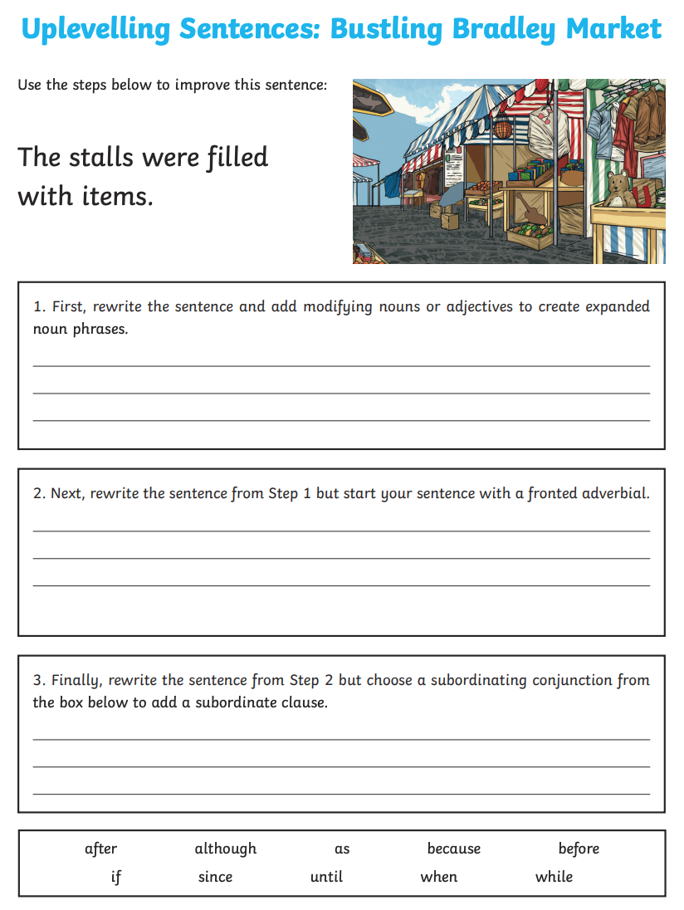
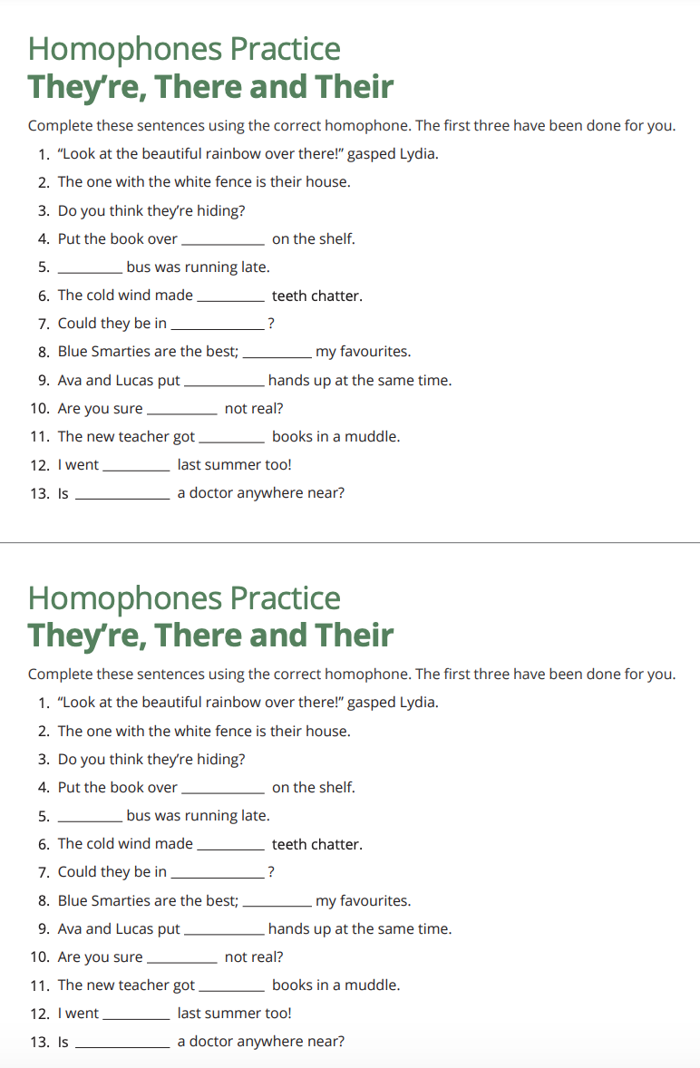
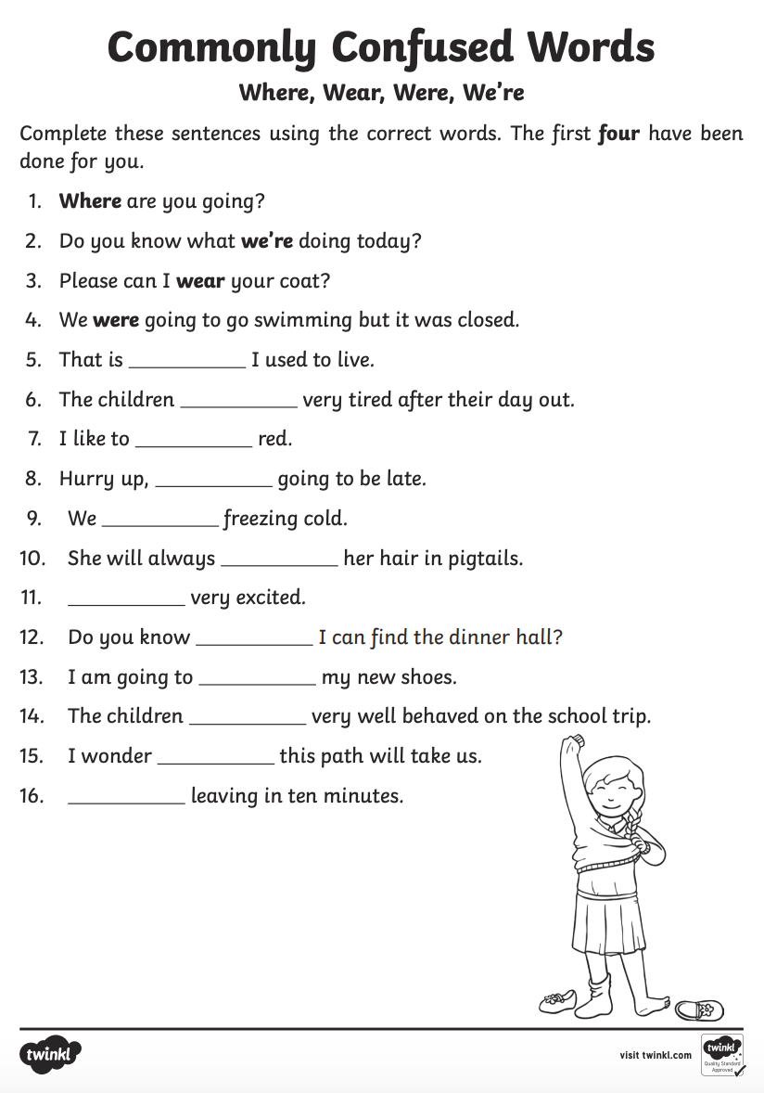
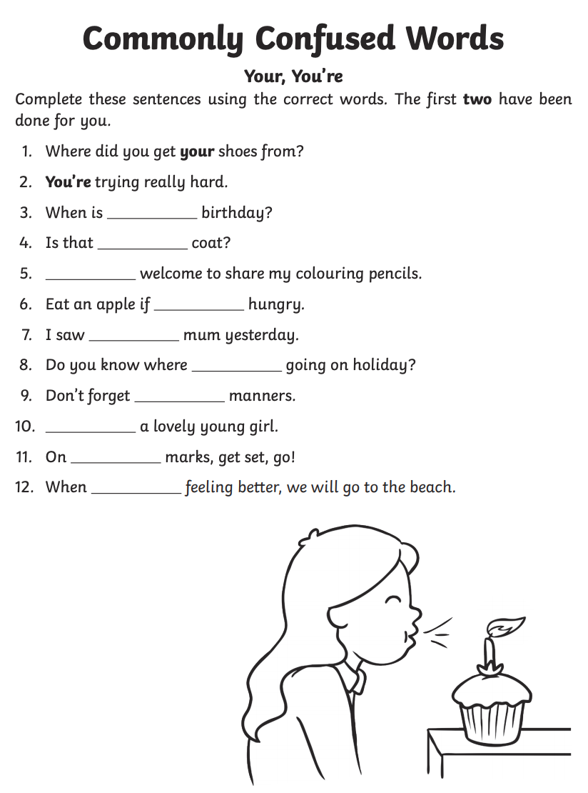
Using Paragraphs

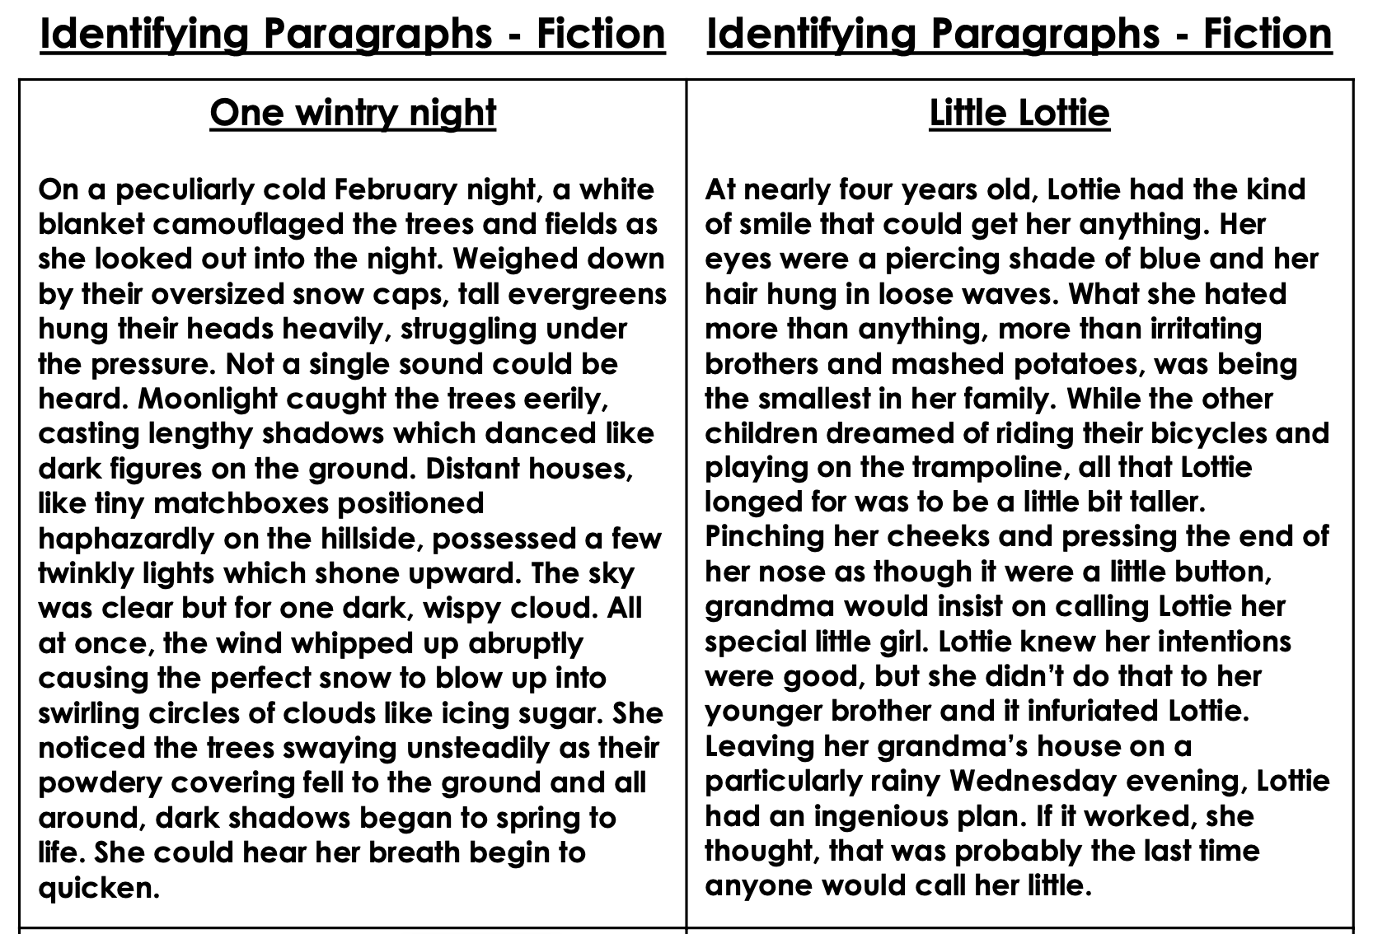
Organise these pieces of writing into smaller paragraphs by leaving a line in appropriate places.

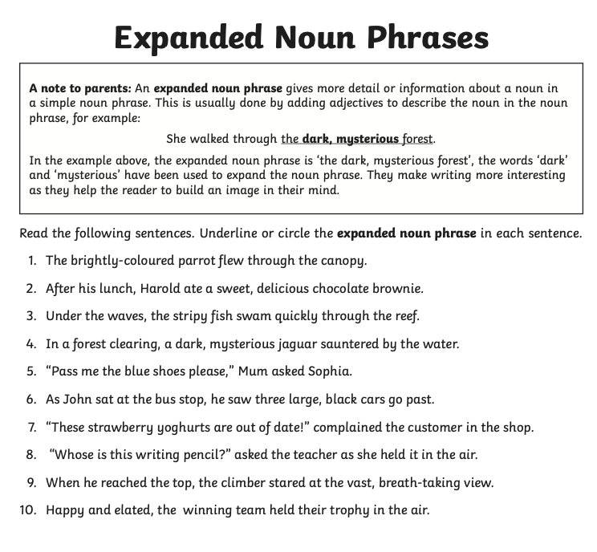
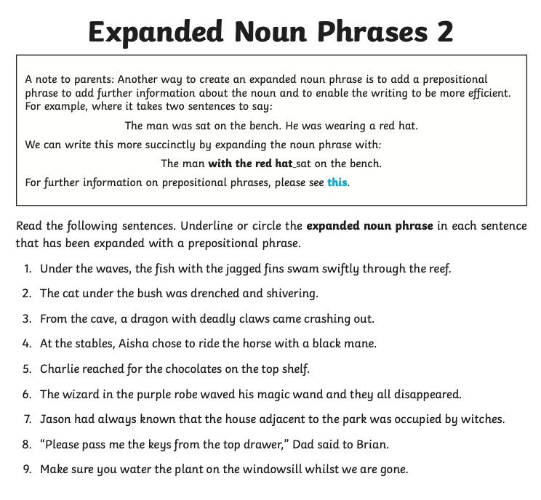
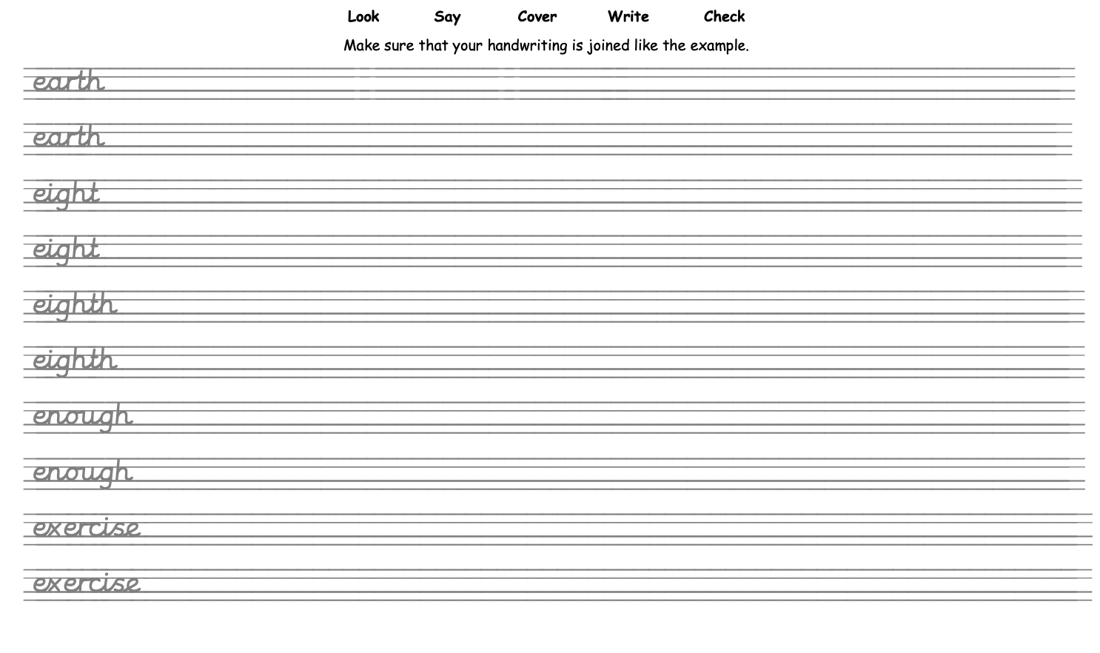
Handwriting
Spelling

Choose 12 words from one of these lists and complete 1 spelling task from the pages below. Do one of these each day as an extension task.
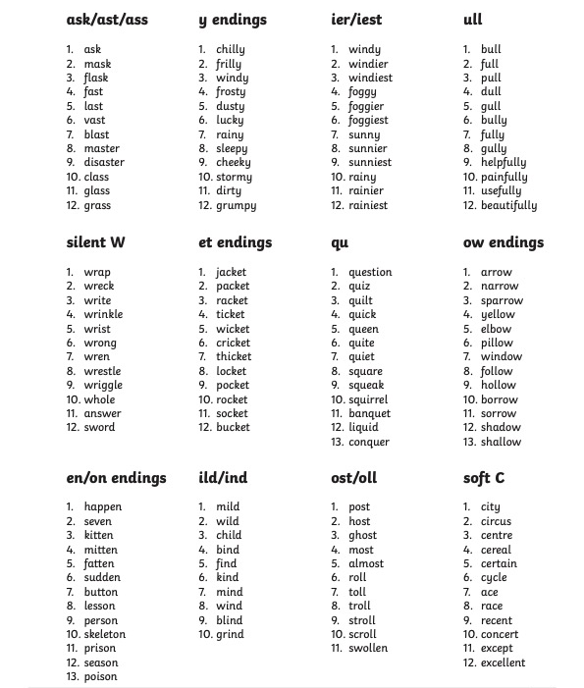

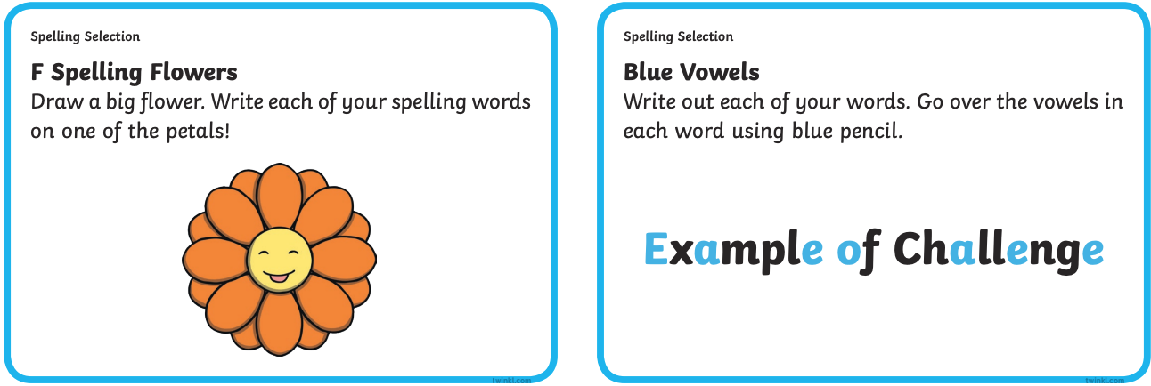
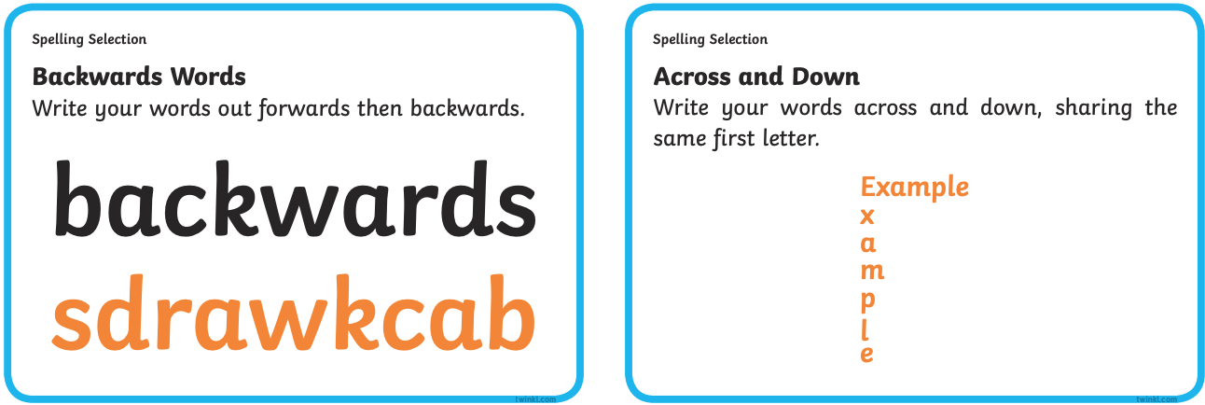
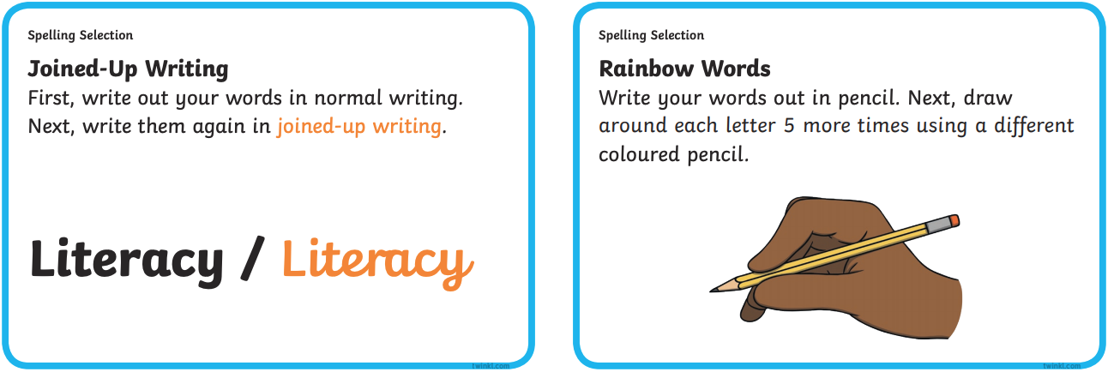
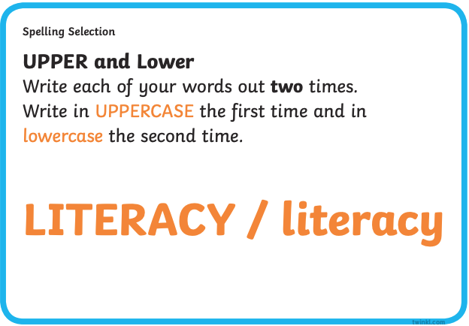
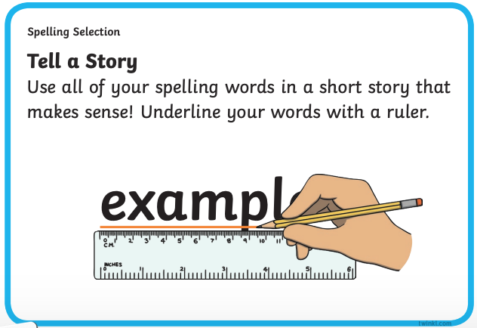
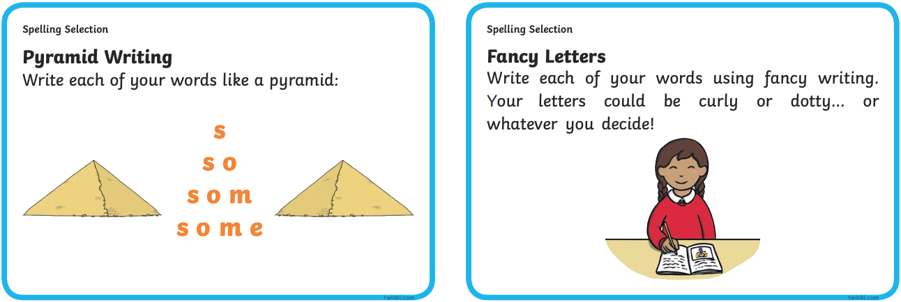
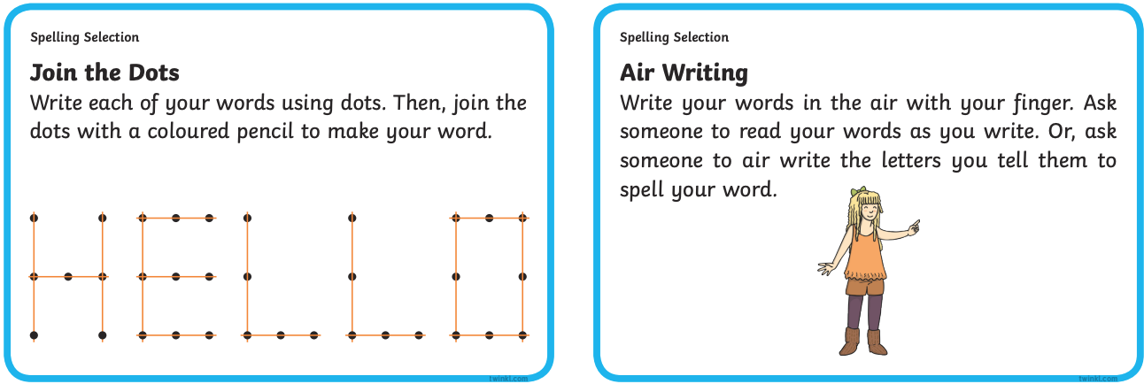

Numeracy

Your Numeracy learning will include;

- Addition
- Subtraction
- Multiplication
- Division
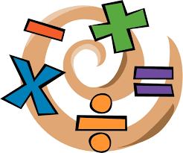
- Shape

Addition – Mental Strategies

Complete these addition sums using your mental strategies. Remember some of our mental strategies include;
- Partitioning
- Friendly Numbers
- Rounding
- Empty Number Line
- Reordering
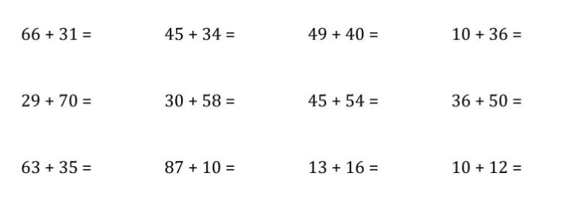

Space for working.
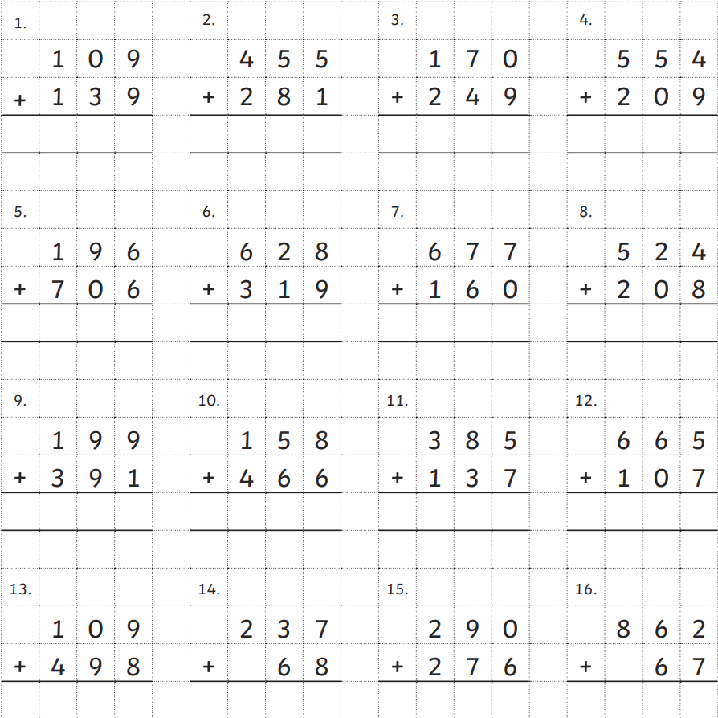
Addition Activity 2

Create a poster displaying the steps involved in completing adding sums using one of the mental strategies.

You can choose any strategy either listed on the previous page or that you have used and feel comfortable to explain.

Please make your poster bright and eye catching but remember it should clearly explain the steps involved in doing the sum.
Subtraction

Solve these subtractions sums using your mental strategies.
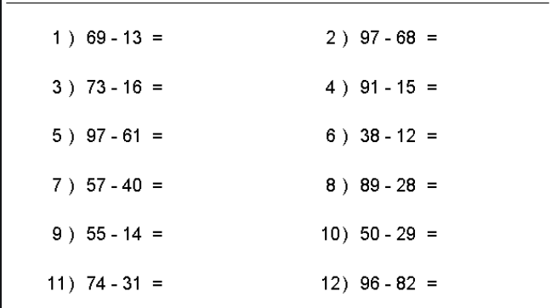

Space for working.

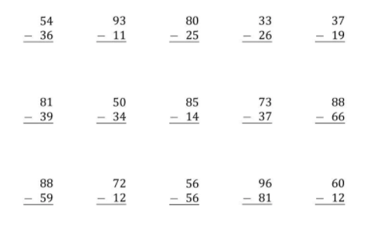

Subtraction Activity 2

Using Topmarks Daily 10, complete 10 mental subtraction questions at whichever level you feel most comfortable with. Once you have completed these write down your score in the space provided. Try this 3 times and aim to achieve 7/10 in at least 1 of your rounds.

Multiplication

Mental Maths Challenge: Using Sum Dog, complete a multiplication challenge. Focus this challenge on the times tables you feel are the hardest and give yourself extra practice.

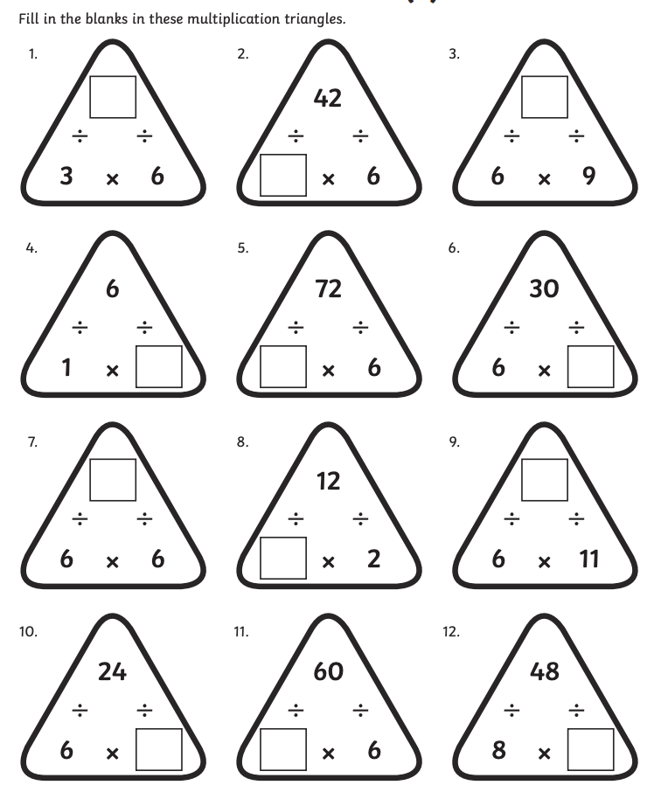
Multiplication Triangles:
Multiplication – Mental Strategies

Using mental strategies which we know, try to solve these multiplication sums. Some of these are;
- Array
- Repeated Addition
- Number lines.
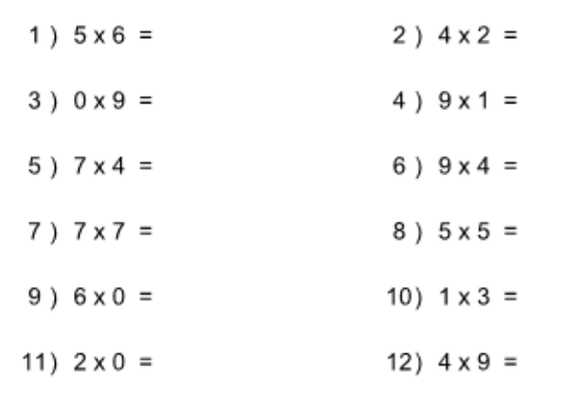

Space for working.

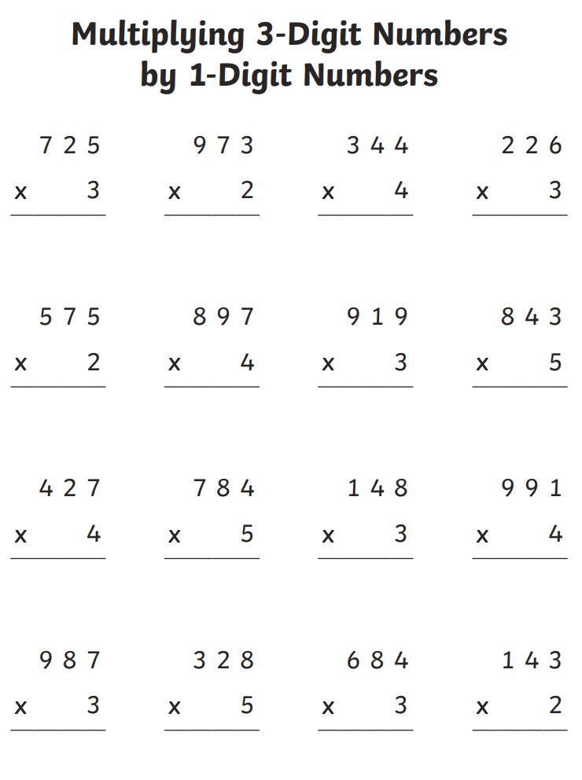
Division

Mental Maths Challenge: Using Topmarks Hit the Button, practice your division questions at a level you are comfortable with. Try to reach a score of 20.

Sharing:
Divide these Sweets into 5 equal groups, then write the division sum and answer in the box below.

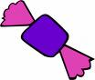
÷ =

Divide these bananas into 2 equal groups, then write the calculation in the box
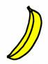
÷ =

Divide these cakes into 10 equal groups, then write the calculation in the box.

÷ =

Divide these sandwiches into 2 equal groups, then write the calculation in the box.

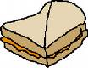

÷ =

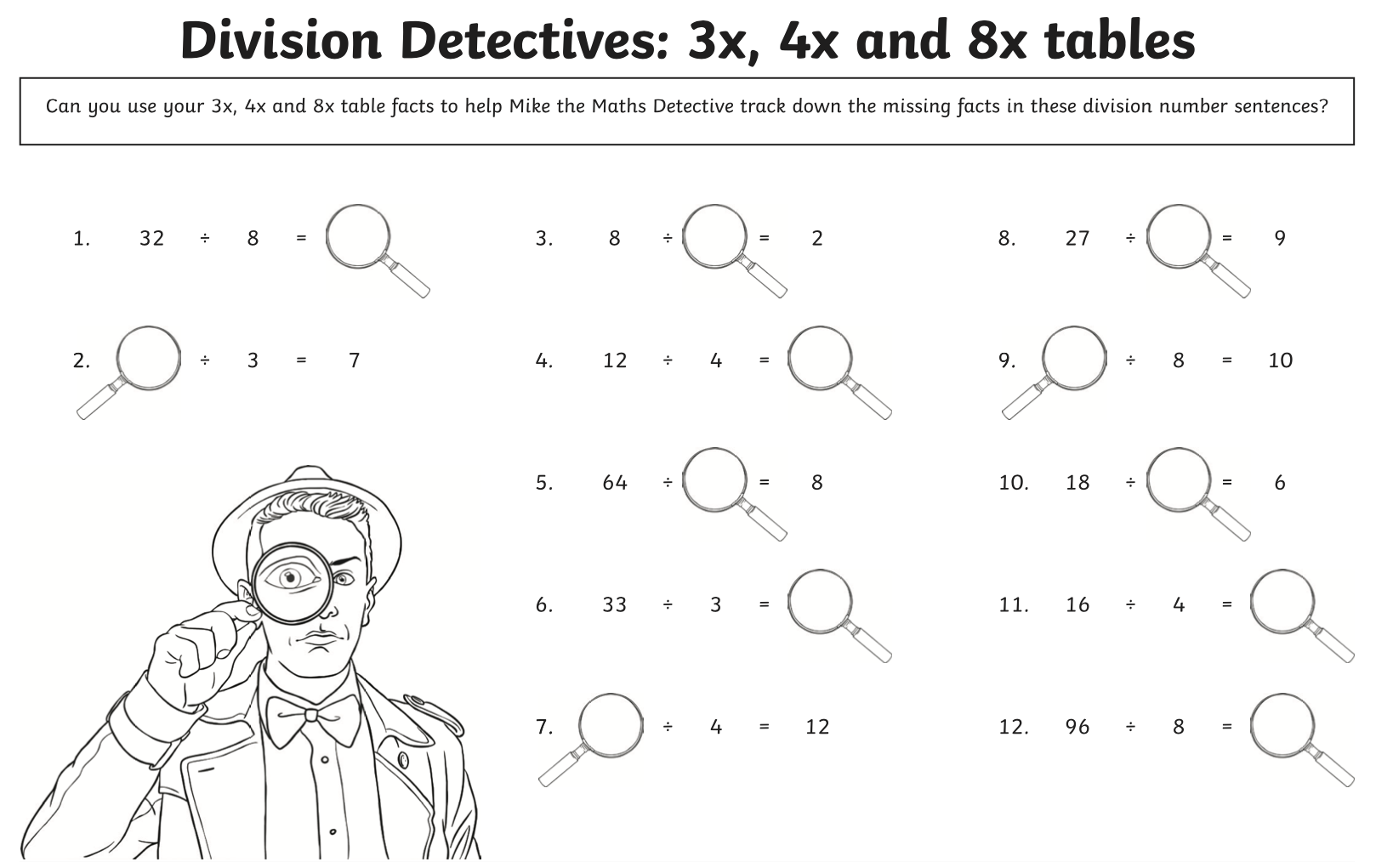
Division – Mental Strategies

Complete these sums using the mental strategies for division, there were;
- Repeated subtractions
- Multiplying up
- Partial Quotients
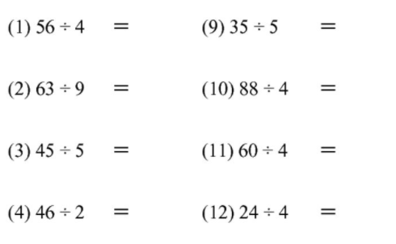

Space for working.

Division – Upstairs Downstairs Sums

Complete these sums using the written method.
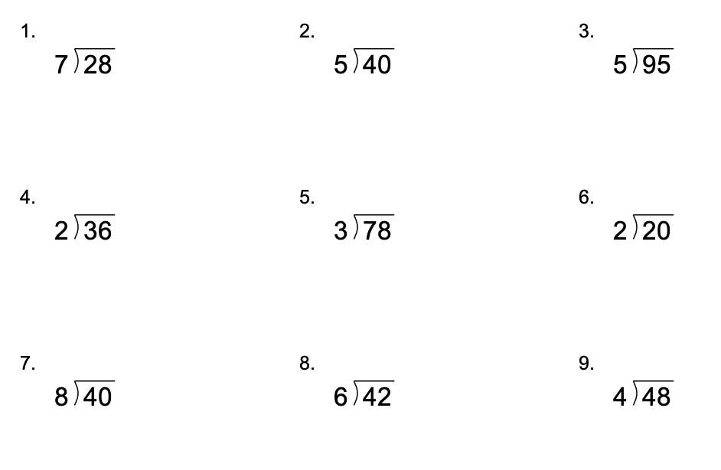
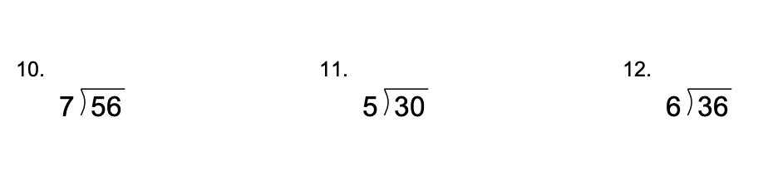

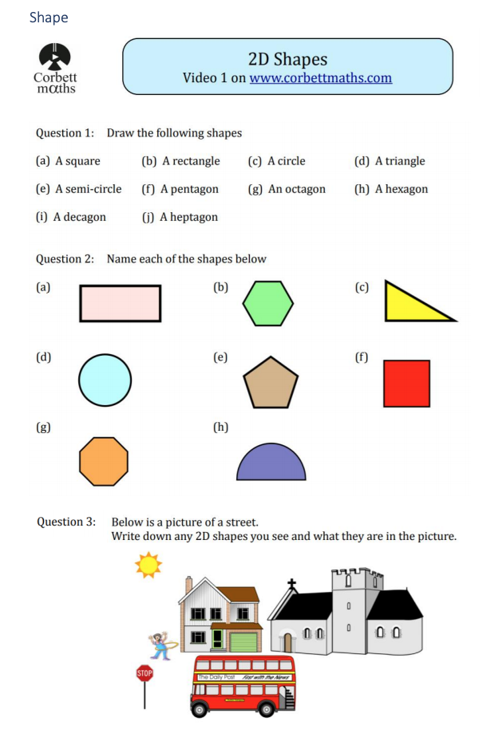
Shape
Space for answers

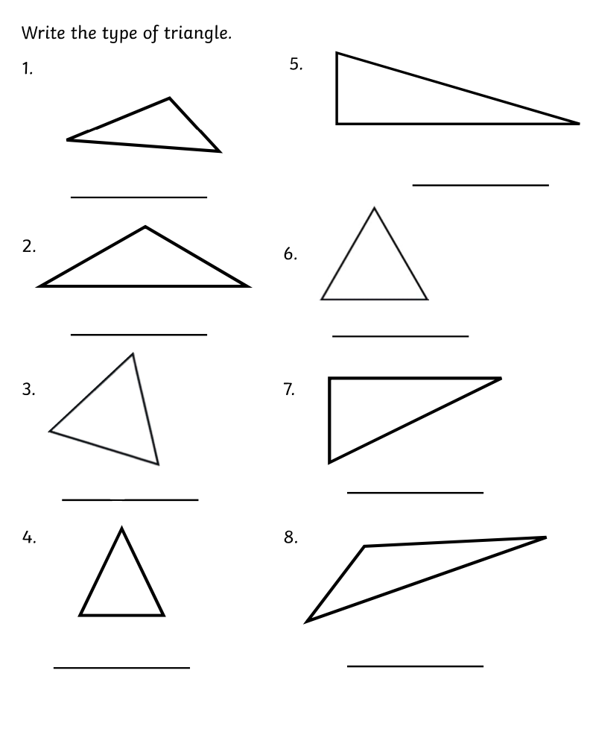
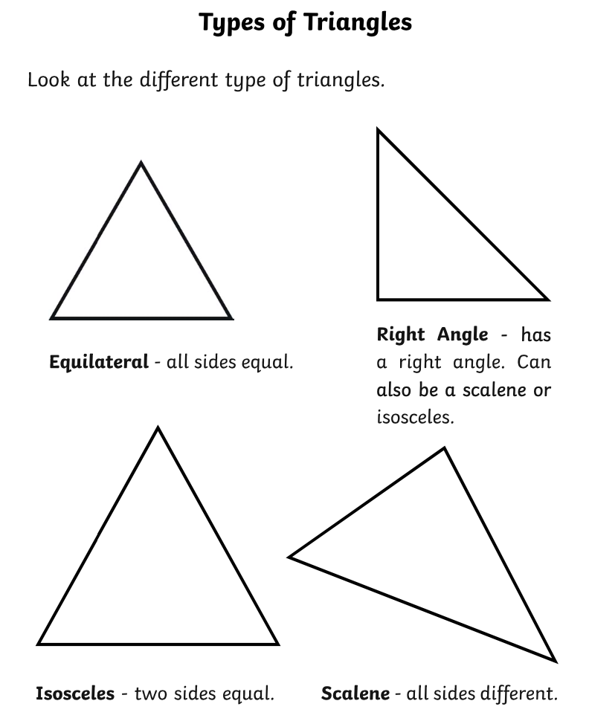

Properties of 2D Shapes

Using any technology you have, search BBC Bitesize on the internet and make your way to the article which says; Sides and vertices on 2D Shapes. Read through the page which will help you with the properties of 2D shapes.

Complete the quiz which helps you to count the faces, edges and vertices.

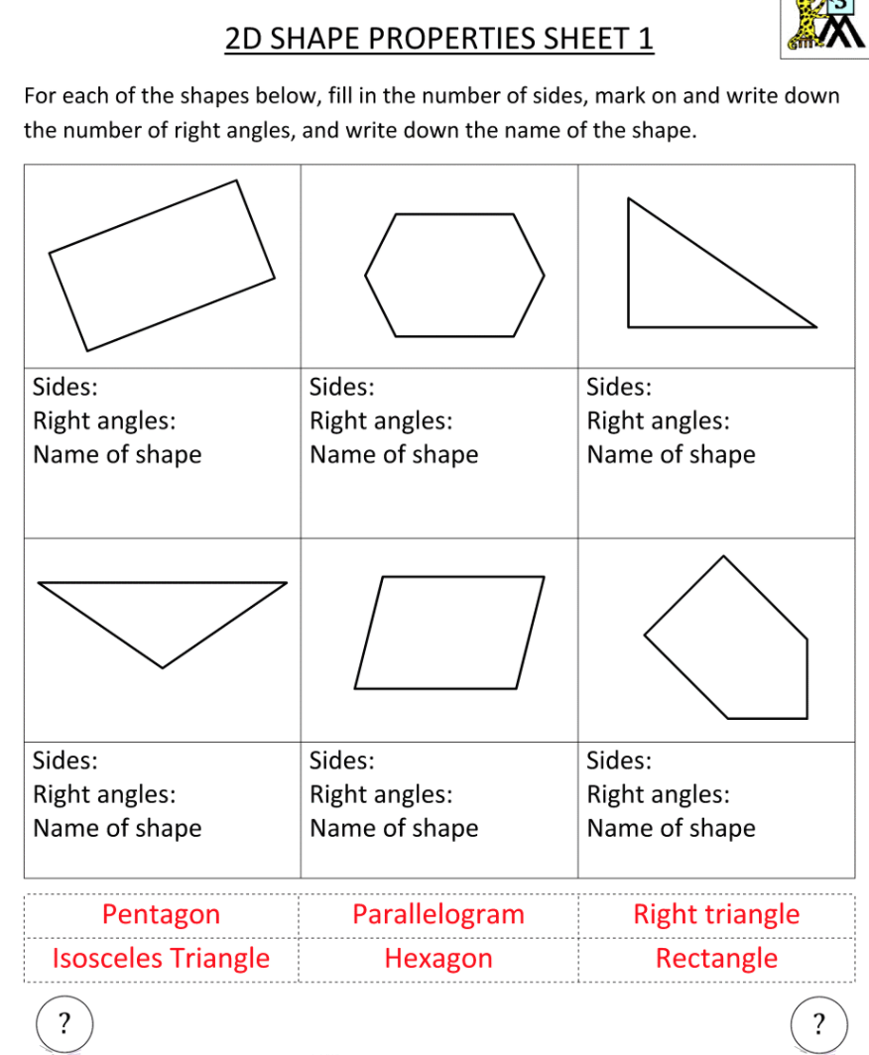
Once you have done so, complete this worksheet.
3D Shape

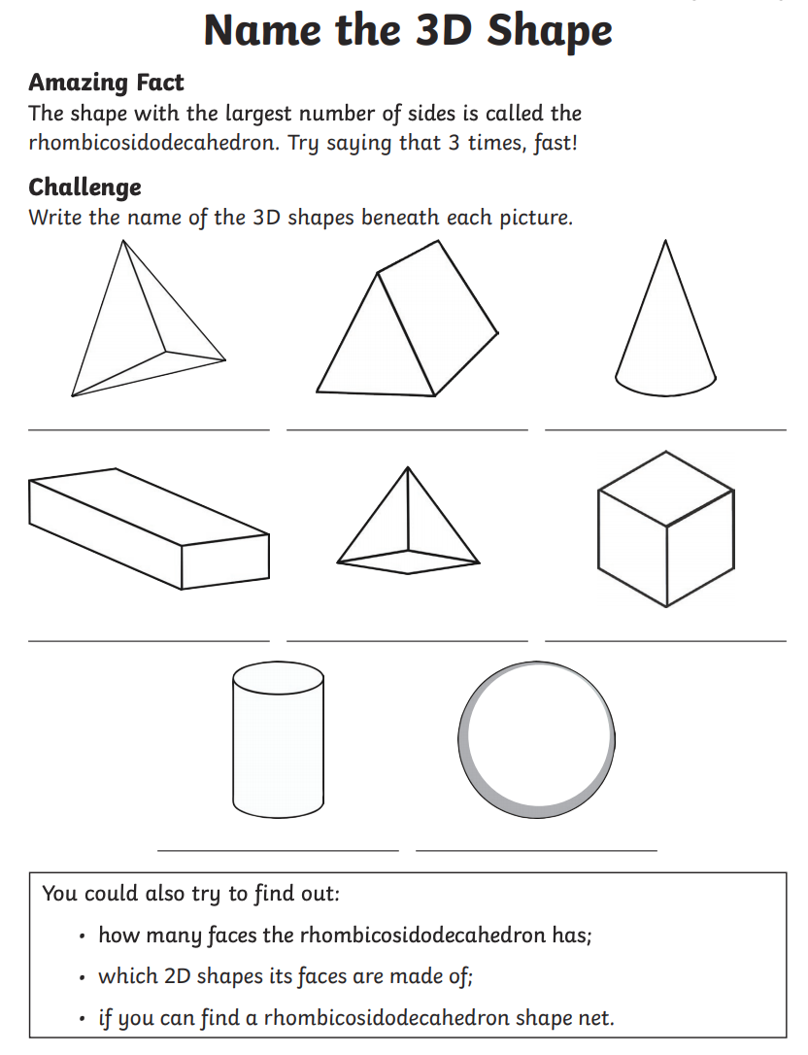
Can you name these 3D shapes?
