Home Learning Pack
Primary 7
Todholm Primary

Useful websites

- Reading Eggs. Pupils have their own logins where they can work independently through the levels. Pupils can focus on spelling and reading.

- Sumdog. All pupils have logins where they can complete different numeracy games to earn coins. They can also be set challenges by their class teacher. This is something pupils can work on independently.

- Education City. Pupils can log in and access both numeracy and literacy games and challenges which they can complete independently.

- Topmarks. No account needed, lots of interactive numeracy games for all age and stage.

Literacy

Writing

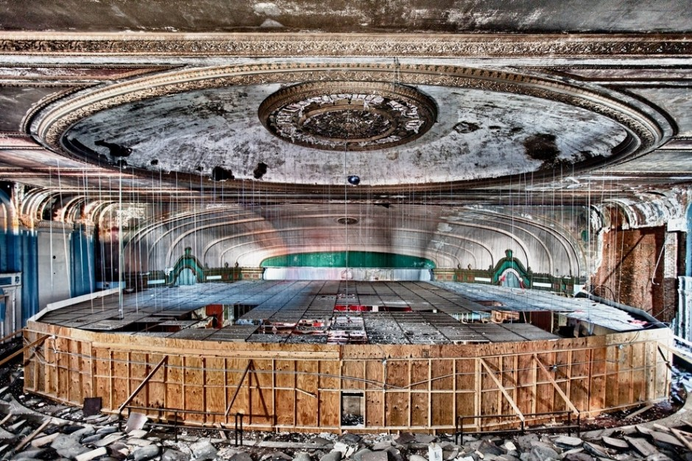
- Using the stimulus, write an imaginative story. (Hint – you could link it to the closed theatres we have as a result of COVID-19)

- Imaginative writing. Where could this path take you?

- Discursive writing. “Should animals be kept in zoos?”.
You should have four main paragraphs – two which agree that animals should be kept in zoos and two which disagree. Make sure you have reasons and evidence to back up each argument. Include an introduction and conclusion.

- Acrostic poem.
C
O
R
O
N
A
V
I
R
U
S
Write an acrostic poem about coronavirus and things that have changed or been affected by the virus like shops closed, sports cancelled etc.

- Netflix Review
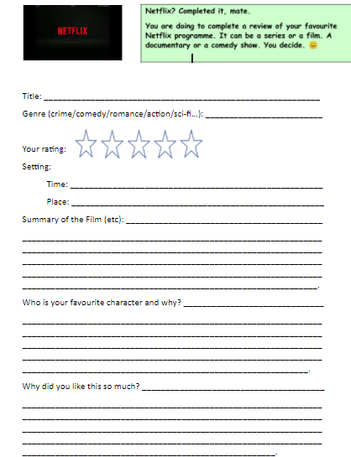

Comprehension

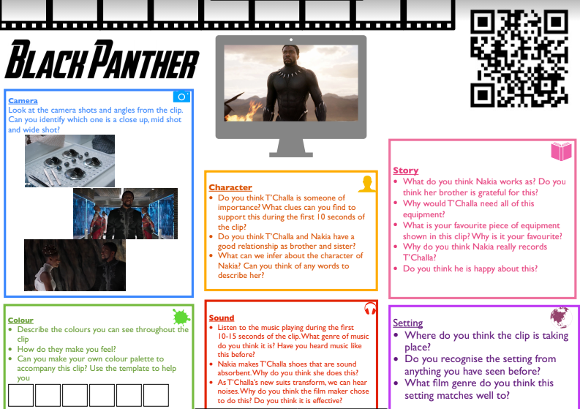
- Inference. Use the QR code to watch the clip of the film. Answer the questions in each section.

- Inference. Listen to the song using the QR code and answer the questions.

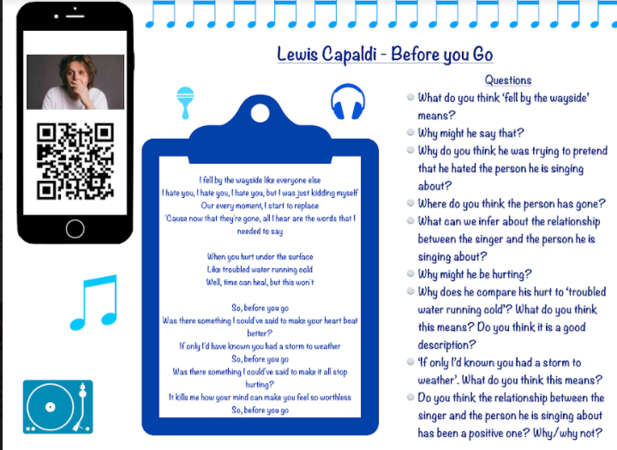

- Comprehension – Grubby Gregor.

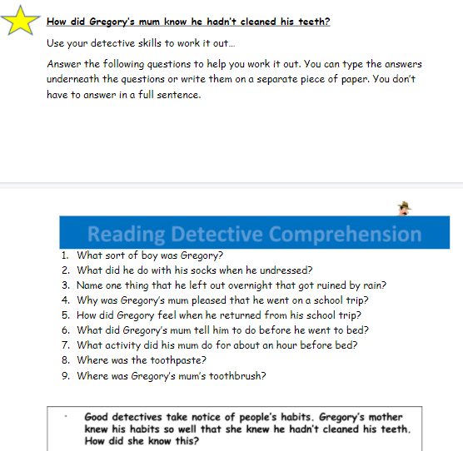
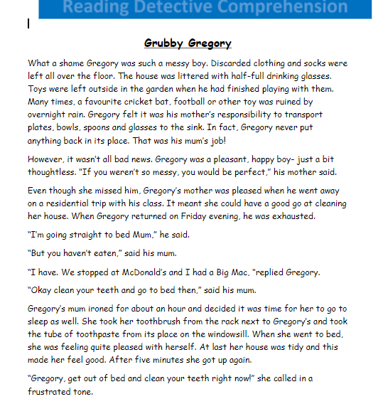

- Complete the passage and answer the questions at the bottom.
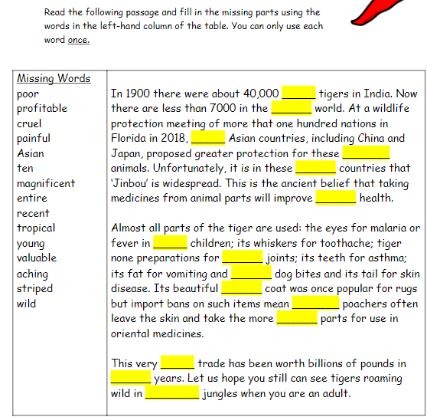
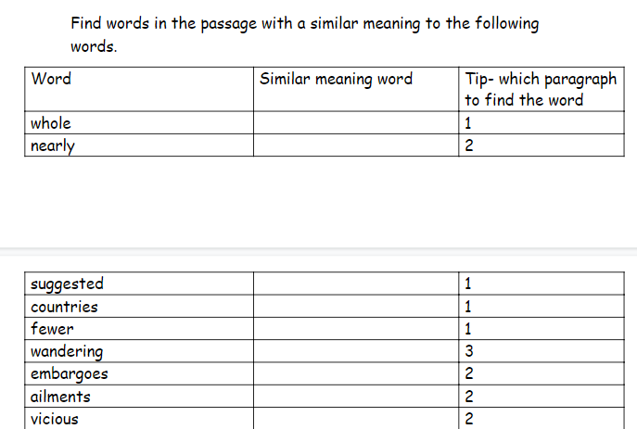

Grammar

- Tenses
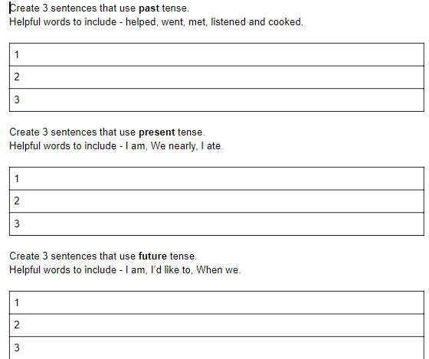

- Punctuate direct speech.
Use: Question mark? Exclamation mark ! Comma , Inverted commas “ “ Full stop .
Don’t know why you went and got yourself the lead part anyway he said Just
means you have to learn more lines than anyone else and actually sing instead
of just pretending to He fished my cap from underneath the art trolley and
plonked it back on my head so hard that it was wedged right over my eyes
Plus you’re wearing tights
They’re leggings I said yanking the cap up not tights Usually I didn’t get that
tingly feeling before a performance until I was just about to
go on stage Not today; my head was already spinning
You In tights In front of all those people Unbelievable

- Commonly confused words. (Homophones)
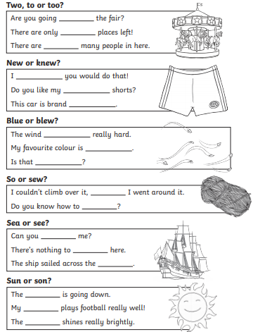

Numeracy

- Number and Number Processes
- Angles and Symmetry
- Estimating and Rounding
- Time
- Shape
- Money
- Fractions, Decimals and Percentages
- Measure
- Data Analysis

Number and Number Processes

- Use number strategies to find the answers. (Chunking, partitioning, number line)

- 1443 + 540 =
- 25, 988 + 2410 =
- 250 + 12, 890 =
- 8,300 – 1,200 =
- 15, 680 – 4, 720 =
- 5,000 – 3450 =
- 120 x 25 =
- 75 x 11 =
- 125 $÷$ 5
- 2046 $÷$ 12

- Word problems

- On Sunday I spent 114 minutes on my art project, and 45 minutes on my numeracy homework. On Thursday evening spent a total of 86 minutes on my history project and 39 minutes reading. What is the difference in minutes between the amount of homework I did on Sunday and Thursday evening?
- Dad drives a truck. Last week he drove 267 kilometres on Monday, 186 on Tuesday and 198 on Wednesday. This week Dad drove 279 kilometres on Monday, 148 on Tuesday and 288 on Wednesday. What is the difference in kilometres between this week and last week?
- One watch costs £1.60 and I bought four. If I had paid with a £20 note, how much change would I have received?
- There are 12 eggs in each egg tray and I bought 11 trays. I used 38 eggs this weekend, how many full trays do I have left now?
- I need to buy enough whiteboards for 273 students and there are 25 in a pack. When the packs arrive 17 whiteboards are damaged. How many whiteboards are undamaged?
- Mum set off at 5:55pm. She arrived at her destination at 7.34pm. Mum had estimated that the journey would take her 2 hours and 16 minutes. What is the difference between her estimated and actual travel time?

Angles & Symmetry

- Supplementary angles. Two angles which add to 180 degrees. Find the value of the other angle.

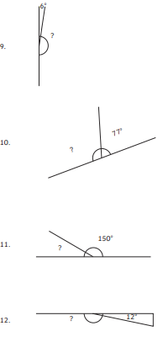
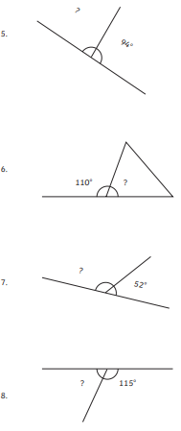

- Calculate missing angles in right angled triangles. (Right angled = 90 degrees)

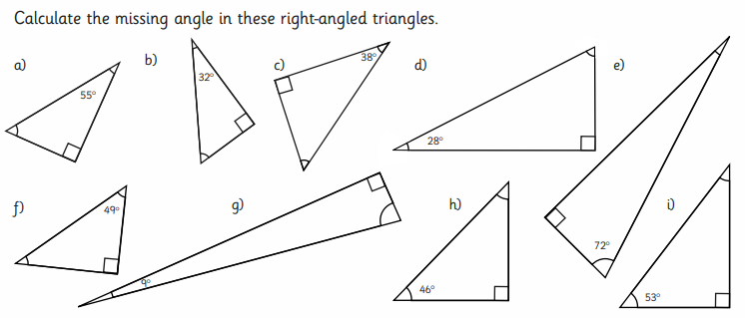

Estimating and Rounding
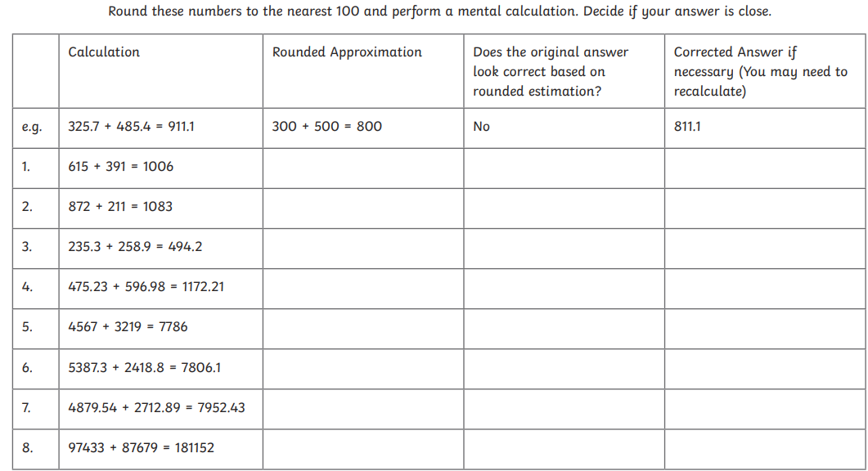

Time
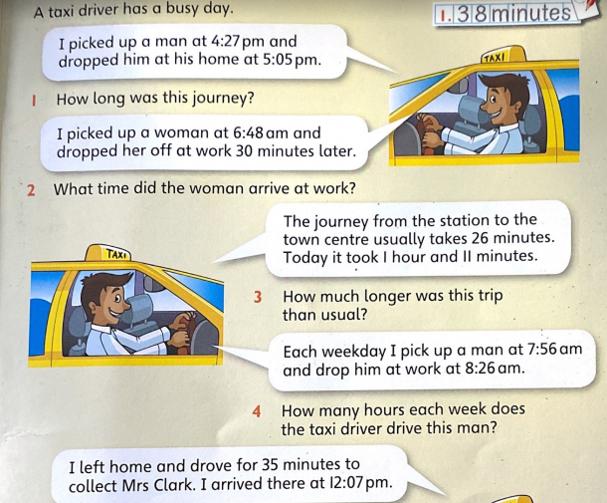

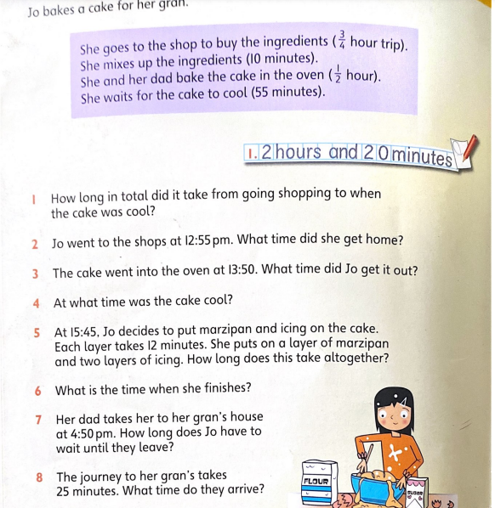

Shape
3D (Vertices – where two edges meet. (The pointy part)
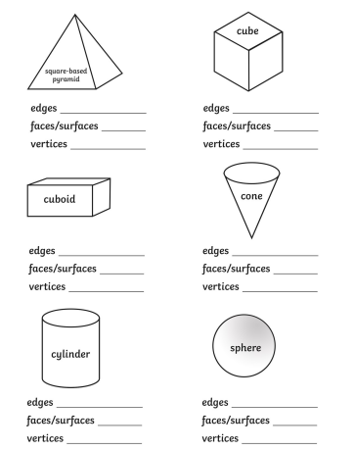

Money
Budgeting – Ordering at a restaurant

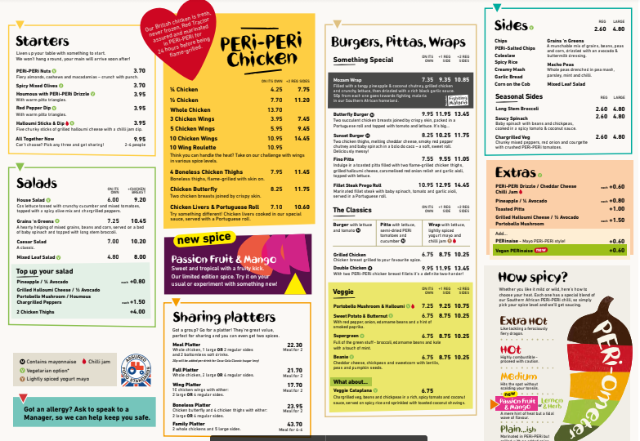

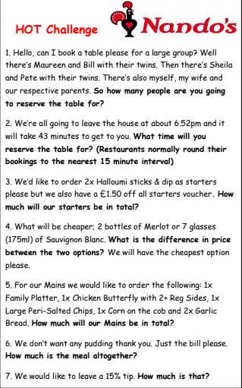

Fractions, Decimals and Percentages

- Ordering decimals
Put these prices in order from lowest to highest:
£2.03 £3.20 £3.02 £0.32 £0.23 £2.30

2. Put these measurements in order from longest to shortest:
11.01m 11.10m 7.52m 7.052m 11.011m 7.502m 7.25m 7.025m

3. Look at these numbers:
7.652 12.45 8.25 14.106 9.03 17.32 10.157 20.967

a) Which number has a 9 in the ones place?
b) Which number has a 2 in the tenths place?
c) Which number has a 0 in the hundredths place?
d) Which number has a 6 in the thousandths place?

- Match the percentage, decimal and fraction
50% 25% 75% 100%

4/4 ¾ ½ ¼

0.25 0.50 1 0.75

- Fractions of amounts
2/3 of 15
½ of 150
2/3 of 30
¼ of 44
¾ of 16
1/5 of 35
3/5 of 95
½ of 60

Measure

- Area of a triangle ( A = ½ l x b =)
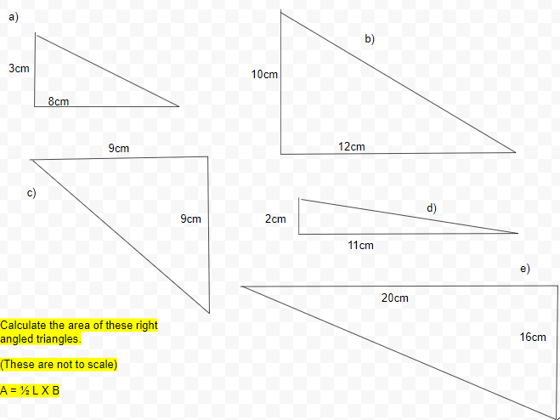

- Zoo designer.
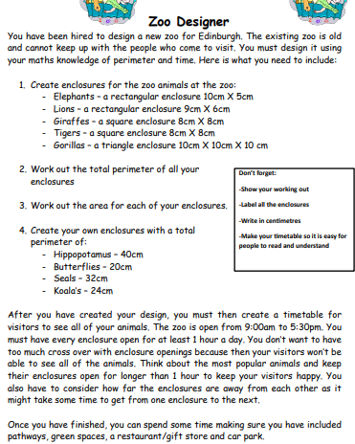

Data Handling & Analysis

- Pie Charts
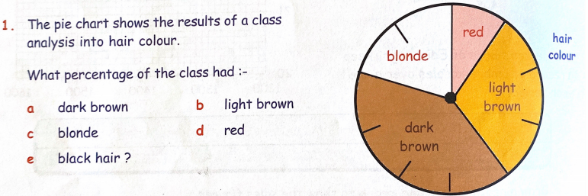

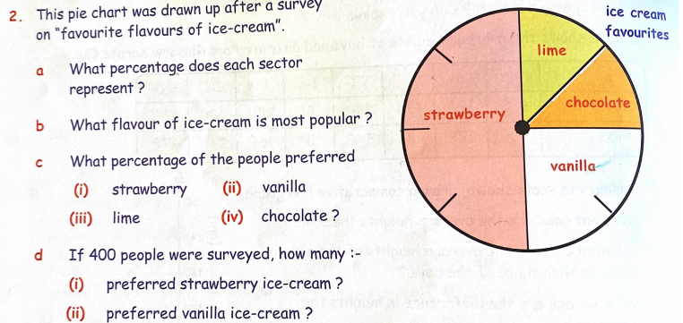
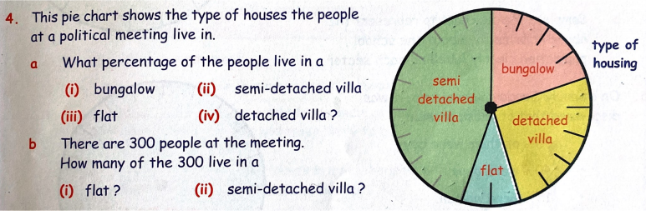

Health and Wellbeing

P.E
Joe Wicks The Body Coach – P,E with Joe.
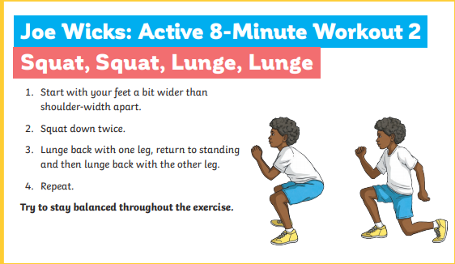
Daily Yoga

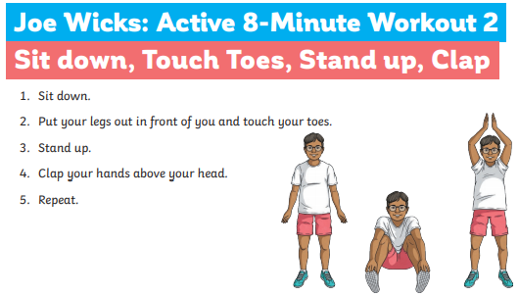
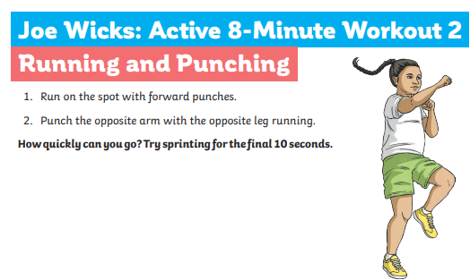
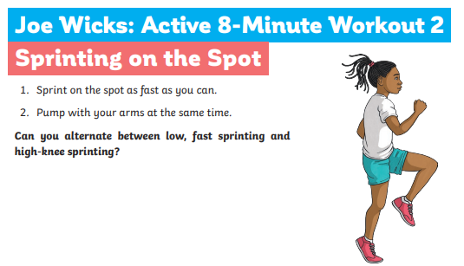
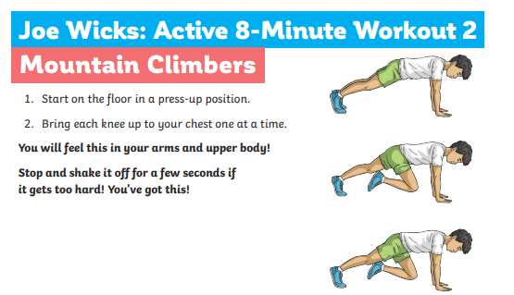
All about me

Healthy lifestyle
https://www.bbc.co.uk/bitesize/topics/zrsb87h/articles/z4dxhbk
Create a healthy meal using the eat well plate.

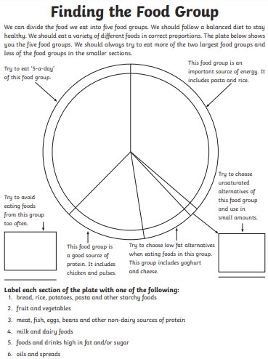

Dangers of Smoking.

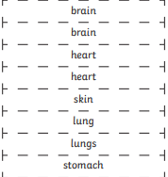
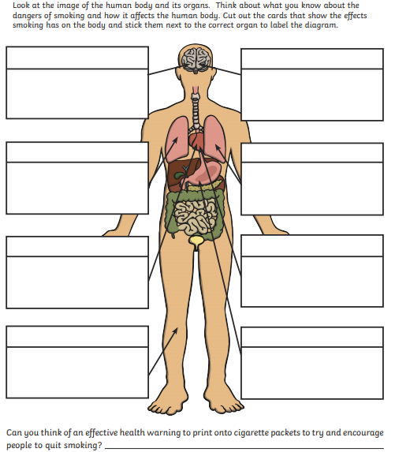
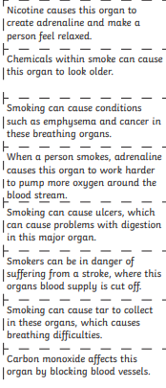

Rights and Responsibility.

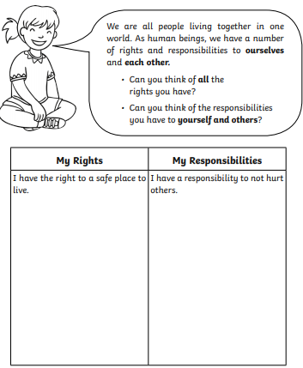

Future self

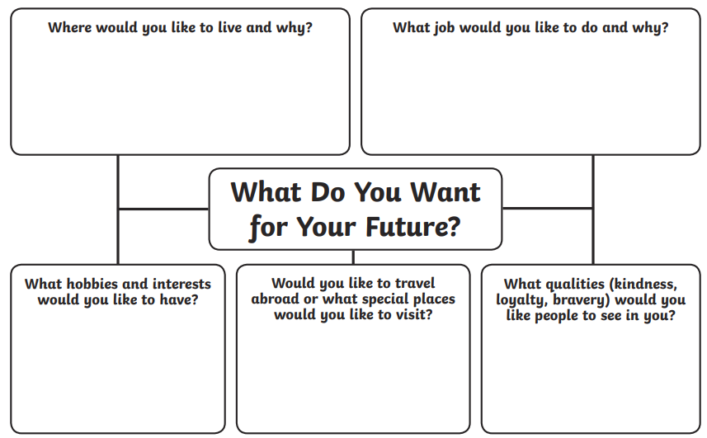

Empathy

How do we show empathy? https://www.youtube.com/watch?v=t685WM5R6aM
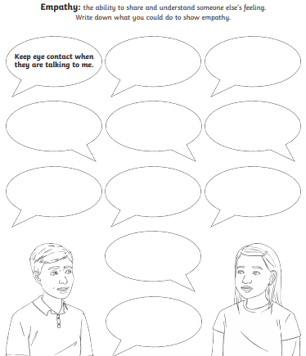

Growth Mindset

The power of yet.
https://www.youtube.com/watch?v=zLYECIjmnQs&list=PLUW9eJYZpIHL8dlcvcsSZsKi3Nfsalu7P
Think of three targets that you want to achieve. Think of changing your statement from a fixed mindset to a growth mindset with the power of yet.
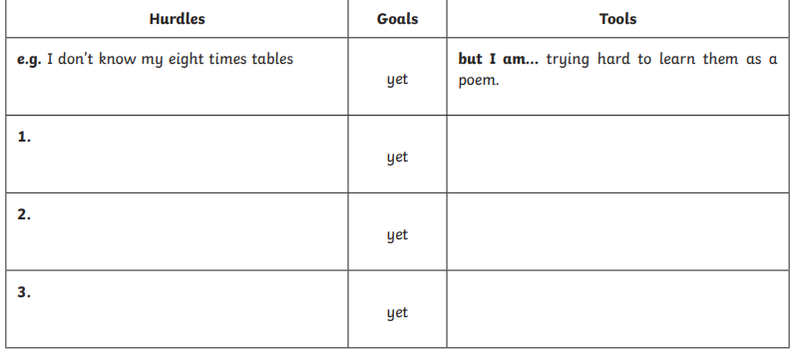
Research someone famous who had to deal with a lot of failures but used growth mindset, perseverance and positivity to get them to where they are today.

Role Model

Who is your role model? It could be someone you know like a friend, family member or sports coach or it could be someone famous. Research about them and create a PowerPoint or poster on why they are your role model. What qualities do they have that make them a good role model?

