Home Learning Pack
Primary 4
Todholm Primary

Useful websites

- Reading Eggs. Pupils have their own logins where they can work independently through the levels. Pupils can focus on spelling and reading.

- Sumdog. All pupils have logins where they can complete different numeracy games to earn coins. They can also be set challenges by their class teacher. This is something pupils can work on independently.

- Education City. Pupils can log in and access both numeracy and literacy games and challenges which they can complete independently.

- Topmarks. No account needed, lots of interactive numeracy games for all age and stage.

Literacy

Writing
- Redesign this abandoned amusement park. Write about walking into this abandoned place and closing your eyes to imagine what it could really look like. Add lots of description!
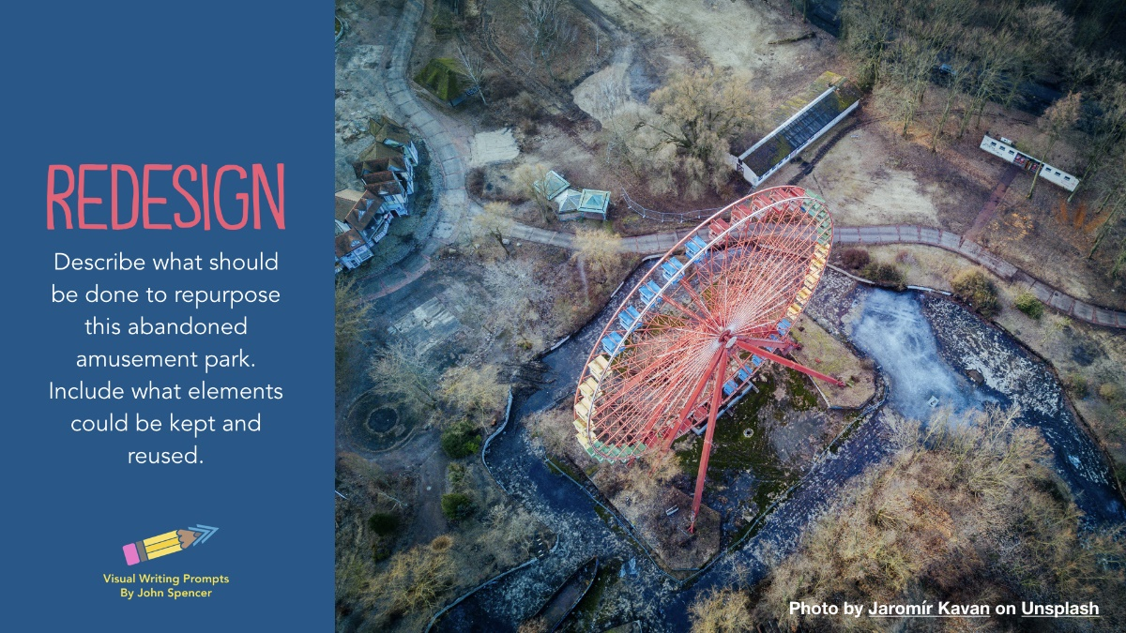

- Time travel. Imagine you could go anywhere in the world, past or present, in this hot air balloon. Describe the travel, where you are going and why. Add lots of description and feelings. 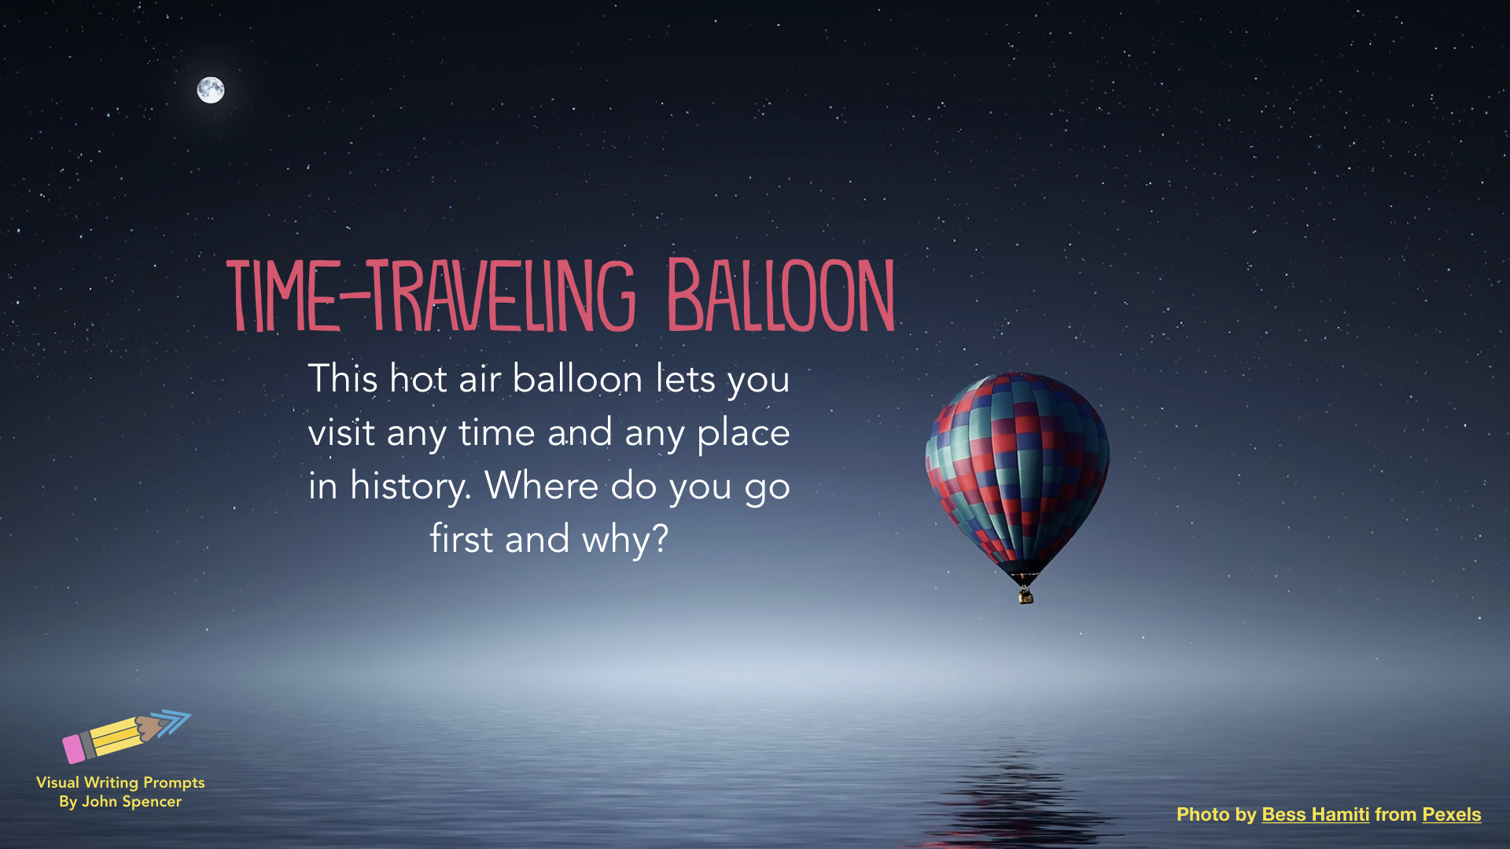

- Research information about Gorillas and write about them in full sentences.
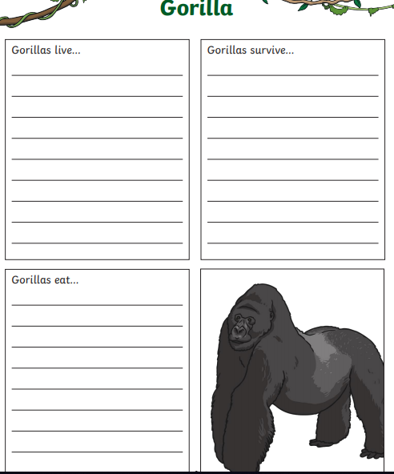
- If you could be a superhero for a day, which superpower would you have and how would you use it?
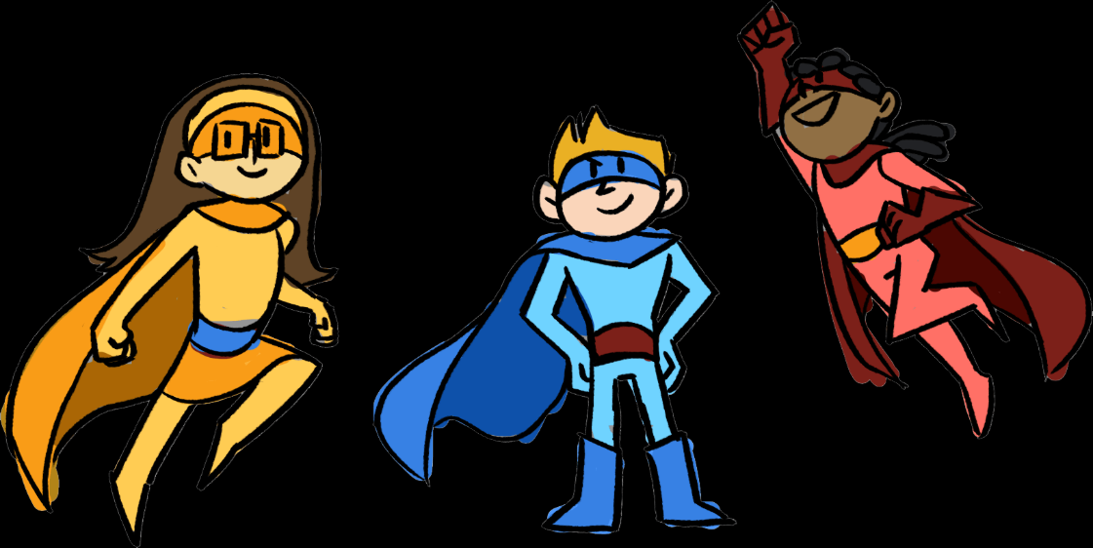

Grammar
- Homophones: there, they’re and their
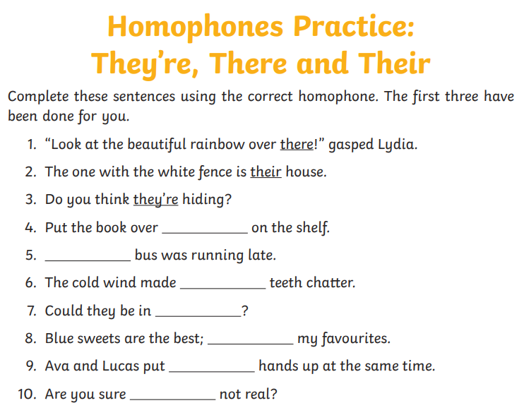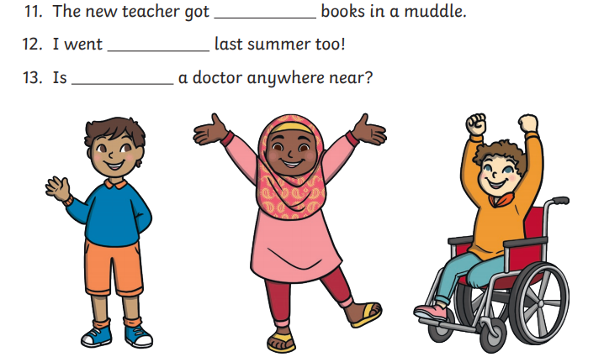

- Nouns
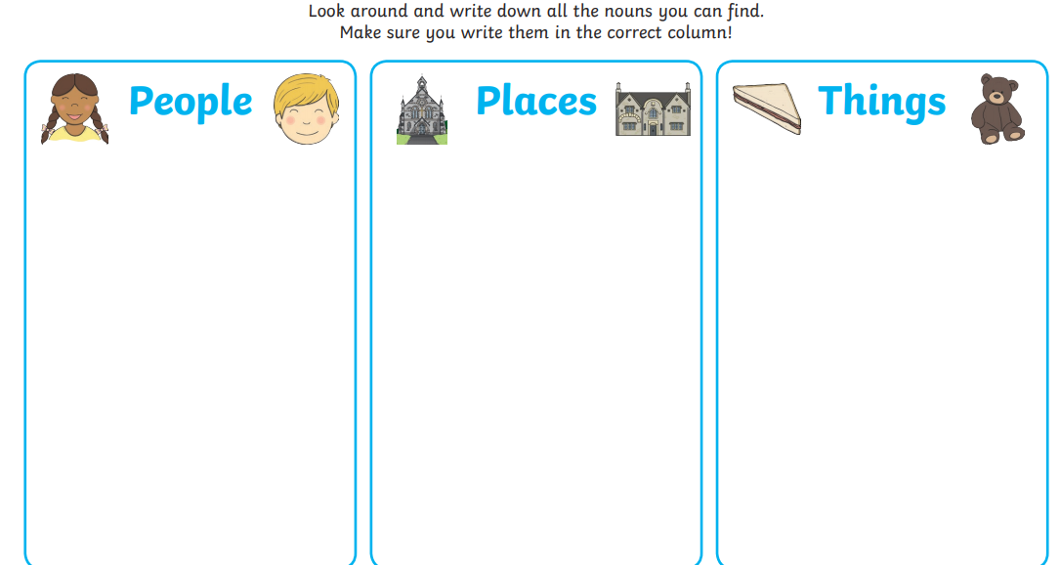

- Adjectives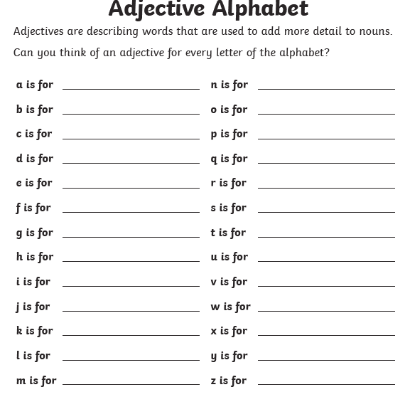
Can you create some sentences using these adjectives?
E.g. The slow, slimy snail.

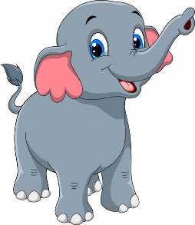
Comprehension
- How the Elephant Got Its Trunk
Once upon a time there was a little elephant. One day, she wanted to know what the crocodile ate for dinner. She asked all the other elephants, but they didn’t know.

So, she went to the river to ask the crocodile. The crocodile said to come closer and he would tell her. The little elephant did. She walked to the edge of the river.

Suddenly, the crocodile bit the little elephant’s nose. The little elephant pulled and pulled to get free. Her nose got longer and longer.

At last the little elephant got away. But now she had a long trunk instead of a nose. At first she didn’t like it but then she found she could squirt water all over her back! And she could us it to wave to all her friends!

Q1. What does the word 'suddenly' in paragraph 3 mean?
- very slowly
- all at once
- sadly
Q2. The little elephant wanted to know what:
- was for dinner
- the crocodile ate for dinner
- the time was
Q3. What happened first to the little elephant?
- she got away
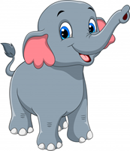
- her nose got longer
- her nose was bitten
Q4. Why do you think the crocodile wanted the little elephant to come closer?
- so he could eat her
- so he could stretch her nose
- so he could squirt water on her back
Q5. Was the little elephant happy her nose turned into a trunk?
- don't know
- yes
- no
Q6. In paragraph 4, 'it' means:
- the little elephant
- her trunk
- a crocodile
- Jiggling Jelly Monster
Jenny and Mum made green jelly and carefully placed it in the fridge to set.

‘This packet of jelly crystals came from Mr Hulk’, said Mum. ‘He is a very strange old man.’

Later, Jenny looked in the fridge to see if the jelly was set.

‘This jelly needs some jelly snakes’, she said. She dropped in red and orange chewy jelly snakes and closed the door. Some time later, Jenny opened the fridge door. A large green, red and orange jelly blob plopped out.

‘Help Mum!’ yelled Jenny. ‘It’s after me!’ Mum saw Jenny slipping and sliding on the floor. A wobbly blob chased her. It grew and grew.

‘If Jenny added sweet things to the jelly, the perhaps salt will stop it’, thought Mum. She threw a handful of salt on the blob. It started to shrink. Soon it was a small runny puddle on the floor.

‘I don’t like jelly anymore’, said Jenny as she helped Mum clean up the mess.

Q1. Who made the jelly?
- Jenny and Mum
- Mr Hulk
- No-one
Q2. Which is an opinion?
- Mr Hulk is a man
- Mr Hulk is very strange
- Mr Hulk is old
Q3. Paragraph 2 tells:
- how to make jelly
- how the jelly grew into a monster
- where the packet of jelly crystals came from
Q4. What caused the jelly to grow into a monster?
- hot water
- red and orange chewy jelly snakes
- salt
Q5. The word 'me' in paragraph 5 means:
- Jenny
- Mum
- Mr Hulk
Q6. Why doesn't Jenny like jelly anymore?
- Jenny likes hotdogs now
- Jelly is too runny
- The jelly monster scared her

- Winter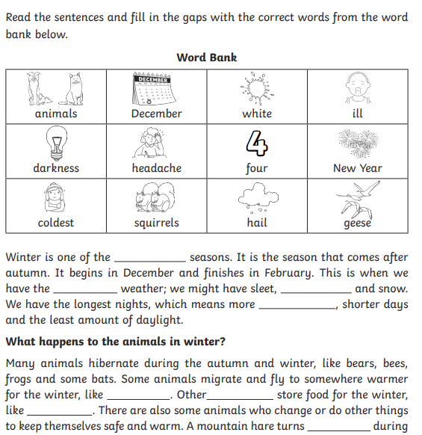
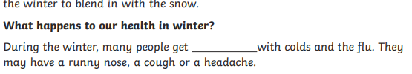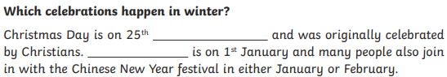

Numeracy

- Number and number processes
- Estimating and Rounding
- Data Analysis
- Fractions
- Time
- Shape
- Measurement
- Angles and Symmetry

- Number and number processes

Place Value
Take each of these numbers and display them as instructed on the worksheet below.
127 249 550 100 781 692
1020 999 1050 1000 5555 1500

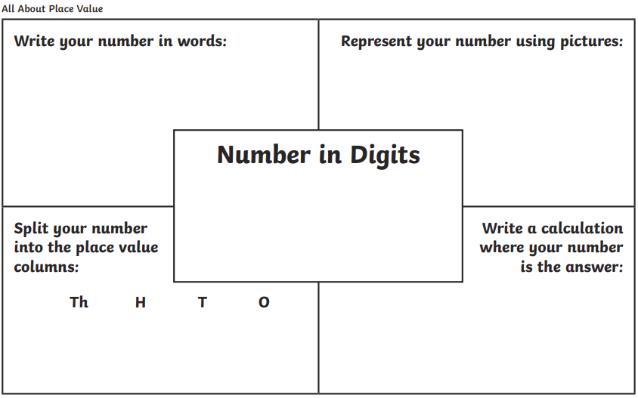

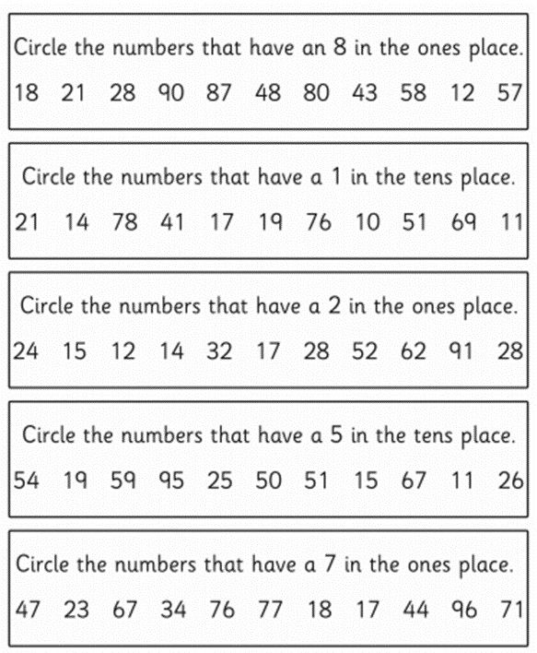
Place Value

Addition and Subtraction

Making 10’s
Using 10 as a friendly number to help find the answer. For example:
16 + 19 =
19 + 1 = 20
16+ 20 = 36
36 – 1 = 35
16 + 19 = 35

- 17 + 19 =
- 21 + 19 =
- 9 + 12 =
- 35 + 9 =
- 40 + 29 =
- 50 + 19 =
- 7 + 9 =
- 28 + 8 =
- 30 + 11 =
- 8 + 21 =

Addition within 100

- 10 + _ = 100
- 50 + _ = 100
- 20 + _ = 100
- 25 + _ = 100
- 99 + _ = 100
- 32 + _ = 100
- 65 + _ = 100
- 85 + _ = 100
- 44 + _ = 100
- 77 + _ = 100

Addition within 1000

- 120 + _ = 1000
- 500 + _ = 1000
- 900 + _ = 1000
- 250 + _ = 1000
- 400 + _ = 1000
- 850 + _ = 1000
- 999 + _ = 1000
- 350 + _ = 1000
- 600 + _ = 1000
- 100 + _ = 1000

Subtraction within 100

- 100 – 90 =
- 75 – 20 =
- 100 – 50 =
- 35 – 15 =
- 50 – 25 =
- 100 – 75 =
- 88 – 22 =
- 75 – 35 =
- 17 – 7 =
- 49 – 19 =

Subtraction within 1000

- 1000 – 900 =
- 800 – 200 =
- 1000 – 50 =
- 700 – 300 =
- 500 - 200 =
- 120 – 90 =
- 300 – 150 =
- 600 – 300 =
- 1000 – 100 =
- 450 – 400 =

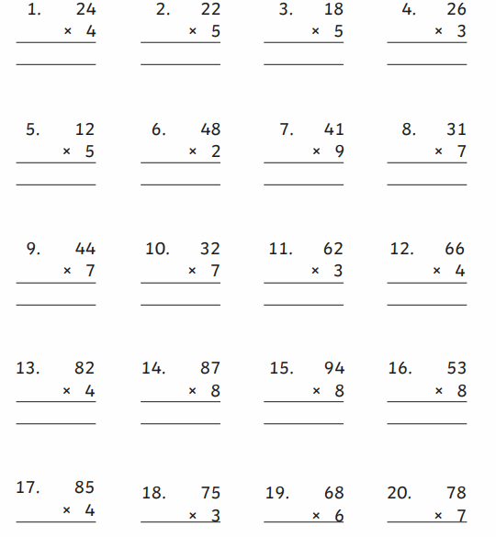
Multiplication and Division
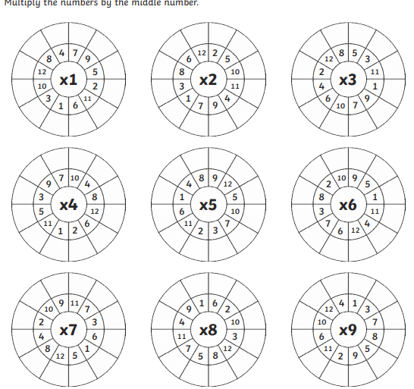

Doubles and near doubles
Near doubles e.g.
2+ 3 =
2 + 2 + 1 =
2 + 2 = 4 + 1 = 5

- 2 + 2 =
- 3 + 3
- 4 + 4
- 5 + 5
- 6 + 6
- 7+ 7
- 8+ 8
- 9 + 9
- 10 + 10

- 2 +3 =
- 3 + 4 =
- 4 + 5 =
- 5 + 6 =
- 6 + 7 =
- 7 + 8 =
- 8 + 9 =
- 9+ 10 =
- 10 + 11 =

Estimating and Rounding
Round these numbers to the nearest 100. Remember to look at the correct columns.
0 – 5 round down
5 – 9 round up
E.g. 375 = 400
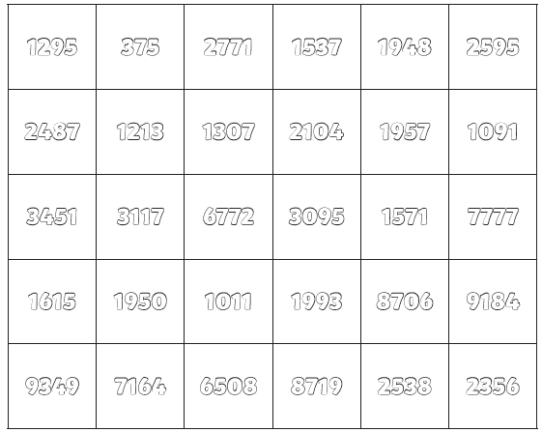

Data Handling and Analysis

- Around your house, see how many items you can find in five minutes that are yellow, pink, blue, green, black and white. Use tally marks when collecting your data.
Which colour has the most items?
Which colour is the least number of items?
How many fewer is the least amount from the most amount?
Draw a bar graph with this information.

- Ask the people in your house what their favourite fruit is. Create a pictograph of this information. Remember to label the axis.

- Answer the questions about the bar graph below?
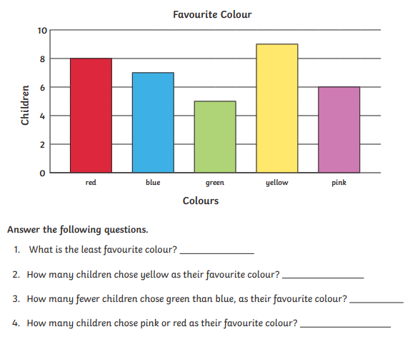
Fractions

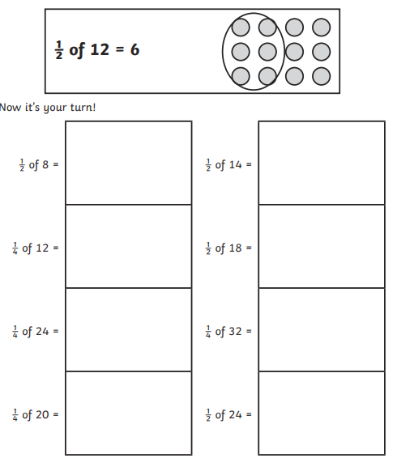

Time

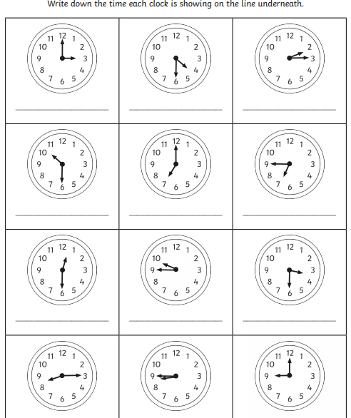

Shape
Vertices are the “pointy” bits of the shape, where two corners meet.
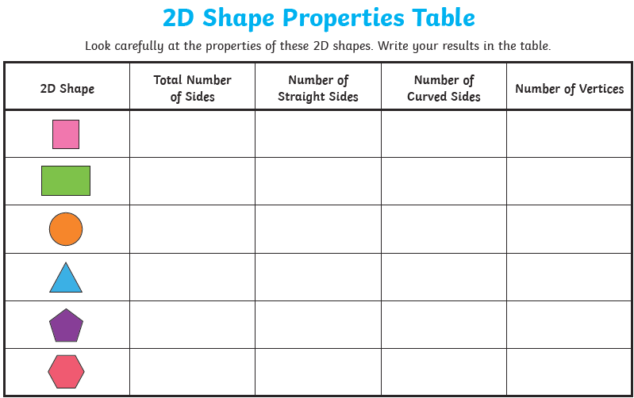

Measurement

- Find 10 items at home and estimate how long you think they are. Once you have the estimations, measure the items with a rules or tape measure and see if your estimations were close.
Angles and Symmetry

- Butterflies are symmetrical insects. Draw a butterfly with symmetrical wings and patterns o each side. Use colour and shapes to design.
- Find different items in your house and see if you can identify different angles. 90 degrees, less than 90 and more than 90 degrees.
- Write whether each of the angles below are 90 degrees, less than 90 degrees or more than 90 degrees.
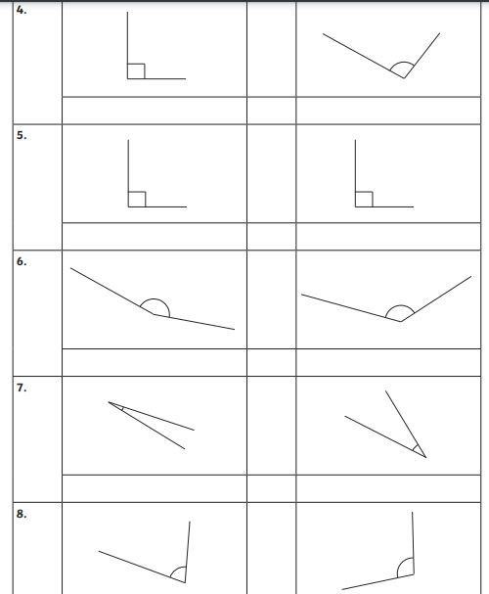

Health and Wellbeing

Mindfulness
Here are some different mindfulness techniques for you to try.

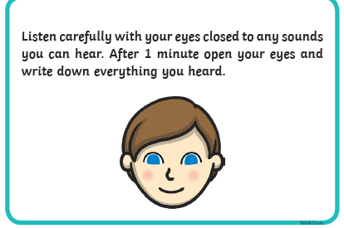

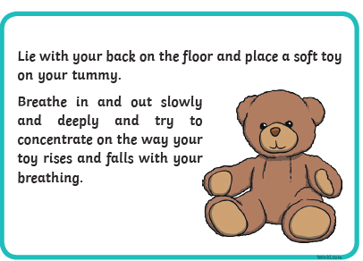
- Turtle : https://www.youtube.com/watch?v=Ur62JmZHUUs
- Five Finger Breathing : https://www.youtube.com/watch?v=DSgOW879jjA
- Hot Chocolate Breathing : https://www.youtube.com/watch?v=xjG-9RS9oCo
- Cosmic Yoga : https://www.youtube.com/user/CosmicKidsYoga

Emotions

Kindness.
- What does it mean to be kind to yourself? What kind of things can we do to be kind to ourselves and our bodies? Can you add some more to this worksheet?
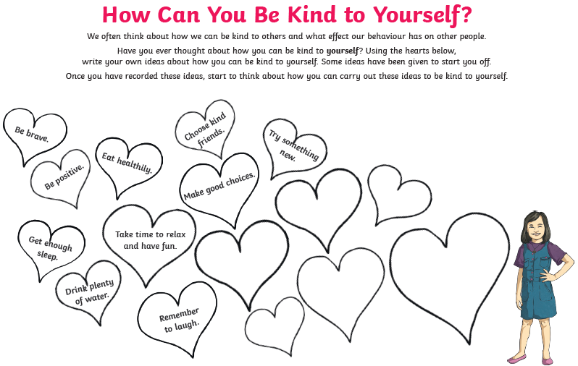

- Design your own kindness poster showing others how to be kind!

Sadness
- What can I do when I’m feeling sad? https://www.youtube.com/watch?v=ZctmpqIu1Zs
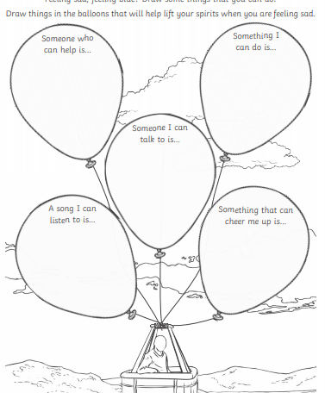
Growth Mindset

- Class Dojo Growth Mindset series : https://www.youtube.com/watch?v=2zrtHt3bBmQ
- The Power of Yet – I can’t do this “YET”. https://www.youtube.com/watch?v=i8AN9tu9Y84
- Can you change these fixed mindset sayings into growth mindset sayings? 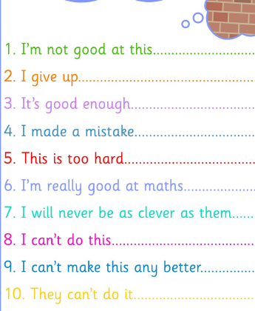
- Make your own positive and growth mindset saying that will help your learning! Design it bright and colourfully. Here are some examples – I believe I can go beyond my best. Mistakes help me learn. I never give up. I gave my brain a workout today.

Looking after Myself

My body

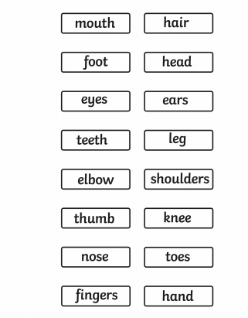
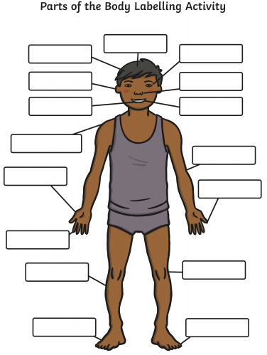

Healthy Eating
- Why eating well and sleeping is important : https://www.youtube.com/watch?v=JgM9bXNVV5U
- Make a healthy lunchbox.

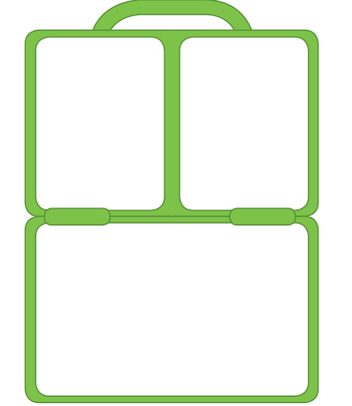

P.E
1. Joe Wicks (The Body Coach) – P.E with Joe https://www.youtube.com/user/thebodycoach1
2. Just Dance : https://www.youtube.com/channel/UC0Vlhde7N5uGDIFXXWWEbFQ
3. Ninja Life : https://www.youtube.com/playlist?list=PLENtKuZxXbME57HhYcNpg64h3Kn8ueigA
