

Home Learning Pack

Primary 3

Todholm Primary



Useful websites

1. Reading Eggs. Pupils have their own logins where they can work independently through the levels. Pupils can focus on spelling and reading.
2. Sumdog. All pupils have logins where they can complete different numeracy games to earn coins. They can also be set challenges by their class teacher. This is something pupils can work on independently.
3. Education City. Pupils can log in and access both numeracy and literacy games and challenges which they can complete independently.
4. Topmarks. No account needed, lots of interactive numeracy games for all age and stage.

Literacy

Writing

1. Can you write a story about this character?

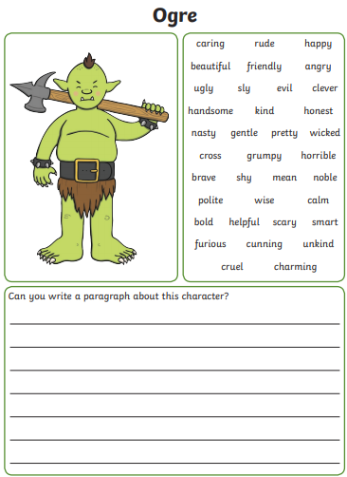

1. Can you write a story about this setting?

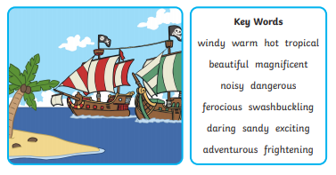

1. Book Review. Choose your favourite book and write a review.

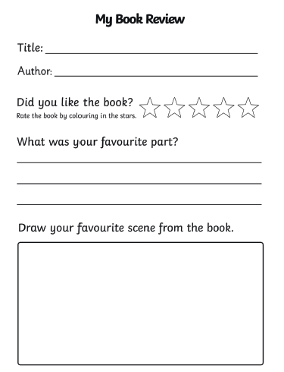

Phonics & High Frequency words.

Useful links

<https://www.youtube.com/user/breakthruchris>

<https://www.youtube.com/channel/UC_qs3c0ehDvZkbiEbOj6Drg>

<https://www.youtube.com/watch?v=2Xy2e78qxNg>

1. Come 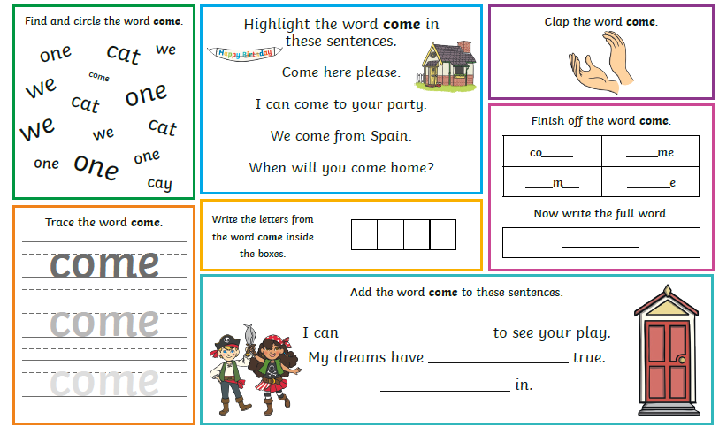
2. Make

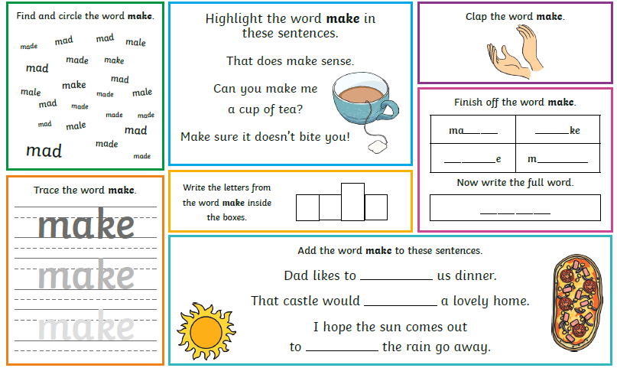

1. “oa”

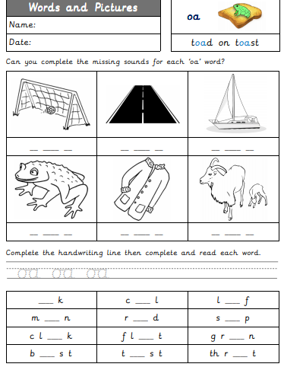

1. “oo”

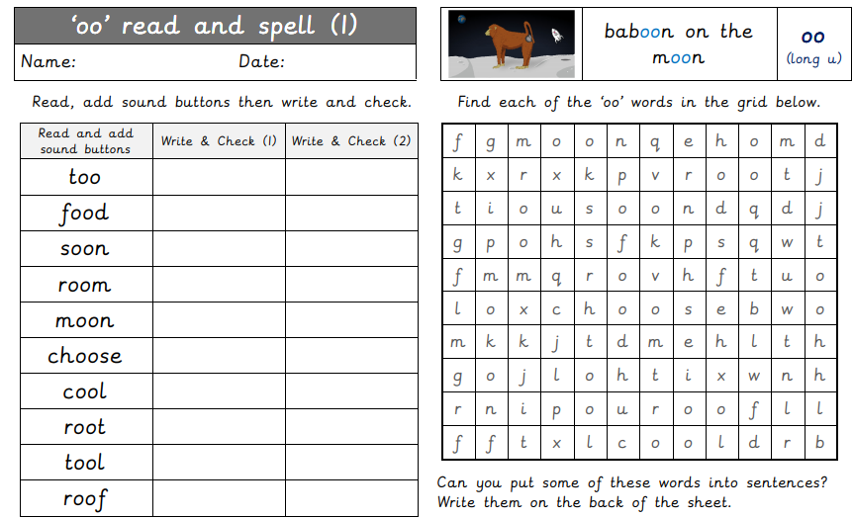

1. “th”

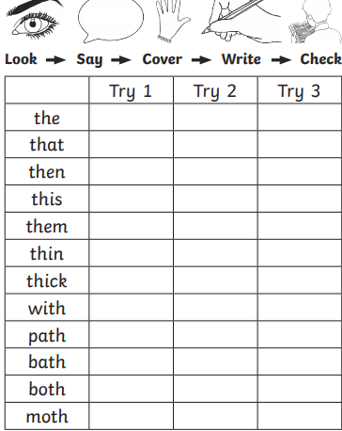

Comprehension

1. Three Billy Goats Gruff

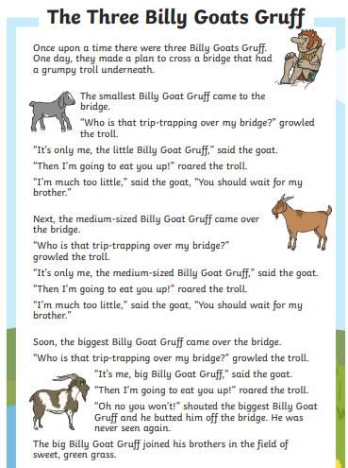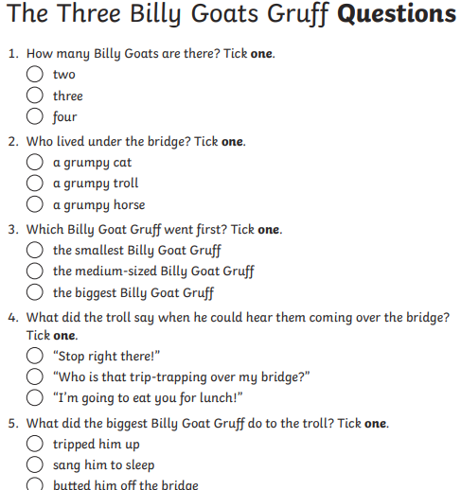

*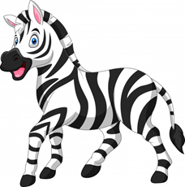*

1. *Why the Zebra Has Stripes*

Once upon a time, zebras were all white.

One day, the jungle animals were having a big party. The male and female zebra were getting ready. They wanted to look special.

First, the male zebra painted his body green. Then the famle zebra painted her body brown. They looked like a lizard and a lion. They did not like that. They wanted to look different so they painted on black stripes.

All the animals at the party liked the stripes, even the lion

The next day, everyone talked about the zebra stripes. The other zebras wanted to look special too. They painted black stripes on themselves.

Soon the zebras got tired of the stripes. They tried to wash them off. The stripes would not wash off.

Today, zebras still have black stripes.

Q1. Once upon a time, zebras were all:

1. White
2. black and white
3. green

Q2. What colour did the male zebra paint himself first?

1. 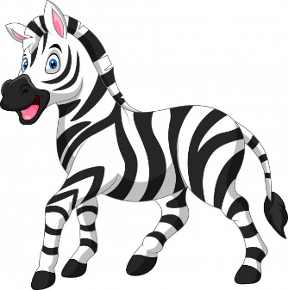green
2. brown
3. black

Q3. The colours of lizard and lion were:

1. black and white
2. green and brown
3. white

Q4. Paragraph 4 tells:

1. how the zebras painted their bodies
2. what happened after the party
3. what happened at the party

Numeracy

1. Number and Number processes
2. Estimating and Rounding
3. Pattern
4. Shape
5. Money
6. Measure
7. Data Handling and Analysis
8. Angles and Symmetry
9. Time

Useful links:

<https://www.youtube.com/user/JackHartmann>

<https://www.youtube.com/channel/UCPlwvN0w4qFSP1FllALB92w>

<https://www.youtube.com/channel/UCWKuiktSh-V3E4ysPU0VC3Q>

Number & Number Processes

Place Value

1. Take each of these numbers and display them as instructed below:

100 125 65 99 21 77 80 10 53 210 500

555 670 301 740 123 20 999 62 39 400 231

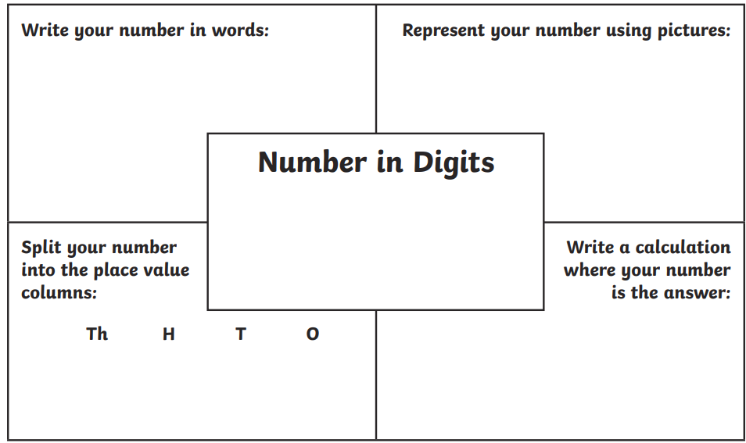

Subitise

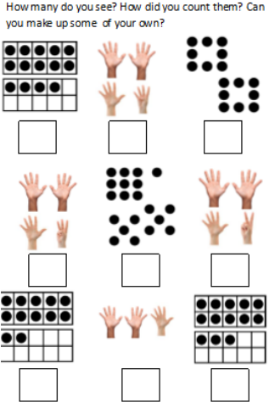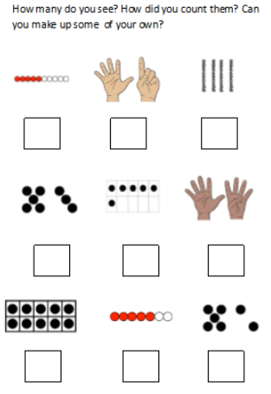

Part-Part-Whole

Using the template below show these numbers using part-part-whole.

E.g. The circle at the top holds the number 125

Circle 1 has the number 100

Circle 2 has the number 20

Circle three has the number 5

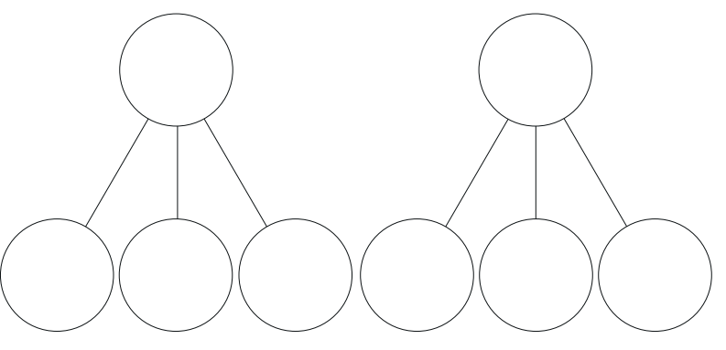

120 310 400 67 99 199 252 555 999 100 54 37 86 71

Multiplication & Division

Revise counting in 2’s, 5’s and 10’s.

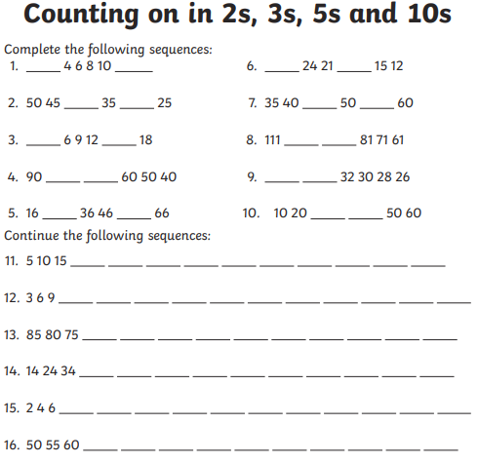

Estimating and Rounding

1. Round these numbers to the nearest 100.

0 - 4 round down

5 – 9 round up

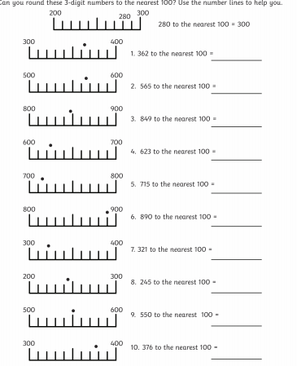

Pattern

1. Create your own pattern. A pattern is something that repeats. You could draw it or use objects from home.
2. Continue these patterns.

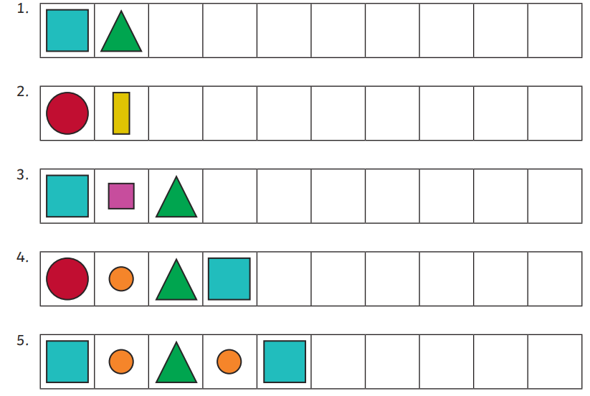

Shape

1. Go on a shape hunt. Which items in your house are the same shape as the ones below?

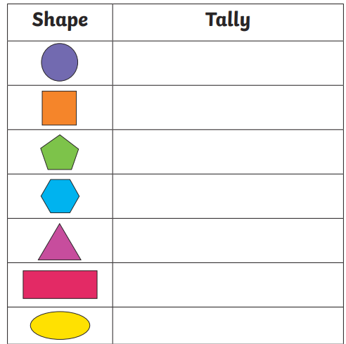

Money

1. Counting coins

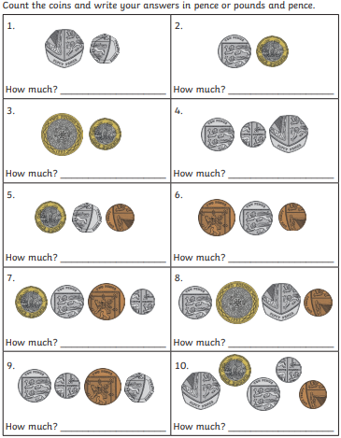

1. Make a shop at home and write how much your items cost and have a grown up or sibling buy things from your shop. Remember to give change!

Measure

1. Go on a hunt and measure different items around your home using a ruler or tape measure.
2. Have an adult measure your height. Before they tell you, guess how tall you think you are and see if your guess is correct.

Data Handling and Analysis

1. Look out a window for five minutes and write how many cars of these colours pass by – red, black, white, silver, yellow, blue. Use tally marks to show your results.
2. Ask family members at home what their favourite fruit is, including yourself. Create a pictogram with your answers like the one below.

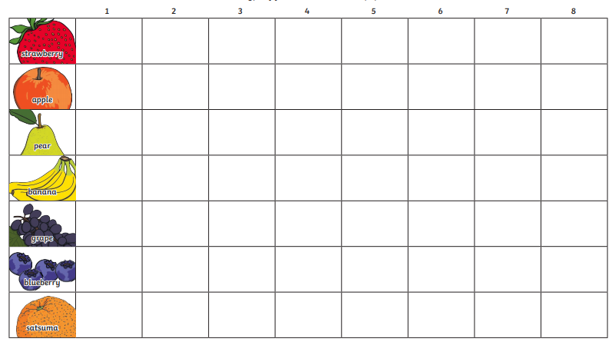

Symmetry

1. Butterflies are symmetrical insects. Draw a butterfly with symmetrical wings. Remember colours and patterns must be the same on each side.
2. Draw the other half of the symmetry below.

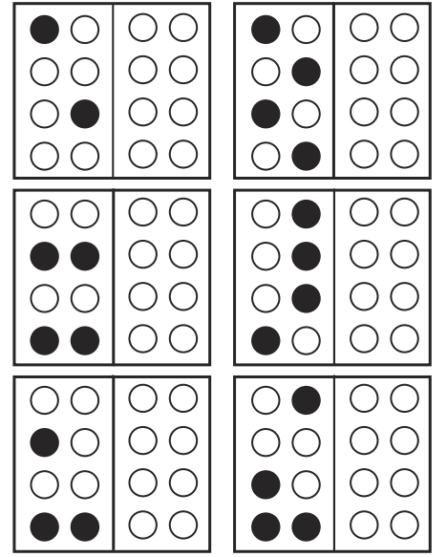

Time

1. What time do you do these different activities?
2. Wake up
3. Arrive at school
4. Have lunch at school
5. Finish school
6. Have dinner
7. Go to bed
8. What is the time of each of these clocks?

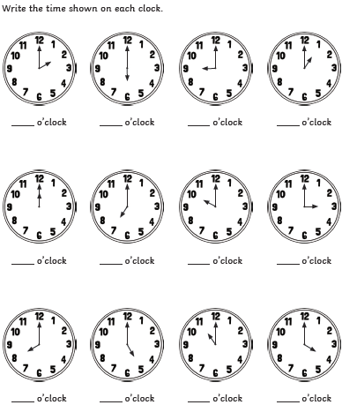

Health and Wellbeing



Emotions

Kindness

<https://www.youtube.com/watch?v=kAo4-2UzgPo>

1. Design your own poster on how to be kind to others. Make it bright and colourful.
2. What is a good friend? What words do you know that describe a good friend?
3. How can you be a good friend?

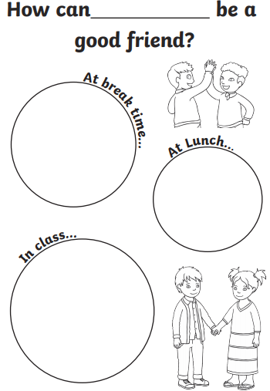

Understanding your emotions.

<https://www.youtube.com/watch?v=dOkyKyVFnSs>

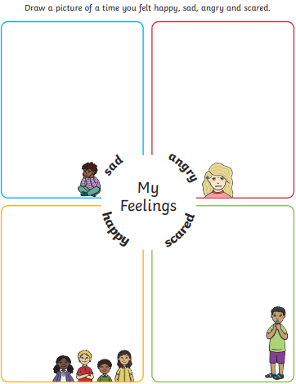

Growth Mindset

<https://www.youtube.com/watch?v=2zrtHt3bBmQ>

Growth mindset means being positive about your learning and knowing that mistakes are ok, its how we deal with them that matters

1. Can you think of a positive saying you could say to yourself when you’re finding earing tricky? Design this as a poster with lots of bright colours!
2. Complete the sheet below.

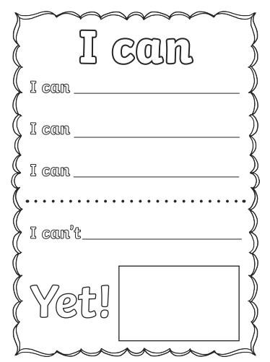

Looking after Myself

We do lots of things to look after ourselves. Draw a picture of the different things you do to look after yourself.

<https://www.youtube.com/watch?v=JgM9bXNVV5U>

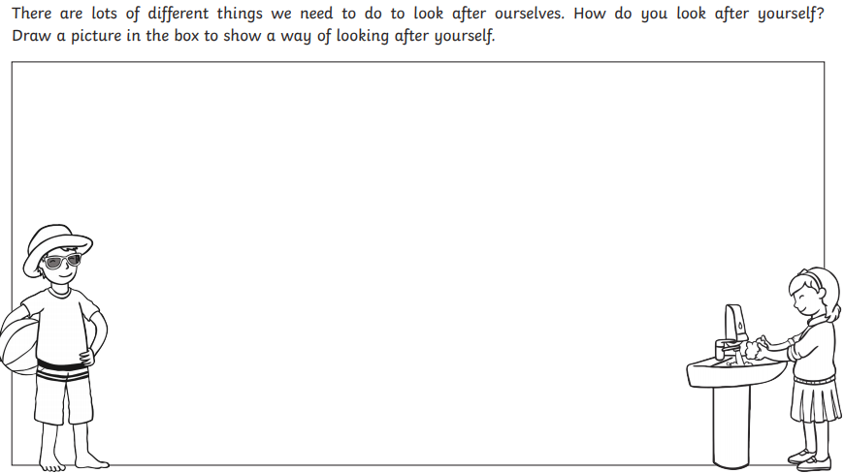

1. Draw a healthy lunchbox.

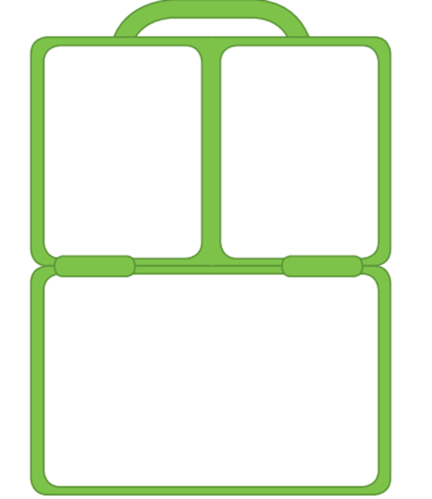

P.E

1. Joe Wicks (The Body Coach) – P.E with Joe <https://www.youtube.com/user/thebodycoach1>

2. Just Dance : <https://www.youtube.com/channel/UC0Vlhde7N5uGDIFXXWWEbFQ>

3. Ninja Life : <https://www.youtube.com/playlist?list=PLENtKuZxXbME57HhYcNpg64h3Kn8ueigA>

4. Cosmic yoga: <https://www.youtube.com/user/CosmicKidsYoga>

