Home Learning Pack
Primary 1
Todholm Primary

Useful websites

- Reading Eggs. Pupils have their own logins where they can work independently through the levels. Pupils can focus on spelling and reading.

- Sumdog. All pupils have logins where they can complete different numeracy games to earn coins. They can also be set challenges by their class teacher. This is something pupils can work on independently.

- Education City. Pupils can log in and access both numeracy and literacy games and challenges which they can complete independently.

- Topmarks. No account needed, lots of interactive numeracy games for all age and stage.

Literacy

Useful links

Mr Thorne & Geraldine the Giraffe - https://www.youtube.com/user/breakthruchris
Alphablocks - https://www.youtube.com/channel/UC_qs3c0ehDvZkbiEbOj6Drg
Doorway Online - https://www.doorwayonline.org.uk/activities/letterformation/
Jolly Phonics Song - https://www.youtube.com/watch?v=2Xy2e78qxNg

Encourage your child to read each day or to listen to a story. There are lots of stories on Authors live - https://www.scottishbooktrust.com/authors-live-on-demand?utf8=%E2%9C%93&filterrific%5Bhas_age_group%5D=three_five&filterrific%5Bhas_curriculum_area%5D=&filterrific%5Bhas_genre%5D=&filterrific%5Bhas_perfect_for%5D=&filterrific%5Bauthors_live_search%5D=

Letter Formation

- Practise writing out your first name.
- Can you recognise your second name?
- Practise letter formation of the letters of the alphabet
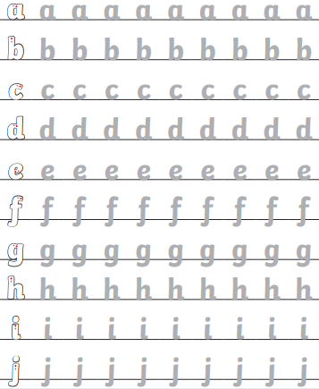

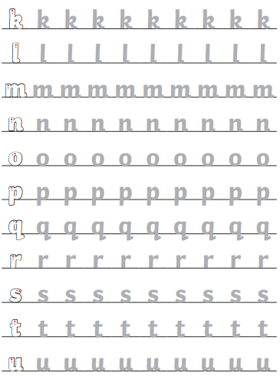

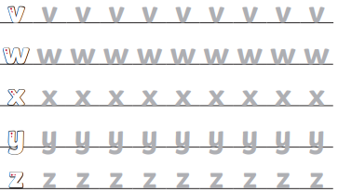
Pencil Control

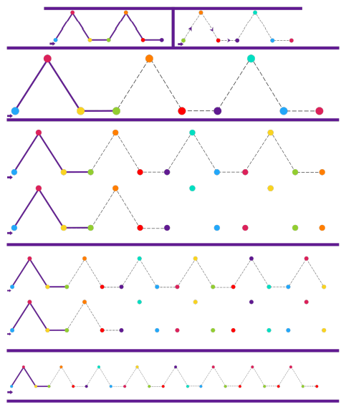

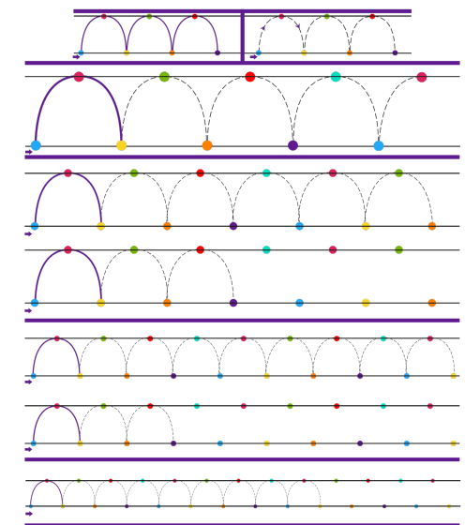

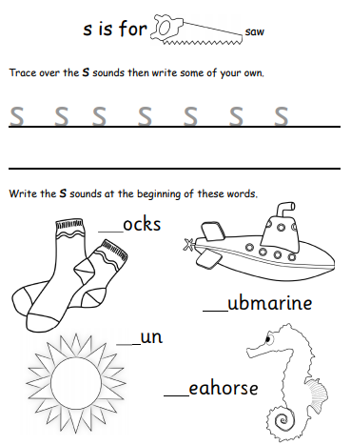

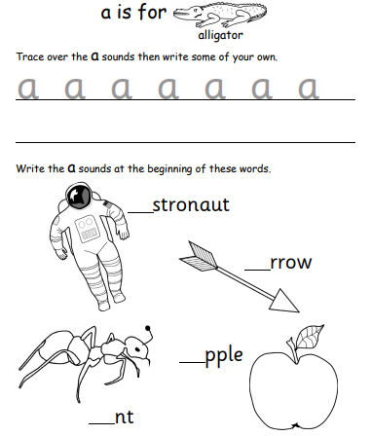

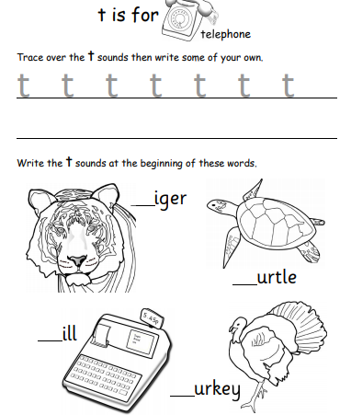

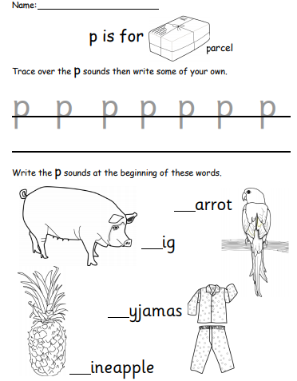

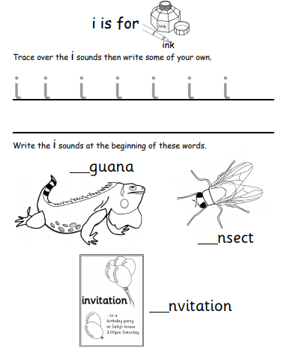

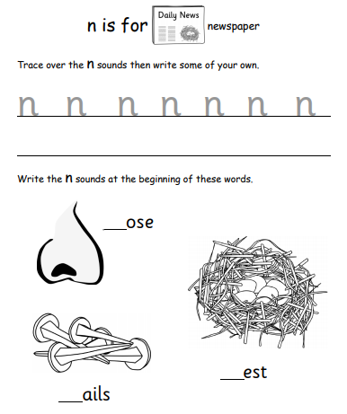

Numeracy
Useful Links

Number Jacks https://www.youtube.com/channel/UCWKuiktSh-V3E4ysPU0VC3Q
Number Blocks https://www.youtube.com/channel/UCPlwvN0w4qFSP1FllALB92w
Jack Hartmann https://www.youtube.com/user/JackHartmann

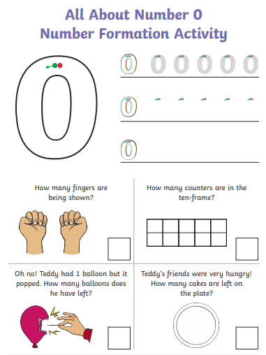

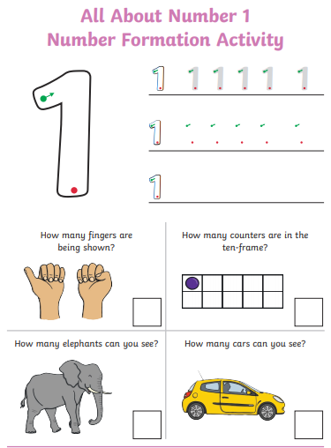

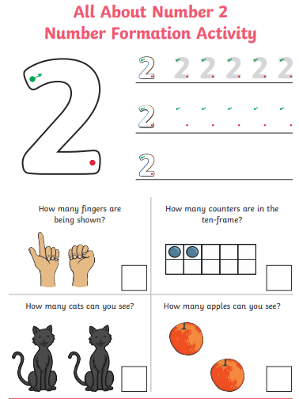

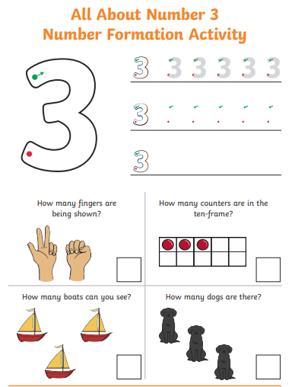

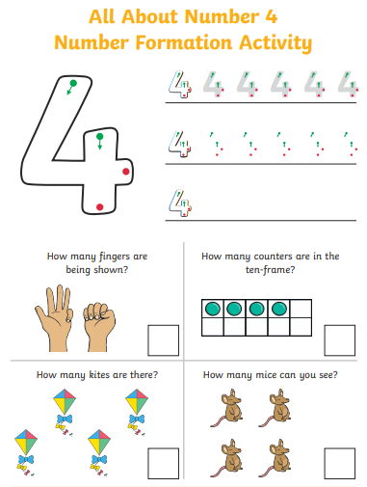

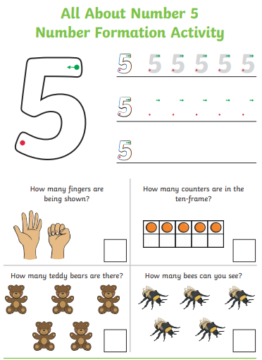

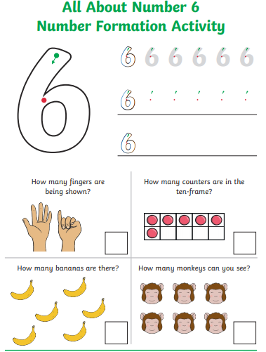

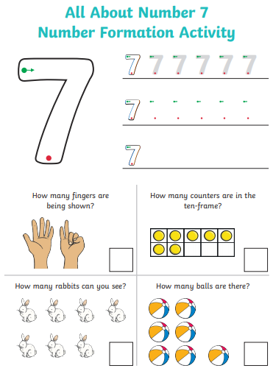

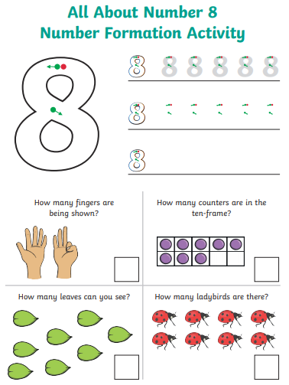

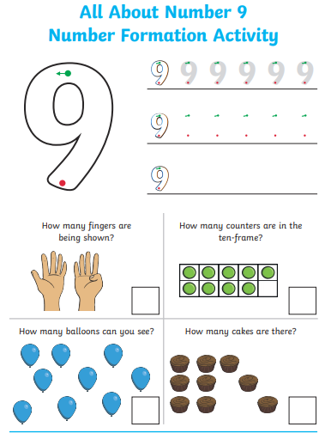

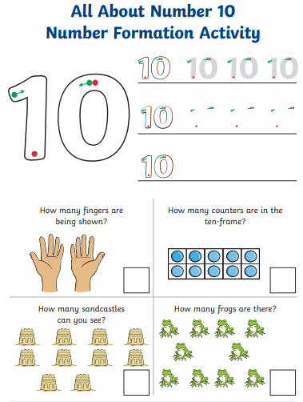

Number Bonds to 10

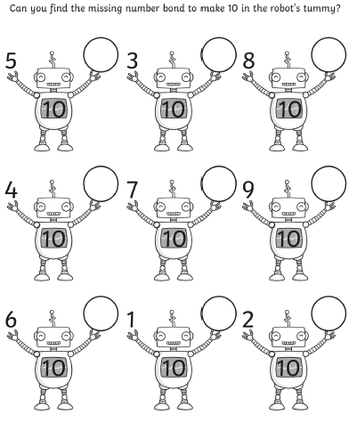

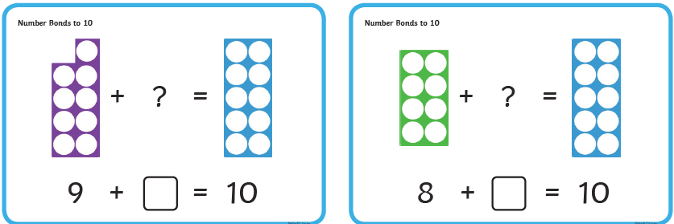
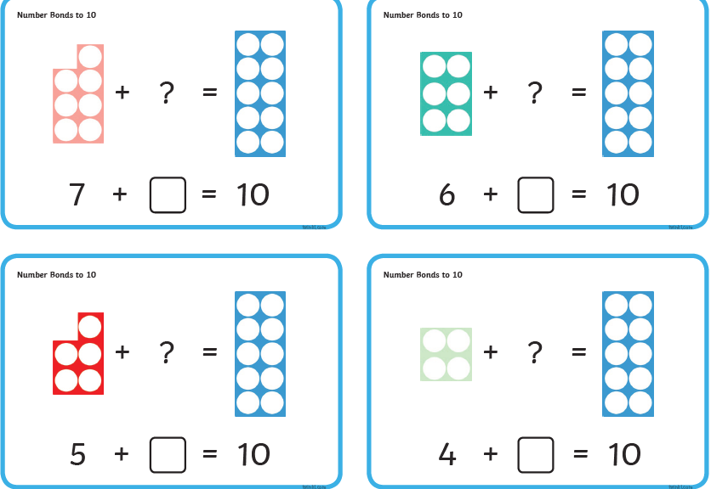
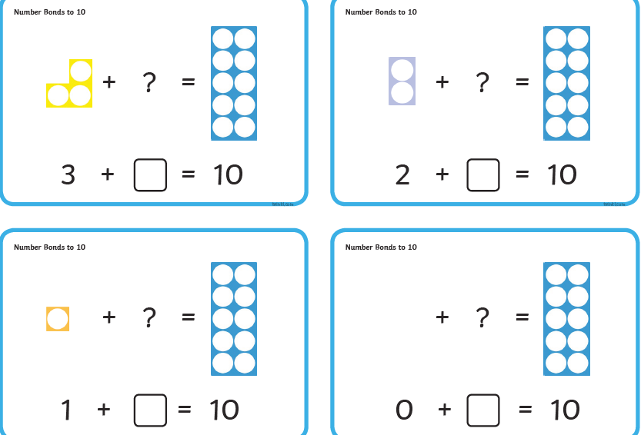

Part-Part-Whole

Using the template below, split these numbers using the part-part-whole method.
E.g.
18 – in the top circle
10 – in one circle
8 - in the other circle
10 + 8 = 18

19, 22, 10, 12, 13, 16, 25, 15, 29, 19, 23, 14, 21
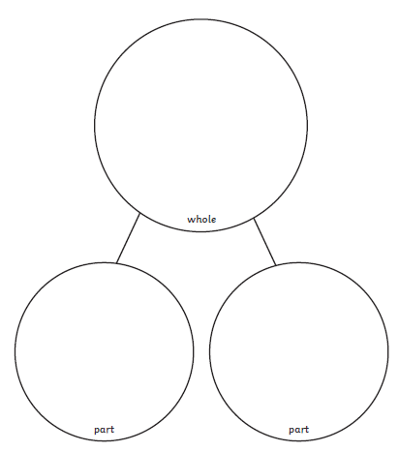

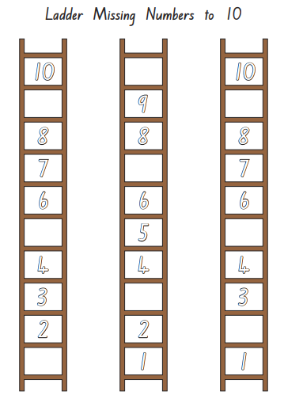

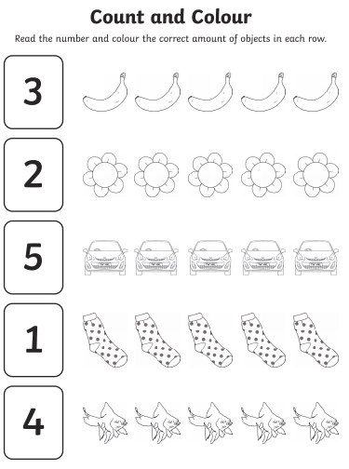
Health and Wellbeing

All about me

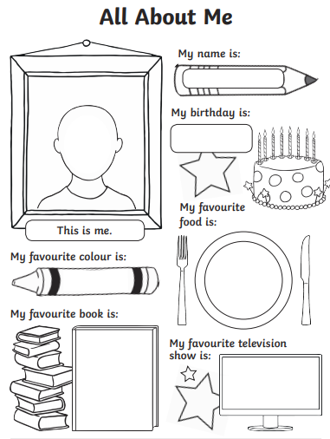

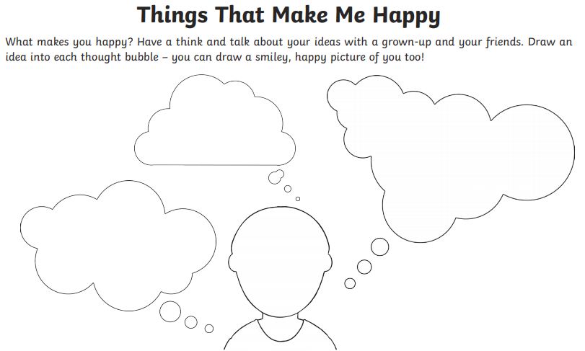

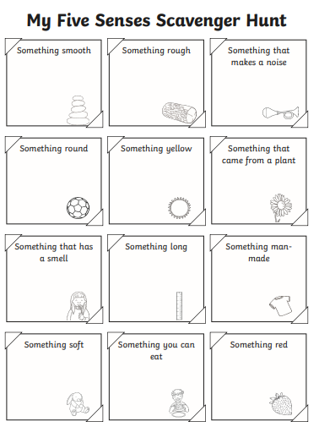

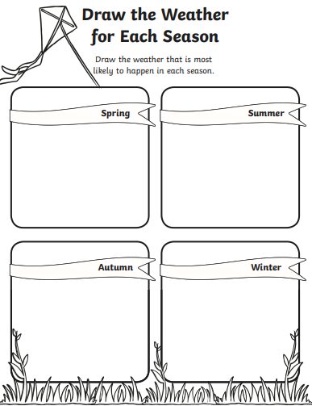

P.E
Cosmic Yoga - https://www.youtube.com/user/CosmicKidsYoga
Kidz Bop - https://www.youtube.com/channel/UCsMXYJDvYOAhpaDZ4QRuqVA
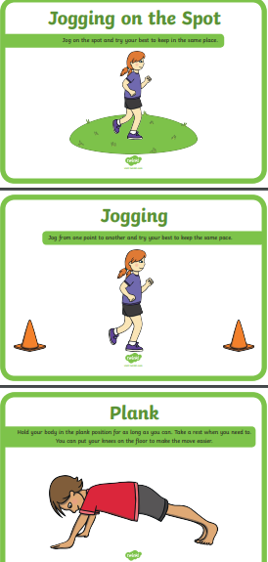

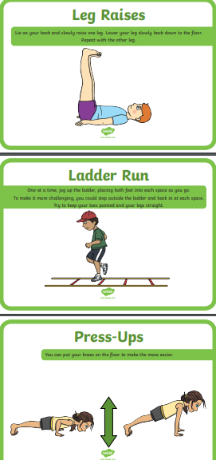

Yoga

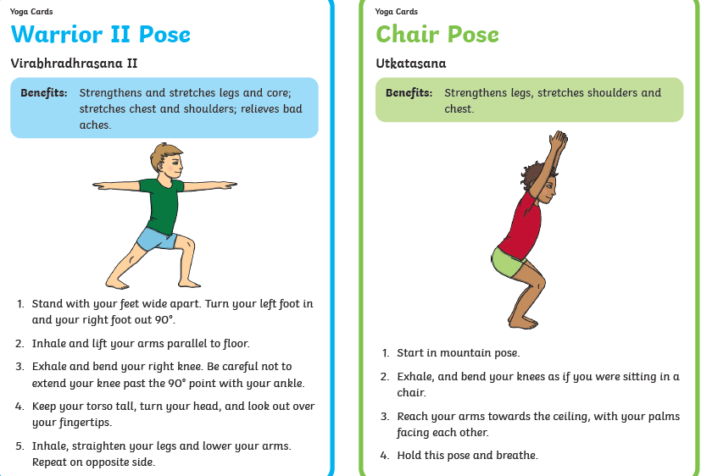

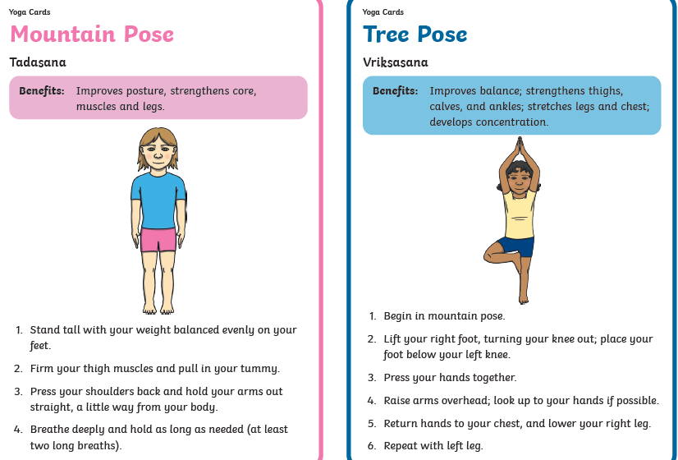

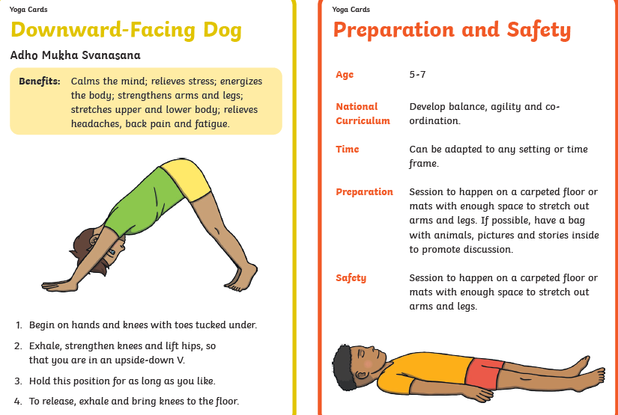

Breathing exercises
5 finger breathing - https://www.youtube.com/watch?v=DSgOW879jjA
Hot Chocolate breathing - https://www.youtube.com/watch?v=xjG-9RS9oCo
Belly breathing - https://www.youtube.com/watch?v=RiMb2Bw4Ae8
Rainbow breathing - https://www.youtube.com/watch?v=O29e4rRMrV4

