St Paul’s Primary – School Uniform
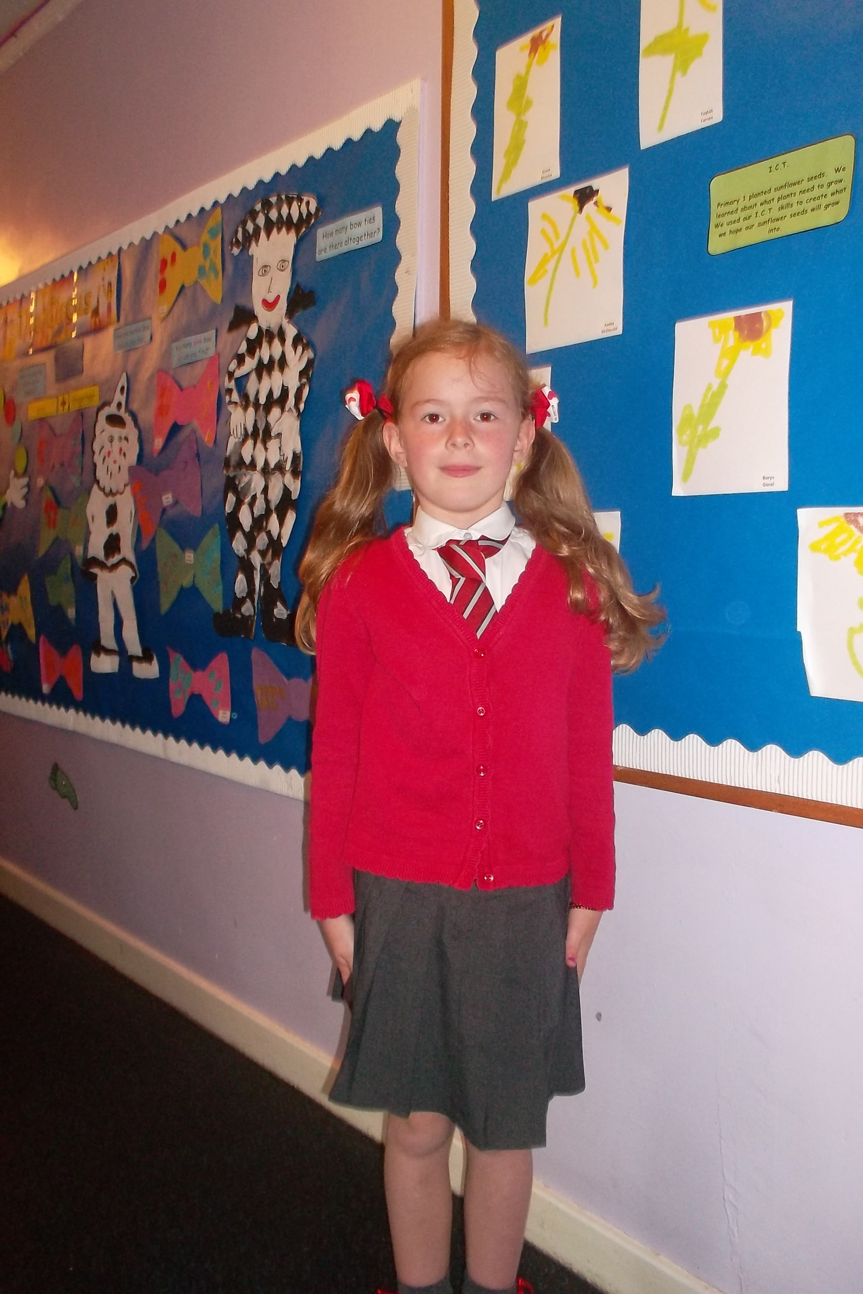
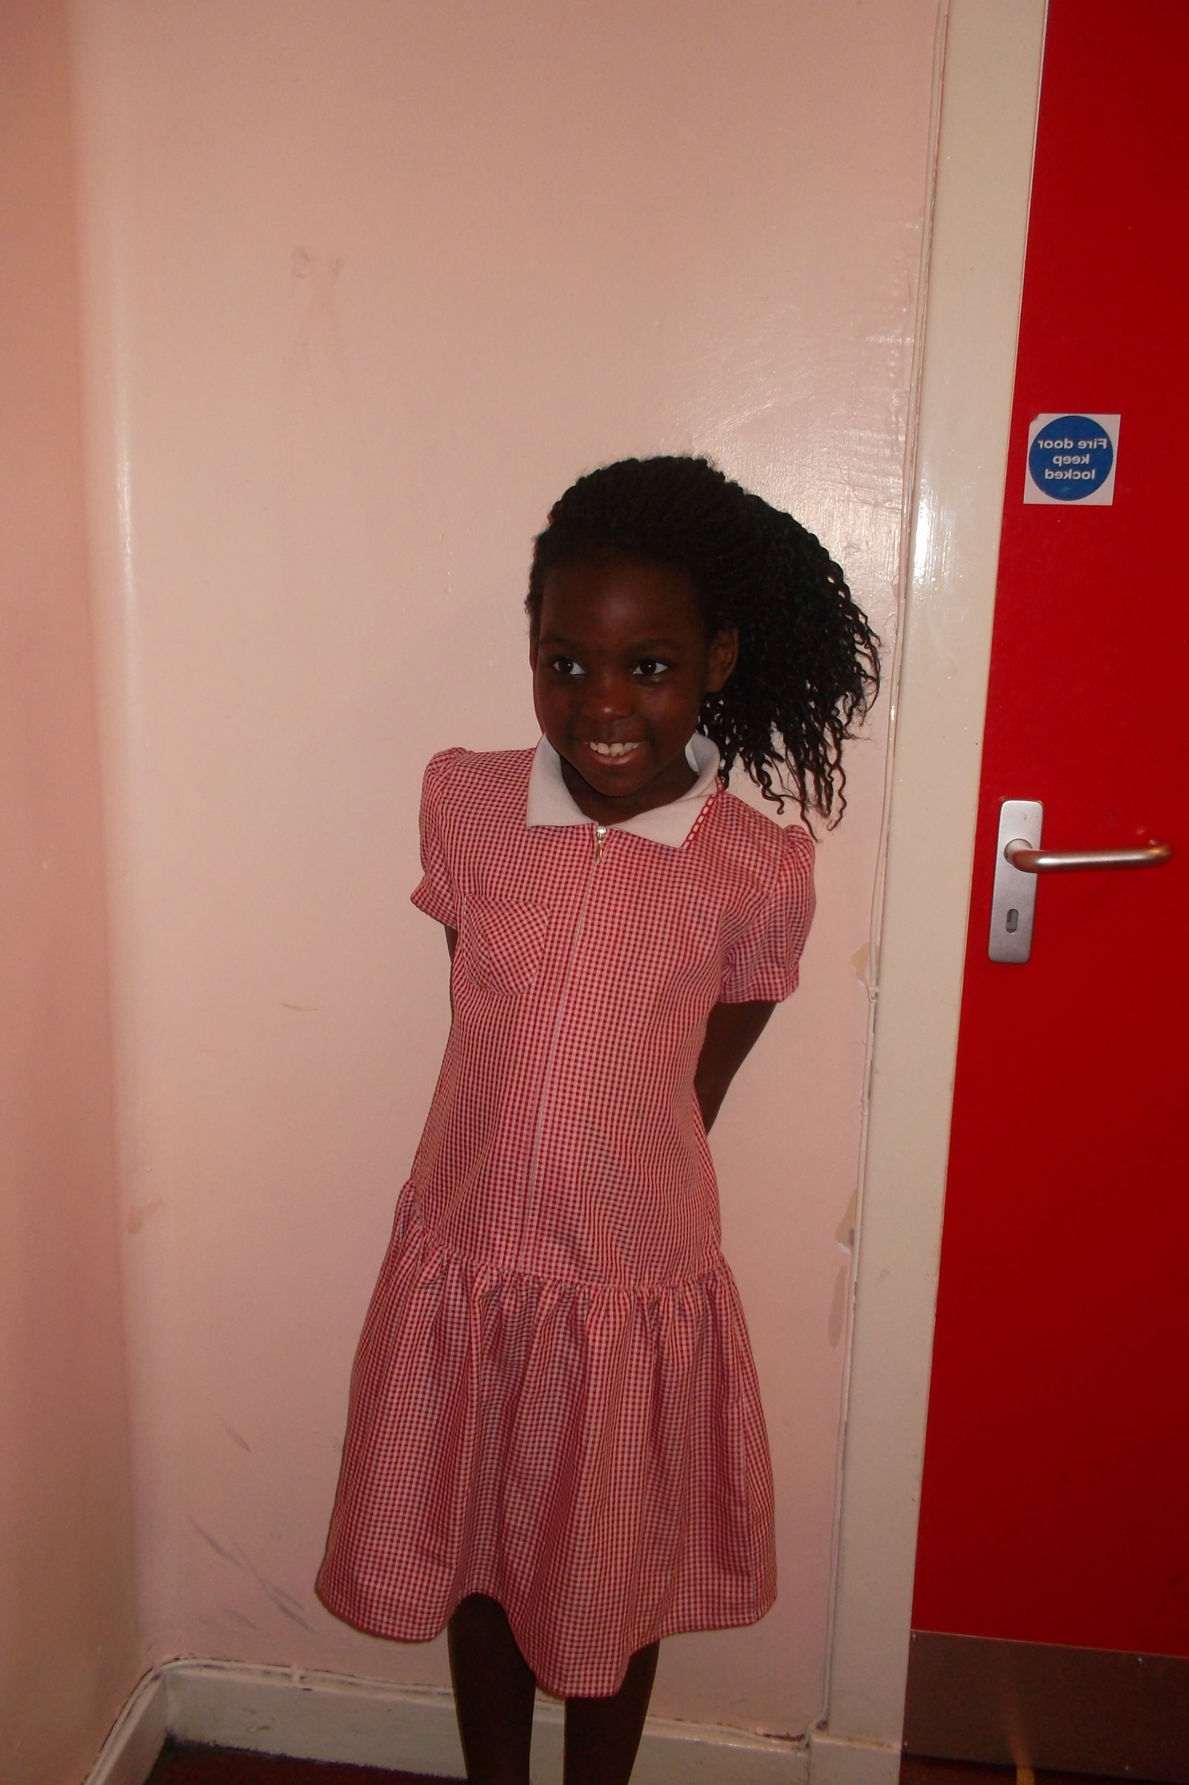
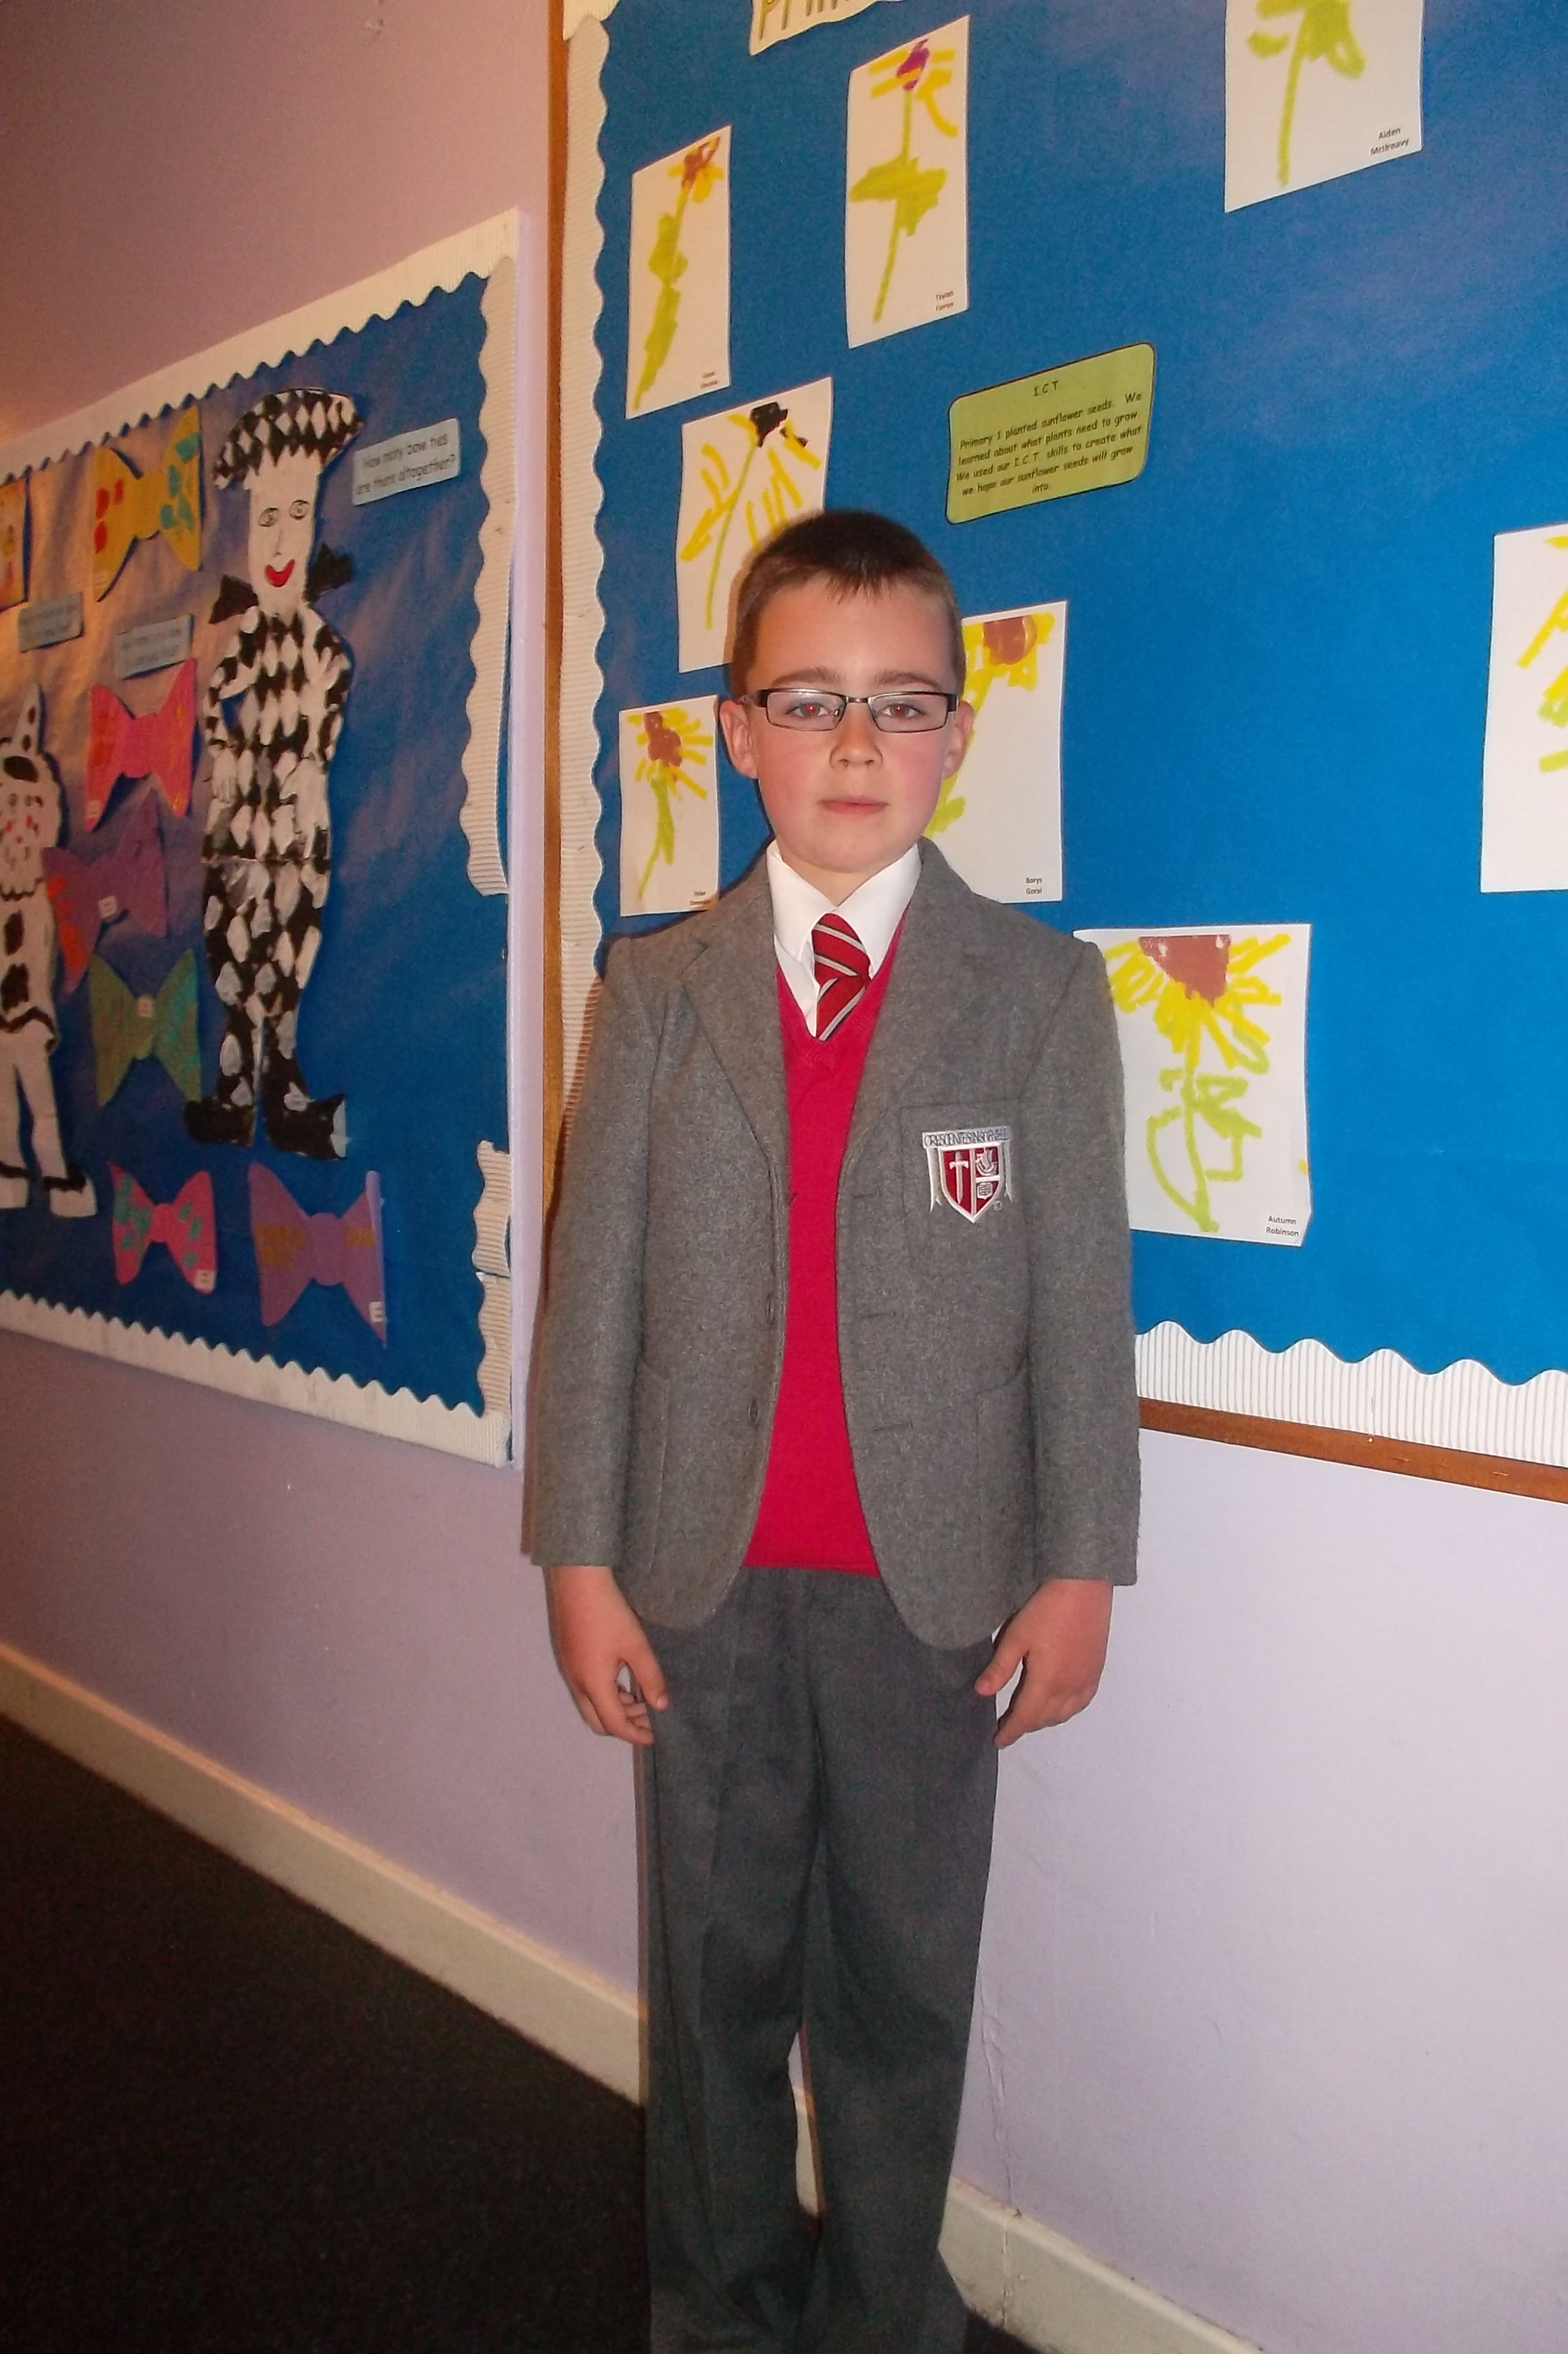
Here is a sample of our children wearing our current school uniform .
Boys should wear :
- Black/or grey blazer, grey trousers, white shirt, school tie, red or grey jumper
- Polo-shirts should be white or red (preferably white)
- School shoes should be dark in colour, preferably black. No bright shoes allowed.
Girls should wear:
- Black/or grey blazer, grey skirt/pinafore/trousers, white blouse, school tie, red/grey cardigan or sweatshirt.
- Polo-shirts should be white or red (preferably white)
- School shoes should be dark in colour, preferably black. No bright shoes allowed.
- Summer dresses should be red and white in line with the school colours.

