St Mary’s Primary and ELCC
St Mary’s Session 2022-2023 Movie
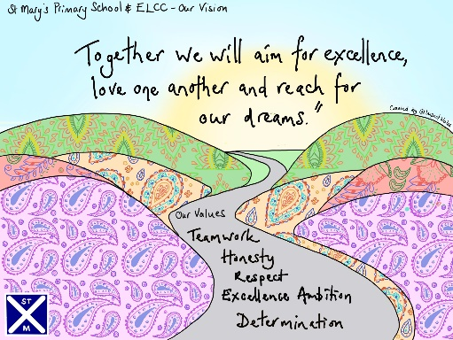

We have enjoyed a very busy and fun-filled session 2022-2023 here in St Mary’s. You can watch some of the highlights using the QR Code shown below.
