St Mary’s Primary & ELCC
Relationships Policy Statement
Together we will:
“Aim for Excellence, Love One Another, Achieve Our Dreams.”
Purpose
The purpose of this policy statement is to provide guidance for teachers, pupils and parents on our restorative and relationship-focussed approach to behaviour management. This will allow children and young people at St Mary’s to enjoy a calm and caring environment which supports each child both emotionally and educationally to give them the best possible chance to flourish and experience success.
Our Relationships Policy begins with a promise from the adults in school to provide a clear, consistent, and calm approach to promoting positive behaviour. It is not primarily concerned with rule enforcement; the main priority of our policy is to promote positive relationships for children with peers and adults, with the common purpose of supporting everyone to learn in a nurturing, empathetic and respectful environment.
Aims
• To provide a clear, fair and consistent approach to managing behaviour, based upon nurture principles and restorative practice.
• To foster, nurture and value strong and healthy relationships in recognition of the importance of this to maximise the growth and development of children.
• To ensure flexibility in supporting behaviours that might be the result of Adverse Childhood Experiences and/or additional support needs.
• To ensure our THREAD Values (Teamwork, Honesty, Respect, Excellence, Ambition and Determination) underpin our ethos, and nurturing and relationship-focussed approach.
• To provide a safe, respectful, equitable and happy school ethos where learning opportunities are maximised.
• To give staff tools to support de-escalation, co-regulation and building resilience.
• To equip children with strategies to manage their behaviour and build positive relationships with others.

St Mary’s Values
Inspiring our St Mary’s family to work together to:
‘Aim for Excellence, Love One Another, Achieve Our Dreams;’
At St Mary’s, we have high expectations for all pupils; we expect children to meet ‘St Mary’s Standard’ by demonstrating our St Mary’s THREAD Values. This is recognised through weekly Values Certificates at assembly, regular house points, positive reinforcement strategies and end of year awards.
We want all members of the St Mary’s family to use our THREAD Values to be the best version of themselves and achieve all that they are capable of.
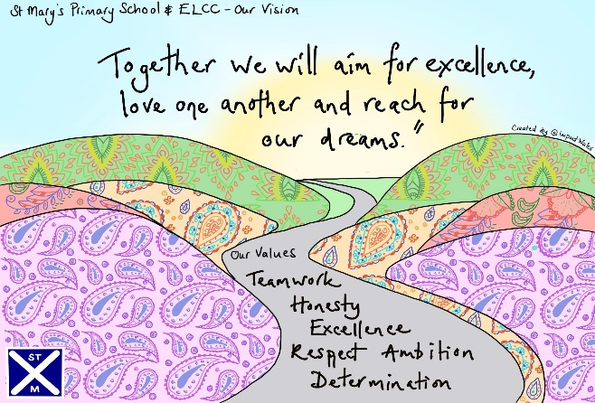
Teamwork
Honesty
Respect
Excellence
Ambition
Determination
In addition, we wish to give recognition to pupils who go ‘Over & Above’. ‘Over and Above’ behaviours include exceeding our school values, impacting the wider St Mary’s community and showing St Mary’s initiative.
‘If you consistently reward minimum standards then children will strive for minimum standards. If you reward children for going over and above then there is no limit to their excellent behaviour.’
Paul Dix
Meet & Greet
Teachers will create a welcoming environment by greeting pupils every morning through a formal meet and greet at the classroom door. This may be a simple, ‘Good morning’ or offering a handshake, high five, etc. to provide a consistent check in and enthusiastic welcome to every child.
All adults will be looking out for children who demonstrate St Mary’s Values and go ‘Over and Above’. Ways that child will be recognised for doing so:
• Golden Letter/Positive phone calls home Member of management team or class teacher phones parents to share child's success.
• St Mary’s Values certificates Awarded at assembly - two children are selected each week by the class teacher.
• End of year awards - Appropriate teachers choose approximately two awards to give to children for St Mary’s Values, Music, P.E., playground, modern languages and P7 awards.
• House points token system is used to award children house points. At the end of each term, the winning house chooses a reward and at the end of the year, the overall winning house vote for a reward of their choosing.
• Achievement book - Children with an achievement outside of school can share it at the weekly assembly through the achievement book.
• Twitter - Teachers and parents alike can share children’s successes through Twitter.
Policy Blueprint & Classroom Plan
Relationships Policy Blueprint (See Appendix 1)
This is a concise A4 document which teachers will refer to for a consistent approach to our Relationships Policy to ensure behaviour and expectations are clear and consistent.
The Language of St Mary’s (See Appendix 2)
This is the second part to our Relationships Policy Blueprint, which details nurturing language scripts which can be used at step 3 of the classroom plan for a variety of purposes, detailed below.
30-Second Script
As part of the Classroom Plan, the 30-Second Script may be used to reinforce expectations when behaviour shown is not reflective of our school values. This will take place at Step 3 of the Classroom Plan for low-level behaviour only. The purpose of this script is to provide a quick, consistent, and non-judgemental dialogue with the child to encourage positive choices to be made. The scripted response should be delivered in a neutral tone, designed to prevent escalation. Once the script has been delivered, the child ‘owes 2 minutes’. They then must ‘pay back’ the 2 minutes at break or lunch time. It is more effective for time to be paid back at the first available opportunity and with younger pupils, With younger pupils, immediately where possible.
Nurturing Scripts
Nurturing scripts may be a more appropriate response at step 3 of the classroom plan for children who are upset, distressed or for repeated incidents where 30-second script has been ineffective. Please note, the scripts do not need to be copied word for word. It is more important that the child gets a clear and consistent message. The purpose of each nurturing script is detailed below.
• Language Patterns- offer a partial agreement and can defuse a situation quickly. You can then follow up the incident later if needed.
• Connecting & Defusing- when things need to be done, consider wording requests in a way that offers options and choice to help the child feel a sense of control and agency. Help the child feel included and share the responsibility.
• Running Commentaries- describe and say what you see with regards to the child’s emotions to help them become aware and connect with the emotion they are feeling, building emotional literacy and helping them make sense of the world around them.
• Language of Belonging- having a sense of belonging is very powerful for a child, especially one who perhaps struggles with friendships and/or has experienced trauma. The aim is to consistently reinforce the message of, ‘You are welcome, safe and belong here.’
Classroom Plan (See Appendix 3)
The Classroom Plan is a sequence of steps which are focussed on small but certain consequences and a restorative, not punitive, ending. The plan will be used by every adult to ensure consistent language and steps are being used throughout the school, and expectations and boundaries for the children are clear and predictable.
Playground Plan (See Appendix 4)
The Playground Plan has the same steps as the classroom plan but has been amended slightly to be more appropriate for use by adults in the playground
St Mary’s Behaviour Plan Visual (See Appendix 5)
The Behaviour Plan Visual has been developed with the children as a visual reminder to be displayed in every class and key areas of school. This clearly reminds the children of the steps we have agreed as part of our plan.
Personalised Relationships Plan (See Appendix 6)
Personalised Relationships Plans will be in place for children with behaviour as an additional need, who require more targeted support if the universal classroom plan doesn’t meet their needs. Class teachers will create these personalised plans, supported by our Depute Head teacher and with the child’s voice included. These should be shared with all adults working with that child in school to ensure consistency. Plans can also be shared with parents where appropriate to support consistency at home.
Restorative Approach
‘Punishment doesn’t teach better behaviour, restorative conversations do.’
Paul Dix
Every adult in our school is important, has the skills and uses the same tools to deal with behavioural incidents. If an incident takes place in the playground, this will normally be responded to by support staff who use the same strategies and process as teaching staff. This allows an intervention to take place immediately and may involve a restorative conversation. If this cannot be done in the playground, ‘Restore’ time can be used following breaks as it is important that children are settled and ready to learn when they return to class. It will not usually then be revisited by the class teacher or management team unless further action is required. Teachers will deal with almost all behaviours which take place in the classroom. In order to minimise loss of teaching and learning time, the management team may become involved in a variety of ways, e.g., releasing the class teacher to have a restorative meeting with a child.
Restorative Conversations
‘The positive relationships you form with pupils depend on a restorative approach being your default mode.’
Paul Dix
At St Mary’s, we believe that nurturing and restorative practice, as well as high expectations, are key to building positive relationships. Restorative conversations aim to help the child realise how their behaviour impacts others, teach what appropriate behaviour looks like and equip the child with tools and create a plan they can use to avoid a similar incident occurring in the future.
Restorative Questions (Detailed on Appendix 1)
These restorative questions will be used to structure restorative conversations. Depending on developmental stage, up to 6 questions will be used. The teacher may decide it would be more appropriate to start with two questions and build on these as the child develops socially and emotionally.
Consequence
‘Children need people, not punishment. It is time we gave them what they need to succeed, not simply what we feel they deserve. Exclusion and heavy sanctions rarely meet the needs of the child.’
Paul Dix
At St Mary’s, we encourage positive behaviour which reflects our THREAD Values. Our behaviour management approach is founded upon building strong relationships between adults and children. The use of positive reinforcement strategies will always be our default approach.
However, if a child is not responding to these strategies, there needs to be clear, consistent consequences chosen by the adult in relation to specific incidents to ensure clear boundaries. For children with behaviour as an additional need, examples of these will be detailed on their Personalised Relationships Plan. We aim for consequences to not be shaming or excluding wherever possible.
Consequences implemented can be ‘2 minutes owed’, ‘THREAD it Back’ or, in more serious or repeated circumstances, parental phone calls home and/or meetings. They are designed to encourage the child to make ‘responsible’ choices and understand that actions have consequences. For example, not completing work in class due to choices made regarding behaviour that is not reflective of our school values results in lost learning time which then needs to be paid back.
‘2 minutes owed’- a reflective time where the child discusses their actions privately with their class teacher and how they may have impacted on others. The purpose of this is to enable the adult to remind the child of our values and to encourage positive behaviour in future.
• ‘THREAD it Back’- is an appropriate action linked to the incident and value which has not been shown. For example, if a child has not completed class work due to failure to respond to positive strategies, work may be sent home. Another example is if the playground has been vandalised, we may ask the child or children involved to help repair the damage. We ask that parents support the St Mary’s Relationships Policy by ensuring the ‘THREAD it Back’ form is signed and returned the following day. Parents having a discussion with their child about how to avoid having to ‘THREAD it Back’ in future would be impactful.
• Parental involvement- We feel it is important for parents to be aware of repeated and/or more serious incidents. We will communicate this through a phone call, or an informal or formal meeting.

Appendix 1- St Mary’s Relationships Policy Blueprint
St Mary’s Relationships Policy

The adults will:  - Nurture relationships  - Model our values.  - Listen.  - Praise positive choices.  - Create a safe environment. | St Mary’s Values  Teamwork  Honesty  Respect  Excellence  Ambition  Determination | ‘Over and Above’  Behaviours  Include the following:  - Exceeding our school values.  - Impacting the wider St Mary’s family.  - Showing St Mary’s initiative.
Our Vision Message
Together we will:
“Aim for Excellence, Love One Another, Achieve Our Dreams.”

Classroom Plan  - Go for green  - Reminder of class rules  - Chat with teacher  - Reflection time (Regulate)  - Referral to SLT | Language Scripts  - Non-Verbal Responses  - 30-second script  - Language Patterns  - Connecting & Defusing  - Running Commentaries  - Language of Belonging | Restorative Questions  - What happened?  - What were you thinking as this happened and how were you feeling?  - Who has been affected by what has happened?  - What do you now need to move on?  - What needs to happen now so that the harm can be repaired?  - How can we do things differently in the future?

Appendix 2- The Language of St Mary’s
The Language of St Mary’s

Non-Verbal Responses  -Proximity: stand next to the pupil/use strategic seating plan  -Waiting: stop talking, stand quietly and wait until pupils are doing what they should be  -Removing distractions: Remove item of distraction and return it when pupil is back on track | 30-Second Script  -‘I noticed you are …’  -‘You are not showing our THREAD Value …’  -‘You have chosen to …’  ‘Do you remember when you …’  -‘That is who I need to see today. Thank you.’ | Language Patterns  -When … then  -‘When you sit down, then I can speak to you.’  -Maybe … and  -‘Maybe you are upset and when you sit down, then I can speak to you.’  -If … then  -‘If you are stuck then put your hand up.’
Together we will:
“Aim for Excellence, Love One Another, Achieve Our Dreams.”

Connecting & Defusing  -Offer choice: instead of,  ‘It’s time to read your book.’ Try, ‘Which of these books would you like to read?’  -Limit use of non-negotiable words: ‘Is it alright with you if…?’  ‘How do you feel about …?’  -Share responsibility: ‘Us’, ‘We’, ‘Let’s’, ‘Together’ | Running Commentaries  Describe and say ‘what you see’ with regards to a child’s emotions  -‘You look happy today – you have a big smile on your face.’  -‘I’m wondering if you feel sad today. You’ve been very quiet.’ | Language of Belonging  -‘You are a valued member of the St Mary’s family.’  -‘You’re a St Mary’s boy/girl.’  -‘You belong and are an important member of our classroom.’  -‘Your feelings are ok with me.’  -‘I’ll be thinking about you and keeping you in mind.’
Appendix 3- Classroom Plan
Classroom Plan
 | Steps | Actions
1. | Go for green | Promotion of positive behaviour and school values.
2. | Reminder of class rules | Use a non-verbal strategy initially or a whole-class reminder. If this is not effective, try a verbal reminder of the desired behaviour, delivered privately, if possible, e.g. ‘I would love to see you focussing on your maths in order to get it finished on time.’
3. | Chat with teacher | A verbal caution delivered to give the pupil a final chance to engage, delivered privately, making the pupil aware of their behaviour. Use the phrase, ‘Think carefully about your next step as you will owe me 2 minutes of your time.’
4. | Reflection Time (30-second script/nurturing language script) | If the pupil still does not engage, use the 30-second script. Attach, ‘You now owe me two minutes of your time.’ These two minutes cannot be removed. The 30-second script is usually only appropriate for low-level behaviour. One of our nurturing language scripts may be more appropriate for other incidences.
 | Restorative conversation (optional) | A restorative conversation is usually only needed where there has been a break down in a relationship, e.g. between teacher and pupil or pupil to pupil. During which the teacher may decide on a related, appropriate consequence for the child’s actions. For example, if significant learning time has been lost, the teacher may decide work should be taken home to complete (‘Pay it Back to THREAD’).
 | Regulate (optional) | This step is only needed if the child is dysregulated. They may be able to regulate themselves or require ‘time in’ with an adult (co-regulation). Our safe space can be used if required or a ‘calm corner’ within the classroom.
5. | Referral to SLT | In more serious circumstances, like threatening behaviour, support may be needed from SMT, ASNA or CA. This support should be specified on a personalised Relationships Plan for children identified with behaviour as an additional need.

Appendix 4- Playground Plan
Playground Plan
 | Steps | Actions
1. | Go for green | Promotion of positive behaviour and school values.
2. | Reminder of rules | Use a non-verbal strategy initially like proximity, eye contact, whistle, countdown or a reminder to all pupils. If this is not effective, try a verbal reminder of the desired behaviour, delivered privately wherever possible, e.g. ‘I would love to see you using your hands kindly whilst playing.’
3. | Chat with adult | A verbal caution making the pupil aware of their behaviour and clearly outlining. Use the phrase, ‘Think carefully about your next step as you will owe me two minutes of your time.’
4. | Reflection time (30-second script/nurturing language script) | If the pupil still does not engage, use the 30-second script. Attach, ‘You now owe me 2 minutes of your time.’ to this step. These two minutes cannot be removed. The 30-second script is usually only appropriate for low-level behaviour. One of our nurturing language scripts may be more appropriate for other incidences.
 | Restore time (optional) | Restore’ time can be used following breaks if the child isn’t settled and ready to go back into the classroom. As a rule of thumb, a restorative conversation is usually only needed where there has been a break down in a relationship, e.g. between an adult and pupil or pupil to pupil. During which you can decide on a related, appropriate consequence for the child’s actions. For example, if the child isn’t making safe choices on the Trim Trail, they lose one day playing on it.
 | Regulate (optional) | This step is only needed if the child is dysregulated. They may be able to regulate themselves or require ‘time in’ with an adult (co-regulation). Our safe space can be used if required, ‘walk and talk’ or a quiet corner in the playground.
5. | Support step (optional) | In more serious circumstances, like threatening behaviour, support may be needed from SMT, another ASNA/CA or a class teacher. This support should be specified on a personalised Relationships Plan for children identified with behaviour as an additional need.

Appendix 5: St Mary’s Behaviour Plan (Visual)
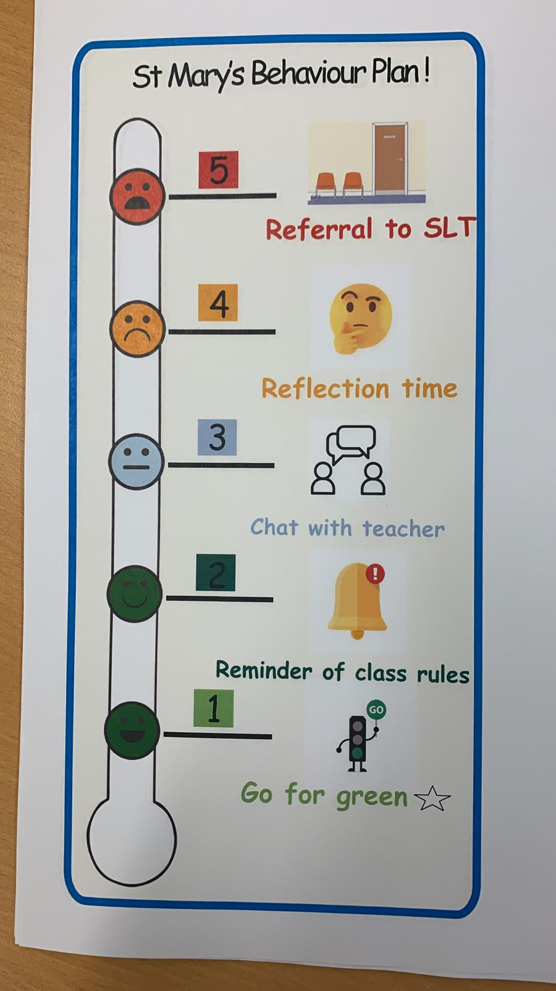

Personalised Relationships Plan (See Appendix 6)
St Mary’s Primary & ELCC
Personalised Relationships Plan
Target | Support | Who is responsible | When | Outcome

