St Mary’s Primary and ELCC
Vision and Values Movie
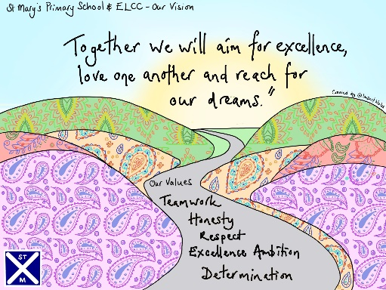

Our Pupil Council gathered suggestions from the children for the best way to share our new St Mary’s Vision and Values with our school community. They decided to go with creating a movie which the whole school were involved in making.
You can watch our wonderful Vision and Values Movie through using the QR Code shown below.
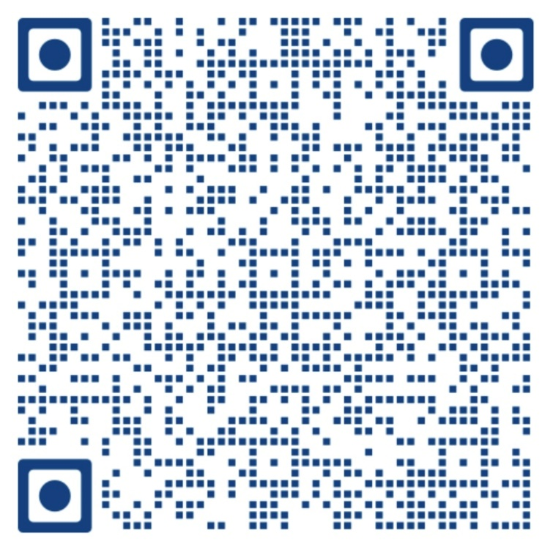
We hope you enjoy watching it as much as we enjoyed making it!

