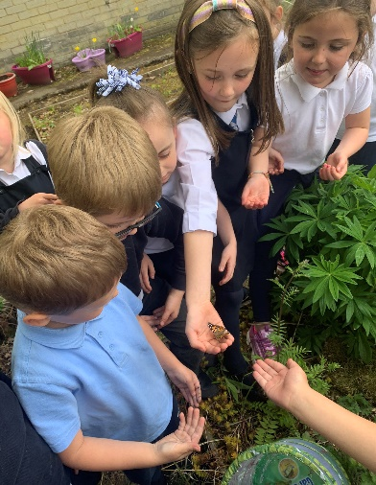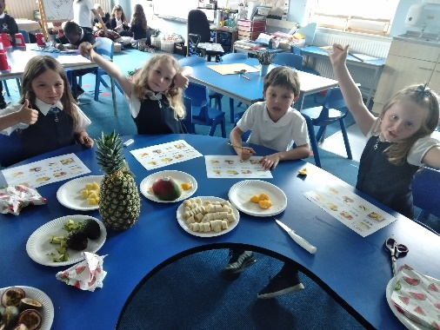

Renfrewshire Coucil

ST. MARY’S PRIMARY SCHOOL & ELCC

STANDARDS AND QUALITY REPORT

June 2021

This report will inform you of the school’s progress and achievements in the last session and let you know about our plans for 2021-2022. I hope that you find it helpful and informative.

*Laura Mitchell*

Mrs Laura Mitchell

Head Teacher

**OUR SCHOOL**

St. Mary’s is a Catholic primary school with two early learning and childcare classes and a Pre School Assessment and Development Unit (PSADU). We are a multicultural school with a high percentage of children who have English as an additional language. The primary school has a roll of 252 pupils. The P1 intake for August 2021 is 33. There are the equivalent of 32 full time places available in the 3-5 playroom (Sunflower Room) and 10 full time places available in the 2-3 playroom (Buttercup Room). We are now providing 1140 hours to all our nursery children. The PSADU provides specialist communication and language support on an advisory and outreach basis for pre-school children and those who have transitioned to P1 across a number of Renfrewshire establishments.

**OUR VISION**

Our vision is that, through the care and education provided by our school community, our pupils will be nurtured to become successful learners, confident individuals, effective contributors and responsible citizens. Driving our work are our core values: love, honesty, fairness and wisdom. These are reflected in our school rule: treat other people the way you would like to be treated.

**OUR VALUES**

FAIRNESS LOVE WISDOM HONESTY

**OUR AIMS**

We aim to provide a:

* **S**afe, happy and nurturing environment where we show respect for each other at all times.

We aim to provide:

* **T**eaching that is high quality and learning experiences that pupils enjoy and that provide appropriate challenge.

We aim to:

* **M**ake sure we communicate with our families and include them in learning.

We aim to provide:

* **A**n environment where all relationships are strong.

We aim to be a school where:

* **R**esponsibility is given to pupils to take leadership roles;
* **Y**our opinion always matters;
* **S**t. Mary’s includes everyone.

**SUCCESSES AND ACHIEVEMENTS**

*The impact of Co-Vid 19, and the subsequent school closures at the beginning of 2021, have resulted in significant changes in working practices and routines. As such, our ability to complete all actions within our improvement plan has been hindered.  Some priorities and actions will be carried forward to academic session 22-22.*

A number of successes and achievements were noted, including, but not restricted to:

* Successfully and safely welcomed all our ELC and school classes back for a full return to nursery and school in August 2020, following the significant disruption encountered as a result of school closure from March to June last session.
* Continued to effectively promote the positive health and wellbeing of all in our school community through a variety of universal and targeted interventions.
* Further improved pupil, staff, and parents’ confidence in the use of digital technologies through use of Google Classrooms for the delivery of homework and subsequently home learning during the period of school closure from January to March 2021
* Overall engagement in online learning of 82% across the school during period of school closure. Those who were unable to engage were provided with IT support or paper home learning packs. 89% of parents/carers reported that their child’s experience of online learning had been positive in a Renfrewshire survey.
* Improved approaches to learning through development of an outdoor learning space to support the delivery of high-quality outdoor learning across our infant classes.
* Despite the many challenges faced this session, staff have continued to engage in professional learning activities clearly linked to our self-evaluation, improvement priorities and recovery planning.

**HOW SUCCESSFUL HAVE WE BEEN IN IMPROVING OUR SCHOOL?**

School Leadership

* The Head Teacher further developed her leadership knowledge, understanding and skills through engaging in a Bespoke Headship Leadership Development programme led by Educational Consultant James Keegans. The Principal Teacher has engaged in an Aspiring Depute Head Teacher programme that has enhanced her leadership knowledge, understanding and skills.
* We have taken steps to develop greater leadership at all levels, which in turn, has improved the overall capacity of the school and ensure a maintained focus on leading learning.
* Our children demonstrated resilience and confidence to take greater responsibility for leading their own learning during periods of school closure.

Teacher Professionalism

* All staff engaged in ongoing professional learning to ensure they were fully up to date with all local and national COVID guidance, creating a shared understanding of best practice and responsibilities to keep everyone in our school community safe.
* All staff across the school and ELC Class continued to further develop their skills in the use of digital learning platforms (Google Classroom/Seesaw) and social media (Twitter). As a result of this, almost all children across the school and ELC were able to engage daily in online learning activities to continue their learning at home during the period of school closure.
* Our staff team have engaged in a wide variety of professional learning activities focused on improving outcomes for learners across literacy, numeracy and health and wellbeing.

Parental Engagement

* We consulted with our parents/carers on their experience of home learning, from which we were able to identify key strengths and more importantly, next steps which were used to help us further improve.
* We have continued to build upon the success of our school Twitter and Parent Facebook page for our new Primary 1 parents to further improve our engagement and communication with parents. Feedback from parents continues to be extremely positive.
* The period of school and ELC closure provided significant opportunity for staff and families to work together to ensure children’s learning continued at home. Regular contact with families through Google Classroom, Twitter and/or telephone conversations ensured timely and effective bespoke support to individual children and families.

Assessment of Children’s Progress

* All staff have used a variety of assessment tools and approaches to identify exactly where our children are in their learning and clear next steps to effectively ensure progress and improved outcomes for all learners.
* Despite the many restrictions faced due to COVID, through consultation and adaptations made, we have ensured effective reporting to parents/carers on their children’s progress, achievement, and wellbeing.
* Face-to-face Parent/Teacher meetings were replaced with phone calls in November and March during which parents were provided with information on their child’s progress and next steps in learning.

School Improvement

* The school received very positive feedback in relation to our Quality Improvement Framework visits from our Education Manager.
* Staff regularly evaluated our practice against key performance indicators (How Good is Our School 4/How Good is Our Early learning and Childcare). This information has been used to inform next steps and lead to ongoing improvement.

Performance Information

* As a result of the pandemic and periods of school closure, our attainment levels in literacy and numeracy have decreased. Our Performance data from June 2021 following the period of school closure is as follows:
  + P1- the majority of children are achieving national levels of attainment for Listening and Talking, Reading and Numeracy.
  + P4- most children are achieving national levels of attainment for Listening and Talking and the majority for Reading and Numeracy.
  + P7- Most children are achieving national levels of attainment for Listening and Talking and Reading. The majority of children are achieving national levels of attainment for Numeracy.
  + Most children across P1, P4 and P7 continue to work towards achieving national levels of attainment in Writing and the school has a robust programme in place to support this.
* The school continues to use robust monitoring and tracking systems to ensure that the needs of children are met. Termly meetings continue to ensure that HT/DHT and teachers have regular opportunities to discuss children’s health and wellbeing, attainment and achievement and to plan interventions/supports. Teachers are expected to provide evidence of children’s work to support professional judgements.
* A range of standardised assessments, moderation activities and a body of evidence folder, including Literacy, Numeracy and health and wellbeing information are used to support teachers’ professional judgement.

**KEY STRENGTHS OF THE SCHOOL**

* The commitment of the whole staff team during periods of school closure, to support our children and families.
* The resilience of our staff team which was demonstrated through how effectively they prepared and adapted to ensure a safe and settled return for our children following periods of school closure.
* The school’s very positive ethos and the strong nurturing relationships across the school community.
* Our hardworking, resilient pupils and their positive contributions to the school.
* Our strong partnership approaches with a variety of agencies which improve outcomes for learners and continued self-improvement for our school community.
* The quality of support for our children and families and the strong commitment to improving outcomes for all.

**PUPIL EQUITY FUNDING (PEF)**

St Mary’s PEF plan has been established in consultation with all stakeholders with the focus on improving outcomes for our children in Literacy, Numeracy and Health and Wellbeing.

For school session 2020/21 the Scottish Government awarded our school £70,449 and this has been used to enhance our staffing allocation across the school.

The PEF Plan included the employment of a Teacher, an Early Years Officer (Part time), Inclusion Support Assistant (Full time) and a Classroom Assistant (Full time) This extra staffing complement has allowed for specialist activities for individual and group support for targeted children and families across all stages.

Our Inclusion Support Assistant has played an instrumental role in supporting the health and wellbeing of targeted learners and families across the school. She has worked in partnership with the Senior Leadership Team, teaching staff and other agencies to ensure more positive outcomes for our children and families. She has planned and delivered bespoke programmes of support that have successfully removed barriers to learning for individuals and groups of learners. Another key aspect of her role has been working in partnership with parents to support their health and wellbeing, allowing them to engage in their children’s learning.

Our teacher has worked collaboratively with the Senior Leadership Team and class teachers to plan and provide targeted support for learners across literacy, numeracy, and individualised support for learners with additional support needs. The impact of this work has resulted in improved levels of attainment for target learners. Our Early Years Officer has worked collaboratively with our Early Years teachers to support the development of Play Pedagogy and provide targeted support for learners. This work has included the development of our Infant open area and a new outdoor learning space. Our Classroom Assistant has worked collaboratively with class teacher to provide targeted support for learners across the school.

This higher level of staffing was also instrumental in supporting our children and families during periods of school closure and on return to school ensuring that they were as well supported as possible.

**OUR NEXT STEPS – PRIORITIES FOR 2021-2022**

We believe that we have made good progress during session 2020/2021. The impact of COVID-19, and the subsequent school closures from January to April 2021, resulted in significant changes once again in working practices and routines. We have done our very best to move forward with our priorities and set new ones for session 2021/2022.

* We will work with our pupils, parents, partners, and staff to review our vision, values and aims to ensure it is relevant, meaningful and a true reflection of what we strive to be and achieve as a school community.
* We will continue to develop our Renfrewshire Nurturing Relationships Approach through creating a whole school Relationships policy to ensure greater consistency in the promotion of positive behaviour across the school.
* There will continue to be a focus on promoting health and wellbeing in order to support children to enjoy positive mental health, which will in turn, help their readiness to learn and achieve.
* We will continue to further develop and improve our use of digital technologies to remove barriers to learning and improve levels of attainment.
* We will aim to improve the consistency and quality of learning, teaching and assessment in numeracy and literacy across all stages of the school and ELC through rigorous self-evaluation and development of evidence-based approaches.
* Continue to make more effective use of our outdoor space and improve understanding of sustainability within our school community through the Pope Francis Laudato Si’ Programme
* We will aim to improve attainment in Literacy through engaging in ‘Talk for Writing’ and bespoke ‘Renfrewshire Literacy Approach’ training led by our authority’s Literacy Development Officer and the provision of targeted support for learners.
* We aim to improve attainment in Numeracy and will engage in Renfrewshire Council’s Maths Recovery Training inputs and the provision of targeted support for learners.

*Full details of the school’s improvement priorities and actions are detailed on the school improvement plan which can be accessed on our website or by contacting the school office.*

**St. Mary’s Primary School**

**Paisley**

**PA1 2RJ**

**0141 889 3960**

[stmarysenquiries@renfrewshire.gov.uk](mailto:stmarysenquiries@renfrewshire.gov.uk)

**HAVE YOUR SAY!**

**Please take the opportunity to share your thoughts with us as we use feedback to help us make improvements to the school. You can do this by speaking to staff, participating in Parent Council meetings and by responding to questionnaires/surveys.**