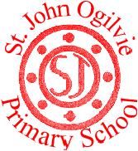

St. John Ogilvie Primary School

School Improvement Plan
2025/26

Planning framework

As part of Children’s Services, St. John Ogilvie Primary School has developed this school improvement plan in line with the national and local priorities listed below.

National Improvement Framework Key Priorities

- Placing the human rights and needs of every child and young person at the centre of education;
- Improvement in children and young people’s health and wellbeing;
- Closing the attainment gap between the most and least disadvantaged children and young people;
- Improvement in skills and sustained, positive school-leaver destinations for all young people; and
- Improvement in achievement, particularly in literacy and numeracy.

National Improvement Framework 7 Key Outcomes
- A globally respected, empowered, and responsive education and skills system with clear accountability at every level that supports children, young people and adult learners to thrive. The system enables the development of their knowledge, skills, values and attributes that give them the best opportunity to succeed and contribute to Scotland’s society and economy.
- Young people experiencing the benefit of schools and early years settings working in excellent partnerships with wider children’s services and other partners, families, and communities, in line with the GIRFEC approach.
- Inclusive and relevant curriculum and assessment which gives young people the knowledge and skills necessary to contribute to society, and shape a sustainable future, while celebrating and supporting progression for all.
- High levels of achievement across the curriculum for all learners, with action to close the poverty-related attainment gap.
- Highly skilled teachers and school-leaders driving excellent learning, teaching and assessment for all, especially those with additional support needs.
- Improving relationships and behaviour, and attendance, with increased engagement in learning and a culture of dignity and respect for all.
- An education system engaging in digital technology to enhance all aspects of learning and teaching, supported by a digitally skilled workforce and tackling digital inequality.

Renfrewshire Council Plan Strategic Outcomes

Cross cutting theme: Improving outcomes for children and families
We will encourage kind and  connected communities—  where our citizens take pride  in their place, attracting  others to move here and  share in the opportunities  Renfrewshire has to offer. | We will support a strong and  flexible local economy—with  Renfrewshire able to adapt  after the pandemic, building  up resilience to support good  green jobs and skills for all  local people to enjoy the  benefits of both living and  working here. | We want Renfrewshire to be  a fair place—where all our  people have the best chances  to live happy, healthy and  fulfilled lives, to feel safe,  supported and empowered  to unlock the strength of our  collective potential. | We are working towards  a greener future—taking  responsibility for our impact  on the planet and taking  brave, bold steps to protect  the natural environment that  supports and benefits us all. | We want our employees  to feel proud to work for  Renfrewshire Council because  we are a values driven  organisation, where we all  understand and value our  contributions, and we are  passionate about making a  difference for Renfrewshire.

Renfrewshire Council’s Values

We are fair, we treat each other and everyone we deal with respectfully and work hard to build trust in Renfrewshire Council.
We are helpful, we care about getting things right and are always approachable.
We are great collaborators; we work as one team and with people who care about this place.
We value learning to help us innovate, improve and deliver better services.

Children’s Services Vision
Working together to get it right for children, families and communities –
protecting, learning, achieving and nurturing

Renfrewshire’s Education Improvement Plan Priorities

Reduce child poverty in Renfrewshire and improving outcomes for children and families currently living in poverty | Place children and young people’s human rights at the heart of the planning and delivery of services that affect them | Protect the most vulnerable members of our communities, including children and young people who are at risk | Support and nurture our children, families and communities | Create the best possible learning estate to allow children and young people to thrive | Raise attainment and enhance learning and teaching in an inclusive environment

Our Vision, Values and Aims

Vision – A community of excellence and opportunity for all

Motto – Starting a Journey of Opportunity

Values – Kindness, Honesty and Respect

Our Aims:

- To promote wellbeing and respect within a culture of ambition and achievement, reflecting Gospel Values within a community of faith and learning.

- To share a common vision with our pupils, parents and staff and to foster high quality leadership at all levels.

- To engage all our pupils in the highest quality learning activities which focus on outcomes and maximise success for all learners

- To value and empower our staff and pupils, to reflect on our work, welcome challenge and to experience personal and collegiate responsibility.

5. To work in partnership with parents, other agencies and our community to improve and support learning.

Who did we consult?

To identify our priorities for improvement, we sought the views of:

Staff
- Staff meetings
Parents/Carers
- Annual Report feedback
- Parent Evenings
- Parent Partnership
- Newsletters
- Questionnaires and surveys carried out throughout the year
- In-Service Days
- Curriculum Development Sessions
- Regular Self-evaluation linked to Quality indicators (HGIOS)
- Individual Forward Plan feedback with SMT
- Personal Review and Development meetings
- Regular review of School Improvement Plan priorities
- Consultation of SIP priorities
- Questionnaires and surveys carried out throughout the year

Pupils
- Pupil Council meetings/ big book
- Pupil questionnaires and feedback
- Weekly Hot Chocolate Friday Sessions
- Assemblies

We have also consulted with our partners/stakeholders. These include:
- The Parent Partnership
- The School Chaplains]
- The Music Service
- The EAL and Sensory Team
- Agencies including Educational Psychology and Health
We gathered feedback through:
- Informal feedback through discussions
- St. Andrew’s Cluster Schools
- Meetings with School Chaplain
- Transition Meetings with Early Years Centres and Secondary Schools
- Termly meetings with Active Schools Co-ordinator
- Collaborative meetings with the Family Wellbeing Worker and Educational Psychologist.
- Stakeholder questionnaires

All information gathered is collated and used to assist us to identify next steps and areas for improvement. The priorities and actions within our school improvement plan meet the needs of the school and articulate with the local and national priorities.

How will we know if we are achieving our aims?
We will measure and evaluate the progress we are making to achieve the key outcomes set out in this plan. We do this using quality assurance activities that include:
- Self-evaluation activity using HGIOS4
- Staff Collegiate Meetings
- SMT Meetings
- Pupil Committee Groups
- Pupil Focus Groups – jotter monitoring and learning & teaching
- Pupil Assemblies
- Observations of Learning &Teaching
- Termly Forward Plan and Tracking Attainment Meetings
- Termly Moderation activities during collegiate sessions
- Termly review of Child’s Plans.
- Parent, staff, learners & partners’ questionaries/surveys
- Professional Review and Development Process for all staff
- Practitioner Enquiry & Sharing Good Practice Sessions for teaching staff
- Observations/feedback from professional collaborators including Educational Psychology, Family Wellbeing and School Chaplains
- Review and update of policy and practices in school
- Parent Partnership Meetings
- Parents’ Evenings – feedback
- Newsletter - feedback
Each year we also complete a Standards and Quality report and self-evaluation document which are monitored by Renfrewshire Council Children’s Services’ staff.

Pupil Equity Funding
Our school receives Pupil Equity Funding (PEF) to provide targeted interventions in literacy, numeracy and health and wellbeing to close the poverty related attainment gap. This funding enables us to plan additional interventions to those which were already planned. These interventions are highlighted throughout this improvement plan using the (PEF) abbreviation.

Improvement Priority 1 – Raise attainment in Reading
NIF Priorities Highlight as appropriate  Placing the human rights and needs of every child and young person at the centre of education  Improvement in children and young people’s health and wellbeing  Closing the attainment gap between the most and least disadvantaged children and young people  Improvement in skills and sustained, positive school-leaver destinations for all young people  Improvement in achievement, particularly in literacy and numeracy |  | NIF 7 Key Outcomes (see page 2 for full descriptors) Highlight as appropriate  Develop knowledge, skills, values and attributes to support children and young people to thrive  Excellent partnerships in line with GIRFEC  Inclusive and relevant curriculum and assessment  High levels of achievement across the curriculum with action to close the poverty-related attainment gap  Highly skilled practitioners and leaders driving excellent learning, teaching and assessment  Improving relationships behaviour and attendance with increased engagement in learning  Engaging in digital technology supported by a highly skilled digital workforce & tackling digital inequality Highlight as appropriate
Rationale for change | Outcome and Expected Impact |  | Measures | Interventions
Reading  Curriculum for Excellence data demonstrates that, as a school, reading is an area for improvement, with the biggest dip being in First Level. (Session 24-25)  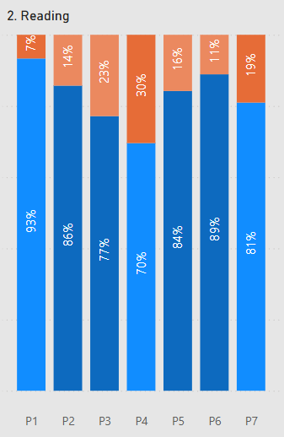  Comparator data available shows that Reading is an area for improvement in Second Level.  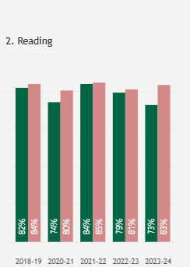  Through the annual staff survey, staff feel that our approach to the teaching of spelling should be a focus for improvement.  ‘Children across the school have difficulty applying phonics/spelling rules across the curriculum - Need a consistent approach to spelling - Possibly look at resources being used - Focus on basics of spelling’.  Through Curriculum Evenings, all staff agreed that approaches to the teaching and resourcing of Reading Comprehension should be discussed and inform the Literacy Policy.  The Self-Evaluation Profile of the school has the Quality Indicator of ‘Attainment and Achievement’ at the level ‘good’. The school would like to improve this grading to ‘very good’. | By June 2026, the school aim to improve the attainment of reading for pupils in targeted groups (below) by:  Session (25-26) Rise from - to (reading):  P4 77%-86%  P5 70% - 78%  P6 82% - 90%  P7 89% - 92%  *based on current class sizes  By June 2026, attainment of pupils impacted by poverty within the targeted group:  In Second Level reading will improve by  Session (25-26) Gains in Reading by those impacted by Poverty.  First Level In First Level - 33% of pupils impacted by poverty are not on track in reading. Through targeted intervention we aim to reduce this to 20%. In Second Level - 54% of pupils impacted by poverty and off track will receive targeted intervention to become on track in reading.  Second Level 54% of pupils impacted by poverty and off track will receive targeted intervention to become on track in reading. |  | We will measure improvement through:  Termly tracking meetings, where data will show the impact of interventions throughout the session.  Teacher targeting interventions will gather data and create actions for the child’s plan which will be reviewed and evaluated each term. Actions will show improvement.  Pupil evaluation will determine areas for development and strengths.  Staff Timetables will reflect work being carried out to support Learners in Reading and Writing across Second Level.  Data from Reading Eggs Subscription will track pupils accessing support in school/ at home. | All staff will be made aware of the new Literacy Policy and follow guidance to ensure consistency across Levels. (by September 2025)  An additional teacher will target pupils in Second Level by working alongside the ADHT to establish a programme to support improvement in Reading attainment. (HQ).  An ASNA will be deployed to support raising attainment in reading and writing across First and Second Level. (PEF)  Through Curriculum Development Sessions (3hrs) staff will create ‘what a good reading lesson/block of lessons looks like. Staff will also plan together with Level partners. (by October 2025)  Reading as a theme will be an option for Practitioner Enquiry and Peer Visits. (by February 2026)  The Principal Teacher will carry out an Audit regarding Staff, Pupil and Parent views on our current approaches to the learning and teaching of Spelling. (October 2025)  The Principal Teacher will carry our research, linking with the ADHT and Educational Psychology on the best approach to take to improve the learning and teaching of Spelling. (June 2026).  All staff will be familiar with the benefits of the ‘Reading Progress’ Tool within Microsoft Teams and use this as a support to Miscue Analysis and as an additional way of gathering information on pupil progress in Reading. Child’s Plans will reflect data gathered from this tool. (December 2025). The Digital Lead will support all Teaching Staff accessing this tool and ensure Support Staff are confident accessing the tool. (PEF)  The teacher with responsibility for the Leadership of Literacy will gather and submit evidence to maintain the Reading Schools Gold Award.  Approaches to the teaching of Reading Comprehension will be agreed via the Literacy Policy and the approaches shared during Curriculum Evenings, Practitioner Enquiry or through Peer Learning Visits. (PEF)  Comprehension Resources will be purchased to ensure consistency and support all learners across P3-P7. (PEF)  The Digital Lead will share ‘online’ approaches to Reading Comprehension that are having a positive impact on pupil engagement in Reading. (June 2026)  Staff training will take place on the August Inservice Day to support staff in using the newly purchased VR Headsets to engage pupils in Reading Lessons. (PEF)  The digital lead will support staff in using VR headsets to promote high levels of engagement across targeted groups of pupils. (PEF)  The Parent Partnership will continue to support the purchase of a Reading Eggs Subscription to make reading fun and to support home learning.  The Literacy and Digital Champion will support the embedding of Termly Class Podcasts (4 per year) to share the learning taking place within the classroom. Through the Reading Schools Grant, the Cluster will apply for money to support Podcasting.
Improvement Priority 2 – Health and Wellbeing
NIF Priorities Highlight as appropriate  Placing the human rights and needs of every child and young person at the centre of education  Improvement in children and young people’s health and wellbeing  Closing the attainment gap between the most and least disadvantaged children and young people  Improvement in skills and sustained, positive school-leaver destinations for all young people  Improvement in achievement, particularly in literacy and numeracy |  | NIF 7 Key Outcomes (see page 2 for full descriptors) Highlight as appropriate  Develop knowledge, skills, values and attributes to support children and young people to thrive  Excellent partnerships in line with GIRFEC  Inclusive and relevant curriculum and assessment  High levels of achievement across the curriculum with action to close the poverty-related attainment gap  Highly skilled practitioners and leaders driving excellent learning, teaching and assessment  Improving relationships behaviour and attendance with increased engagement in learning  Engaging in digital technology supported by a highly skilled digital workforce & tackling digital inequality Highlight as appropriate
Rationale for change | Outcome and Expected Impact |  | Measures | Interventions
Through our approach to Self- Evaluation, all staff identified that Health and Wellbeing was an area for development.  Through the staff survey (April 2025), staff highlighted the following areas to be developed:  - A review of our current Health and Wellbeing Programme and calendar.  - A whole school approach to emotional check-ins.  - A focus on Mental, Emotional, Social and Physical wellbeing.  - Staff training on digital wellbeing.  - Support development of resilience across all areas of the school.  - Staff training on support for children and families who are affected by loss, change of relationships and bereavement.  SMT and Staff identified an increase in the number of digital wellbeing challenges children are experiencing.  The Parent/Carer Survey identified Health and Wellbeing as a priority for improvement. In particular the following areas were highlighted:  - Introduction of the daily mile  - Communication of the new Mobile Phone Policy  - Development of Outdoor Learning approach  - Use of the green spaces surrounding our school  - Online safety sessions for children and parents  - Tranquil green learning space  - Mental health – particularly resilience and confidence  Through the Pupil Survey for P4-6, the following statistics were gathered.  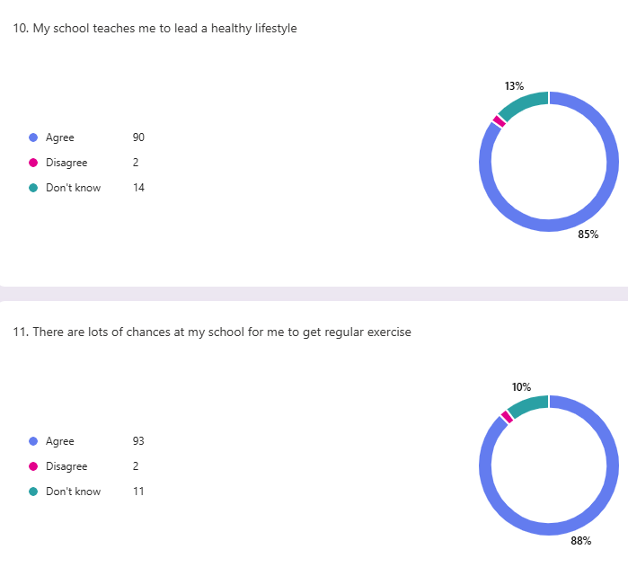  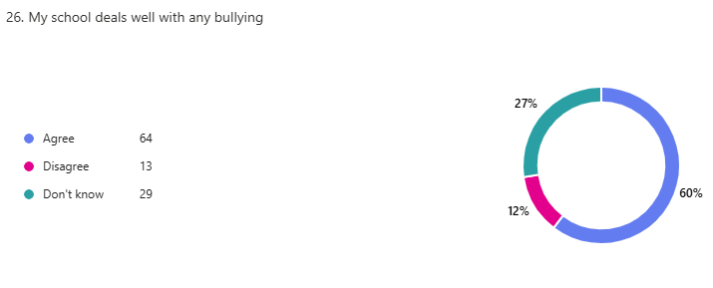  Information gathered from the Pupil Survey also highlighted that children felt having calm areas within the school grounds would help them to learn well.  The Stakeholder Survey identified that areas for visiting staff to work with children would be an area to continue to develop.  Through Participation in the Young Leaders of Learning Programme, our staff and pupils appreciated the feedback and as a result developed 3 main areas impacted positively on Relationships.  - Introduction of a Mini-Vinnie Market supporting our families to access food on a weekly basis upholding our school values of kindness and respect.  - Introduction of a Buddy Bench in both playgrounds.  - Move to change the House System to reflect Saints.  These 3 successes have had such a positive impact on our school community that staff and pupils are aware of the benefit of working alongside different schools to make positive change and as a result would like to work with another school. | By June 2026:  A Health and Wellbeing Policy will be created and introduced to our school community. This Policy will be used to support consistency and progression across all stages of the school.  A staff survey issued at the middle and end of the year will show improvement in the areas identified by staff. In particular staff confidence in supporting pupils affected by loss/bereavement.  Parents/Carers will feel that they have more robust information regarding the types of apps/online content that the children can access at home on devices.  Staff and pupils will have more consistent access to the outdoor areas surrounding the school.  - Seedhill pitches will be booked for all PE slots  - All pupils will be able to participate in the ‘Daily Mile’ at least 3 times per week.  The pupil survey will show an increase in the number of children who feel the school deals well with bullying.  Parent/carer views regarding outdoor learning and the use of outdoor spaces will be sought via the Monthly Newsletter and demonstrate that the school listen to views and act on suggestions.  Through Self Evaluation of the HGIOUR document pupils and staff will identify our strengths and next steps in Theme 3 – Our School and Community. We hope to identify and action any areas for development within the school session. |  | Staff survey middle and end of year to establish impact of Health and Wellbeing Working Party.  Pupil Survey at the end of the session to gather views of children with regards Health and Wellbeing Themes.  Pupil Wellbeing Surveys will be issued termly and contain additional questions regards Anti-Bullying and Online Safety.  A Parent Question regarding the areas they identified as ‘priorities’ will be issued in the School Newsletter to help gather the views of all parents/carers in relation to our development work.  Staff and pupils will work together with West Primary School to evaluate our performance using the HGIOUR document – Theme 3. | The Renfrewshire Council Health and Wellbeing Development Officer will deliver training on ‘Online Safety’ to all staff. (Planned for the 4th September).  The Renfrewshire Council Health and Wellbeing Development Officer will deliver sessions on ‘Online Safety’ to parents/carers. (Planned for during and after school on Tuesday 8th September). This session will be combined with a Digital Fayre Event to demonstrate the Positive Impact Technology can have on our learners. VR Headsets, Sphero, Garage Band, Beebots, Robots and Ipad packages will be demonstrated. By September 2025.  The new Mobile Phone policy will be communicated with all parents/carers by September 2025.  A working party will be established to refresh the school’s Health and Wellbeing Calendar (8hrs). By June 2026.  A rolling calendar of areas that should be introduced and discussed during Assembly will be established. For example, Online Safety, Rights of the Child, Additional Support Needs, Anti-Bullying and Values should feature on a Monthly rolling programme and be shared with all staff prior to assemblies taking place. By June 2026.  The Principal Teacher will introduce Rights Respecting Schools to all classes within the school. (PEF Funding to support resource).By June 2026  The school will continue to promote resilience through the purchasing of ‘Tree of Knowledge’ (PEF). By June 2026.  The school will continue to develop links with Accord Hospice and refer for support in the areas of loss/bereavement. By June 2026  The school will organise training for staff who wish to attend loss/bereavement training.  Depending on RC Training Calendar.  The school will continue to evaluate their Spiritual wellbeing under the theme of ‘Serving the Common Good’. The school will develop Faith via the Mini-Vinnie Committee and strive to make a link with a Twin Community in a developing Country. By June 2026.  The Principal Teacher will gather and share data from the Glasgow Wellbeing Tool and disseminate termly the actions to all appropriate staff. By June 2026.  The Gardening Committee will develop a Sensory Garden to the rear of the school to support the development of green space as well as support pupils with their emotional wellbeing/regulation. By June 2026. (PEF)  The Pupil Council will work with the Parent Partnership to create a plan for an Outdoor Classroom to be installed into the school grounds. This classroom will support outdoor learning and provide all classes with an opportunity to take learning outdoors irrespective of the weather. By June 2026.  Seedhill playing pitches will be timetabled to support PE and outdoor learning. By August 2025.  All classes will participate in the Daily Mile at least 3 times per week (on days where no PE takes place) during two of the school terms. (September 2025)  Our school will participate in the Young Leaders of Learning Programme. Primary 5 and a couple of children from the group last session will work on Theme 3 ‘Our School and Community’ with West Primary School. (June 2026)  The school will continue working on the Renfrewshire Nurturing Relationships Approach – Principle ‘Learning is understood developmentally’. The evidence of the development work will be submitted to achieve accreditation. By June 2026  The Digital Lead will gather evidence to attain the next step in our Digital Schools Award including the Online Safety module and award. Both by June 2027.

Improvement Priority 3 – Developing a consistent approach to skills language
NIF Priorities Highlight as appropriate  Placing the human rights and needs of every child and young person at the centre of education  Improvement in children and young people’s health and wellbeing  Closing the attainment gap between the most and least disadvantaged children and young people  Improvement in skills and sustained, positive school-leaver destinations for all young people  Improvement in achievement, particularly in literacy and numeracy |  | NIF 7 Key Outcomes (see page 2 for full descriptors) Highlight as appropriate  Develop knowledge, skills, values and attributes to support children and young people to thrive  Excellent partnerships in line with GIRFEC  Inclusive and relevant curriculum and assessment  High levels of achievement across the curriculum with action to close the poverty-related attainment gap  Highly skilled practitioners and leaders driving excellent learning, teaching and assessment  Improving relationships behaviour and attendance with increased engagement in learning  Engaging in digital technology supported by a highly skilled digital workforce & tackling digital inequality Highlight as appropriate
Rationale for change | Outcome and Expected Impact |  | Measures | Interventions
The Curriculum Improvement Cycle review in Scotland is systematic review process focused on ensuring the Scottish curriculum remains relevant and effective. A key aspect of this review is the identification of essential skills alongside subject-knowledge to better prepare students for future success. These essential skills, also known as transferable or employability skills, include communication, problem-solving, teamwork and self-management.  Through the staff survey (April 2025), staff highlighted that a more focused approach to the teaching of STEM skills/Meta skills was required.  In May 2025 a pupil survey identified that a significant number of children felt STEM should be a priority in the next improvement cycle.  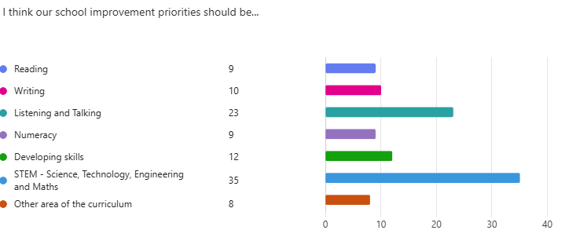  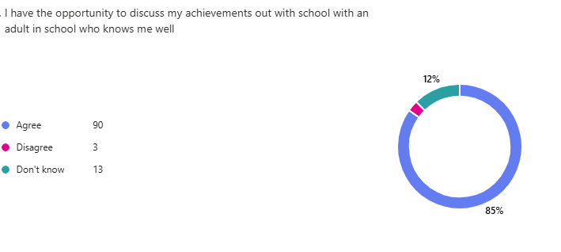  Pupils identified that not all pupils feel they have the opportunity to share their achievements out with school.  In August 25 P4-7 Pupil Survey Results demonstrate that pupil confidence in relation to knowledge of skills requires improvement  - recognise & identify  - articulate the language of skills  - relate to real life contexts  - link to world of work  P4-7 children scored on average XXXX out of 5 on a confidence scale | Long term outcome – 2025 - 2028  A skills framework will be agreed within the cluster to ensure consistency of skills development at all stages using a shared language. Pupils will be able to use this language to reflect upon the skills for learning, life and work they have developed and be clear about how their achievements relate to these. This cluster approach will also contribute to effective transitions between Primary and Secondary school.  By June 2026  Almost all teaching staff will have an increased awareness, understanding and confidence in skills development.  Pupils will have an increased ability to identify, talk about and reflect on skills in a variety of contexts.  All classes will adopt a skills-focussed approach to learning and explicitly reflect on skills during lesson introductions, mid-points and plenaries.  All Pupil Committee Groups will be skills focussed to ensure the approach and language is embedded and pupils can apply their knowledge and awareness in a variety of contexts.  Families will develop an awareness of the skills framework through the My World of Work Online tool. This will enable families to support effective dialogue relating to skills development and link this with personal achievements outside of school.  By June 2026  Cluster plan developed to include level-appropriate staff groups that will work across schools to plan and moderate skills development. This will be embedded into all cluster SIPs for session 26/27 to ensure a shared and continued focus for improvement. |  | All staff across cluster to undertake baseline (by Sept) and post (June) survey to evaluate confidence around skills development.  Learning visits will be skills focussed and evidence an increased understanding of pupil abilities to reflect on skills using skills-appropriate language.  The pupil survey in June will show an increase in the in pupils who feel that they have the opportunity to share their achievements out with school.  The staff survey issued in June will show that staff have an awareness and a consistency of approach to the language of skills. | Staff will receive an introduction from Skills Development Scotland (SDS) to launch the development work on Skills. This is provisionally planned for Thursday 11th September 2025.  A working party will be established (allocated 8hrs from the Working Time Agreement) for the school to develop an annual plan of the work to be carried out across all areas of the school.by June 2026  A Cluster network of lead practitioners will be established to share practice across the Cluster. By October 2025.  Primary 5, 6 and 7 will introduce the My World of Work digital tool endorsed by Education Scotland. By October 2025.  By June 2026, My World of Work application will be shared with parents/carers.  The My World of Work application will transition with Primary 7 in June 2027.  STEAM – Science, Technology, Engineering, Arts and Maths will be an area for development via the Pupil Council and the staff leads. STEAM should feature in a newly launched approach to Fun Friday where mixed year groups have the opportunity to take part in a variety of fun STEAM learning activities.  Two members of staff should complete Food Hygiene Level 1 and 2.  Using a digital platform the school will collect data from children on their achievements out with school and use these to develop areas of the school life.

