Starting School



St James’ Primary School
3/5 Gockston Road
Paisley
PA3 2QB
TEL: 0300 300 1330
Enquiries: stjamespaisleyenquiries@renfrewshire.gov.uk
Head Teacher: Mr Derek Retson




Welcome to St James’ Primary School

In St James’ Primary School, we aim to give all children the best possible start to their primary education.

Children achieve more when pupils, teachers and parents work together towards a common goal.

This booklet has been produced to give you some practical advice on starting school and an insight into your child’s school day.

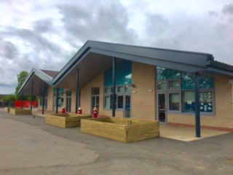

Preparing your Child for School

School should be a very enjoyable and positive experience.

If you are worried about your child going to school, your child will pick up on your anxiety.

Tell your child it is going to be good fun – because it will be!

Remember to tell your child that it is going to be a great adventure. It will be a chance to learn about lots of new things. It is also a chance to make lots of new friends.

Children can be very good at countering this sort of argument.

‘I don’t want to make new friends.’

‘I like it at home.’

‘I want to stay with you.’

Keep up the message and reassure your child– school will be good fun. Remain positive and your child’s confidence about going to school will increase.

Times and Dates

On the first day of term, a staggered start will be in place.
Children should be brought to the P1 classroom fire door, which is just beside the Broomdyke Way gate near the Beechwood Community Centre.

First Day Tuesday 16 August 2022
Start at 9.15am
Collect at 3pm

Second Day Tuesday 17 August 2022
Start at 9am
Collect at 3pm

On the first day, the children should be brought in to find their coat peg and then taken into their classroom by their adult. You are welcome to stay for a little while (5 mins) to take photographs or video of your child’s first day. The class teacher will then ask parents to leave the classroom. We welcome your support in this as it allows the teachers to begin the school day.

The children will have their own playtime on the first two days to allow them to become familiar with the layout of the playground and the adults responsible for them whilst out playing. They will join the other children, all being well, on day three.

The pupils will be dismissed from the classroom door. To allow the teachers and pupils to easily identify the person collecting each child we would ask you to stand well back in the playground. Staff will send the children over to you. The children will stay with their teacher until they are collected by an adult.

Interval
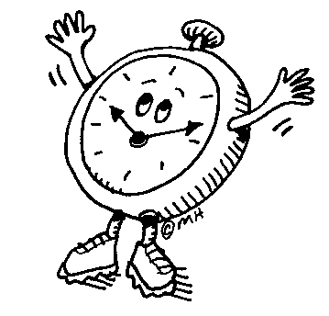

The children are in the playground supervised by our janitor, classroom assistant and Primary 7 buddies. They will be allocated their own area for playing. This helps to minimise accidents and keep all children safe.

Snacks
Young children tend to eat slowly therefore, a small snack will allow the children time to eat and play with new friends. In St James’ Primary, we encourage healthy eating, can children bring a healthy snack e.g. fruit or cereal bar.


Toys
Sometimes children like to bring a toy to play with at school. Unfortunately toys can easily be misplaced at school, so we would ask you to discourage children from bringing their own things in from home as it can be very upsetting if they are lost or broken. Playground games/toys are provided by the school are available at intervals.

Uniform

Our uniform is very smart and we encourage all pupils to wear it every day. It promotes a positive ethos and a sense of pride in the school. It also presents a good image of the school to pupils, parents and the wider community. It allows us to identify our pupils whilst on school outings and distinguish them from any other visitors within the school grounds.
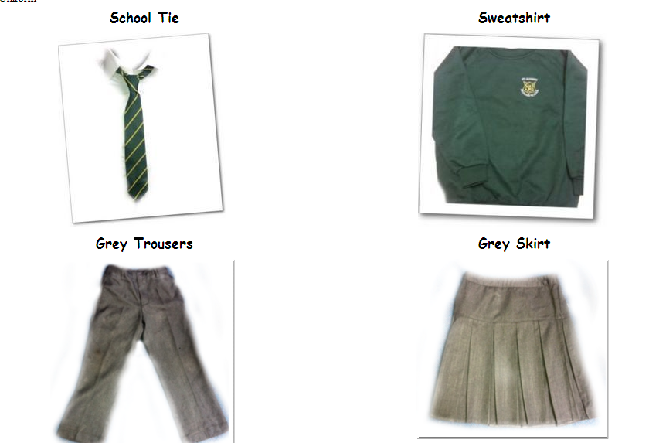
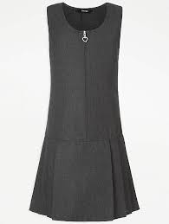

Grey Pinafore

Grey Shorts

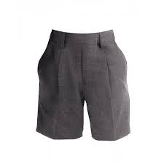

Basic items can be easily purchased from supermarkets and local stores. St James’ logo polo shirts, sweatshirts, fleeces etc can be purchased from a variety of specialist stores in Paisley.

We also ask that pupils bring soft shoes that can be worn during the day in class. This means that if the weather is bad children can wear dry shoes and feel comfortable throughout the day. It also helps us keep our floors nice and clean!

If possible, on PE days, pupils should wear a polo shirt, which can be kept on when they go to the gym hall. This helps them change more quickly and gain maximum benefit from their time in the gym hall. We also ask that dark coloured shorts are worn, and no jewellery, including earrings.

Outdoor learning forms a big part of our daily curriculum, so please ensure weather appropriate clothing like a waterproof jacket is always provided.

Learning at Home

Learning happens wherever children go!

There is much you can do to support your child’s learning in the home – please see our ‘Help your Child…’ leaflets for some ideas to aid learning in basic maths and language concepts.

We also try to encourage the children to be as independent as possible in the classroom. Therefore, when starting school, it is helpful to staff if the children can do all/some of the following:

- get themselves dressed/changed (in preparation for going to PE)
- put on and fasten their shoes and jackets
- eat lunch without help using the appropriate cutlery
- organise their own personal belongings

Please do encourage them to ask their teacher for help when necessary.
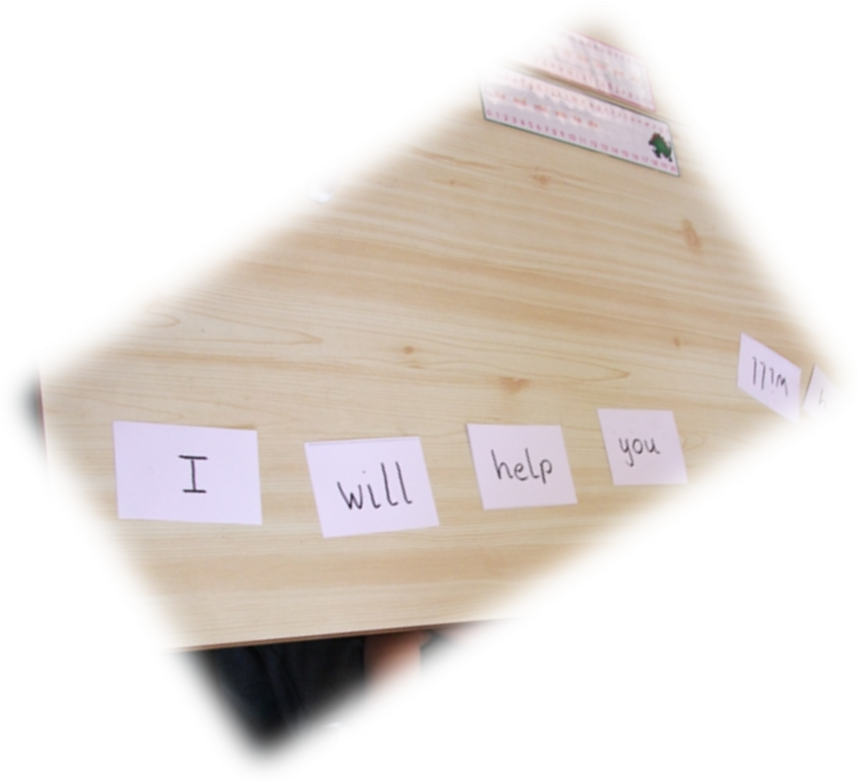

Through time, your child will bring home a variety of homework activities. Please help them choose an appropriate, quiet space in the home to complete these and help and encourage them as required. Remember - any homework given will be predominantly consolidation of work already covered in class. Therefore, your child should have a very good idea of what they have to do!

Absence

If your child is going to be absent, we would ask you to telephone the school office between 8.30 am and 9.00 am. A message will be passed on to the class teacher. A written note explaining the absence should be given to the class teacher by the child on his/her return or given through Seesaw to Senior Management. If your child is absent and we have not received any notification, the school will text/telephone home after registration has taken place. An unexplained absence will be recorded as an unauthorised absence on your child’s record.



Enquiries

We realise that starting school is a new experience for many parents. At St James’ Primary we encourage open communication between staff and parents. If you have a concern or require a ‘quick word’ we would ask you to either send the teacher a message through Seesaw or call the school office to speak to speak to a member of staff. By following this system it will allow the staff to undertake their teaching duties and ensure the safety of all pupils in the classroom. You may also make an appointment to talk with our Head Teacher, Mr Derek Retson or our Depute Head Teacher Mrs Walsh, so that problems or concerns can be dealt with quickly.

Wet Weather Arrangements

Children go out to play in most weather conditions so please make sure they are dressed appropriately. If it is raining heavily at interval or lunchtime and an indoor play is required, your child will be supervised by the management team, classroom assistant and our janitor. Pupils will eat their snack in class and have the opportunity to visit the toilet.

Parking

Only authorised vehicles are allowed into the school car park. In the interest of safety for all our pupils we ask you to find a suitable drop off point/parking space out with the school grounds. For easiest access to the P1 classroom, it is suggested you park close to and arrive via the gate on Broomdyke Way. Please take local residents into consideration when doing so. Please also avoid parking on the Zig-Zag lines immediately outside the playground; this is to allow the children crossing the road to have clear visibility.


Staff Parking only!


Parent Council

St James’ Primary School has a very active, hardworking Parent Council.
Many fundraising events are held throughout each year. Discos, community BBQs and family fun days to name a few. The Parent Council works closely with the school and all funds raised are used to enhance your child’s education. Please “like” the Parent Council Facebook Page to keep up with the latest information.

Meetings are held approx. 5 times a year and new parents are always welcome. If interested please contact the Parent Council via their email address stjamespaisley@renfrewshire.npfs.org.uk – it would be wonderful to have you on board! The dates for all meetings are posted on the St James’ Primary Paisley Parent Council Facebook Page.

What your child will need

A school bag – big enough to carry essentials!
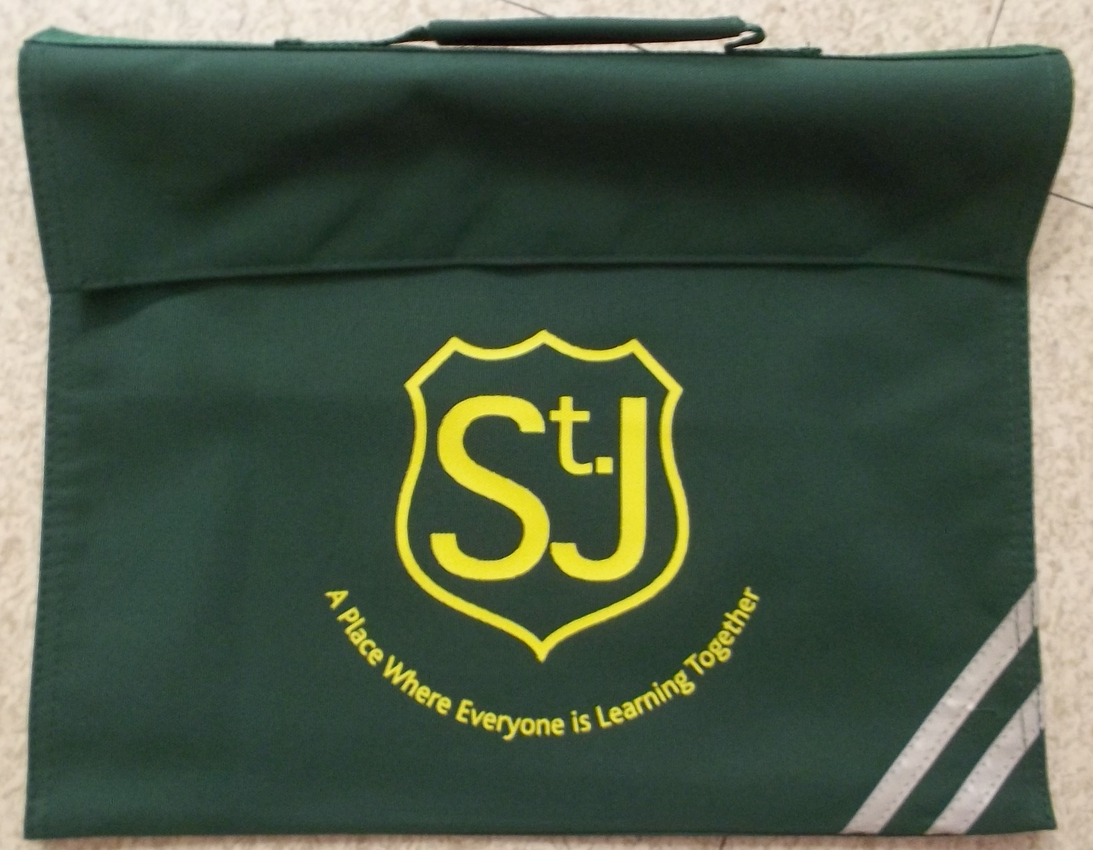

PE kit – dark coloured shorts, white t-shirt/polo shirt and sandshoes/trainers.
Sandshoes can be put in a small shoe bag and stored permanently on your child’s coat peg or can double up as their soft shoes (for indoor use).

Writing pencils, a set of coloured crayons/pencils and glue stick
Classrooms are well stocked, however, it is helpful if every child has the basics in their pencil case and brings it to school every day.

Lunchtimes

From August 2022, all children will receive a free school dinner.

Packed lunch box – please do not give your child too much to eat for lunch as it can take them some time to finish and they can miss the chance to get out for some fresh air afterwards.

We cannot stress enough the importance of naming all clothing, bags, wallets/purses, packed lunch boxes etc. It allows the pupils to identify their own belongings and is also a great help to the staff.

Parish Community Links

Here in St James’ we work very closely with St James’ Parish Church. We are very lucky to have Fr John working alongside us. We visit the church regularly and are supported in our sacramental programme by the parish. Sunday mass is at 10 am in St James’ Parish Church, Greenock Road, and there is a Family Mass once a month which includes a Children’s Liturgy.

Staff list for 2021-2022

Head Teacher – Mr Derek Retson
Depute Head Teacher – Mrs Jen Walsh

Classroom Assistant – Mrs O’Neil
Classroom Assistant – Miss Porte
ASN/Clerical Officer – Mrs Connell
Senior Clerical Assistant – Gayle Haggarty
School Chaplain – Fr John Morrison
Janitors – Mrs Michelle Gordon and Mrs Aileen Carter
Active Schools Coordinator – Miss Victoria Collins
Parent Council Chair – Mrs Anne McCabe

Full staffing complement for 2022/23 and allocation of teachers to specific classes is still to be completed.

If you have any further questions surrounding any aspects of your child’s education or with the transition to St James’ please do not hesitate to contact the school.

Yours sincerely

Mr Derek Retson
Head Teacher

