

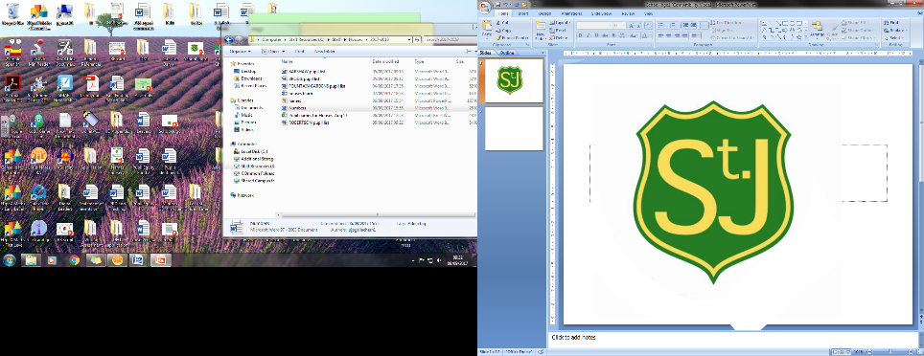

Renfrewshire Coucil

**St James’ Primary School**

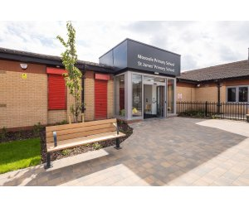

STANDARDS AND QUALITY REPORT

June 2022

This report will inform you of the school’s progress and achievements in the last session and let you know about our plans for 2022-2023. I hope that you find it helpful and informative.

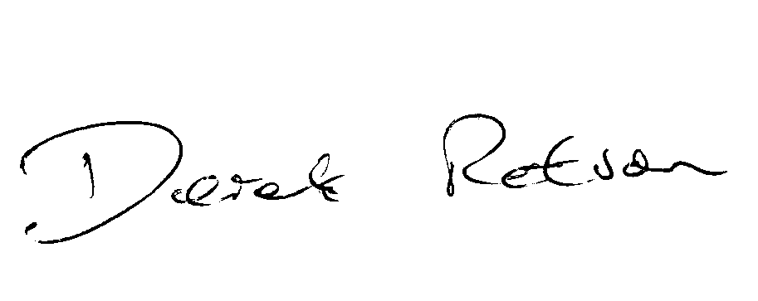

Head Teacher

SUCCESSES AND ACHIEVEMENTS

* The Pope Francis Faith Awards are fully embedded and are showing a positive impact in developing the faith formation of pupils at P6 and P7. This year, 17 P7 pupils received awards with 1 pupil receiving a special Parish Commendation.
* Staff Working Parties have worked on further developing a whole school approach to supporting children using RNRA and on creating a system for short, medium and long-term planning online.
* Primary 7 came third in a Renfrewshire wide poster competition detailing learning about COP 26.
* Primary 6 participated in a Glasgow Science Centre initiative focussing on sustainability and Global Goals. Their work was displayed during COP 26 at the Science Centre.
* A P7 Pupil won a bronze medal in Judo at the Northern Ireland Open.
* Improvement Plan objective focussed on tackling bureaucracy by moving all short-, medium- and long-term planning to online formats. Recognised at Council level as good practice and shared with other schools.
* Seesaw Ambassador invited to lead staff in use of this app at Our Lady of Peace Primary School and share good practise from St James’ Primary School.

OUR VISION, VALUES AND AIMS

**Vision**

Our vision, as a faith enriched school community, is to provide a values-based curriculum characterised by excellent learning and teaching whilst inspiring a passion for lifelong learning and a commitment to social justice and moral courage.

**Values**

Joy; Respect; Responsibility; Inclusion; Resilience and Compassion & Love

**Aims**

To ensure a safe, welcoming, stimulating and **inclusive** environment which creates positive attitudes to learning and is responsive to the voice of children.

To ensure staff have high aspirations by developing best practice in the pursuit of the highest standards and best outcomes for children.

To support our children to become confident individuals who are motivated to develop **resilience** and self-belief and experience the **joy** of learning.

To build strong collaborative partnerships with families and the local community through involvement in learning and decision making.

To empower children to develop **responsibility** by taking an active role in society.

To embrace the values of **respect**, **compassion** and **love** by understanding and celebrating the diversity of our community and valuing the place of each individual in the wider world.

OUR SCHOOL

St James’ Primary is a denominational school serving the Shortroods and Gockston areas of Paisley with the school role currently standing at 183 pupils.We take advantage of the uniqueness of sharing a campus to work closely with Mossvale Primary School. The catchment area comprises a mixture of local authority and private housing with 83% of pupils identified as living in Scottish Index of Multiple Deprivation deciles 1-3. With children from 14 different nationalities across the school, there is a high percentage of children for whom English is an additional second language (34%). **The school has an active and supportive Parent Council and is well regarded amongst parents with** positive comments from respondents to recent questionnaires indicating that they are happy with the school.The school is led by the Head Teacher and Depute Head Teacher. There are eight class teachers, three Classroom Assistants, one part-time Additional Support Needs Assistant, a Business Support Officer and a Music instructor. **Together, staff provide a warm and** supportive **environment** for learning **where children are** supported in a positive and nurturing environment. The school also works closely with St Andrew’s Academy and associated cluster schools to promote and develop a strong Catholic ethos.

**HOW SUCCESSFUL HAVE WE BEEN IN IMPROVING OUR SCHOOL?**

**School Leadership**

* All staff have further enhanced their own ICT skills and online planning formats are embedded across the school
* Numeracy Champion provided in-house training for support staff in numeracy related resources and approaches which have supported children in their learning
* Health and Wellbeing Champion trained in NVR Level 1, and has since led staff training which feeds in to our RNRA SIP Priority and developing nurturing approaches across the school
* Depute Head Teacher leading Principal Teacher Learning Set, working with 6 Principal Teachers across the Local Authority to enhance and develop leadership capabilities across Renfrewshire schools
* Head Teacher and 2 Class Teachers undertook Project Leader Training in Talk for Writing approach
* All teachers have taken on leadership roles linked to their skills, interests and school improvement priorities. This ensures that we all work in a consultative and collegiate manner, with a shared commitment to improving our whole school learning environment
* Digital Leader working with Local Authority to develop progressive ICT planners
* Digital Leader leading all staff and children to work towards Digital Schools Award which we hope to achieve by December 2022.
* Primary 5 class teacher successfully took on the role of mentoring a newly qualified teacher
* Classroom Assistants undertook various training opportunities, including S.E.A.L Maths, to help equip them with knowledge of teaching approaches.

**Teacher Professionalism**

* All staff participated in training from the school’s Educational Psychologist and school staff on using NVR approaches to support the wellbeing and nurturing approaches throughout the school
* All staff have undertaken training from Learning Through Landscapes to develop and enhance outdoor learning
* All teaching staff have undertaken training on the new GTCS Standards to ensure staff are focussed on using these for their own self evaluation and improvement
* P3 teacher embarked upon learning with Strathclyde University aimed at embedding Inquiry Based Learning approaches in P3
* Infant staff and DHT were involved in training from Alistair Bryce Clegg to ensure progression within a Play Based environment. This is helping to ensure the provision of wider learning experiences tailored to meet the needs of learners
* Almost all staff undertook Maths Recovery training aimed at identifying gaps in learning and meeting the needs of children at an individual level
* P4 class teacher led staff in embedding Laudato Si across the school, raising awareness of environmental responsibilities for all and linking with messages of COP26.
* Four members of teaching staff undertook reviews of school policies. This helped to empower staff to develop leadership responsibilities and gain ownership for curriculum development.

**Parental Engagement**

* Analytical data from Seesaw shows a consistently high level of parental engagement, with family views/comments ranging from 249 to 490 within a school week
* All school newsletters have moved to a digital format and shared on digital platforms, with analytics showing over 200 views for each Newsletter by families
* Following relaxation of Covid restrictions, we have benefitted from a high level of parental participation

in a number of events, including City of Play, class and whole school trips

* School Twitter account has been developed to enhance parental engagement and used to promote our work with the wider community including the local Parish Church
* The introduction of regular parental questionnaires through Google Forms has provided opportunities for parental voice to be heard and robust data that has fed into our School Improvement Plan

**Assessment of Children’s Progress**

* Our new format for recording discussions at Tracking and Target Setting meetings has been embedded which all staff find helpful for enhancing transition discussions and pass on of information
* The introduction of regular pupil questionnaires through Google Forms has provided opportunities for pupil voice to be heard and robust data that has fed into our School Improvement Plan
* All teachers participated in peer moderation of writing to share best practise and provide support for colleagues
* Use of Benchmarks in Literacy and Numeracy have become embedded by all teachers in assessment of individual pupil progress and attainment
* SNSA and GL Assessments have been used to support teachers in identifying gaps in learning caused by lockdown disruption teaching and to inform and support teacher judgement

**School Improvement**

* The introduction of regular staff questionnaires through Google Forms has provided opportunities for staff voice to be heard and robust data that has fed into our School Improvement Plan
* Led by our Digital Leader, all teaching staff are confidently using online planning formats which has reduced workload and tackled bureaucracy
* All staff have improved skills and increased confidence in using digital tools to support learning and, where required, practitioners have accessed CLPL to further enhance personal digital skills
* All staff have been involved in Talk for Writing training which will continue next session in order to embed research-based approaches to raising attainment in this area
* An introduction to Non-Violence Resistance training has been delivered to all staff to increase the use of nurturing approaches across the school. This is also ensuring a consistency of approach in building positive relationships
* Almost all staff have benefited from input from Numeracy Modelling and Coaching officer, and a further programme of CLPL has been developed to include this in the coming session
* All staff benefited from CLPL on providing learning opportunities in the outdoor environment
* All staff have increased knowledge and understanding of the supports available to support the mental health and wellbeing of children and young people and signpost and draw upon these supports as required

**Performance Information**

* All teachers meet termly with the Senior Management Team to discuss progress for all pupils. Through this, all teachers are becoming more skilled at identifying interventions to raise attainment and secure improved outcomes for all learners, specifically those most affected by poverty and looked after pupils
* Teachers are becoming more confident about making judgements on achievement of Curriculum for Excellence levels through engagement with benchmarks which have been incorporated into the Literacy forward plans ensuring teachers are focussed on more accurate and analytical evaluation in relation to these.
* Achievement of a level information at Primaries 1, 4 & 7 evidences increases in attainment in Literacy and Numeracy from the previous year

PUPIL EQUITY FUNDING

Through tracking and target setting discussions, self-evaluation exercises and consultation with the Parent Council, all teaching staff and the parent body indicated that the appointment of Classroom Assistants has had a positive impact on classroom practice and opportunities for our children. This additional staffing of 2 Classroom Assistants has been funded through PEF and has been beneficial in raising attainment during the Covid Recovery period. In addition to this, 1 teacher partly funded through PEF has worked with targeted children from P1 – P7 to improve attainment in Literacy and Numeracy by using specific, targeted interventions. These include Small group work and introducing resources such as IDL Spelling, Toe by Toe and 5 Minute Box which have helped to close identified gaps in learning. For sustainability, our PEF teacher has trained all Support Staff in the use of these interventions to ensure continued success for our children. Our PEF teacher has also specifically supported the Health and Wellbeing of identified children at various stages to ensure children’s mental wellbeing is protected by supporting them in developing their emotional resilience

KEY STRENGTHS OF THE SCHOOL

* Caring, supportive and welcoming environment in the school and visitors regularly comment on the positive ethos within across the school
* Classrooms provide a happy, safe, bright and stimulating space for children to learn
* Shared values are evident in the behaviour of the children and staff
* Children, parents and staff at all levels take on leadership roles to support and enhance the learning experiences for all
* Following the Covid period, the school has worked hard to re-establish strong community links with partners, including: St James’ Church; Mossvale Community Church; Disability Learning Resource Centre; Starr Project; Community Police and Morrisons.

OUR NEXT STEPS – PRIORITIES FOR 2022-23

* Provide professional learning opportunities to support all teachers to develop skillsets and confidence in raising attainment in Literacy and Numeracy
* Work with Numeracy Modelling and Coaching Officer to further develop approaches to learning, teaching and assessment in Numeracy
* Work with joint campus school to moderate introduction of Talk for Writing approach, with teachers involved in termly joint planning, teaching and assessment
* All staff to attend further Talk for Writing training led by the Local Authority
* After the success of obtaining a funding grant from Learning Through Landscapes, all staff will have further training on outdoor learning approaches
* Continue to seek accreditation through Digital Schools Award
* Further develop whole school nurturing approaches whilst embarking upon the achievement of Renfrewshire’s Nurturing and Relationships Approaches (RNRA) Ruby Accreditation
* Family learning programme planned and led by RNRA core group for targeted families
* SMT increased focus on targeting attendance and late comings as a measure to support raising attainment
* Embark on Rights Respecting Schools journey to ensure children’s rights are known and understood by all

Full details of the school’s improvement priorities and actions are detailed on the school improvement plan which can be accessed on our website or by contacting the school office.

**St James’ Primary School**

**3-5 Gockston Road, Paisley, PA3 2QB**

**Phone: 0300 300 1330**

**Website: blogs.glowscotland.org.uk/re/stjamess/**

**Twitter: twitter.com/stjamespaisley**

HAVE YOUR SAY!

Please take the opportunity to share your thoughts with us as we use feedback to help us make improvements to the school. You can do this by speaking to staff, participating in Parent Council meetings, responding to questionnaires/surveys and by completing evaluations at school events.