St James’ Primary School
Relationships and Behaviour Policy
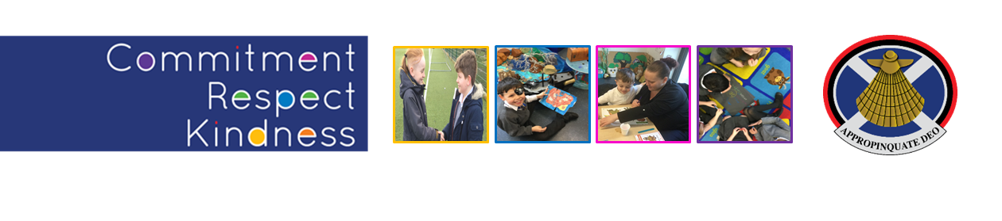



Our Tree is Different, We Grow Stars

Children's wellbeing is at the heart of Getting it Right for Every Child. This means focusing on the wellbeing of every child to ensure they are Safe, Healthy, Achieving, Nurtured, Active, Respected, Responsible and Included.
A positive school ethos and culture is essential to developing good relationships and positive behaviour in the classroom, playground and wider community.
The Scottish Government tell us:
‘A culture where children and young people feel included, respected, safe and secure and where their achievements and contributions are valued and celebrated is essential to the development of good relationships. In order to create this environment for effective learning and teaching there should be a shared understanding of wellbeing underpinned by children’s rights and a focus on positive relationships across the whole school community’.
“Getting the culture right is pivotal. With the right culture the strategies that are used become less important. The culture is set by the way the adults behave,”- Paul Dix, When the Adults Change, Everything Changes: Seismic Shifts in School Behaviour
How do we do this at St James’?
Everything we do at St James’ starts with our Values; they underpin everything we do - our Values are how we behave. When we role model relationships, we do so, using our values and when we help our pupils when they are not getting on or treating each other well, we use our values to explain this.
Our School Values are Kindness, Respect and Commitment
Kindness - We care for each other at St James’. Treating others with kindness helps create a school where children feel happy, valued and safe. We remember that our behaviour impacts on other people, and we should ask ourselves, ‘was my behaviour kind?’. We are honest and we help others wherever we can, in our class, our school, our community and across the world.
Respect - We believe respect is an action and not just a word. We treat each other with consideration, we take turns and listen to each other. When we disagree, we do so in a way that does not harm each other. We recognise the diversity within the school, and we celebrate our differences. We will challenge inequality and unkind behaviour wherever we see or hear it.
Commitment - We are hard-working at St James’. We commit to always giving our best efforts. We know it is not about being the best, it is about working as hard as you can. We are learners, we learn from each other, and we all have something to contribute. We see things through, we will support each other through difficulties and through success. We will nurture resilience in each other.
“But why crush behaviours with punishment when you can grow them with love? Visible consistency with visible kindness allows exceptional behaviour to flourish”- Paul Dix, When the Adults Change, Everything Changes: Seismic Shifts in School Behaviour
Our vision at St James’ is Shaping Futures and Inspiring Limitless Possibilities
Children’s Rights
Our role is to promote and protect children’s Rights. Our children have the right to be safe, to be listened to and have a say in what happens in their life. Positive relationships across the school are supported by attitudes and actions that respect the rights of others. Our staff are trained in understanding children’s Rights, and they are a part of our Values. Every year we raise awareness of the UNCRC through classroom and whole schoolwork.
We link this work to our work on relationships, behaviour, on mental health and wellbeing, and to anti-bullying and equality and diversity.
Participation
As part of our commitment to children’s Rights, we ensure that our pupils have a voice at St James’. They are involved in policy development across the school and help to write relevant polices including Anti-Bullying and Equality and Diversity.
We are committed in the coming year to reviewing and re-establishing a series of pupil forums based on their priorities.
Our Approach to Relationships and Behaviour
At St James’ we believe in taking a blended approach and we do not rely on one single method or model to do this. We have a range of approaches, and we seek to use the most appropriate one for each situation. We put the needs of our pupils first and will always see them as individuals that are part of a family and a community.
The key at St James’ is that all our work and whatever approach we use, is underpinned by our values and that relationships are protective and vitally important for us to succeed as a school.
“Let me suggest five pillars of practice that should underpin every behaviour policy in every school: Consistent, calm, adult behaviour. First attention for best conduct. Relentless routines. Scripting difficult interventions. Restorative follow-ups.”- Paul Dix, When the Adults Change, Everything Changes: Seismic Shifts in School Behaviour
Relationships come first, the building of trusted, predictable and consistent relationships between adults and children is what we aim to do at St James’.
We use a Nurture Approach, a Restorative Approach, A Trauma-Informed Approach, we take a Values-Based Approach to relationships and behaviour at St James’ and these all blend into a broad and child-centred approach that values relationships, respect and learning. We also have an approach we use to deal with bullying, discrimination and prejudice that forms part of what we do at St James’.

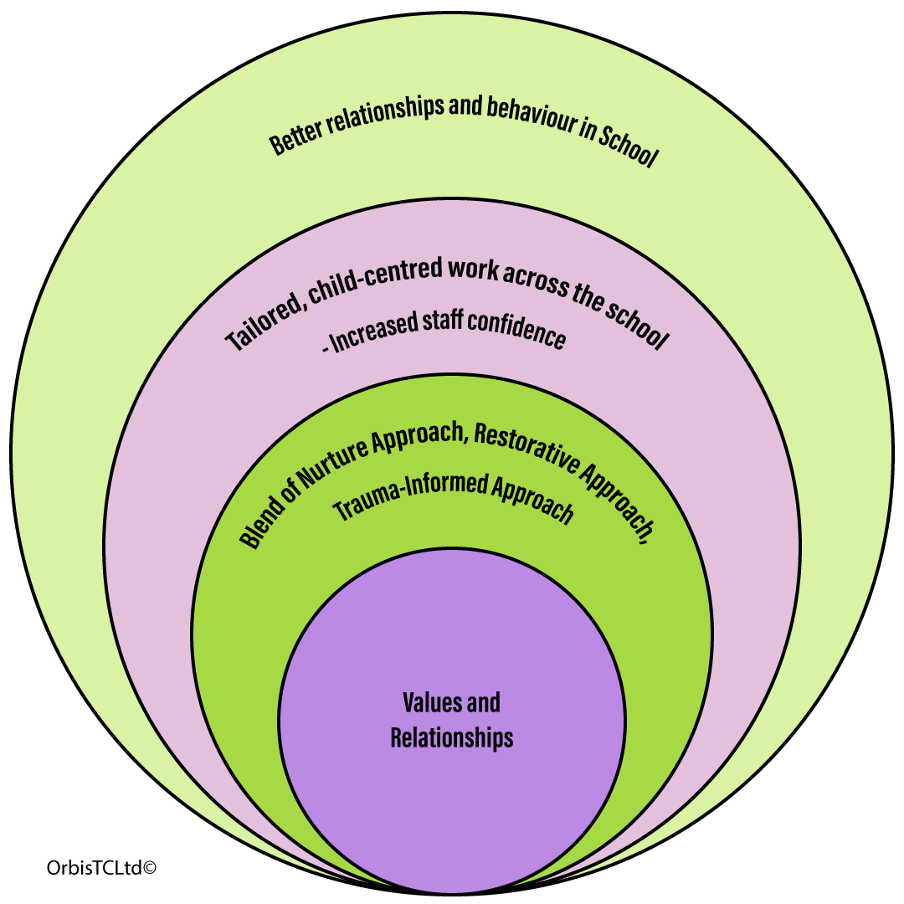

Renfrewshire’s Nurturing Relationships Approach (RNRA)
RNRA increases knowledge of attachment theory and an understanding that early experiences can have a significant impact on development.
• RNRA helps staff to understand the key importance of nurturing relationships to children and young peoples’ mental health and wellbeing, social and emotional development and attainment.
• RNRA supports Staff to put key principles of nurturing practice in place across their establishment.
Renfrewshire aims to ensure that all our schools and nurseries are places in which children feel welcomed, nurtured and secure. We want children and their families to feel that their needs are understood and met in our schools and nurseries. To do this we work to help all staff continually develop nurturing approaches so that they can meet the needs of all children

A key aspect of a nurturing approach is an understanding of attachment theory and how early experiences can have a significant impact on development.
There are 6 Principles to a Nurturing Approach

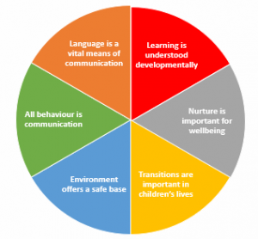

“Behaviour Management is a Team Sport. It needs a team discipline, ethos and look. To get the behaviour you want there can be no gaps between the adults on what matters. It is this consistency that is most important. “- Paul Dix, When the Adults Change, Everything Changes: Seismic Shifts in School Behaviour
NB- See appendix for a copy of the Principles of Attunement Poster which is displayed in all classrooms and a copy of examples of Scripts which staff can use to facilitate restorative conversations
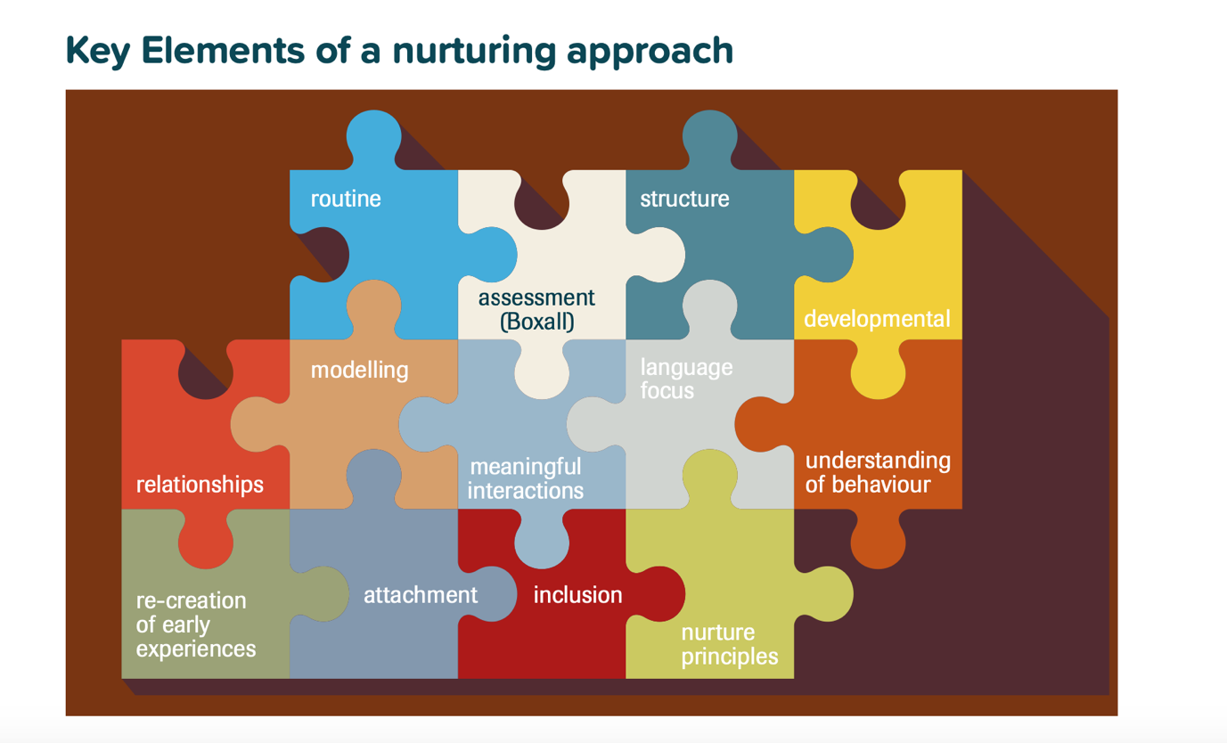

Restorative Approach
Restorative approaches can change the emotional atmosphere in a school and lead to more positive relationships between pupils and between pupils and staff. They are defined as restoring good relationships when there has been conflict or harm and developing school ethos, policies and procedures to reduce the possibility of such conflict and harm arising.
The focus on repairing relationships reflects the values of St James’, it does not mean actions are consequence free, but we seek to model and teach children the skills to manage relationships.
A restorative approach may include having a ‘restorative conversation’. These conversations may happen during the school day and practitioners will use restorative language and questions to allow children and young people to understand the impact of their behaviours. All school staff refer to a ‘Restorative Practice card’ which are worn on their lanyards.
More serious incidents may require practitioners to hold a formal meeting and involve parents or families where appropriate. Examples of questions used in a formal meeting include:
- What happened?
- What were your thoughts at the time?
- What have been your thoughts since?
- Who has been affected by what happened?
- How have they been affected?
- What do you need to happen now?

Restorative practices work well as part of a blended approach and should be used appropriately. There may be occasions where, for example some bullying, or prejudice-based behaviour should not see the children involved sit together to discuss what happened. We will be mindful of the dynamics of situations and balance the risk where someone may be fearful, worried or anxious about the impact of a face-to-face discussion.
“If we don’t address the language we use by default, then we risk the greatest inconsistency of all; managing poor behaviour with improvised responses.” – Paul Dix, When the Adults Change, Everything Changes: Seismic Shifts in School Behaviour
Trauma-Informed Approach
The impact of trauma, stress, attachment and Adverse Childhood Experiences is being increasingly better understood and assimilated into approaches to managing behaviour.
Experiences such as neglect, abuse, poverty, loss and violence can result in children developing coping strategies to manage the difficult feelings this can lead to. These coping strategies can be challenging, difficult to manage, harmful to themselves and others as well as distressing to deal with.
Our aim when dealing with this distressing behaviour is to help children and young people to learn new ways to respond to difficult feelings, to help learn new coping mechanisms for their difficult feelings.
“Adults who manage the behaviour of angry children brilliantly understand that the first principle is to manage their own response so it is predictable, consistent and empathetic.”- Paul Dix, When the Adults Change, Everything Changes: Seismic Shifts in School Behaviour

Our approach to dealing with challenging and distressing behaviour is based on us reframing our understanding of behaviour. We see behaviour as an indicator of stress. We recognise that when behaviour is escalating and a child is becoming distressed and anxious, their stress levels are increasing. Our approach is to reduce their stress levels and then we can deal effectively with behaviour.
This illustration indicates the increase in stress levels and the impact it can have on behaviour and helps us focus our interventions appropriately.
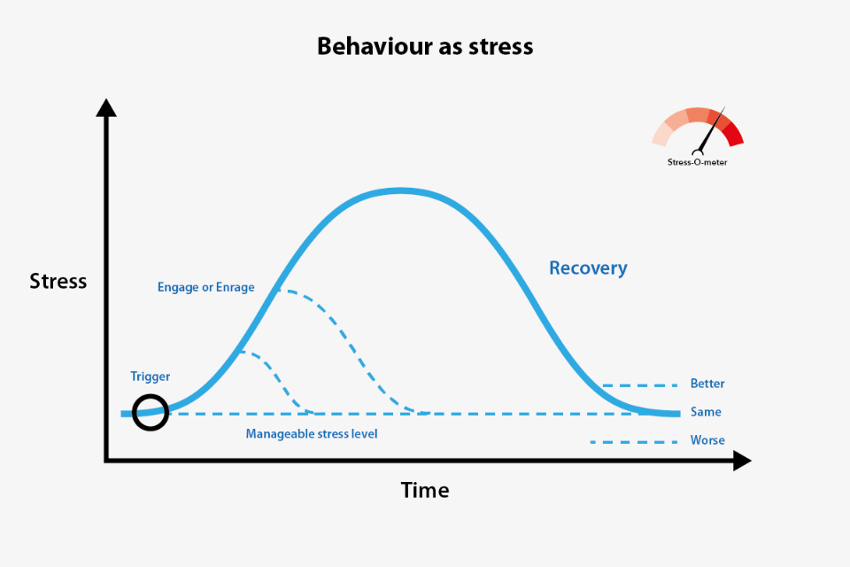
Some of the children and young people who come to our school will have experienced or are still experiencing traumatic events. Children that have had Adverse Childhood Experiences, children who have suffered violence, neglect, loss, abuse and have attachment issues will have developed ways to respond to the feelings these traumas cause, and these can persist and affect them even after these events have happened.
These experiences can lead to children being hypersensitive and reactive. They may struggle in groups or changes in routine. Changes can trigger an increase in stress levels.
Some of this trauma will impact on a child for a very long time and our focus needs to be on helping them learn ways to cope with these traumas.
When we focus on reducing stress, we are teaching new coping mechanisms for difficult feelings. We still deal with their behaviour and the impact it has had; we reduce stress levels first then deal with that.
Responding to distressing behaviour
Children and young people will operate with a manageable level of stress, where they can cope with the routine and with others. For stress levels to increase, something will ‘trigger’ this. A change in routine, being told ‘no’, a threat, a mistake. These triggers will lead to a feeling and in response to this feeling, stress levels begin to increase.
There will be some signs that suggest stress is increasing, there will be physical changes, face colour, clenched fists and teeth, agitation, breathing changes and so on.
When something has triggered an increase in stress and a child’s behaviour begins to show signs of changing, or escalating, we can do one of two things, we can engage with this person, or we can enrage them.
PATHS- Staff in St James’ have been trained in using The PATHS programme for schools (UK Version) on a regular basis within their classroom. This programme empowers all children to develop the fundamental social and emotional learning skills which will enable them to make positive choices throughout life. This programme is designed to facilitate the development of self-control, emotional awareness and interpersonal problem-solving skills.
Natural Consequences
We have an approach at St James’ that seeks to teach our children about natural consequences. Our aim is to link behaviour to actions. This does not mean behaviour is consequence free, some consequences can be very serious.
The goal is to help pupils learn that their behaviour has an impact on themselves, others, and their environments
This can range from if we break something, we do not have it to use, if we make a mess, we can help clean it, if we hurt someone’s feeling, we make amends. If someone is aggressive or hurts someone outside, they may have to come inside as a result.
This approach helps children understand the impact of kindness on others.
“Children, like adults, want to feel important, valued and like they belong. They crave it. If that appreciation is not given for positive behaviour than you invite it to be elicited through poor behaviour.” – Paul Dix, When the Adults Change, Everything Changes: Seismic Shifts in School Behaviour

Mobile Phones and Digital Devices
At St James’ Primary, we are committed to ensuring a safe, respectful and focused learning environment. In line with our school values of Kindness, Respect, and Commitment, we have clear expectations around mobile phone and digital device use.
- Pupils should not use mobile phones or digital devices during the school day unless specifically agreed with a member of staff for learning or health-related reasons.
- If a child brings a mobile phone to school, it should be switched off and kept in their school bag during school hours.
- Any misuse of devices (including filming, photographing or messaging during the school day) will be addressed in line with our relationships and behaviour approaches.
- Repeated issues or serious misuse will involve contact with parents/carers and may result in a child being asked not to bring a device to school.
This approach supports our work on creating respectful, inclusive learning spaces where everyone feels safe, valued and able to focus on their learning.

Review
This policy will be reviewed in 2026

