Renfrewshire Council Children’s Services

St James’ Primary School, Renfrew

Improvement Plan
2023-2024

Planning framework

As part of Children’s Services, St James’ Primary school has developed this establishment improvement plan which provides a framework for how we intend to achieve Children’s Services’ vision of working together to get it right for children, families and communities – Protecting, learning, achieving and nurturing.

National Priorities
We must also take account of the Scottish Government’s national improvement framework which provides a vision for education in Scotland, namely to:

- place the human rights and needs of every child and young person at the centre of education;
- improve attainment, particularly in literacy and numeracy;
- close the attainment gap between the most and least disadvantaged pupils;
- improve children’s health and wellbeing; and
- improve children and young people’s employability skills so that they move into positive and sustained destinations.

Renfrewshire’s Education Priorities
Our priorities will also align with the Renfrewshire Council Plan and Education Improvement Priorities listed on the next page.

Pupil Equity Funding
Our school received Pupil Equity Funding (PEF) to provide targeted interventions in literacy, numeracy and health and wellbeing to close the poverty related attainment gap. This funding enables us to plan additional interventions to those which were already planned. These interventions are highlighted throughout this improvement plan using the (PEF) abbreviation.

The priorities and actions within this improvement plan address the needs of our school and articulate with local and national priorities.

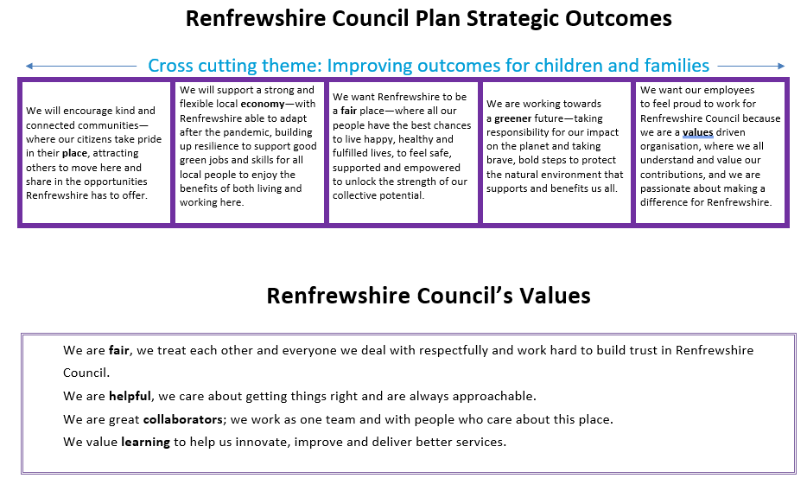

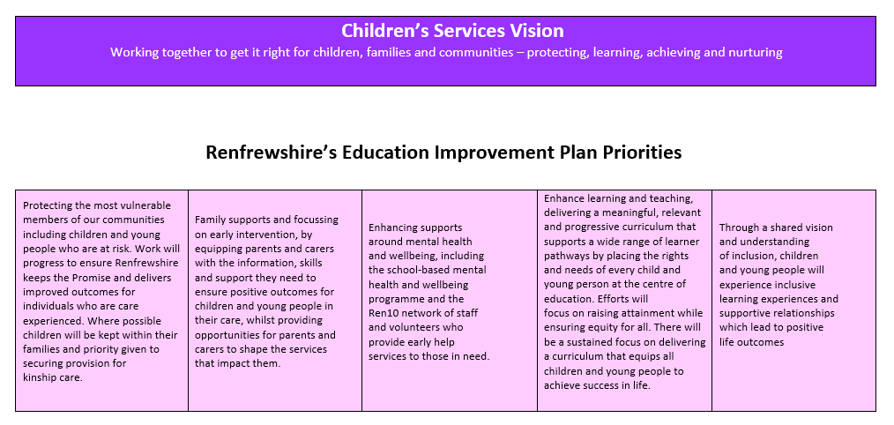

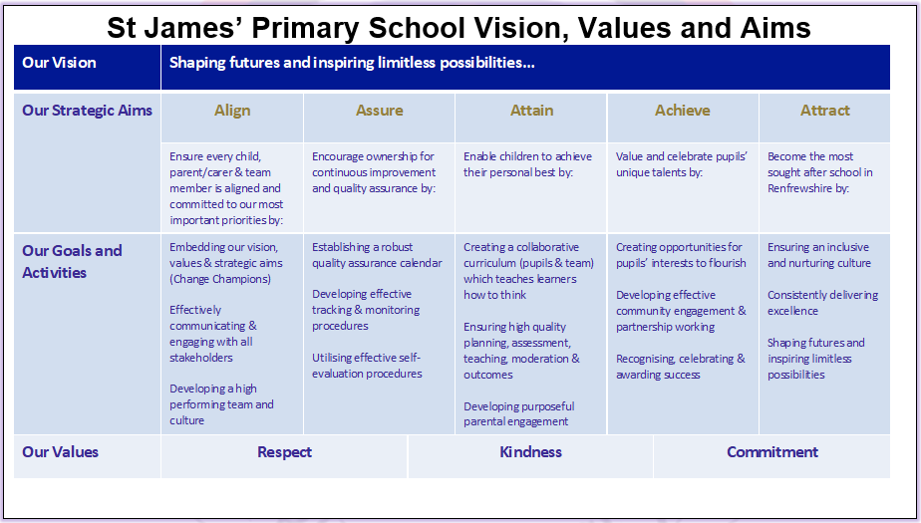

Who did we consult?
To identify our priorities for improvement, we sought the views of our pupils, parents and carers, our team and our key partners. We used a variety of methods of getting the views of those who are involved in the life and work of St James’ Primary School such as Google Classrooms, TEAMs discussions and Microsoft Forms. All information gathered is collated and used to assist us to identify next steps and areas for improvement.

Who are our Partners?
- Our Families and Parent Council
- Our Parish Priest Father John Eagers and our Diocesan Community
- Our Cluster Family: Moorpark Pre 5 Centre, St Anne’s, St Catherine’s and St John Bosco Primaries and Trinity High School
- Our Neighbourhood Community: Glendee Pre 5 Centre, Kirklandneuk, Newmains, Arkleston Primaries and Renfrew High School

We have also consulted with our partners across and out with the Council to assist us in the delivery of our priorities.
- Education Scotland Attainment Advisor for Renfrewshire Council provides advice and guidance around raising attainment
- Our Health and Wellbeing Officer, Art Therapist and Orbis Relationships and Behaviour all appointed through PEF who provide us with bespoke support and guidance to help us to create an environment where children and families can thrive
- OneRen our local charitable trust in Renfrewshire providing culture, leisure and sporting opportunities to help our children and families enjoy active and healthy lives
- Community Learning and Development working together to ensure our community, people and families have the capacity, support, resilience and opportunities they need to thrive

How we will know if we are achieving our aims?
We will measure and evaluate the progress we are making to achieve the key outcomes set out in this plan. We do this using quality assurance activities that include Teacher judgement, assessment and moderation, learning rounds, professional dialogue, tracking and monitoring of wellbeing, attainment and achievement.

Each year we also complete a standards and quality report and self-evaluation document which are monitored by Renfrewshire Council Children’s Services’ staff.

St James’ Primary School Renfrew
School Improvement Priorities 2022-2025
 | 2022-2023 | 2023-2024 | 2024-2025
1 | - All staff working collaboratively to enhance the learning and teaching of Writing (fiction) leading to high quality experiences for our learners | - Enhance teaching and learning in non-fiction writing  - Improving engagement and attainment in writing | - Average of 85% of learners across each stage achieving the expected level at the appropriate time alongside closing the attainment gap in writing  - 1+2 Languages – Building capacity in staff to lead the learning of languages and work collaboratively with Modern Languages department to ensure an effective pathway and transition for our learners from P1 – S1  - Learner Participation
2 | - To improve outcomes for learners through effective teaching and learning of Mental Maths | - Raise attainment in Numeracy with a priority focus on high quality learning, teaching and assessment through collaboration and further development of a Growth Mindset | - Impact of Cluster Numeracy Recovery approach attainment increase by 5-10% in numeracy
3 | - Celebrating and Worshipping | - Improve outcomes in Health and Wellbeing with a focus on developing knowledge, skills and understanding to positively impact the whole school community and many aspects of life, such as behaviour, relationships, faith, attendance and attainment | - Curriculum Rationale  - Learning for Sustainability  - Place2B  - Rights Respecting Award  - Digital Wellbeing Award
4 | - To develop our learning spaces and our active pedagogies across the school | - GIRFEC Processes (through Target 1-3)  - RNRA/RICE/CIRCLE/NVR (through Target 1-3) | - Assessment, Achievement, Profiling & reporting

Improvement Priority 1 – ATTAIN – Ensuring high quality planning, assessment, teaching, moderation and outcomes
LITERACY - Enhance teaching and learning in non-fiction writing
NIF Priorities  - Placing the human rights and needs of every child and young person at the centre of education  - Improvement in attainment, particularly in literacy and numeracy  - Closing the attainment gap between the most and least disadvantaged children  - Improvement in children's and young people’s health and wellbeing  - Improvement in employability skills and sustained, positive school leaver destinations for all young people |  |  | NIF Drivers  - School Leadership  - Assessment of Children’s Progress  - Teacher Professionalism  - School Improvement  - Parental Engagement  - Performance Information | 5 A’s  - Align  - Assure  - Attain  - Achieve  - Attract
HGIOS QIs | How good is our leadership and approach to improvement? | 1.2.2 Leadership of learning - Impact of career-long professional learning  1.3.2 Leadership of change - Developing a shared vision, values and aims relevant to the school and its community
 | How good is the quality of care and education we offer? | 2.3.2 Learning, teaching and assessment – Quality of teaching
 | How good are we at improving outcomes for all of our learners? | 3.2.1 Raising attainment - Attainment in literacy Writing

Tracking progress of plan:
Term 1 – Blue Term 2 – Green Term 3 – Red Actions completed - Purple
 | Rationale for change | Outcome and Expected Impact | Actions/Interventions | Measures | Resources | Lead(s) | Monitoring/ Evaluation
A | Enhancing Teaching and Learning  In Aug 2020, Education Scotland confirmed our results from our self-evaluation - the need to develop both a progressive pathway and consistent approach to writing across the school. | Enhancing Teaching and Learning  Almost all teachers are more confident and skilled in the learning and teaching of non-fiction writing by June 2024.  Almost all support staff are more confident and skilled in providing in-class support to identified groups of pupils by June 2024. | Enhancing Teaching and Learning  Non-fiction Talk for Writing CLPL for teaching and support staff.  Creation of an operational plan, by October ’23, for implementation of the Talk for Writing approach (fiction and nonfiction) to include key features e.g.: -  - create/maintain a whole school reading spine. create/maintain a whole school. overview with resource linked units.  - adapt templates for unit planning to align with existing planning approaches.  - establish teaching non-negotiables and ensure consistent implementation across the school.  - establish/maintain effective procedures for quality assurance of the approach.  By January ’23, all teaching staff will be introduced to Talk for Writing’s ‘Planning. Assessment and Progression’ overviews and will use these to plan learner experiences and inform professional judgements on pupil progress.  Through collegiate sessions and Literacy Group Meetings, there will be a re-evaluation of our school’s ‘Literacy Position Statement’.  Through collegiate sessions, there will be opportunities for whole-school (stage/level/cross-level) moderation and local cluster moderation opportunities.  Use staff ‘Writing Ambassadors’ and Literacy Champions from each stage/year group to lead, share successful practice and team teach. | Staff pre/post survey – confidence in applying the TfW process (learning, teaching and assessment)  Moderation of pupil work across stages | Talk for Writing (non-fiction) CLPL for staff and CLPL sessions for support staff.  3 x Collegiate Sessions for teaching staff | DHT / Literacy Champions/ Literacy Group/ Project Leaders
 | Improving Attainment in Writing  Attainment over time (2018-22) shows that a few (currently average of 19% across P1, P4 and P7) of learners are not achieving the expected level in writing year on year.  Current CfE data shows a consistent level of achievement in writing achievement (same cohort) from the previous year across all stages, however, there have been no increases in attainment in each stage.  Although there was a decrease of 3% in the average attainment gap in writing, There was approx. 8% attainment gap in our 2022-23 data for our current P2-6 learners in writing. | Improving Attainment in Writing  By June 2025, writing attainment across all stages will be in line or above Quartile 3 and community schools.  Decrease the average attainment gap in writing by 3% in our 2023-24 data for writing by June 2024.  All ‘at risk’ pupils identified at Term 1 STAC meetings will remain ‘on track’ in writing by June 2024. | Improving Attainment in Writing  Raising Attainment Group plan for raising attainment in writing for targeted pupils using Project Leaders and Classroom Assistants to provide additional support for targeted pupils both within the school day.  Raising Attainment group supporting teachers in the writing of high-quality Staged Intervention Plan SMART targets or 3-Domain for pupils who are disengaged/ off-track in writing.  ’  Using research informed practice and Renfrewshire’s Inclusive Communication Environments (RICE), Child Inclusion Research Into Curriculum Learning Education (CIRCLE) and Nonviolence Resistance (NVR) to develop learning environments/spaces and approaches which will promote meaningful interactions and communication.  Using research informed practice to develop literacy-rich learning environments/ spaces/play pedagogy which will increase engagement. | Surveys on staff confidence in the writing of Stage Intervention Targets for pupils who are off track in writing pre/post Raising Attainment Group intervention  Termly STAC (School Team Around the Child) meetings to monitor and track writing attainment  Standardised assessment SNSA (Standardised National Assessment) (at P4 and P7) and GL Assessment (P2-7)  Learning Conversations and Pre-post Writer Engagement Surveys | Classroom Assistants to deliver targeted interventions in class  Project Leaders to deliver targeted interventions in class  Digital packages for independent learning – Education City (£812)  Widget used for visual displays | DHT / Literacy Champions/ Literacy Group  Project Leaders  Educational Psychology team

Improvement Priority 2 – ATTAIN – Ensuring high quality planning, assessment, teaching, moderation and outcomes

MATHS - Raise attainment in Numeracy with a priority focus on high quality learning, teaching and assessment through collaboration and further development of a Growth Mindset

NIF Priorities  - Placing the human rights and needs of every child and young person at the centre of education  - Improvement in attainment, particularly in literacy and numeracy  - Closing the attainment gap between the most and least disadvantaged children  - Improvement in children's and young people’s health and wellbeing  - Improvement in employability skills and sustained, positive school leaver destinations for all young people |  |  | NIF Drivers  - School Leadership  - Assessment of Children’s Progress  - Teacher Professionalism  - School Improvement  - Parental Engagement  - Performance Information | 5 A’s  - Align  - Assure  - Attain  - Achieve  - Attract
HGIOS QIs | How good is our leadership and approach to improvement? | 1.3.3 Implementing improvement and change
 | How good is the quality of care and education we offer? | 2.2.2 Development of the curriculum  2.3.1 Learning and engagement  2.3.2 Quality of teaching  2.3.3 Effective use of assessment  2.3.4 Planning, tracking and monitoring  2.5.1 Engaging families in learning  2.6.3 Continuity and progression in learning
 | How good are we at improving outcomes for all of our learners? | 3.2.1 Raising attainment - Attainment in numeracy

Tracking progress of plan:
Term 1 – Blue Term 2 – Green Term 3 – Red Actions completed - Purple
 | Rationale for change | Outcome and Expected Impact | Actions/Interventions | Measures | Resources | Lead(s) | Monitoring/ Evaluation
A | Mindset  McKinsey report 2016 states that-  “Student mindsets, such as motivation and self-belief, have greater impact on student performance  than any other factor—and double the effect of socioeconomic background.”  Improving attitudes towards numeracy and mathematics remains a key St James’ priority by encouraging children to think critically and flexibly as well as apply a growth mindset to mathematical problems.  Attainment remains consistently high in Maths however this contradicts some pupils' mindset of their ability in maths.  From a recent survey 25% of children across the school state they do not like or are unsure of Maths. 32% of children worry when they do not know how to calculate an answer.  Education Scotland feedback 2020 stated that Children need to consolidate and apply a wider range of numeracy and mathematical skills regularly across learning including information handling skills and shape, position and movement. ‘The recognition that using real-world numeracy and mathematics contexts can have a huge impact on learners’ motivation.’ Multiplying skills and adding Value – Education Scotland.  92% of teachers rate Maths Journals, on a scale of 1 to 10, as 7 or above, as a useful tool in supporting teaching and learning. 70% of teachers feel this could be developed with further training.  Maths Recovery  Maths Recovery is based on The Framework in Number programme developed by Robert J. Wright. It provides teachers and/or support staff with the necessary tools to implement effective interventions using research-based strategies and activities.  The approach aims to expand children's number knowledge and address learning gaps, enhancing their mathematical skills, confidence, and overall knowledge. It involves assessing students' current understanding and strategies, emphasising ongoing assessment.  In June 2023, 11% of children in P3, 12% of children in P4 and 10% of children in P5 would benefit from Maths recovery targeted interventions. (At each stage 6% of these children are in SIMD 1-3). | Mindset  By December 2023 all teachers will continue to develop confidence in using journals as a learning tool.  By June 2024 100% of targeted children will have demonstrated increased engagement, enjoyment and attitudes to Maths.  By June 2024 all teachers have increased pupil engagement with open-ended tasks.  By June 2024 30% of Parents/carers will have participated in a Maths Family Learning opportunity.  Maths Recovery  100% increase of maths and numeracy attainment across Primary 4, Primary 5 and Primary 6 of targeted children.  Evidence of narrowing the poverty-related attainment gap in P3, P4 and P5 ( by targeting 6% of children from SIMD 1-3).  By May almost all evaluations from teachers and support staff demonstrate an improvement in their pedagogical knowledge and understanding of the Framework in Number.  By April all teachers and some support staff have developed their understanding of the diagnostic and formative assessments to identify the exact level of the conceptual understanding of their learners.  This understanding enables all teacher(s) to feel greater confidence in planning bespoke interventions to close identified gaps in numeracy.  It will enable some support staff to have greater confidence in supporting interventions. | Mindset  To form a working party to further develop a progressive and consistent framework for journals.  Embedding the use of Maths Journals as a progressive tool to describe, evaluate, create and investigate learning.  Engaging Parent/Carer’s through workshops (Maths FEST).  Full transition to the new Renfrewshire Maths Progression on-line Planners will be evident at all stages. To ensure a structured, progressive and consistent approach.  Increased planning using open ended planning.  Planning for opportunities to teach and/or consolidate maths and numeracy in other curricular areas and/or contexts.  Maths Recovery  All teaching staff and some support staff will participate in training to develop an understanding of the pedagogy ensuring a consistent approach and empowering staff to support identified learners.  DHT working with cluster to consistency of pedagogy (Maths Recovery).  Raising Attainment group (PEF) to work with targeted children on gaps identified by Maths Recovery Assessments.  PEF funded Support staff to work with identified children to raise attainment (SIMD 1-3).  All teaching Staff will use the New Renfrewshire Maths Assessments to measure progress and plan next steps. | Mindset  Teacher Pre/Post survey on knowledge of using journals progressively throughout the school.  Pre/Post on targeted children’s self-perception as mathematicians.  3 Domain Model  Parental Feedback on family learning opportunities.  Moderation of Journals showing consistency and progression.  Learning conversation/pupil form to measure engagement, enjoyment,opportunities for support, challenge and struggle.  STAC meeting discussion on Assessments.  Feedback Form from family engagement.  Maths Recovery  Maths Recovery Assessment scores – pre and post intervention will show children’s progression within the framework for number.  Pre/post teacher judgement data.  Pre/post pupil learning conversations - individual target setting.  STAC meetings to inform progress of the intervention.  Standardised assessment data including SNSA at P4 and P7.  Google form/professional dialogue/collegiate reviews to  measure staff confidence in their pedagogical knowledge and understanding of the Framework in Number.  Google form/professional dialogue/collegiate reviews to  measure staff confidence in using the related diagnostic.  assessments to identify gaps and plan appropriate intervention.  Google form/professional dialogue at STAC’s / to measure support staff  confidence in supporting children through the intervention. | Mindset  Learning Journals.  Renfrewshire Maths Planners and Assessment Planners.  Maths Recovery  Maths Recovery Resources.  PEF funded targeted support. | Mindset  Maths  Group.  Numeracy Development Officer.
B | Mental Maths  A program for mental maths has been implemented across all stages. This has had a positive impact in all stages. (P7 82%, P6 90%, P5 87%, P4 97%, P3 91% of children improved on their baseline scores.)  From teacher feedback the programme needs to be adapted for Primary 1 and 2 enabling progress and data to be collected. | Mental Maths  By January 2024 an appropriate programme of mental maths will be implemented for P1 and P2.  By June 2024 100% of children will have increased baseline scores.  By June 2024 all teachers are using new Maths assessments for end of topic and level.  By May 2024 P1,P4 and P7 will have used end of level maths assessments.  By May 2024 end of level maths assessments will be used in STAC meetings. | Mental Maths  Working party will create a mental maths programme suitable for P1 and P2.  This programme will allow data to be collected to evidence progress.  All teachers will show daily mental maths inputs in their timetables.  Numeracy coaching officers will provide CPL on New Renfrewshire Numeracy Assessments. | Mental Maths  Pre/Post Mental Maths Baseline.  Teacher judgement.  Moderation of Assessments. | Mental Maths | DHT.  Numeracy.  Working Party.

Improvement Priority 3 – ATTRACT - Ensuring an inclusive and nurturing culture
H&WB / RE - Improve outcomes in Health and Wellbeing with a focus on developing knowledge, skills and understanding, to positively impact the whole school community in many aspects of life, such as behaviour, relationships, faith, attendance and attainment

NIF Priorities  - Placing the human rights and needs of every child and young person at the centre of education  - Improvement in attainment, particularly in literacy and numeracy  - Closing the attainment gap between the most and least disadvantaged children  - Improvement in children's and young people’s health and wellbeing  - Improvement in employability skills and sustained, positive school leaver destinations for all young people |  |  | NIF Drivers  - School Leadership  - Assessment of Children’s Progress  - Teacher Professionalism  - School Improvement  - Parental Engagement  - Performance Information | 5 A’s  - Align  - Assure  - Attain  - Achieve  - Attract
HGIOS QIs | How good is our leadership and approach to improvement? | 1.1.2 Analysis and evaluation of intelligence and data  1.1.3 Ensuring impact on learners’ successes and achievements
 | How good is the quality of care and education we offer? | 2.2.3 Learning Pathways  2.4.2 Targeted support  2.5.1 Engaging families in learning  2.7.3 Impact on learners
 | How good are we at improving outcomes for all of our learners? | 3.2.1 Wellbeing  3.1.3 Inclusion and equality  3.2.3 Overall quality of learners’ achievement  3.2.4 Equity for all learners
DiF | Developing as a community of faith and Learning | 4.3.1 Formation- All those in positions of responsibility within the local catholic community will receive training and ongoing support and formation for the roles they perform

Tracking progress of plan:
Term 1 – Blue Term 2 – Green Term 3 – Red Actions completed - Purple
 | Rationale for change | Outcome and Expected Impact | Actions/Interventions | Measures | Resources |  | Lead(s) |  | Monitoring/ Evaluation
A | RNRA  Our school will adopt Renfrewshire’s Nurturing Relationships Approach in order to become a more inclusive communication environment. We will adapt our physical environment appropriately to become language and communication friendly for all pupils. | RNRA  By June 2024 almost all teaching and support staff will be more confident and skilled in supporting and modelling the implementation of Renfrewshire’s Inclusive Communication Environments (RICE) and will have a more consistent approach to using (RICE). | RNRA  All staff will undertake training in Renfrewshire’s Inclusive Communication Environments (RICE). | RNRA  Staff Pre and post training surveys- focussing on confidence and skill in applying the RICE approaches. | RNRA  Two Coaches-Educational Psychologist and Speech and Language Therapist) will deliver initial and ongoing training to all staff.  Coaches will work directly with staff to support and implement approaches or provide additional information/training if required. |  | RNRA  DHT (EB)  Lead Implementation Team consisting of teaching and support staff (EB/SM/LF/CR)- engage with Coaching team during their visits and support the ongoing implementation of RICE across the school. Regularly feedback information to the rest of the staff team.
B | Implement RICE  Our school will introduce Widgit to create visual, communication and learning supports across the school to ensure consistency for all pupils. | Implement RICE  By June 2024- consistent visual, communication and learning supports will be visible in every class/base/wall display across the school. | Implement RICE  All staff will undertake training in using Widgit to improve our visual, communication and learning supports across the school. | Implement RICE  There will be visible evidence of Widgit being used throughout the school. | Implement RICE  School to purchase Widgit licence  APT (SM) to deliver Widgit training to staff (August IS day). |  | Implement RICE  APT (SM)  RICE Lead Implementation Team (EB/SM/LF/CR)
C | Implement RICE  Our school will facilitate wider engagement with pupils and parent/carers to ensure that Renfrewshire’s Inclusive Communication Environments (RICE) is shared with our pupils and parent/carers. | Implement RICE  By June 2024 a RICE pupil group will have informed all pupils about RICE (assemblies).  By June 2024 RICE pupil group will have informed parent/carers of RICE initiative through school Website/School Newsletter/ Parent leaflet/ Seesaw. | Implement RICE  RICE pupil group will provide regular feedback information to other pupils (assemblies) and parent/carers (School Website/ School Newsletter/ Parent leaflet/Seesaw). | Implement RICE  Pupil/ParentMicrosoft form issued to generate feedback on RICE. | Implement RICE  Lead Implementation Team to establish a RICE pupil group. |  | Implement RICE  Lead Implementation Team EB/SM/LF/CR
D | Developing in Faith  As a result of the Covid pandemic, many of our pupils and their families have not returned to Sunday Mass in our two affiliated parish churches. Our school will find ways to encourage children and their families to celebrate Mass together in our affiliated parish churches and strengthen our home-school-parish links to deliver positive outcomes for pupils. | Developing in Faith  By June 2024, almost all pupils and a significant number of family members will have had the opportunity to join together in the parish masses at St James and St Columba's parish churches. | Developing in Faith  Regular visits to parish churches by stages/classes/groups of pupils throughout the year.  Pupils will be consulted on ways to encourage family members to join with them at parish masses (use of Invitations/School Newsletter/Seesaw/Twitter etc). | Developing in Faith  After each parish mass, event organised by school- seek feedback from family members via Microsoft forms. | Developing in Faith  Parent Helpers from each stage of the school.  Parishioners from the parish churches of St James and St Columba’s.  Refer to Diocesan Toolkit ‘Partnership with Parents: From Ideal to action’ and ‘A Community of Faith: Centred on Christ.  Refer to’Diocesan document ‘Chaplaincy in Catholic schools: A School-Parish partnership. |  | Developing in Faith  DHT (EB)  School Chaplain (FJE)  Chap;aincy/ Laudato Si Committee
 | Planning for Staged Intervention  Our school has a strong and positive vision for inclusion in Renfrewshire. We will introduce Renfrewshires’s Staged Intervention Framework to school staff ( Single and Multi Agency Planning Framework) to ensure staff have a shared vision and understanding of inclusion to ensure children experience inclusive learning experiences and supportive relationships which lead to positive outcomes. | Planning for Staged Intervention  By June 2024, staff will be confident in using the stages of intervention within the framework.  Staff will understand the policy and procedures in relation to our school.  By June 2024, Staff will have a greater understanding of “The Promise” and supporting our care experienced children, promoting and protecting their rights and involving them in decision making.  By June 2024, Staff will bring together and share good inclusive practice, focusing on approaches to improve the engagement and achievement of all learners, including those who require additional support. | Planning for Staged Intervention  Teaching staff will undertake training in Renfrewshire’s staged intervention programme, including The National GIRFEC approach, Renfrewshire Inclusion Service Priority, Supporting Children’s Learning Code of Practice and The Stages of Intervention.  Teaching Staff will undertake CLPL from Link Educational Psychologist on Staged Intervention Planning.  All staff will undertake training from Who Cares? Scotland on ways to support our care experienced children and deliver improved outcomes for our children who are care experienced.  School will identify a “Promise Keeper.”  All staff will undertake training in The Circle Framework, in order to be equipped with practical strategies to support the underlying skills that pupils require to enable them to participate in school. | Planning for Staged Intervention  Pre and post training surveys: The Promise/The Circle Framework. | Planning for Staged Intervention  Renfrewshire’s Staged Intervention Framework.  Who Cares? Scotland resources.  “The Promise” Scotland resources.  VR Headsets.  The Circle Framework resources. |  | Planning for Staged Intervention  Senior Leadership Team (HT/DHTs)  EP (Charlotte Murray)  Who Cares? Scotland staff (Lynsey Emmery)  “The Promise” keeper- APT (SM)  The Circle Framework ( Ger McGauley)
 | Improving pupil Health and Wellbeing  As a result of the impact of the Pandemic, we will focus on improving the physical and mental well being of our pupils by getting “more children, more active, more often.” | Improving Pupil Health and Wellbeing  By June 2024, most pupils will participate in regular sports and physical activity throughout the school day/at after school clubs and school competitions.  Targeted pupils will participate in a “before school/ lunchtime or after school club.”  Targeted pupils will take part in weekly Art Therapy sessions in order to build greater self esteem/self awareness/ resilience and improved social skills. | Improving Pupil Health and Wellbeing  Active Schools will offer pupils the opportunities and motivation to adopt active, healthy lifestyles at various after school clubs/ school competitions/Activity days/ Health Week activities.  Active Schools will provide targeted support for individual/small groups of children.  Art Therapist will provide weekly targeted support for individual/small groups of children with a focus on supporting pupils’ emotional wellbeing. | Improving Pupil Health and Wellbeing  Health and Wellbeing Officer will monitor and evaluate pupil engagement in clubs and competitions.NB- In August 2023, our Health and Wellbeing Officer secured a promotion elsewhere in the council and has left us. Due to this change, we will revisit areas where we had planned her support and update and adapt in light of this change  Weekly assemblies and termly STAC meetings will have a focus on pupil participation in clubs/wider achievements.  Seek feedback from Parent and Pupils on impact of weekly Art therapy sessions. | Improving Pupil Health and Wellbeing  Appointment of a Health and Wellbeing Officer for universal and targeted support (see PEF plan).  Indoor space including gym hall/fitness suite/PE equipment.  Outdoor space including playground/pitch.  Art Therapist (MR).  Music room. |  | Improving Pupil Health and Wellbeing  DHT (EB) with responsibility for Health and Wellbeing  Health and Wellbeing Officer (ED)  Health and Wellbeing Champ for school (SM)  Art therapist (MR)

