How to Complete Tasks Within Google Classroom.

Your child can access all relevant programmes through the ‘My Launch Pad’ facility which should already be saved.

Office 365 Home – Suite

Mail

People

Google Classroom

Once your child has logon on to Glow, ensure ‘Launch Pad’ is selected and then the top option chosen to open your child’s own launch pad.

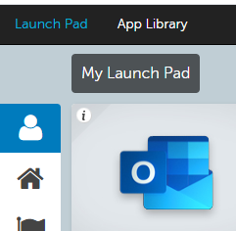

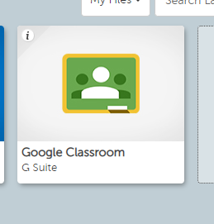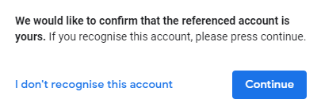

Click ‘Continue’ to enter.

Enter Google Classroom through this tile.

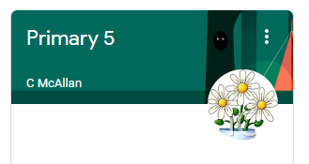

Clicking on the class name will allow you access to your child’s classroom.

If viewing through ‘Stream’, your child should see work the teacher has assigned.

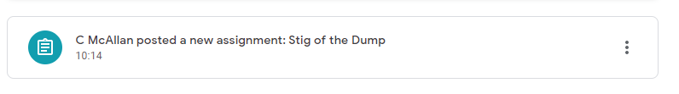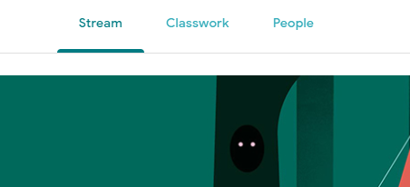

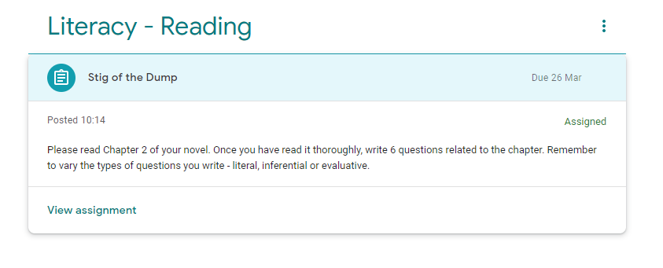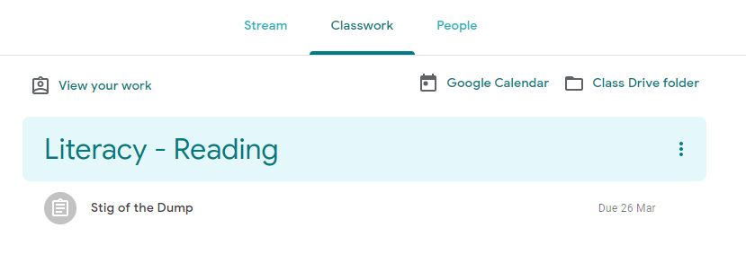

If viewing through ‘Classwork’, your child will be able to access the work the teacher has assigned.

Clicking on this icon and it will open up the information to the work.

‘View assignment’ allows you to see the image as seen below.

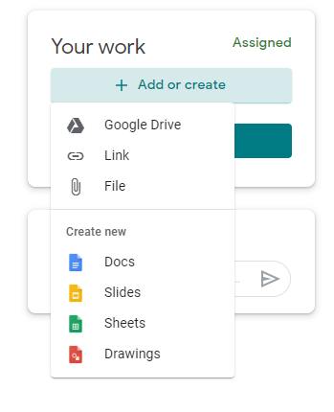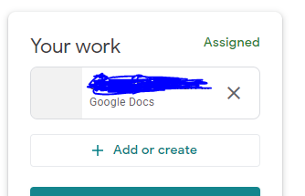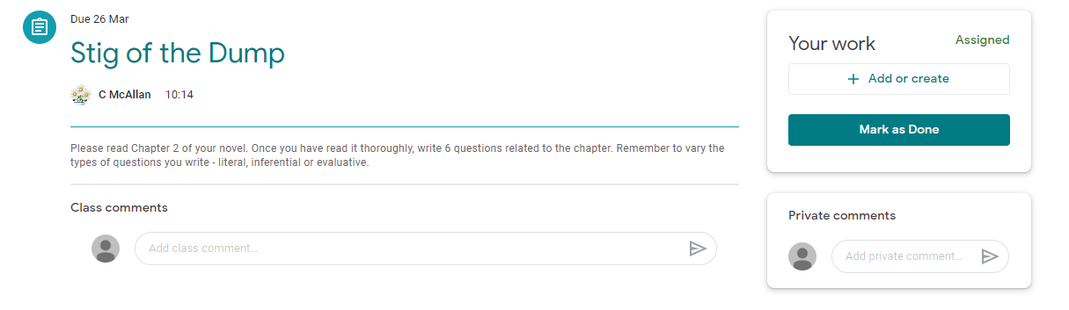

Your child can work on their task(s) by clicking on ‘+ Add or create’ and then selecting ‘Docs’. This will create a file, click to open a word document.

The document can be closed at any time because as your child enters items, it saves it automatically.

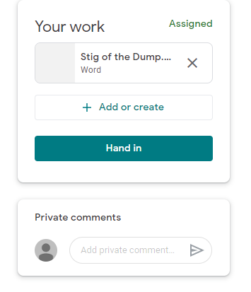

Click on ‘Hand in’ when the work is completed and ready to be marked.

How to Complete Upload Work Within Google Classroom.



Your child can upload their work if they have completed it offline by clicking on ‘+ Add or create’ and then selecting ‘File. This will create a file, click to open a word document.

Click on ‘Select files from your device’ to access where the file is saved.

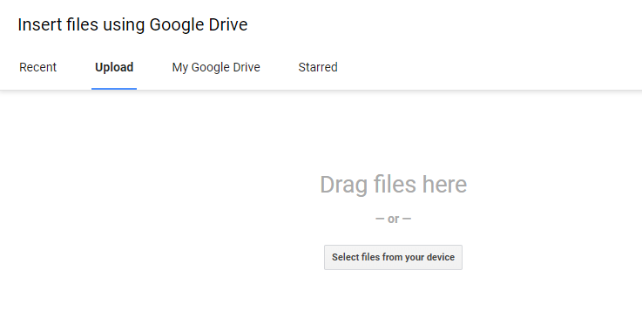

1.

2.

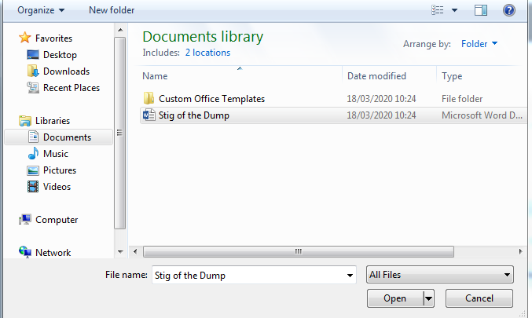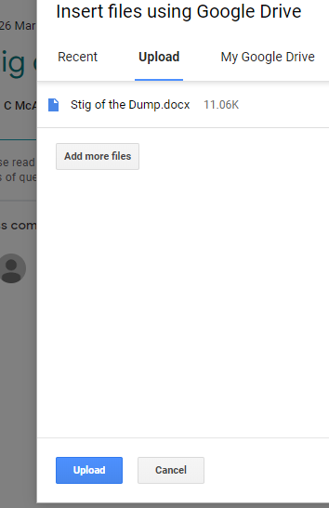

3.

Click ‘Open’ then ‘Upload’.



Click on ‘Hand in’ when the work is completed.

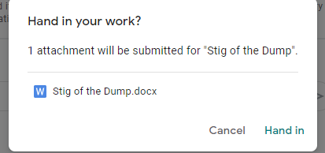

Click on ‘Hand in’ when the work is completed and ready to be marked.

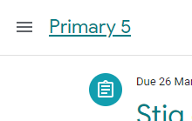

To return to the classroom, click on the 3 lines.

Choose the ‘Primary 5’ option and then ‘Classwork’ where work should be marked as ‘Handed in’.

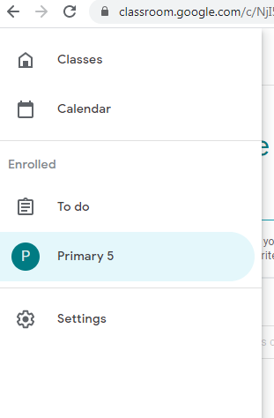

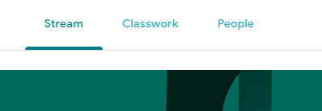

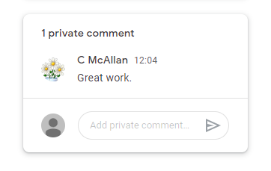

Once your child’s teacher has marked the work, they will receive a comment regarding their progress in the ‘Classwork’ section.