Parents In Partnership

How do I raise concerns about my child?
We understand that when your child comes home from school and they have expereinced a falling out within their friendship group this can be very distressing for you all. Please know that if a teacher or support staff member has been made aware or witnessed any incident then the correct procedure will have been put in place.

Please work with us to reinforce our School Slogan of
‘If It Doesn’t Sit Well Then You Should Tell’ to enable us to deal with incidents prior to your child coming home.

Please contact the school and ask for the class teacher in the first instance if you have not been contacted.
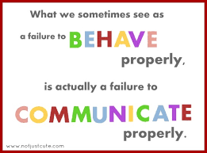
Staff Awareness & Procedure

Please trust us, that we will deal will all incidents (low level/high level) in a controlled, calm and consistent manner ensuring fairness and equity for all.

Please know that all staff follow the same agreed principles and practice. We are not reactive to incidents when they occur, we adopt a prevention framework with is proactive.

Our Behaviour Blueprint which is robust has steps and actions in place to ensure we provide a consistent approach when dealing with incidents.
Relational Practice. What you need to know as Parents.

Restorative Practice

Restorative approaches are all about building community and strengthening relationships. Restorative approaches are based on the idea that when we feel part of a supportive community, we respect others in that community and become accountable to it.

A great way to understand the Restorative Practice process is to look at it through the lens of the 5 R's: Relationship, Respect, Responsibility, Repair, and Reintegration
Trusting Us To Get It Right For Your Children’s Relationships In School
If your child has experienced any relationship challenges with their friends, please trust us to work with them to solve the problem.
We have clear guidelines in place.
Your child’s voice and views will be heard.
We will endeavour to keep you updated during the process.

