St. Fillan’s Priamry School
A Parent’s Guide to Glow and Google Classroom

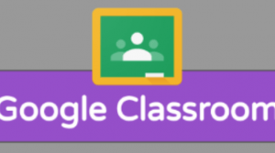
Google Classroom
Each class at St. Fillan’s Primary School has their own Google Classroom which they can access via Glow.
What is Glow?
Glow is an online platform which is available to all pupils and teachers in Scotland. It was designed by RM Unify. Glow services is a catalogue of free and paid for resources in an application (app) library. One of the resources available through Glow is access to Google Workspace where Google Classroom is one of the apps.
What is Google Classroom?
Google Classroom is one of the apps available in Google Workspace. In Google Classroom there are different sections:
Stream – Where class members can write posts. This could be to share information and ask questions. Teachers can set whether or not pupils can post on the stream.
Classwork – This is where you will find the assignments which have set for the children to complete.
People – This is where you can see who is a member of the Google Classroom.
How to Access Google Classroom via their Glow account
If you have a Google account, make sure you are logged out before starting this process.
Find the Glow sign in page by searching for ‘Glow RM Unify’ using a search engine.
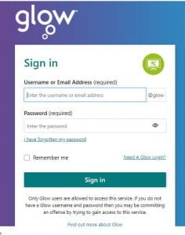
Type in your child’s Glow username and password. Your child’s username will begin with ‘gw’.
On Glow there is a Launch Pad with tiles. Find the tile ‘Google Classroom’. (To make this easier to find then click on the ‘i’ symbol, select ‘Add to my Launch Pad’ then close this box. This means that they can find the tile on their own Launchpad (see symbol of a person on the left of the Launchpad). Click on the Google Classroom tile in the Launchpad. This will take you to the Google Classroom app in Google Workspace.)
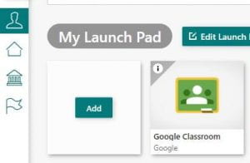
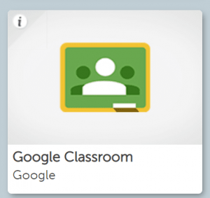

You should then see the classes which your child is already and member of and any new Google Classrooms they have been invited to invites. Accept the invite to join the online classroom by clicking ‘join’ or click on the classroom you need to access.
Glow Passwords
If your child doesn’t remember their password, your child’s teacher can reset their Glow password to ‘glow’ and you can help your child change this when you sign in to Glow. This password needs to be a certain strength for security so your child may need to add numbers or symbols to their passwords to increase the strength.

