St Benedict’s High School  Bridge of Weir Road, Johnstone, PA5 8EX  Tel: 0300 300 1441 Website: www.oraetlabora.co.uk  Email: stbenedictshighenquires@renfrewshire.gov.uk  Twitter: @stbenedictsren  Head Teacher: Alan Taylor | Children’s Services

Dear Parent/Carer
I would like to provide you with details and hopefully some reassurance regarding your son/daughter’s transition from their primary school to St Benedict’s High School. I am aware that as well as being very excited, some of our young people may be anxious, especially given the current situation.
To help with this and to give you and your child a flavour of what life is like at St Benedict’s, I would encourage you to look at our most recent newsletter (available on our website - click Primary Transition Tab). Previous editions are also available on the school website.
Our Twitter feed (@stbenedictsren) is also an excellent way to see the variety of activities taking place across the school community.
Our senior students have also produced a short transition video which includes a “virtual” tour of the school and an opportunity to hear from some of our staff and pupils. This video will be available on the St Benedict’s school website – P7 Transition Tab.
Upcoming Events
Introduction to the school
I will meet online with pupils to provide information about the school and our transition process. Dr Phelps (Depute Head Teacher – S1) will also been involved in this. This will provide an opportunity for your child to meet us but also give them a chance to ask any questions they may have.
Pupil Support Team
Our pupil support staff will meet with our associated and non-associated schools to gather key information on your child’s progress.
There will also be follow up meetings with your child’s pastoral care teacher and some of our pupils.
Your child will also receive a letter from a current S1 pupil in which they share their first year experience at the school.

Induction days – June 2021
I am hopeful that by this time we will be able to welcome pupils physically into the building. However, if this is not possible, we will do this through a virtual programme. Pupils will be able to take part in several subject related activities, meet with their classmates and some of their teachers.
A meeting will be organised after the Easter break for parents/carers. The purpose of this is to share final arrangements and provide further details of what your child will experience in S1.
Communication

I am delighted that you have chosen to send your child to St Benedict’s High and look forward to meeting and working with you in the future. I will provide regular updates during this important time in your child’s education.
If you have any questions, please contact me or Dr Phelps (Depute Head Teacher)
Yours sincerely,

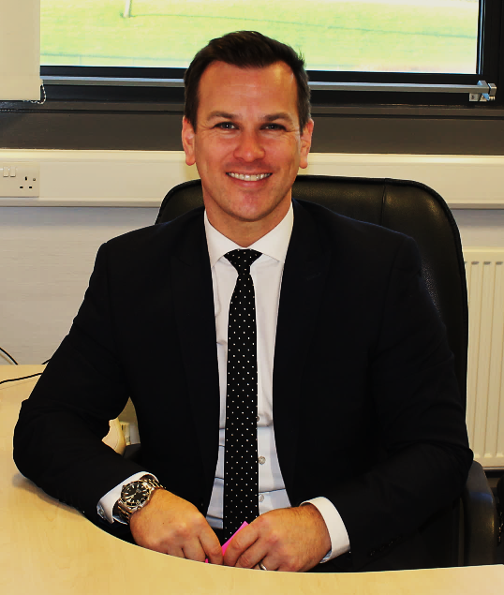

Alan Taylor
Head Teacher

