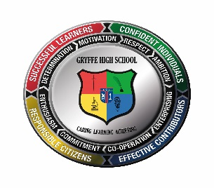
Dear Primary 7 Pupil
Hello and welcome to your virtual transition programme. I am sorry that we cannot meet you in person right now. However, we have made some videos to welcome you.
This letter will give you an outline of the exciting things that we have planned so far for your P7 Induction and transfer to Gryffe High School. We think it is an excellent programme for you and even better than previous years because it is longer there is more in it for you to do.
You can see from the other letter issued with this one that we can created a virtual class.
You are all in it. All 176 of you!!
Staff at Gryffe High have worked very hard to create lessons to challenge you, for you to enjoy and give a taster for Gryffe High. The lessons are not live but teachers from Gryffe High will give you feedback on the work you complete.
Pupils from Gryffe High also wanted to make you part of our community and so have created information videos for you. Later in June they will answer any questions or worries that you might have about coming to Gryffe High.
Remember you need a code to join the Virtual Programme. The code to join Gryffe High P7 Transition Team is sg9uunn. Here is the youtube link for how to join the team:
https://youtu.be/buXRy7BQROM

P7 Induction Timetable – Please log on every day at 9.30am
May – Introductory Welcome Letter – hope everyone has got this!!
- Monday 1 June– Welcome videos from Key staff and various pupils
- Tuesday 2 June – Virtual Tour of the School
- Wednesday 3 June – Rights Respecting Schools and School Charter
- Thursday 4 June – Learning Diary
- Friday 5 June – Informative videos from pupils.

Page 2 of this letter has your timetable of classes.

I will keep you informed of any further information I have about coming to Gryffe High when the Scottish Government updates us all.
Take care
Mrs Brown
Depute Head Teacher
Gryffe High School
gw07brownangela3@glow.sch.uk
Week beginning 8 June
 | Monday | Tuesday | Wednesday | Thursday | Friday
9.30am | Science | Music and Modern Languages | English  And Drama | Health and Wellbeing | S6 and  A Brown
12.30am | ABC | Maths | Humanities | Art, Design and Technical

Week beginning 15 June
 | Monday | Tuesday | Wednesday | Thursday | Friday
9.30am | English  And Drama | Health and Wellbeing | Science | Music and Modern Languages | S6 and  A Brown
12.30am | Humanities | Art, Design and Technical | ABC | Maths

Week beginning 22 June
 | Monday
9.30am | Guidance/PSE

