



Renfrewshire Coucil

St. Fillan’s Primary School

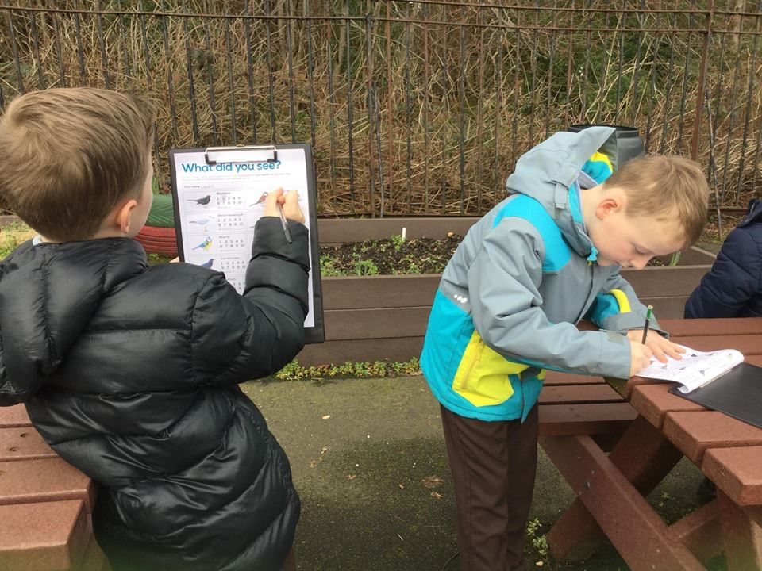



STANDARDS AND QUALITY REPORT

June 2019

This report will inform you of the school’s progress and achievements in the last session and let you know about our plans for 2018-2019. I hope that you find it helpful and informative.

Mrs C Mackenzie

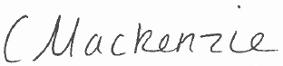

Head Teacher

**SUCCESSES AND ACHIEVEMENTS:**

* Refreshed our displays across the learning environment to ensure consistency around high standards of display. Installed a TV in the Central Area to showcase our children’s work and achievements.
* We have continued to raise the positive profile of our school within our local community and beyond through media coverage, use of social media and increased engagement in community events and partnership working – Bee Happy Group (Orchard planting and pot planting in the local community), Erskine Hospital, SVDP Parish Group, Killelan Parish Church and associated Cameo Club, Salvation Army – ‘Carols in the Crescent,’ Team Clean up community litter picks.
* Celebrated the grand opening of our newly refurbished Nurture Room – ‘Paradise Planet.’
* Whole school celebrated the achievement of our 3rd Eco flag and enjoyed a sustainable family picnic.
* Refreshed and relaunched our ‘Celebrating Diversity Anti Bullying Policy’ following an extensive period of consultation with children, staff, families and partners.
* Engaged in community commemorative events to mark the 100 years since the First World War – ‘Archie Dobson’s War’ play, ‘Remembrance Community sing-a-long’ and flag bearing at the Freeland Church on Remembrance Sunday.
* Primary 7 girl was awarded second place in the Renfrewshire Active Schools Cross Country event.
* Enhanced links and transition with Houston Primary School through participation in anti-sectarianism workshops around the novel ‘Divided City’ and input from the ‘Nil by Mouth’ team.
* All Primary 7 pupils have been trained in ‘Heartstart.’
* Every class participated in at least one educational excursion this session to further enhance their learning.
* Our children have experienced a wide range of learning/sporting opportunities this session including: Renfrewshire Active Schools clubs, events and tournaments, Gryffe Fun Run, Scoobmobile, Judo, Squash, Strathgryffe Tennis, Taekwando, SPCA coding/ICT visits, Gaelic singing, traditional Scottish music, I am Me Scotland, Rookie Rockstars, RSPB- ‘Tag and Track,’ Living Eggs (Nurturing chickens), transition visits for Primary 6 and 7 to St. Benedict’s, Mr McKendrick’s Science inputs (Primaries 5 to 7) and sessions during STEM week.

OUR VISION, VALUES AND AIMS:

**Vision:** ‘In learning, we are growing and succeeding together.’

**Values:** Respect, Responsibility, Faith, Trust, Team work, Success.

**Aims:**

1. Be Brave.
2. Unleash creativity.
3. Demonstrate excellence.
4. Show/radiate enthusiasm.

OUR SCHOOL:

St Fillan’s Primary is a denominational school in Houston. **The school building provides good facilities including office space, quiet area, a separate gym hall with stage and a meeting room. There are good-sized school grounds with a grassed area, outdoor learning space and a garden area. The school was refurbished during session 2014/15 and is well resourced.**

St Fillan’s Primary school **has a roll of 125. The school enjoys a reputation for it’s participation in the local community, has an active and supportive parent council and is well regarded amongst parents, with** many respondents to the 2 stars and a wish survey indicating that they were happy with the school.The Senior Leadership Team (SLT) consists of a Head Teacher(HT) and a Principal Teacher (PT). The PT supports the Head Teacher with Pupil Support and has responsibility for a range of areas within planned school improvement. There are 9 class teachers, five of whom work in partnerships across the school week, 1 classroom assistant, 2 Additional Support Needs Assistants, a Home Link worker, a Service Delivery Officer, 2 office staff and 2 music instructors. The environmental services team comprises of a janitor, catering and cleaning staff. **Together, staff provide a welcoming, nurturing and** supportive **environment** for learning **where children are** enabled to reach their full potential.

The school has a low FME resulting in a small amount of money from the PEF (Pupil Equity Fund).

**HOW SUCCESSFUL HAVE WE BEEN IN IMPROVING OUR SCHOOL?**

**School Leadership:**

* **Almost all staff have taken on leadership roles liked to their skills, interests and priorities in our ‘School Improvement Plan.’ (SIP). They have shared good practice with one another during planned Collegiate Times.**
* **The frequency and duration of Committee Groups have increased and as a result, children have enjoyed more opportunities to take an active role in the school community and lead improvements across the school, especially during ‘Committee Context Weeks.’**
* **The Head Teacher has participated in: HT Learning Sets, Individual Coaching Programme, Leadership Development days, Curriculum Rationale, Transition to Secondary, Wider Achievement and SNSA training. All programmes have helped develop knowledge, skills and capacity to lead and deliver school improvement more effectively.**
* **The Principal Teacher has participated in: Lead Moderation Training and ‘Dive into Writing’ training and as a result is better informed to lead developments in these areas.**
* **The SLT have worked in partnership with Educational Psychological Services and participated in a three day training event. The SLT now have a sound knowledge of Nurture principles and are empowered to lead improvements across the school with confidence.**
* **Leadership opportunities for children in Primary 7 have increased with the introduction of the Credit Union facility. Children have a responsibility for leading all financial transactions with the support of an adult facilitator.**
* **Liaison with schools of a similar context have strengthened with regular meetings to discuss strategic planning and issues related to our context. The Head Teacher has visited Inchinnian Primary and the visit has been reciprocated to share strategies for monitoring the quality of learning and teaching across the school.**
* **The HT has benefitted from continued Mentoring sessions with a well-established Head Teacher within the Local Authority. This has contributed to improvements in the strategic direction of the school.**

**Teacher Professionalism:**

* **All staff participated in the ‘RNRA’ Nurturing schools training to develop a shared understanding and language around the principle of ‘all behaviour being communication.’ This has contributed to a consistent approach across the school.**
* **All teaching staff engaged in the ‘Moderation’ training provided by the Local Authority. Staff demonstrated skill in this area as we achieved one hundred percent accuracy in our professional judgements of the learning, teaching and assessment process.**
* **The Head Teacher and Principal Teacher engaged in national Paul Dix training entitled ‘When the Adult’s Change, Everything Changes.’ As a result, opportunities were facilitated for all staff to engage in professional reading and development around positive behaviour and relationships.**
* **Three additional members of staff attended a series of ‘Stages of Arithmetical Learning’ training (SEAL). Staff have a clearer understanding of the developmental stages in a child’s acquisition of number and learners progress in Numeracy has improved through experiencing success at an early level.**
* **Teaching staff have an increased awareness of ‘Adverse Childhood Experiences’ through attending our community screening of the ‘Resilience’ film.**
* **Staff engaged in a collaborative approach to develop Literacy planning across the school. Reading planners are more robust and fit for purpose.**
* **Staff professional development opportunities have included: MFL training (Primary 1 Teacher), Understanding suicide and self-harm (Primary 4 Teacher), online safety (Primary 4 Teacher) and Behaviour De-escalation training (Primary 7 Teacher). All training opportunities have benefitted positively on learners.**

**Parental Engagement:**

* **The Head Teacher hosted a ‘Coffee and Chat’ session for all families when reviewing the ‘Anti Bullying’ Policy. Eleven of our families were in attendance and the event fostered stronger home/school links with parents feeling their contributions were valued, listened to and had a direct impact on the guidance within the final policy.**
* **Opportunities for parental engagement were increased across the school through a variety of initiatives and events including: ‘Rookie Rockstar’s Concert, St. Andrew’s Day Assembly, ‘Celebrating Diversity’ Launch, Sustainable Family Eco Picnic, Book Gifting events and Primary 7’s play ‘Archie Dobson’s War.’ Both social media and verbal feedback was extremely positive with families commenting that they enjoyed a sense of belonging and feeling part of the ‘St. Fillan’s Family.’**
* **Four Parental workshops were hosted by the SLT and associated partners (Home Link, Educational Psychologist and the PATHS Co-ordinator) to support parents and empower them to support their children. The workshops included: PATHS (Promoting Alternative Thinking Strategies), Resilience, Growth Mindset and Primary 7 Transition.**
* **Parental Engagement has increased through parent’s being consulted on a wide range of issues including: Anti bullying, Curriculum Rationale, School Improvement Planning, PEF (Pupil Equity Fund) priorities, ‘Reporting to Parent’s Framework,’ Nurture, Achievement and Attainment, Meet the Teacher format, Learning and Teaching, Parents know that their feedback is important to us and that we value their contributions and suggestions. They are regularly updated in monthly Newsletters about how their participation in consultation has contributed to school improvement.**
* **There has been an increase in parents/family members volunteering to assist/lead areas of school improvement. We now have a Credit Union Facilitator, two parents trained and accredited in providing ‘Bikeability Training’ and several gardening enthusiasts who are willing to develop outdoor learning with our children in our school grounds. This has increased the opportunities we are able to provide to our children through skills development within the wider curriculum.**
* **There have been increased opportunities for improved relationship building with new Primary one parents. Opportunities have included: an Open Afternoon, Nativity performance, the Easter Bonnet Parade and Sport’s Days. Parents have commented that they felt relaxed and welcomed and feel their children will benefit in the form of a smoother transition from Nursery to Primary one.**
* **We were the first Primary school in Renfrewshire to achieve one hundred percent parental engagement of the Parent Pay cashless system. Parents have shared positive feedback around the new system.**

**Assessment of Children’s Progress:**

* **All children in Primary 1, 4 and 7 have participated in the Scottish Standardised National Assessments (SNSA). The results correlate with and have supported teachers’ professional judgement.**
* **GL Assessments were carried out from Primary 2 to Primary 7 in the four key areas of: Reading, Spelling and Numeracy in May 2019. Individual reports for pupils were downloaded and analysed with stanines being used as a summative means of assessment. This provided Class Teacher’s with an opportunity to reflect on their own judgements around pupil’s progress in these areas. The data now forms the basis of a termly tracker that will be used to track children’s progress on a more regular basis.**
* **All children have developed their skills in creating and evaluating termly learning targets in: Literacy, Numeracy and Health and Well-being. The evaluation of targets has been used as means of systematically reporting to parents on children’s progress.**
* **Well-being wheels were completed by every child in Primaries 1 to 7 allowing rich discussions between staff and the SLT at racking meetings.**
* **We have developed and implemented an ‘Annual Assessment Calendar,’ which has provided us with a strategic overview of assessment across the school and the intended impact that it is having on our learners. Staff are more clear around the expectations around assessment.**

**School Improvement:**

* **The whole school community have been involved in an extensive period of consultation around our ‘Curriculum Rationale. We have produced a clear and simple visual outlining what we want for our children and how we are going to achieve our aims. Staff, children, parents and partners have a clear, shared understanding of what we are aiming to achieve through our curriculum.**
* **Through self-evaluation, we identified the need to revisit our core school values. During Assembly and learning within classrooms, explicit links have been made between school values and Gospel values. There has been an improvement across the school of children living by our Christian and school values in their words and actions.**
* **Through collaborative working and professional reading, we have created a series of ‘visible consistencies’ that all staff members have embraced in relation to building and sustaining positive relationships with all learners. The result is that there is a consistent approach across the school which is founded on the core value of kindness. Our ‘Promoting Positive Behaviour Policy’ has also been enhanced.**
* **An improved format for flexible year planning has been introduced. This template has been welcomed by staff as there is now a holistic overview of planned learning and teaching across a session including opportunities for Interdisciplinary Learning (IDL), skills development and an in-depth evaluation of learning and teaching based on the seven principles of curricular design.**

**:**

**School Name**

**School Address**

**Phone**

**Fax**

**Website**

**Twitter/Facebook**

**Performance Information**

* **The SLT have participated in further SNSA training to improve confidence in analysing data. The skills gained through this training will be valued in measuring the impact of targeted interventions in terms of pupil’s progress.**
* **Our SLT meet termly with teachers to discuss children’s progress. We have revised these meetings to ensure there is a greater focus on monitoring children’s attainment in terms of predicted and actual. Strategies for supporting and challenging children are identified and a variety of assessment evidence is discussed which ensures children make effective progress.**

Performing in the play ‘Archie Dobson’s War,’ helped me to channel an inner confidence that I never knew I had. My family were very proud of my performance and I loved sharing the story with the residents in Erskine Hospital.

Primary 7 child.

The Eco Picnic showcased a key strength of St. Fillan’s in my mind which is giving the kids, through Committee work, a voice and autonomy in their learning journey. I was so impressed by the kids and staff and the genuine enthusiasm and confidence the kids displayed. It was also a lovely chance to see the kids at work and play. Thank you.

Primary 2 Parent



I absolutely loved my experience at Lochgoilhead. I learned things about myself that I did not know. I am so much more confident and braver now and my resilience has improved. I feel that I was a good leader during the week and maybe one day I can develop my leadership skills when I leave school.

Primary 7 Child.



**KEY STRENGTHS OF THE SCHOOL:**

* **We have a strong Catholic ethos and the value of faith permeates throughout our school. We have close links with the Parish.**
* **Our ethos is nurturing, caring and inclusive. (Education Scotland, November 2017)**
* **Our school is a family and we have strong partnerships with families, partners and the wider school community.**
* **We have very good levels of attendance and attainment.**
* **We have articulate, caring, generous and thoughtful pupils. (Education Scotland, November 2017)**
* **We have a supportive staff team who are willing to support one another in any way they can.**
* **We value team work and are keen to work collaboratively to bring about school improvement.**
* **We welcome positivity and we are keen to embrace change for the benefit of the whole school.**
* **Children are listened to and are made to feel respected by all members of staff.**
* **Children are nurtured and very well cared for from the moment they arrive to the minute they leave.**
* **All staff are committed to doing their absolute best for each and every child.**
* **Our children are provided with many opportunities to develop their skills in learning, life and work through a range of activities and initiatives and there are many opportunities for wider achievement.**
* **As a small school, we know our families very well and are well able to support children with their learning.**
* **We involve the whole school community when making decisions to foster a culture of inclusion.**
* **We are effective at communicating to parents and reporting on progress in a variety of ways – through social media, the school website and comprehensive newsletters.**

**OUR NEXT STEPS – PRIORITIES FOR 2019-20:**

We believe that we have made good progress during session 2017-18 and we will use the improvement priorities listed below to build on this progress moving forward:

**Religious Education: Developing in Faith:**

* **Engage in a variety of opportunities to develop as a community of faith and learning.**

**Learning & Teaching:**

* **Empower our children to become better learners by developing learner’s habits and preferences.**
* **Review how best to track and assess children’s progress across the school.**
* **Develop shared standards and expectations in writing at school level and within the St. Benedict’s Cluster.**
* **Raise the profile of writing in our school.**
* **Implement a revised approach to learning logs, profiling of the learner’s journey and assessment.**
* **Develop children’s skills for learning, life and work by implementing skills-based afternoons called ‘BUDS.’**
* **Implement ‘Playful Pedagogy’ in Primary one.**
* **Develop Modern Foreign Languages through a Cluster approach.**
* **Continue to raise the profile and attainment within writing by making effective use of our Pupil Equity Funding.**

**Health and Well-being:**

* **Develop policy and practice in our approach to transition.**
* **Implement the ‘Emotion works’ programme across the school to develop emotional competence and resilience.**

**Full details of the school’s improvement priorities and actions are detailed on the school improvement plan which can be accessed on our website or by contacting the school office**.

**HAVE YOUR SAY!**

Please take the opportunity to share your thoughts with us as we use feedback to help us make improvements to the school. You can do this by speaking to staff, participating in Parent Council meetings, responding to questionnaires/surveys and by completing evaluations at school events.

St. Fillan’s Primary School

1A Main Street, Houston

PA6 7EL

0300 300 0182

Email: [stfillansenquiries@renfrewshire.gov.uk](mailto:stfillansenquiries@renfrewshire.gov.uk)

Website: <https://blogs.glowscotland.org.uk/re/stfillans/>