St. Fillan’s Primary School – Agenda/Minutes – 2018 -2019
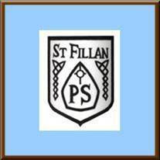
Day: Date: Meeting: Parent Council
Time:
Members/People Present:
- Mrs C McKenzie, Mrs J McPherson, Dougie Harvey, Julie-Ann Dunn, Julie Shields, Laura McAulay and Louisa Stevenson.
*Discuss minutes of last meeting and Actions.
Our shared vision - “We are all learning, growing and succeeding together”
Our Shared Values:
R – Respect R – Responsibility T – Team work F – Faith T – Trust
S – Success
Item | Discussion | Action/  Responsibility | Timescale (If applicable) | √
Head Teacher’s Report | Mrs McKenzie read through the details of the report. | Helmets to be bought to support with Bikeability training.  Treat for the children during Sports Day. Possibly ice-cream.
Treasurers Report  Primary Seven Prom | See attached note.  Balance £3000  £230 from the Quiz night.  Spent-communion funds  Rag bag money is still coming in.  Disco  Decorations-red carpet was purchased  Photographer/photo booth  Bunting and hanging decorations/balloon arch  Date for prom 26th June  Domino pizza/Candy cart/Chocolate fountain | E-mail builders to see if they could support the building of the hobbit hut.  Money will be given for a new computer trolley.  New football nets will also be purchased.  J.Dunn to source cost of food.  L Stevenson to source price of photo booth.  J Shiels to source cost of balloons.

