



Renfrewshire Coucil

St. Fillan’s Primary School

STANDARDS AND QUALITY REPORT

June 2018

This report will inform you of the school’s progress and achievements in the last session and let you know about our plans for 2018-2019. I hope that you find it helpful and informative.

Mrs C Mackenzie



Head Teacher

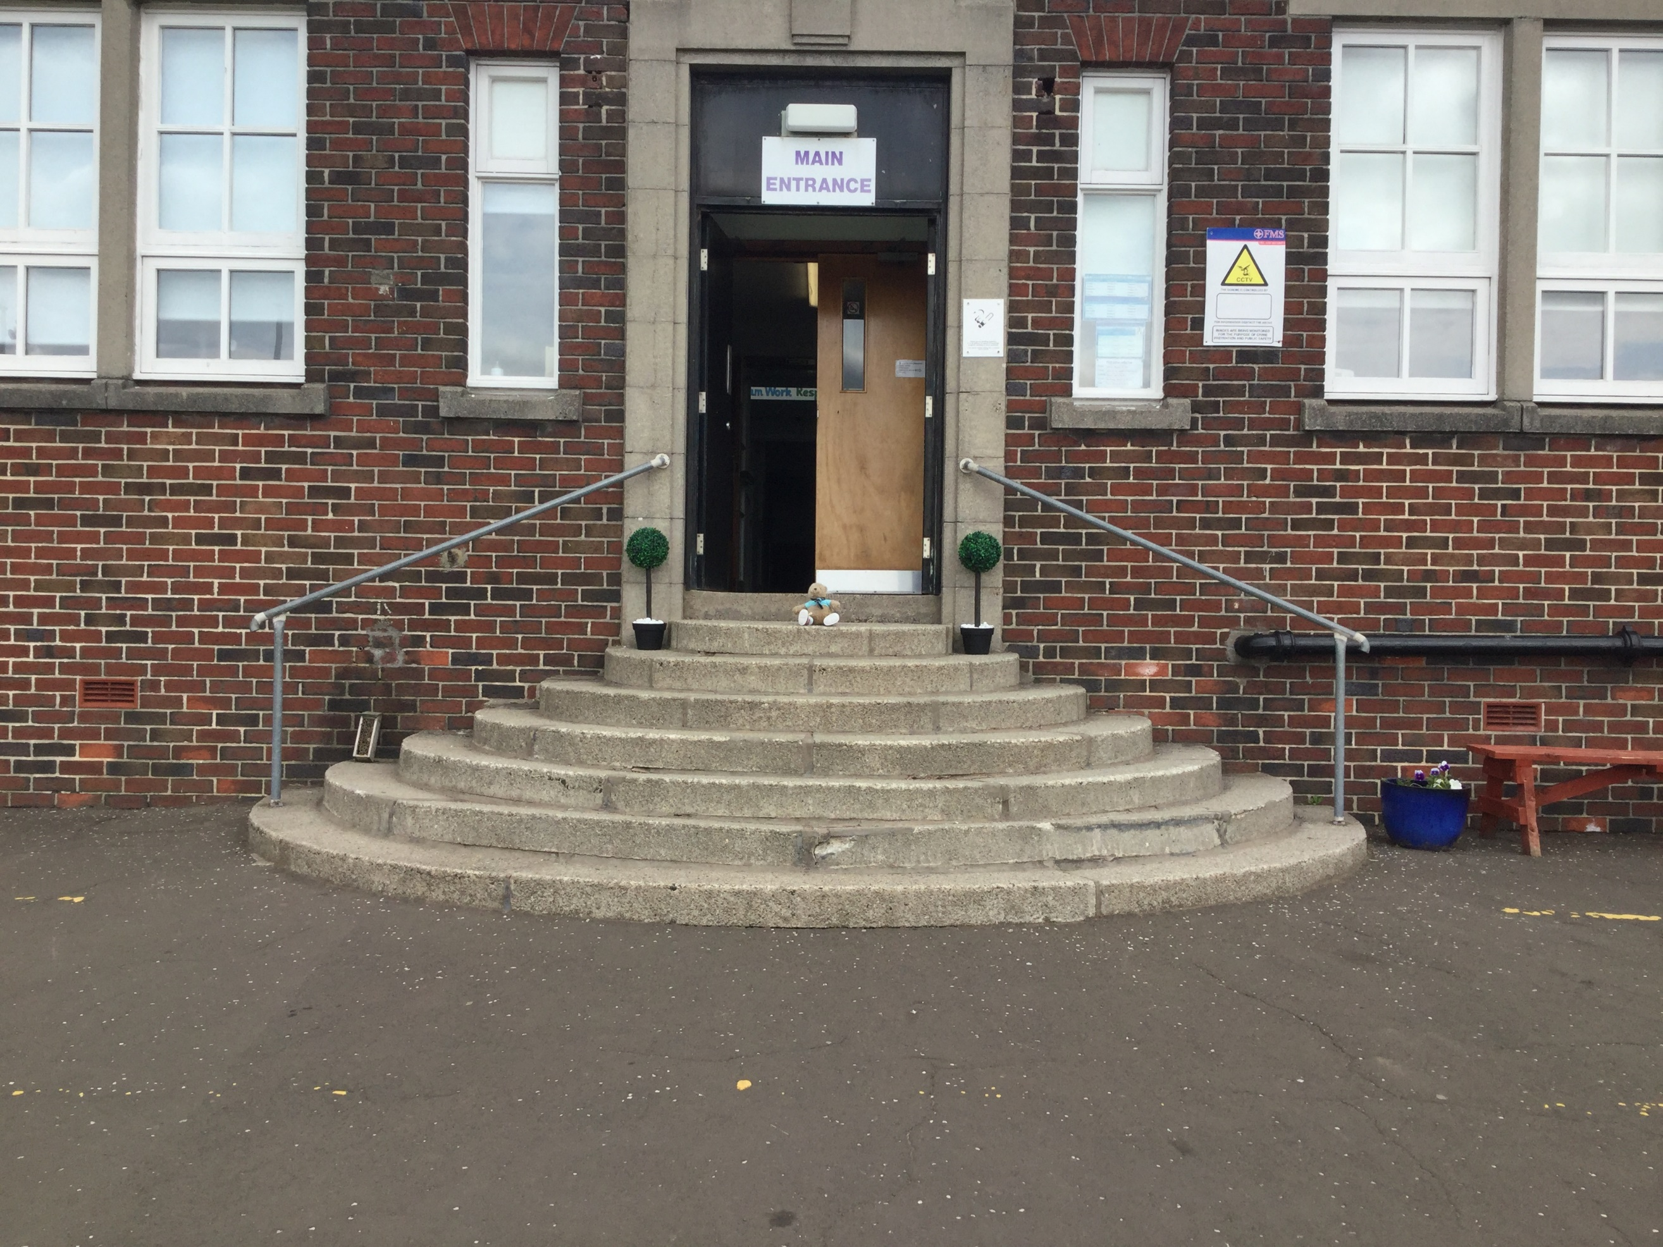

**SUCCESSES AND ACHIEVEMENTS:**

* Successful engagement with Education Scotland providing a clear mandate for continuous improvement/ moving forward.
* Newly formed SLT have worked well in partnership to drive forward improvement across a range of the ‘National Improvement’ drivers.
* Awarded RHS Award – Level 3 for outdoor work in the School Garden.
* Primary 7 pupils won a Cluster Maths Challenge during ‘Maths Week Scotland.’
* Two children won a National STEM Competition in June 2018 by creating their own inventions.
* The introduction of ‘Golden Time’ and ‘Golden Ticket Tea Parties’ as a means of celebrating achievement and providing the Head Teacher with a good opportunity to get to know children.
* Parents value the improved format of the monthly school newsletter which has a clear focus on school improvement.
* Successful Primary 1 Induction Programme.
* Successful refresh of ‘Sharing our Learning’ with parents/families.
* Opportunities for children to engage in physical activity through working in Partnership with Active Schools – 87 percent engagement of pupils this year.
* Primary 6 and Primary 7’s engagement with sustainable projects including: ‘Tag and Track,’ ‘Eels Release’ and Glasgow Airport’s ‘Flying Fish’ project.
* Wide range of activities provided to bring learning alive, including: Zoo lab, LEAP, Sports Champions, transition IDL days and Leadership skills development, Health Day, Primary 7 Underpass Project, Committee events,

OUR VISION, VALUES AND AIMS:

**Vision:** ‘In learning, we are growing and succeeding together.’

**Values:** Respect, Responsibility, Faith, Trust, Team work, Success.

**Aims:**

1. Be Brave.
2. Unleash creativity.
3. Demonstrate excellence.
4. Show/radiate enthusiasm.

OUR SCHOOL:

St Fillan’s Primary is a denominational school in Houston. **The school building provides good facilities including office space, quiet area, a separate gym hall with stage and a meeting room. There are good-sized school grounds with a grassed area, outdoor learning space and a garden area. The school was refurbished during session 2014/15 and is well resourced.**

St Fillan’s Primary school **has a roll of 131. The school enjoys a reputation for its participation in the local community, has an active and supportive parent council and is well regarded amongst parents, with** many respondents to the 2 stars and a wish survey indicating that they were happy with the school.There is an Acting head teacher and a principal teacher. The PT supports the Acting Head Teacher with Pupil Support and has responsibility for nursery to P1 transitions. There are 9 class teachers, five of whom work in partnerships across the school week, 1 classroom assistant, 2 Additional Support Needs Assistants, a Home Link worker, a Service Delivery Officer, 2 office staff and 2 music instructors. The environmental services team comprises of a janitor, catering and cleaning staff. **Together, staff provide a welcoming and** supportive **environment** for learning **where children are** enabled to reach their full potential.

The school is in the 4th quartile of family schools and has a low FME resulting in a small amount of money from the PEF (Pupil Equity Fund).

**HOW SUCCESSFUL HAVE WE BEEN IN IMPROVING OUR SCHOOL?**

**School Leadership:**

* **The Head Teacher has taken part in Renfrewshire’s ‘Head Teacher Training Programme’ and the ‘Columba Leadership Academy’ accreditation experience to develop knowledge, skills and capacity to lead and deliver school improvement effectively.**
* **The Principal Teacher has participated in the ‘Drummond International Leadership Programme’ to develop knowledge, skills and capacity to support the Head Teacher and all staff in driving the school forward.**
* **The SLT have engaged in ‘Coaching Training’ at Local Authority level and through ‘Growth Coaching International Consultancy’ and the model has been used to empower others to take ownership as agents of change and actively drive the school forward through a cycle of continuous improvement.**
* **The HT has benefitted from Mentoring sessions with two well-established Head Teacher’s within the Local Authority to develop skill in strategic planning over time and self-evaluation. This has ensured the school has a strategic overview of improvements and priorities over a longer period of time.**
* **This session, pupil leadership roles were developed through the ‘Committee Group Framework’ to better equip our children with the skills required to lead improvements across the school. Leadership roles included: Chairperson, Vice Chairperson, Treasurer and Secretary.**
* **SLT developed knowledge and skills by working in partnership with Education Scotland during their visit in September 2017.**
* **Pupil leadership roles developed across Health and Well-being with the training of Primary 7 Playmakers. Playmakers were able to plan and facilitate play sessions for younger children and buddies.**
* **HT engaged in a training session with Shona Taylor from Education Scotland around the use of Inspection model and use of evaluative language. This enabled the SLT to ‘unpick’ the ‘Summary of Inspection Findings’ and identify the core, key priority within each statement.**

**Teacher Professionalism:**

* **All staff participated in the ‘PATHS Training Programme’ to deliver Health and well-being experiences which are progressive and focus on a child’s ability to express their emotions, build resilience and self- regulate their feelings.**
* **Almost all staff participated in the ‘Dive into Writing Training’ provided by Sue Ellis in association with Strathclyde University. This input empowered staff to reflect critically on their current pedagogy and to consider the three domains when engaging learners in the writing process.**
* **The Classroom Assistant participated in training to develop their understanding of children’s acquisition of number. The Classroom Assistant is now more confident and able to support children with their Numeracy work.**
* **Two members of staff co-facilitated the development of Numeracy in our school by attending Local Authority ‘Champion’ meetings and provided a valuable input to staff around Problem Solving using the ‘CUBES’ approach. Learners are more able to articulate their thinking by using concrete strategies to solve complex problems or calculations.**
* **The Literacy Champion attended all Literacy Champion meetings and cascaded the learning to all staff during Collegiate sessions. A detailed audit of policy and practice has been undertaken to highlight key areas of strength in Literacy and areas of improvement. Staff have developed their knowledge in ‘Reader Response’ and learners have benefitted from more focussed discussions and deeper thinking opportunities when exploring a class novel.**
* **The Primary one Class Teacher participated in the ‘Primary one Pedagogy’ sessions delivered by Deirdre Grogan at Strathclyde University. She also attended three sessions around monitoring, tracking, assessment and profiling in the Early Years setting. The Class Teacher is more skilled and confident in setting up a learning environment to promote playful pedagogy and has developed new ideas around the tracking, monitoring and achievement of learners.**
* **Almost all staff engaged in raining provided by the RHS to build confidence and capacity when providing meaningful outdoor learning opportunities. One Class Teacher attended further training provided by the RHS to ensure there is a sustainable approach to planning outdoor learning across the stages.**
* **Three members of staff attended a series of ‘Stages of Arithmetical Learning’ training (SEAL). Staff have a clearer understanding of the developmental stages in a child’s acquisition of number and learners progress in Numeracy has improved through experiencing success at an early stage.**
* **The Principal Teacher participated in the ‘Child Protection for Managers’ refresher training and an additional member of staff has also been trained. The Head Teacher has attended ‘Child Sexual Exploitation’ training. Staff are confident in quickly responding to any child protection’ or safeguarding concerns.**

**Parental Engagement**

**Assessment of Children’s Progress**

**School Improvement**

**Performance Information**

* **All staff have attended the annual’ Child Protection Update’ to ensure they are kept abreast about current issues and have confidence in responding to any child protection of safeguarding concern around e-safeguarding, child sexual exploitation and extremism.**
* **One member of staff attended the ‘Children’s Services Conference’ and the SLT both attended community screenings of the ‘Resilience’ film. Staff now have a greater understanding of the impact of toxic stress and ‘Adverse Childhood Experiences’ (ACES) on children and their families and the importance of atunement within the learning environment.**
* **Most staff participated in a CLPL session facilitated by Gordon Boyd from the ‘Home Link Service.’ This input focussed on the impact of trauma and stress in relation to children’s behaviours and progress in school. Staff have a greater awareness of the science of trauma and individual children have benefitted from planned opportunities to talk to staff about stress and anxiety.**
* **Two members of staff have participated in the ‘Get us all Reading’ book group sessions to deepen their knowledge and repertoire of rich reading material for children. They are able to provide guidance and resource material for Class Teacher’s around the choice of text/novels. This expertise has resulted in increased learner engagement whilst fostering a love of reading.**
* **All staff engaged in ‘The Write Stuff’ CLPL sessions, focussing on using the resource to refresh methodologies when teaching writing. Staff feel more empowered to provide immediate feedback to pupils and the children are better equipped to identify next steps in their learning.**

**Parental Engagement:**

* **Families of children in Primaries 1,2 and 3 were invited to attend ‘Book Gifting’ events where they were given the opportunity to explore the ‘Read, Write and Count’ bags with their child. Parents verbally reported that they valued the one to one time spent with their child and felt confident in using the strategies modelled by the Class Teacher when reading with their child at home.**
* **The Primary one Induction Programme was reviewed and refreshed by the SLT this session. Parental inputs were focussed on equipping our families with the essential skills in supporting their child’s health and well-being. This was facilitated by partnership working and sessions on PATHS and Growth Mindset. Feedback from parental questionnaires were 100 percent positive with parents feeling more aware, confident and skilled in their role as primary educators of their children.**
* **The ‘Sharing our Learning Showcase’ events were reviewed and refreshed following parental feedback in the Education Scotland questionnaires. Feedback from parental questionnaires was 100 percent positive with parents feeling more involved in engaging in their child’s learning.**
* **The Head Teacher hosted a ‘Coffee and Chat’ session for all families when reviewing the ‘Promoting Positive Relationships and Behaviour’ Policy. One fifth of our families were in attendance and the event fostered stronger home/school links with parents feeling their contributions were valued and listened to.**

**Assessment of Children’s Progress:**

* **Our attainment remains good across all stages and Education Scotland confirmed that Teacher Judgement data for June 2017 was in line with gathered evidence of children’s progress during the week of inspection. This reaffirmation has increased staff confidence levels.**
* **There has been a significant improvement in attainment at the Primary 7 stage in: Listening/Talking, Reading, Writing and Numeracy.**
* **GL Assessments were carried out from Primary 2 to Primary 7 in the four key areas of: Reading, Spelling, Numeracy and Cognitive Ability in April 2018. Individual reports for pupils were downloaded and analysed with stanines being used as a summative means of assessment. This provided Class Teacher’s with an opportunity to reflect on their own judgements around pupil’s progress in these areas. The data now forms the basis of a termly tracker that will be used to track children’s progress on a more regular basis. Individual Dyslexic assessments were used as a means of gathering additional information in line with the dyslexic framework.**
* **SNSA assessments were implemented at Primary 1, 4 and 7 in May 2018. The SLT have used the data to assist in the structuring of classes for the 2018-2019 school session and to compare and contrast Class Teacher’s judgement in terms of predicted and actual attainment.**

**School Improvement:**

* **We have worked in partnership with our Local Authority Education Manager and Educational Psychologist to self-evaluate leadership, learning, teaching, assessment, children’s well-being and attainment and achievement. This has helped us to showcase our strengths and identify areas for improvement.**

**School Name**

**School Address**

**Phone**

**Fax**

**Website**

**Twitter/Facebook**

* **Through prioritising areas for school improvement as outlined in the ‘Summary of Inspection Findings’ in November 2017, we have:**
* **Involved the whole school community in the review of our school aims. The aims are now shared, succinct and easily accessible to all using the acronym: BUDS. (1.3 – HIGIOS4).**
* **The whole school community were involved in the review of the ‘Promoting Positive Relationships and Behaviour’ policy which has led to a clearer, consistent structure around the expectations of appropriate behaviour. (1.3 – HIGIOS4).**
* **All staff (teaching and non) have worked collaboratively to create a three year plan for improvement by participating in a scanning and scoping session. This has created a more focussed vision for change and a clearer direction for moving forward which is shared by all. (1.3 – HIGIOS4).**
* **PR and D meetings have been refreshed by the SLT using a coaching model and the GTC coaching values wheel as a vehicle for professional discussion. Self-evaluation in this area has led to all teaching staff taking on a more active role as a Champion in an area of development, interest or expertise. This has led to school improvement being more focussed in terms of workstreams and staffs confidence and enthusiasm to lead change has improved as they are active agents of change. (1.3 – HIGIOS4).**
* **A robust calendar of monitoring has been put into place following the findings of Education Scotland in the area of learning, teaching and assessment. The SLT have engaged in class learning visits and provided feedback to staff by engaging in professional dialogue. There has been regular monitoring of: Homework, Writing, Writing Termly Assessments, Literacy and Numeracy work and staff have been provided with both individual and collective feedback. The importance of making learning visible to learners has been revisited in terms of sharing learning intentions with the children and co-creating success criteria. Staff have worked collaboratively to produce an ‘Effective Teaching and Learning’ guide, outlining the basic principles of facilitating a successful learning experience. This has ensured that teaching and learning remain at the forefront of focus in all that we do. (2.3 – HIGIOS4).**

**Performance Information:**

* **The Head Teacher and Principal Teacher have engaged in ‘Data Analysis’ Training which was provided by the Local Authority. This provided the SLT with the skills to extract relevant data from excel spreadsheets and create pivot tables to analyse specific data of choice – SIMD, Attendance, Attainment etc.**
* **The Principal Teacher and Classroom Assistant attended Local Authority training on the implementation of the SNSA Assessments and the Principal Teacher attended ‘follow up’ training in analysing the data. This has been useful to support the SLT in making decisions around class structures and when confirming Class Teacher’s judgements during the snapshot exercise.**
* **The Head Teacher has worked with Fiona Wright, the Local Authority’s Data Analysist to create a bespoke electronic tracker to support the tracking of data over time. This will provide a useful insight into’ telling the child’s story’ over the primary years.**
* **Two Class practitioners participated in the ‘Inter-authority Moderation Programme’ to share their expertise of standards with other professionals. This helped to improve the consistency of decision making about pupils learning and achievements.**

**KEY STRENGTHS OF THE SCHOOL:**

* **We have a strong Catholic ethos and the value of faith permeates throughout our school. We have close links with the Parish.**
* **Our ethos is caring and inclusive. (Education Scotland, November 2017)**
* **Our school is a family and we have strong partnerships with families, partners and the wider school community.**
* **We have very good levels of attendance and attainment.**
* **We have articulate, caring, generous and thoughtful pupils. (Education Scotland, November 2017)**
* **We have a supportive staff team who are willing to support one another in any way they can.**
* **We value team work and are keen to work collaboratively to bring about school improvement.**
* **We welcome positivity and we are keen to embrace change for the benefit of the whole school.**
* **Children are listened to and are made to feel respected by all members of staff.**
* **Children are nurtured and very well cared for from the moment they arrive to the minute they leave.**
* **All staff are committed to doing their absolute best for each and every child**
* **Our children are provided with many opportunities to develop their skills in learning, life and work through a range of activities and initiatives and there are many opportunities for wider achievement.**
* **As a small school, we know our families very well and are well able to support children with their learning.**
* **We involve the whole school community when making decisions to foster a culture of inclusion.**
* **We are effective at communicating to parents and reporting on progress in a variety of ways – through Social Media, comprehensive newsletters, My School App.**

**OUR NEXT STEPS – PRIORITIES FOR 2018-19:**

We believe that we have made good progress during session 2017-18 and we will use the improvement priorities listed below to build on this progress moving forward:

**Literacy:**

* **Continue to embed & extend evidence-based approaches to the teaching of reading as highlighted within the Primary Literacy Coaching Programme (P1-3) & Dive into Reading (P4-7) strategies.**
* **The Head Teacher will participate in high quality CLPL to gain a deeper understanding of the Renfrewshire Literacy Approach.**
* **Provide opportunities for staff to participate in high quality CLPL in relation to planned period (holistic) assessment.**
* **Develop a detailed understanding of the moderation cycle through participation in authority moderation processes linked to reading.**
* **Implement evidence-based approaches to the teaching of writing.**
* **Establish clear links between reading & writing using the 3 Domain Model.**
* **Develop a knowledge-rich, literacy-rich curriculum providing high quality literacy experiences across all curricular areas.**
* **Support Classroom Assistant to engage in CLPL opportunities to further develop their skills in supporting learners.**

**Pupil Equity Fund:**

* **Facilitate and support high quality professional learning for teaching staff and classroom assistants focussing specifically on writing (The Write Stuff).**
* **Use short term, targeted interventions to improve attainment within our lowest economic decile by using evidence- based research from the EEF, Dylan Williams and John Hattie around the power of feedback through meaningful learning conversations.**

**Numeracy:**

* **Use summative assessment data to measure impact and triangulate assessment information.**
* **Engage in targeted and universal support provided by Modelling and Coaching Officers & Numeracy Development Officer.**
* **Benefit from guidance and support from Numeracy Development Officer and Modelling and Coaching Officers for Numeracy and Mathematics developments as pertinent to the school.**
* **Continue to embed and extend evidence-based approaches to the teaching of Numeracy and Mathematics, by engaging with Numeracy Development Officer and staff network at Numeracy Champion meetings.**

**Health and Well-being – Nurture:**

* **Implement this evidence-based approach at a whole school level.**
* **Promote an understanding of attachment theory and the importance of nurturing relationships in helping children to learn and develop socially and emotionally.**
* **Promote an understanding of the key principles of nurturing practice.**
* **Develop practices which will improve wellbeing and promote resilience in children and their families.**

**Religious Education: Developing in Faith:**

* **Undertake self-evaluation in terms of the school’s:**

**- Community ecumenical activities.**

**- Celebration of diverse religious traditions.**

**-Policies and procedures to respect other faiths.**

* **Begin to develop Cluster values.**

**Reporting to Parents:**

* **Review our policy and practice around how we report to parents to ensure feedback is meaningful and responsive to the child’s ongoing progress.**
* **Involve parents and children together in the setting of learning targets more frequently throughout the school session.**
* **Provide parents with improved information about their child’s learning journey through implementing a target setting approach where targets are set and evaluated by the Class Teacher, learner and parent.**

**Full details of the school’s improvement priorities and actions are detailed on the school improvement plan which can be accessed on our website or by contacting the school office**.

**HAVE YOUR SAY!**

Please take the opportunity to share your thoughts with us as we use feedback to help us make improvements to the school. You can do this by speaking to staff, participating in Parent Council meetings, responding to questionnaires/surveys and by completing evaluations at school events.

St. Fillan’s Primary School

1A Main Street, Houston

PA6 7EL

01505 616131

Email: [stfillansenquiries@renfrewshire.gov.uk](mailto:stfillansenquiries@renfrewshire.gov.uk)

Website: <https://blogs.glowscotland.org.uk/re/stfillans/>