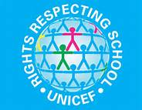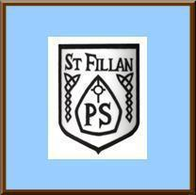
St Fillan’s Primary
School Charter
As a community we have created our School Charter to help us be happy, safe and to support us as learners.
As Adults we will: | The Article | As Children we will:
- Treat children fairly.  - Support them in their work.  - Supply children with the proper equipment | The Right To An Education  (Article 26) | - Follow the rules  - Pay attention in class  - Give best effort at all times  - Be grateful for our education
- Make school a place where children want to go to  - Provide children with a safe environment  - Help children to find a positive solution to any problem | We have a right to feel happy and safe  (Article 19) | - Respect each other  - Tell adults if there are problems  - Keep ourselves safe and do not do anything dangerous  - Be open to any ideas or solutions
- Listen to children  - Try to resolve their problems  - Use the ideas of children | We all have the right to be listened to  (Articles 12 and 13) | - Pay attention  - Look at the person who is talking  - Listen carefully to the person who is talking
- Encourage everyone to participate.  - Facilitate opportunities for all children to join groups | We all have the right to join groups (Article 15) | - Co-operate during the group  - Take advantage of the opportunities to join groups when given the option  - Behave well at all times
- Allow time to play  - Provide play equipment  - Provide adequate supervision | We all have the right to play  (Article 31) | - Play safe games  - Include everyone  - Be kind and gentle with our words and actions

