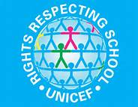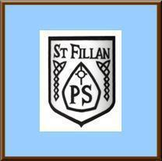
St Fillan’s Primary
Playground Charter Charter
As a community we have created our Playground Charter to help us be happy, safe and to support us as learners.
As Adults we will: | The Article | As Children we will:
- Help children if they are hurt  - Listen to and respect children  - Help children find a positive solution to their problems | The right to say what we think should happen and to be listened to  (Article 12) | - Follow the rules in the playground  - Listen to and respect all adults  - Value the opinions of other children  - Include others
- Treat each child fairly  - Provide children with a safe environment  - Help children if there is something troubling them or if they are hurt | The Right To meet with friends and join clubs  (Article 15) | - Have free choice to interact with other children  - Include as many people as possible in games  - Keep ourselves safe and not do anything dangerous
- Listen to children  - Try to resolve their problems  - Clearly guide children to what is right and what is wrong  - Make sure children are reminded of the playground charter | We have a right to feel happy and safe  (Article 19) | - Not lift our hands or feet to others  - Use positive language  - Be happy and have fun  - Play safely  - Follow adults instructions  - Not ‘play fight’
- Encourage everyone to participate.  - Facilitate opportunities for all children to have the opportunity to play and relax  - Treat everyone with respect | We all have the right to play  (Article 31) | - Co-operate during the game  - Take advantage of the opportunities to join groups and play  - Behave well at all times
- Help if children are hurt  - Provide play equipment  - Provide adequate supervision  - Encourage safe play | We all have the right to be protected from doing things that could harm us  (Article 36) | - Listen to adults  - Keep hands and feet to ourselves  - Will not get involved in rough play  - Be kind and gentle with our words and actions

