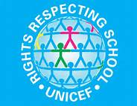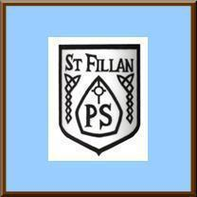
St Fillan’s Primary
Lunch Hall Charter Charter
As a community we have created our Lunch Hall Charter to help us be happy, safe and to support us as learners.
As Adults we will: | The Article | As Children we will:
- Remind children of the rountines of lunch time  - Provide appropriate bins to recycle  - Provide help when needed | Everyone who works with children should always do what is best for each child  (Article 3) | - We will put our lunch box back on the trolley  - Recycle our rubbish in the bins  - Ask an adult for help with our lunch
- Provide enough seating  - Respect and listen to all children | Learn how to use your rights as you grow up (Article 5) | - Stand quietly in the hot meal line  - Stay in the canteen when we are eating  - Use good manners to all for example: Please and thank you
- Remind children to respect others by modelling and advising  - Remind children to sit and eat properly  - Encourage you to eat as much as you can | You have the right to life and to be healthy  (Article 6) | - Respect others when eating  - Not throw food or juice  - Make sure our lunch is ordered in time  - Try minimise food waste
- Provide healthy food options  - Provide access to clean water  - Encourage less food and water wasteage  - Remind children to fill bottles are correct time to ensure learning is not interrupted. | We all have the right to good food and water  (Article 24) | - We well keep the lunch hall tiday and put away our mess  - We will try not to waste water or food  - We will fill our water bottle at lunch or play time.
- Help if children need assistance  - Provide food and nourishment  - Provide adequate supervision | We all have the right to be protected from doing things that could harm us  (Article 36) | - Listen to adults  - Respect adults in the lunch hall  - Clean up our mess after we are finished  - Follow instructions from adults

