Reading  Listen to the chapter, ‘Throwing the Hammer’ - Throwing the Hammer  Write down your likes, dislikes. puzzles and connections about this chapter. | Spelling  - Write your spelling words in any font of your choice.  2) Choose 5 of your spelling words to write 5 high quality sentences. | Numeracy  Have a go at using the bar model to solve these division questions.  - 125 divided by 5  - 324 divided by 4  - 522 divided by 2  - 636 divided by 6  - 112 divided by 7 | Times tables  Keep working on your 6 and 7 times tables.  Hit the Button
Writing  Can you write a descriptive paragraph about this character? Remember to think about the character’s looks and traits (personality). | Think outside the box  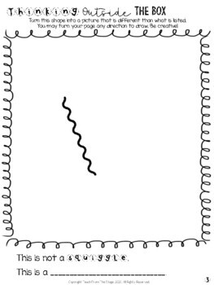 | R,E  Today is the Feast of All Saints.  For your research task I would like you to choose a Saint and find out about them. Here are a few ideas of what you could find out.  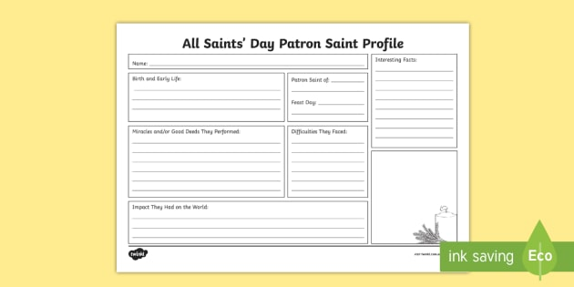 | HWB  Take some time today to practise some mindfulness. Here are a few videos to help you.  Lego  dominoes  Music

