Wednesday 1/11/23 Learning Grid
Task 1 – spelling copy each word 3 times.  green spelling  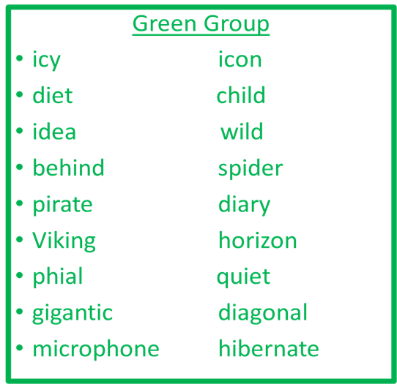  blue spelling  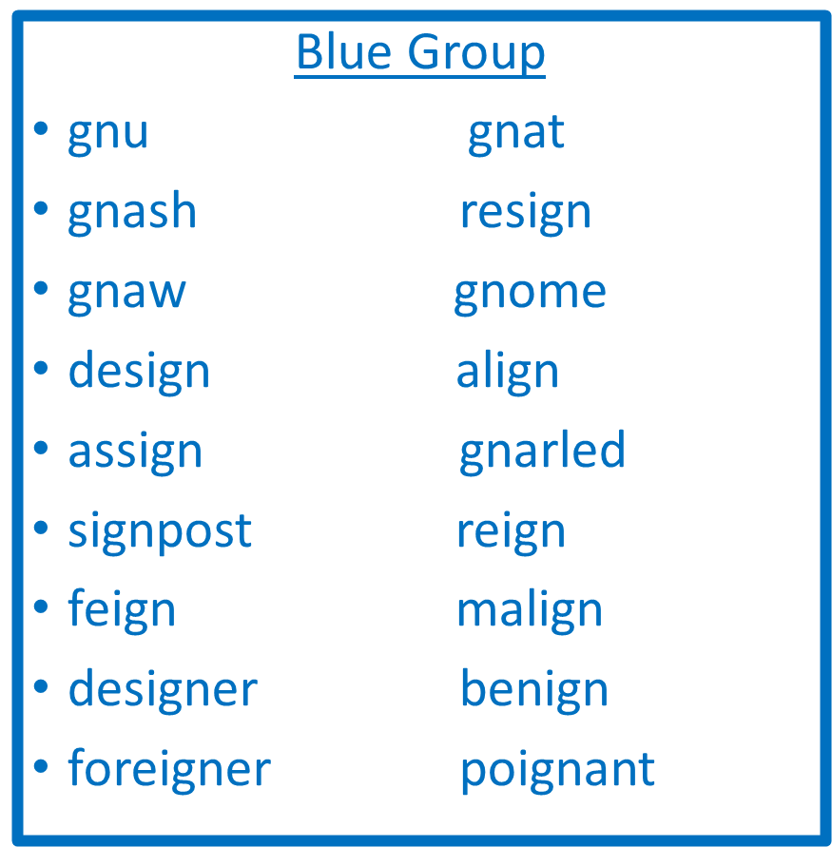 | Task 2 – fraction worksheet | Task 3 – R.E. - St Columba
 | 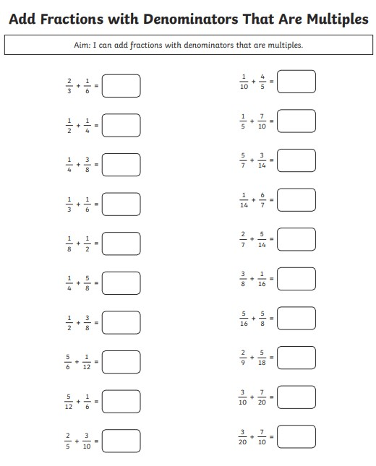 | Research task – use the following links to research St Columba and answer the following questions.  When was he born?  Where did he come from?  How many disciples did he bring with him?  What famous Scottish “animal” is he famous for banishing?  On what Scottish Island did he build an abbey?  http://www.stcolumbasculloden.org/who-was-st-columba.html  http://www.stcolumbasculloden.org/who-was-st-columba.html

