Outdoor Learning, First Level Numeracy

Learning experience

Bird Counting, Tally marks and Graphs.

CfE Level -First

Experiences and Outcomes and associated benchmarks/skills

E&Os  MNU-1-20b I have used a range of ways to collect information and can sort it in a logical, organised and imaginative way using my own and others criteria. | BMs/Skills  Asks and answers questions to extract key information from a variety of data sets including charts, diagrams, bar graphs and tables.  Selects and uses the most appropriate way to gather and sort data for a given purpose, for example, a survey, questionnaire or group tallies.
Overview of learning experience
Identifying types of birds. Using tally marks to count type of birds. Using data gathered to create graphs.

Outline of learning
LI/SC  - I can identify different types of birds  - I can create data using tally marks.  - I can sort an understand the data gathered.  - I can create a graph to display the data gathered | Resources  Bird Feeders, Whiteboards and pens, labelled picture of common birds, chalk, natural materials, sticks/stones, flowers, leaves. Camera for teacher.
Description of learning experience and assessment opportunities

(Teacher may want to put out bird feeders in the school grounds 2 weeks before this activity to attract birds to the area. Or teacher could walk pupils to an area known to attract birds.)
Pupils should be shown images of the types of birds they are likely to see in their area. Teacher to discuss with them the names of the birds, colour, likely places they will see them ie in trees/water/flying high overhead.
https://www.rspb.org.uk/globalassets/downloads/biggardenbirdwatch/2021/how-to-resources/eng_id-print_at_home--min.pdf
Pupils introduced to the use of tally marks. Teacher may wish to do some practice tasks using tally marks before using them in counting birds.
Pupils should go outside for 20mins very week for 4-6 weeks and conduct a count of the birds seen. If birds seen are not on original list pupils may wish to photograph them to identify and add to the count later.
Once gathered pupils should be asked to sort this information. Which bird did they see most of? Which bird did they see least of? They may be able to sort the birds in order from most to least spotted.
Pupils could then create graphs from their data. These could be made from natural materials in the playground. Teacher to photograph these for evidence/assessment purposes.
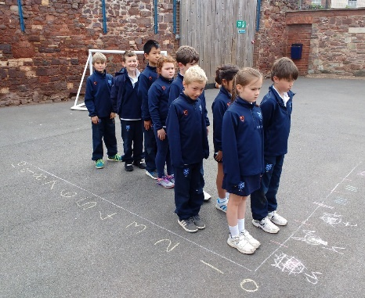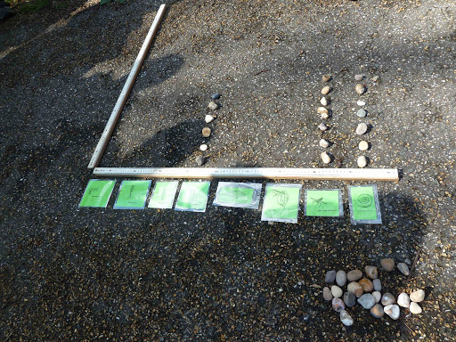

Consideration of risk
Pupils foraging for materials may find sharp sticks, thorns, guidance should be offered to pupils on what to avoid before foraging begins. If going for a walk outside school grounds, adult pupil ratios, traffic etc should be considered.
Taking it further – what else could you do?
Talking pupils a walk to gather materials.
Doing research on the types of birds most commonly seen or to identify additional birds seen.
Using tally marks for different purposes.
Making different types of graphs to show the same info and comparing which is the best.
Set a task to improve the numbers or types of birds in the school environment. (bird habitats for different types of birds or less food waste to discourage crows/seagulls?)

