Outdoor Learning, First Level Literacy

Learning experience

Read/hear a story/poem/diary entry, make a character, create the scene, write a new story/poem/diary entry.

CfE Level -First

Experiences and Outcomes and associated benchmarks/skills

E&Os  Lit 1-04a As I listen or watch, I can identify and discuss purpose, key words and main ideas of the text, and use this information for a specific purpose.  Lit 1-09a When listening and talking with others for different purposes, I can exchange information, experiences, explanations, ideas and opinions, and clarify points by asking questions or by asking others to say more.  (If making this into a writing task also can include Lit 1-20a, 1-21a, 1-22a, 1-23a, 1-24a) | BMs/Skills  Identifies the purpose and main ideas of spoken text and uses then information gathered for a specific purpose.  Communicates clearly and audibly.  Contributes to group/class discussions, engaging with others for a range of purposes.  Selects and shares ideas/information using appropriate vocabulary in a logical order.
Overview of learning experience
Chose a story to be read. Use natural materials to make a character from the story. Use natural materials to make the scenery from the story. Write a different version or the next chapter for the story. This could be one long lesson or a series of 3 connected lessons.

Outline of learning
LI/SC  - I can make a character from natural materials  - I can create a scene from a story using natural materials  - I can create and act out a story given a character and a scene.  - I can write a story about a character in a scene. | Resources  Natural Materials: sticks, leaves, clay, flowers, stones, chalk or whiteboards and pens. Camera for teacher to record evidence.
Description of learning experience and assessment opportunities

Chose a piece of text and read to the class.

Task one is to make the main character from the text from natural materials. Depending on location you could collect and provide these materials or pupils could collect materials from school grounds or you could go on a walk to collect these materials. Teacher to model a possible way to make the character. Discuss the main features of the character to be made. Pupils could make individual characters or in a group. Photos to be taken of the pupils final character models.
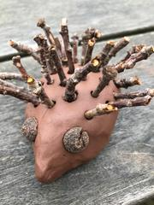
Task two is to make the scenery of the text from natural materials. Again these materials could be provided or foraged for. Teacher to model how the scenery could be made. Again discuss possible features of the scenery either included in the original text or from pupils ideas. Ask pupils to consider what kind of story could take place with the character in this scenery. Photos to be taken of scenery created. 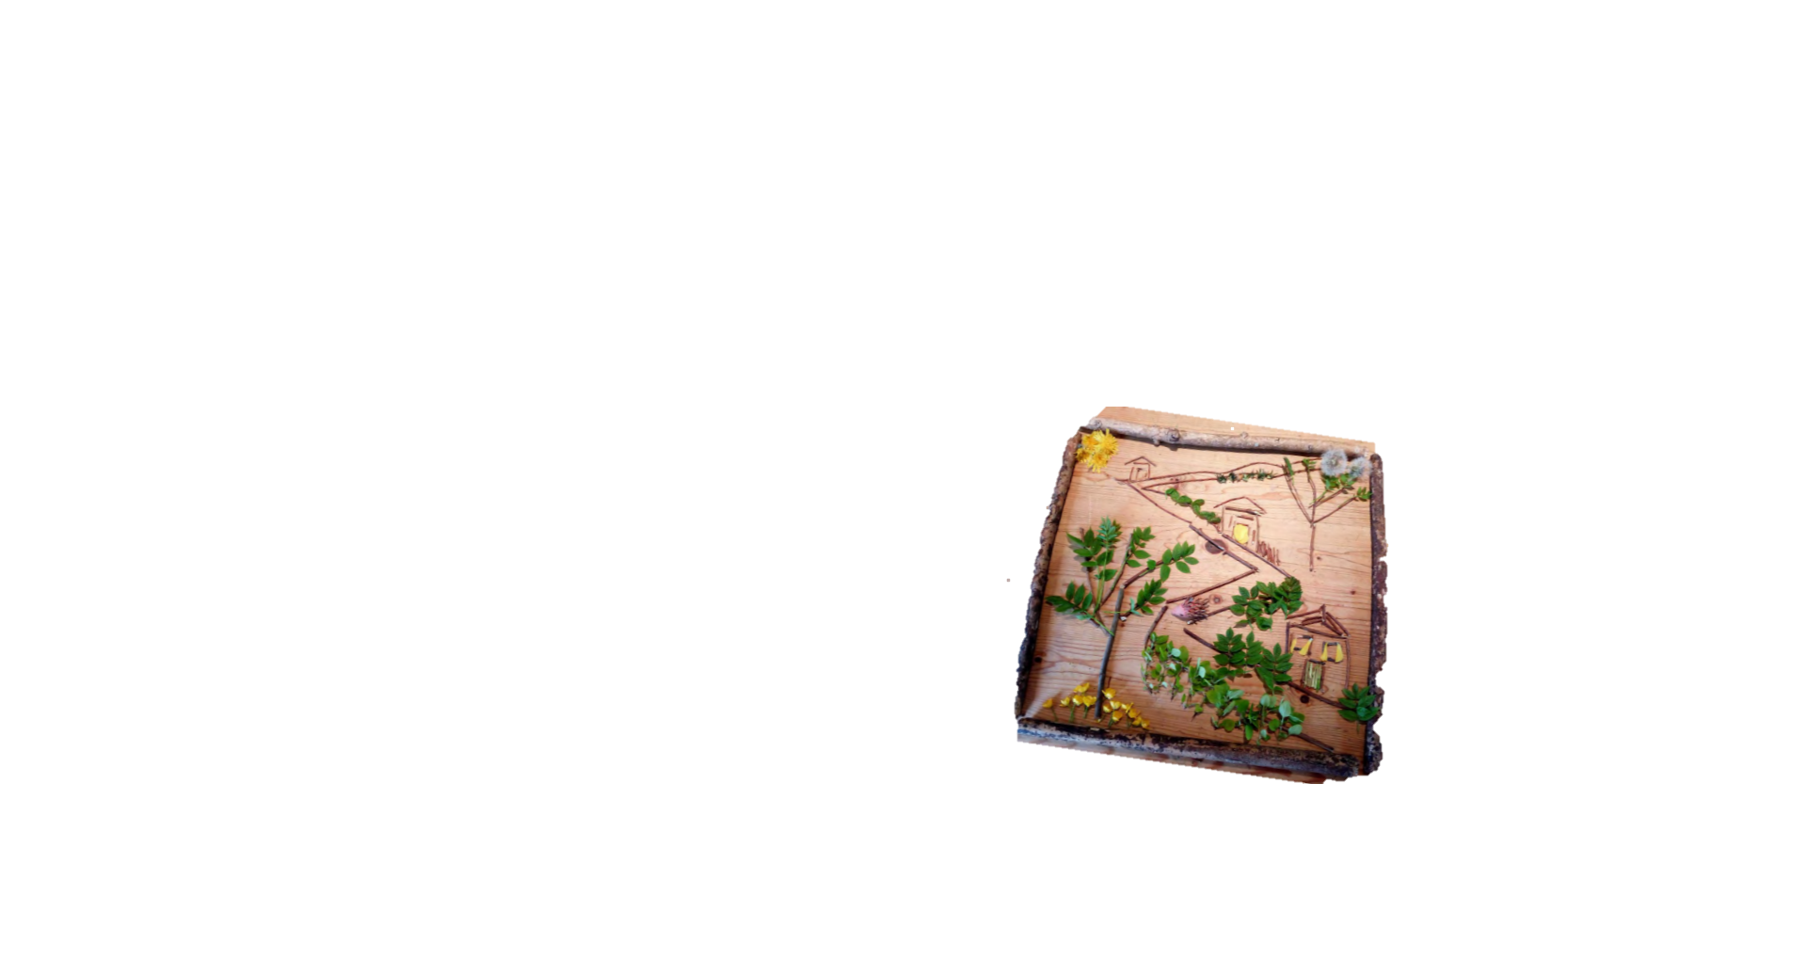
Task three is to write a new text using the character and the scenery created. (if these lessons take place as separate tasks it may be useful to print the scenery photos to jog pupils memory about what they created.) This could be done in groups and acted out, written on the playground using chalk, written on whiteboards or a combination of all 3. Pupils writing could be photographed or could be used to form the bones of a writing piece back in class.

Consideration of risk
Pupils foraging for materials may find sharp sticks, thorns, guidance should be offered to pupils on what to avoid before foraging begins. If going for a walk outside school grounds, adult pupil ratios, traffic etc should be considered.
Taking it further – what else could you do?
Talking pupils a walk to gather materials.
Using the tasks as inspiration for a longer writing piece.
Do some factual research on the character or for the storyline created.
Create different genre or types of writing, poems, diary entries.
Discuss script writing for a play, speech, stage directions.
Create music to go along with the performance by using natural materials to make sounds.
Create costumes for a performance of the plays created.

