St. Charles’ Primary School
Rowan Street
Paisley
PA2 6RU

Tel: 0300 300 0181

Children’s Services

Web site: www.st-charles.renfrewshire.sch.uk
E Mail: stcharlesenquires@renfrewshire.gov.uk
Acting Head Teacher: Judith Kirk
Director of Children’s Services: Steven Quinn
Cotton Street: 03003000170

Date: 19.03.2020

Dear Parents
We would like to thank you for your support at this difficult time. We appreciate how worried parents and carers will be about the continuity of learning for all of our children.
We have put together a paper pack of work for every child, but most of the work the children will be expected to do will be directed by class teachers through Google Classroom and Seesaw. Every child has been issued with a Glow log on. If parents have not accessed Seesaw, the barcode will be sent home in the pack for parents to access the App. Please make sure you do this as it is vital for communication.
Senior management will also be part of the Google classrooms and while children are expected to comment and feedback to the teacher, please tell your children that they should not post TikTok videos or silly comments on the page. They should behave the same way as they would at school. Parents will be contacted if children do not follow the rules on this social media platform.
There will be daily uploading of learning for all children from their class teacher on-
Google classrooms and/or Seesaw
Accessing Google Classroom at home via Glow
- Type Glow into Google search bar or enter link
https://sts.platform.rmunify.com/account/signin/glow
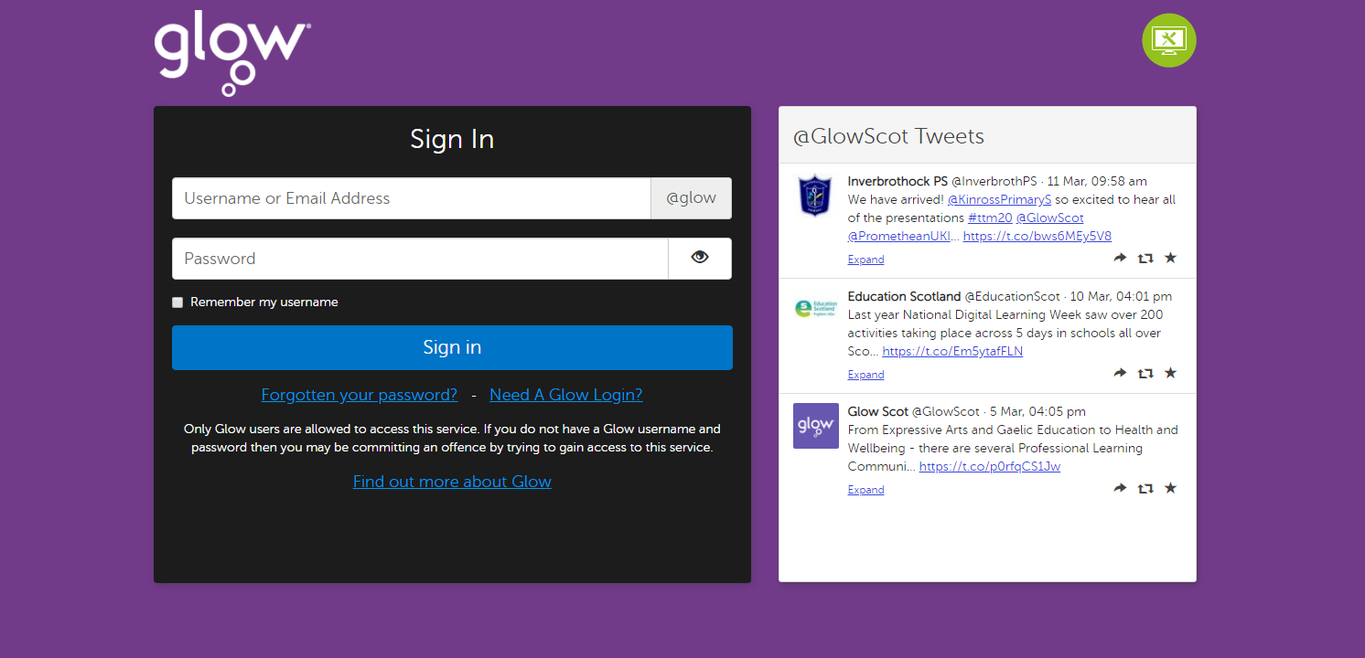

- Enter email address and password.
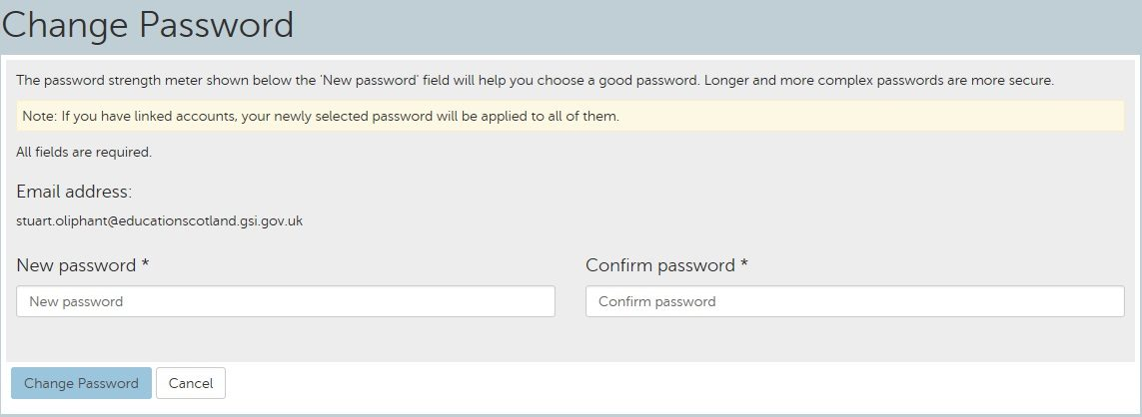
- You may be asked to reset your password.

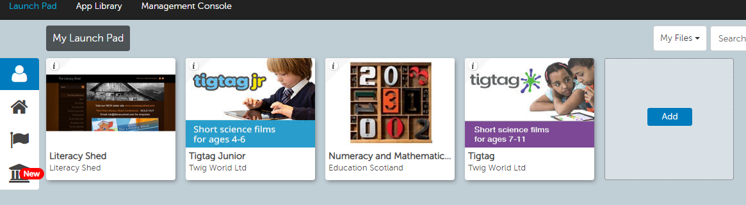
- After logging in you will be taken to your launch pad.

Click on the home icon.

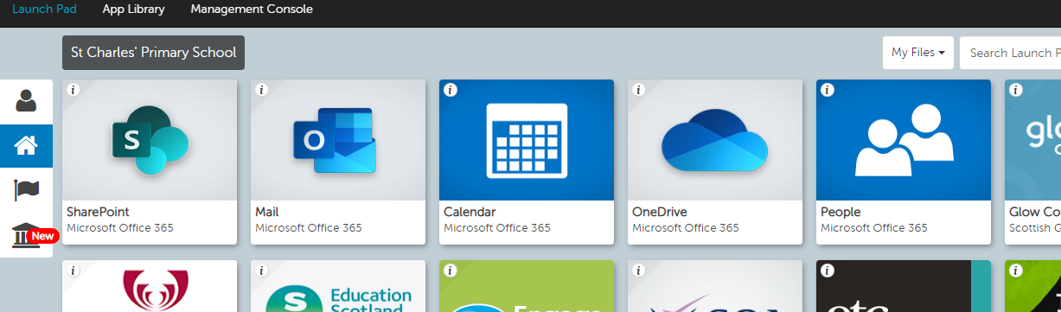

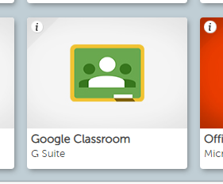
Scroll to the bottom to find Google Classroom.

- A classroom should appear on your dashboard. Please click to join.
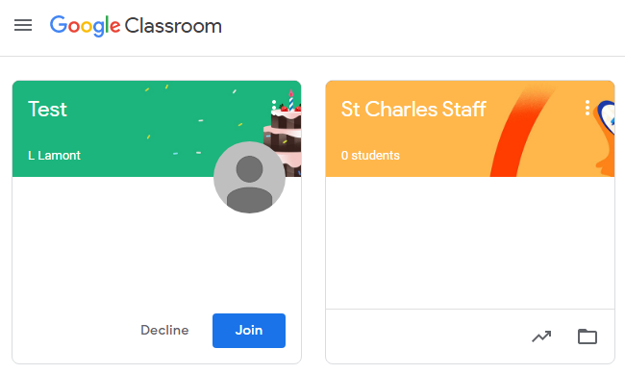

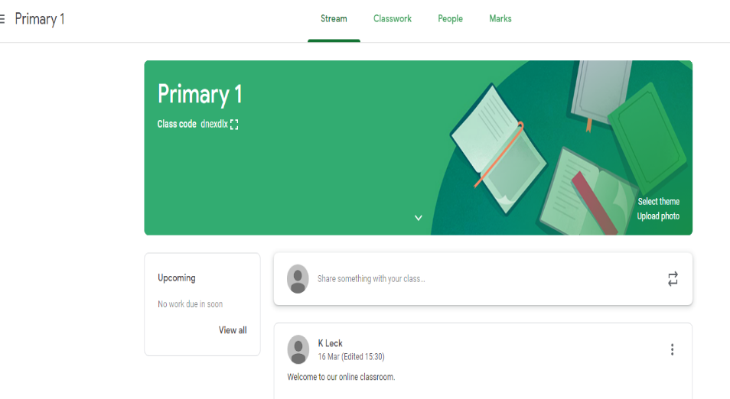
- Once you have accepted you will have access to the classroom. Posts will be avaliable to view on Stream.

Teachers will communicate a few times a day through GLOW email.
Follow steps 1-4 above and then click on the mail icon to access emails

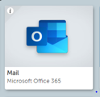

Downloadable free resources are also available for children’s learning-
www.Topmarks.co.uk | www.educationcity.co.uk  User name- stcharles1  Password - primary | www.sumdog.co.uk
www.twinkle.co.uk | www.Sparklebox.co.uk | www.Teacherspet.co.uk
www.starfall.com | www.duolingo.com  languages | www.Twinkl.co.uk  code – UKTWINKLHELPS
www.youtube.com/use/CosmicKidsYoga Cosmic Yoga | www.youtube.com/user/thebodycoach1 Joe Wicks - 5 min workout
We also have a new school App. Please download this as it will be an important means of communication. It is called School App for Parents. There is a banner on the school railings and there will be a flier in the teaching packs. Please scan the QR code to download.

The school will contact parents through the App, Seesaw, Glow Classroom, the school website, Twitter and Facebook. We will keep you updated as we receive information.
Please take care of yourself and your family and loved ones. We hope to see you all again very soon.
Kind Regards
Judith Kirk
Head Teacher (Acting)

