Contents
Contents 1
Welcome from the Director of Children’s Services 4
Welcome from the head teacher 5
School aims 6
Service Pledges 8
Standards and expectations 8
About our school 10
School staff 10
School information 12
School day 12
School year 13
School in-service days 13
School dress 14
Registration and Enrolment 15
Induction procedures for pupils starting school and their parents 16
Class Organisation 16
Assessment and reporting 16
Summary of the School Improvement Plan 17

The Scottish Attainment Challenge 18
Transfer to secondary school 18
Nursery class of St Charles’ Primary 18
Nursery Class Provision 18
Admission to Nursery 19
Transfer from Nursery to Primary 19

Car Parking 19
Care and welfare 19
School security 19
Attendance and absence 20
Bullying 20
Safeguarding including Child protection 21
Mobile phones 21
School meals 22
School transport 22
Pick-up Points 23
Placing Requests 23
Assisted support needs 23
Playground supervision 23
Pupils leaving school premises at breaks 23
Equalities 23
Medical and health care 24
Religious Observance 24
Behaviour and discipline 25
Wet weather arrangements 25
Curriculum matters 26

Getting it right for every child (GIRFEC) 29
Additional support for learning 29
Inclusion 29
Support 29
Universal support 29
Targeted support 30
Educational Psychology Service 30
Health and Wellbeing Education 31
Specialist support service – teachers teaching in more than one school 31
Homework 32
Enterprise in education 32
Extra curricular activities 33
Home school community links 35
Parental Involvement 35

Home school links 36
Pupil council 37
Community links 37
School lets 37
Other useful information 38
Listening to learn - complaints, comments and suggestions 38
Data protection 38
Information in Emergencies 39
Important Contacts 40
Websites 41
Glossary 42
Parent feedback 43
Tell us what you think 44

Dear parents,
Schools are a vital part of every community, and in Renfrewshire we want all children to have a chance to succeed. Through the Council’s work with the Tackling Poverty Commission and as an Attainment Challenge authority, we are already seeing increases in pupil attainment, more young people going on to employment, training, or further and higher education after leaving school and a reduction in exclusions.
More and more, we are working in partnership with others as we work towards getting it right for every child. As a Council, we are ambitious for the children and young people of Renfrewshire.
This handbook outlines the current policies and practices of the Council and the school. At the back of the handbook, you’ll find details of other websites which may be of interest. You can also find information about schools in Renfrewshire on the Council’s website.
I hope you find this handbook a useful source of information about education in Renfrewshire and about your child’s school in particular.
Yours sincerely
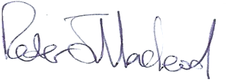
Peter Macleod
Director of Children’s Services

Welcome from the Head Teacher

Dear Parents/Carers,

The purpose of this handbook is to provide you with useful and interesting information regarding Saint Charles’ Primary School: our aims, our values and the educational opportunities on offer.
The information contained is not exhaustive therefore if any questions remain unanswered after reading the handbook please do not hesitate to contact the school to arrange a meeting.
Parents are always welcome to visit our school or speak with the staff about any aspect of their child’s education, as ultimately true success for children can only be achieved, when home and school work together.
I look forward to working with parents, in genuine partnership, to support all learners in our school community.

Yours sincerely
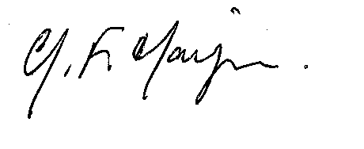

Grace F.Hannigan
Headteacher

School aims
Our vision, values & aims
Our vision is that all children are safe, happy, and confidently engaged as learners in an environment where all individuals are respected; where the message of Christ is central in all that we do; where parents and carers are highly valued as partners and where everyone is motivated and encouraged to do their very best.

In St. Charles’ Primary School.......
We value GOD'S LOVE
We will endeavour to live our lives according to the life & teachings of Jesus Christ.
We will demonstrate our faith in words & actions, through prayer & worship. We value INCLUSION
We will recognise and celebrate our own uniqueness and that of others.
We will encourage everyone to develop in their own individual way.
We value EACH OTHER
We will listen to and appreciate the opinions and contributions of others.
We will show consideration and kindness to others, especially those in need. We value RESPECT
We will treat each other, with kindness & courtesy, as we would like to be treated.
We will be mindful of the feelings of others & try to make our school a happy place for all.
We will take care of ourselves, each other, our property & surroundings.
We value HONESTY We will always be truthful & accept ownership of our own words and actions.
We value HARD WORK
We will strive enthusiastically to do the best we can in all that we do.
We will take pride in our achievements.
We value RESPONSIBILITY
We will be responsible for our own actions and consider the effect of these on others.
We will actively participate in the life of our school, parish, local and wider community.

Our aims are-
- To provide a broad general education that meets the needs, expectations and aspirations of pupils and parents supported by well-trained motivated staff and well organised modern education resources.
- To create a welcoming atmosphere and a positive ethos, allowing all children to be educated according to their needs in a safe, secure, happy and health-promoting environment based on Christ’s Gospel values

- To enable learners to realise their full potential through the provision of high quality learning opportunities which encourage independence & co-operation in learning.

- To support children’s growth in all aspects of their intellectual, physical, spiritual, social and emotional development affording all children equality of opportunity.

- To ensure all pupils value learning & achievement and are motivated to participate in the wider life of the school community.
- To provide highly effective personalised support for learners to minimise the impact of potential barriers to learning.

- To develop a genuine partnership with parents & other service users where every member of the community holds a deep respect for all others and their personal wellbeing and happiness.

- To ensure the school’s approach & commitment to improvement through self-evaluation, and high quality leadership at all levels, maximises pupil attainment & achievement.

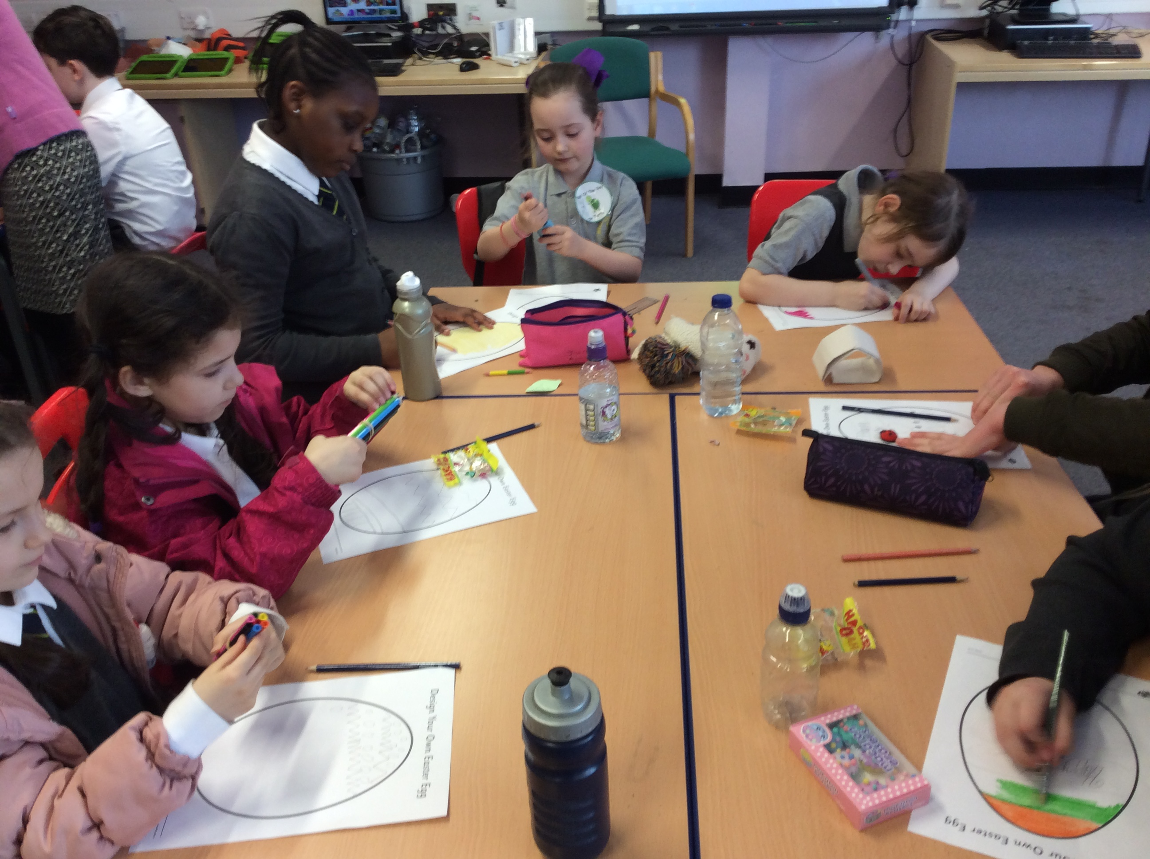

Service Pledges

Standards and expectations
We will:
- offer all children and young people in our catchment area a free school place;
- provide school premises which meet health and safety standards;
- provide information on your child’s progress;
- provide religious and moral education for your child;
- give support and encouragement for parents to be involved in school life;
- provide regular information on school activities; and
- provide 25 hours of class contact time in each normal school week for pupils of primary-school age.

Pupils will have opportunities for:
- personal and social development;
- music, cultural activities and creativity;
- access to healthier lifestyles and sports activities; and
- community involvement.

You can also expect us to:
- provide a formal written report on your child’s progress;
- provide an annual report on progress within the school improvement plan;
- give you an opportunity to have a formal meeting with your child’s class teacher or teachers;
- strive to meet your child‘s needs; and
- provide regular reports on the quality of the school.

How can you help?
By law, you must make sure your child receives education.
As a parent, you can help your child by:
- making sure your child goes to school regularly;
- encouraging and supporting your child with any homework given;
- showing that you are interested in how your child is getting on at school;
- encouraging your child to respect the school and the whole school community; and
- being involved in the school.

The Act uses the broadly framed definition of ‘parent’ set out in the 1980 Act. This is as follows:

“Parent” includes guardian and any person who is liable to maintain or has parental responsibilities (within the meaning of section (13) of the Children (Scotland) Act 1995) in relation to, or has care of a child or young person;

This is a wide definition which might, by way of example, include:

- non-resident parents who are liable to maintain or have parental responsibilities in respect of a child;
- carers who can be parents;
- other with parental responsibilities, e.g. foster carers, relatives and friends who are caring for children and young people under supervision arrangements; and
- close relatives, such as siblings or grandparents caring for children who are not looked after or are under home supervision arrangements

Everyone who is a parent, as defined in terms of the 1980 Act, has rights under the Act. This includes the right to receive advice and information about their child’s education, general information about the school, to be told about meetings involving their child, and to participate in activities, such as taking part in decisions relating to a Parent Council. Education authorities and schools should treat parents equally, the exception to this general requirement being where there is a court order limiting an individual’s exercise of parental rights and responsibilities. It is for education authorities to advise schools on the application of these rights in individual cases.

About our school

School staff
Head Teacher Mrs Grace Hannigan

Depute Head Teachers Mrs Judith Kirk (Nursery, P1 – P3)
Mrs Yvonne Kinsella (P4 – P7)
Principal Teachers Mrs Angela Dolan & Mrs Pauline Kelly

Teachers
P1 Mrs Lynne, Ferguson, Mrs Anne Copstick & Mrs Lynne Flanagan/Mrs Pauline Kelly
P2 Mrs Courtney West & Miss Lynsey Milne
P3 Mrs Catherine Powrie & Mrs Susanne Stevenson/Mrs Anne McGarvey
P4 Mrs Angela Ferguson & Miss Sharon Hanlon,
P4/5 Miss Lauren Lamont/Miss Sara Kelly & Miss Lori Anne Tormey
P5 Mrs Anji Roddy
P6 Mrs Siobhan Wilson & Miss Katie Leck
P7 Mrs Laura Armstrong & Mrs Angela Dolan/Mrs Michelle Ward
NCCT Teachers Mrs Martha Tormey & Mrs Samaira Asghar

Family Worker Catriona Blackmore

Nursery
Senior Nursery Officer Miss Shameela Tariq
Nursery Officers - Butterfly Room: Mrs Micheline Caldwell, Mrs Carol Ann McWilliams, Miss Julie McFarlane, Mrs Nicola Cavanagh & Mrs Debbie Brown
Nursery Officers – Busy Bee Room: Miss Rachael Daly & Mrs Kathleen Ferguson
Support Staff: Mrs Janie Bryce, Mrs Margaret Winters, Mrs Lesley Girvan, Mrs Anne Dineen & Mrs Linsey Schneider

Janitor Mr Brian Wilson
Catering Manager Mrs Esther Reid

School Office
Senior Clerical Officer Ms Carol-Anne Kerr
Clerical Assistants Mrs Carol Howe & Mrs Kathleen Collins (P/T)
Service Delivery Officer Mrs Joanne Duffy
Team Leader Mrs Carolyn Stewart

Visiting Specialists
EAL Support Mrs Hazel Douglas
LAC Teacher Mrs Pamela Higton
Instrumental Teacher Mr Michael Howie
Home Link Worker Ms Ashley Lavelle

School information

School day
Opening 9am
Interval 10.30am – 10.45am
Lunch – P1, 2 & 7 12.15pm – 1.00pm
P3, 4, 5 & 6 12.30pm – 1.15pm

Primary 1 pupils attend school on a full-time basis from the first day of term.

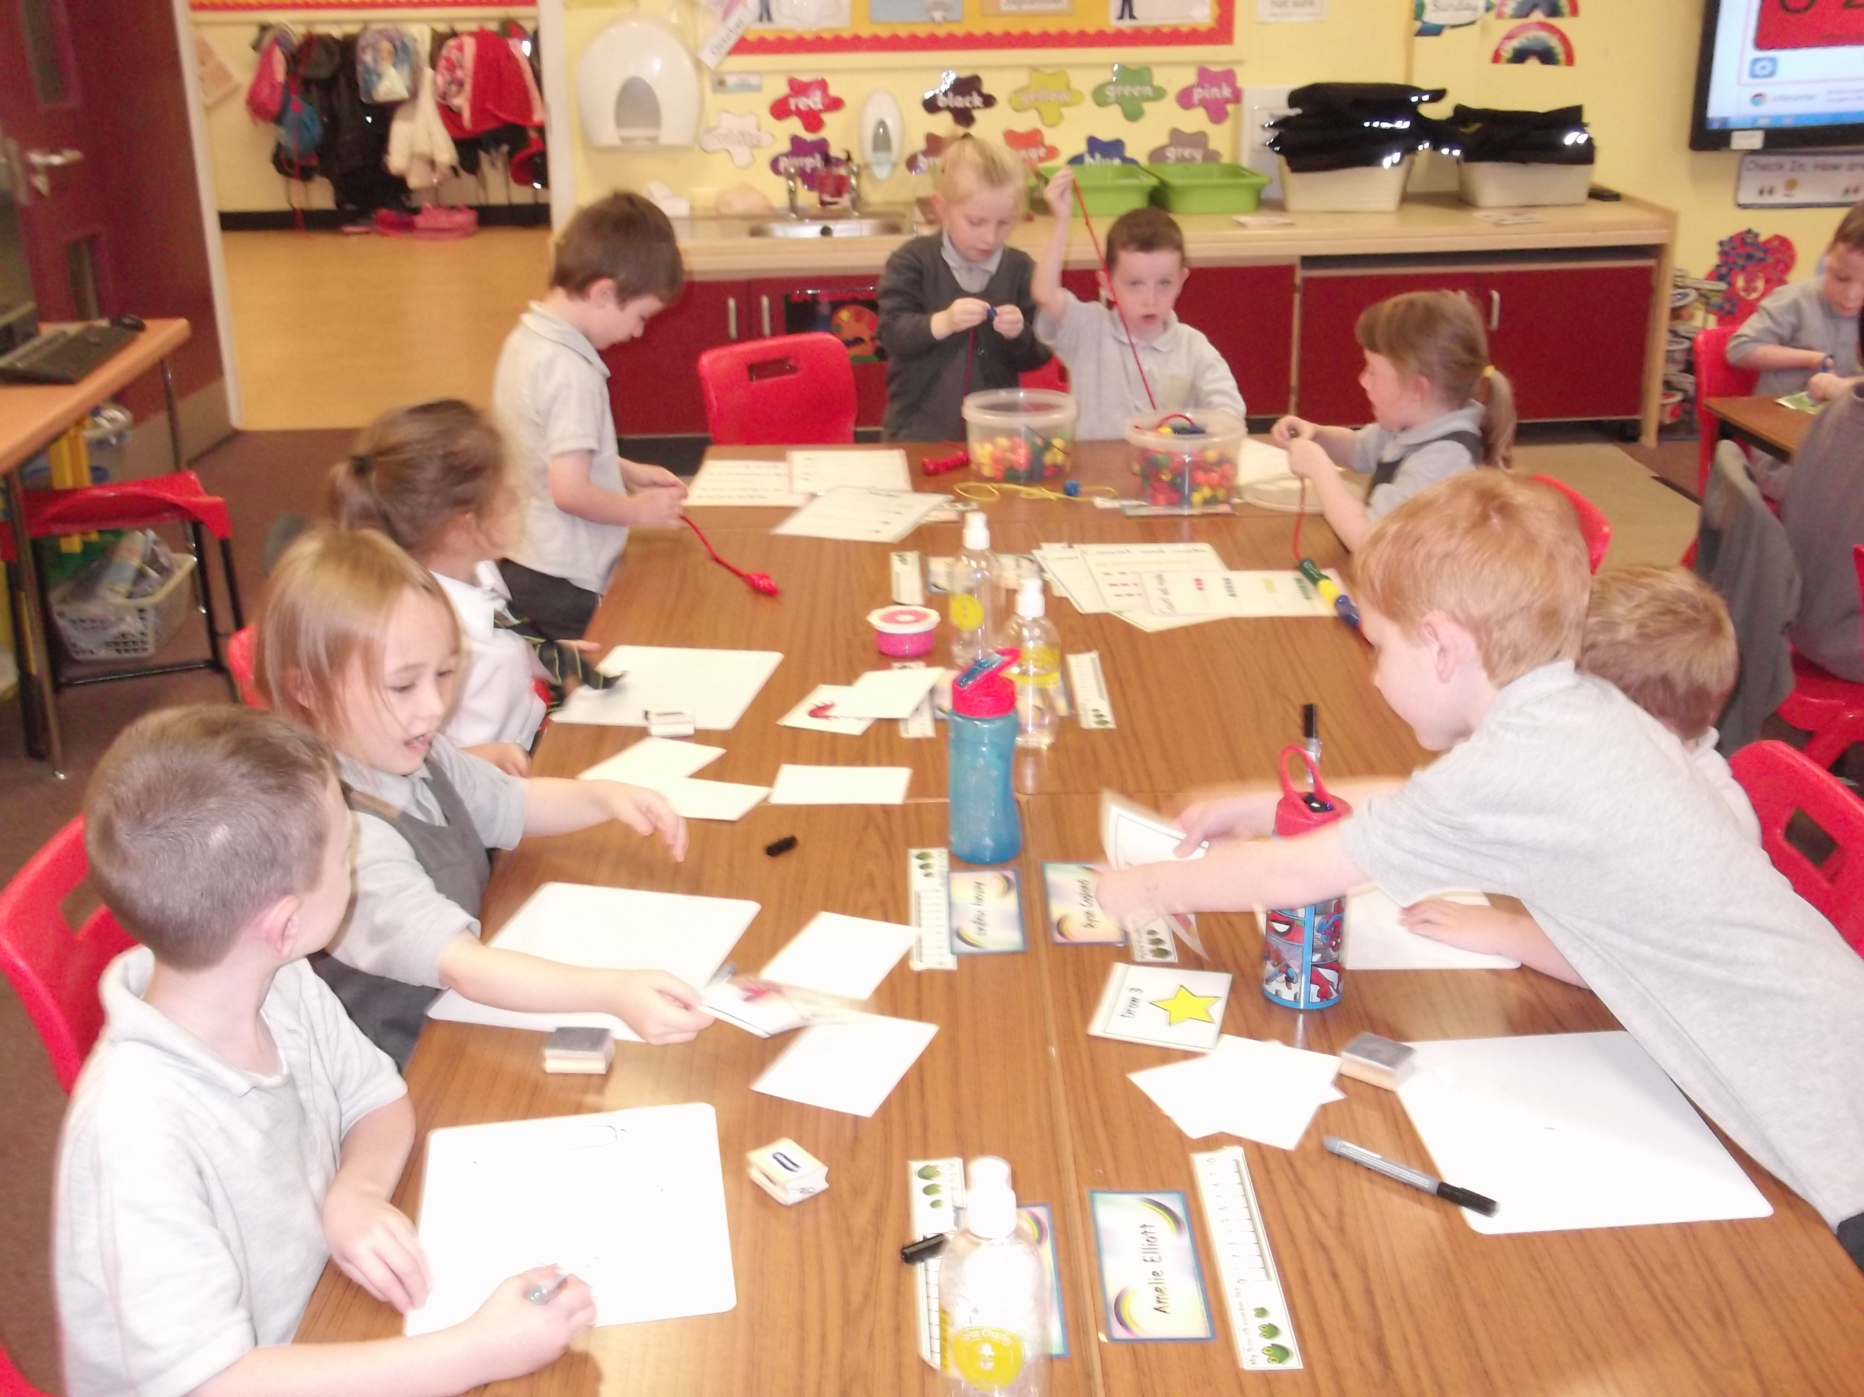
School year
First Term | Return date for Teachers | Tuesday 13 August 2019 (IS)
 | In-service Day | Wednesday 14 August 2019 (IS)
 | Return of Pupils | Thursday 15 August 2019
 | September Weekend | Friday 27 September 2019 and Monday 30 September 2019 (inclusive)
 | In-service Day | Friday 11 October 2019 (IS)
 | Schools closed | Monday 14 October 2019 to Friday 18 October 2019 (inclusive)
 | Schools re-open | Monday 21 October 2019
 | St Andrew's Day | Monday 02 December 2019
 | Schools re-open | Tuesday 03 December 2019
 | Christmas / New Year | Monday 23 December 2019 to Friday 3 January 2020 (inclusive)
Second Term | Schools re-open | Monday 06 January 2020
 | In-service day | Friday 07 February 2020 (IS)
 | Mid Term break | Monday 10 February 2020 to Tuesday 11 February 2020 (inclusive)
 | Schools re-open | Wednesday 12 February 2020
 | Spring Holiday | Friday 03 April 2020 to Friday 17 April 2020 (inclusive)
Third Term | Schools re-open | Monday 20 April 2020
 | In-service Day | Friday 01 May 2020 (IS)
 | May Day | Friday 08 May 2020
 | Schools re-open | Monday 11 May 2020
 | May weekend | Friday 22 May 2020 and Monday 25 May 2020 (inclusive)
 | Schools re-open | Tuesday 26 May 2020
 | Last day of session | Friday 26 June 2020

Teachers return Wednesday 12 August 2020.

School in-service days
- Tuesday 13 August 2019
- Wednesday 14 August 2019
- Friday 11 October 2019
- Friday 07 February 2020
- Friday 01 May 2020
- Two additional in-service days to be confirmed

School dress
Renfrewshire Council encourages each school to adopt a dress code after discussion with parents, pupils and the parent council. The council supports an agreed dress code because of the benefits it brings, including improvements in safety, security, discipline, ethos and community spirit, and a decrease in bullying and expense for parents.
Some types of clothing will not be allowed in school for reasons of safety, decency or indiscipline. Types of clothing which will not be allowed include:
- clothes which are a health or safety risk;
- clothes which may damage the school building;
- clothes which may provoke other pupils;
- clothes which are offensive or indecent; and
- clothes which encourage the use of alcohol or tobacco, or other inappropriate substances.
Pupils will not be deprived of education, any benefit or access to examinations because of not wearing school uniform.
In St. Charles’ Primary School parents are asked to provide their children with the following items of school uniform.
Grey trousers/skirt, white shirt & school tie, white polo shirt, grey jumper/sweatshirt/cardigan, grey blazer with school badge.
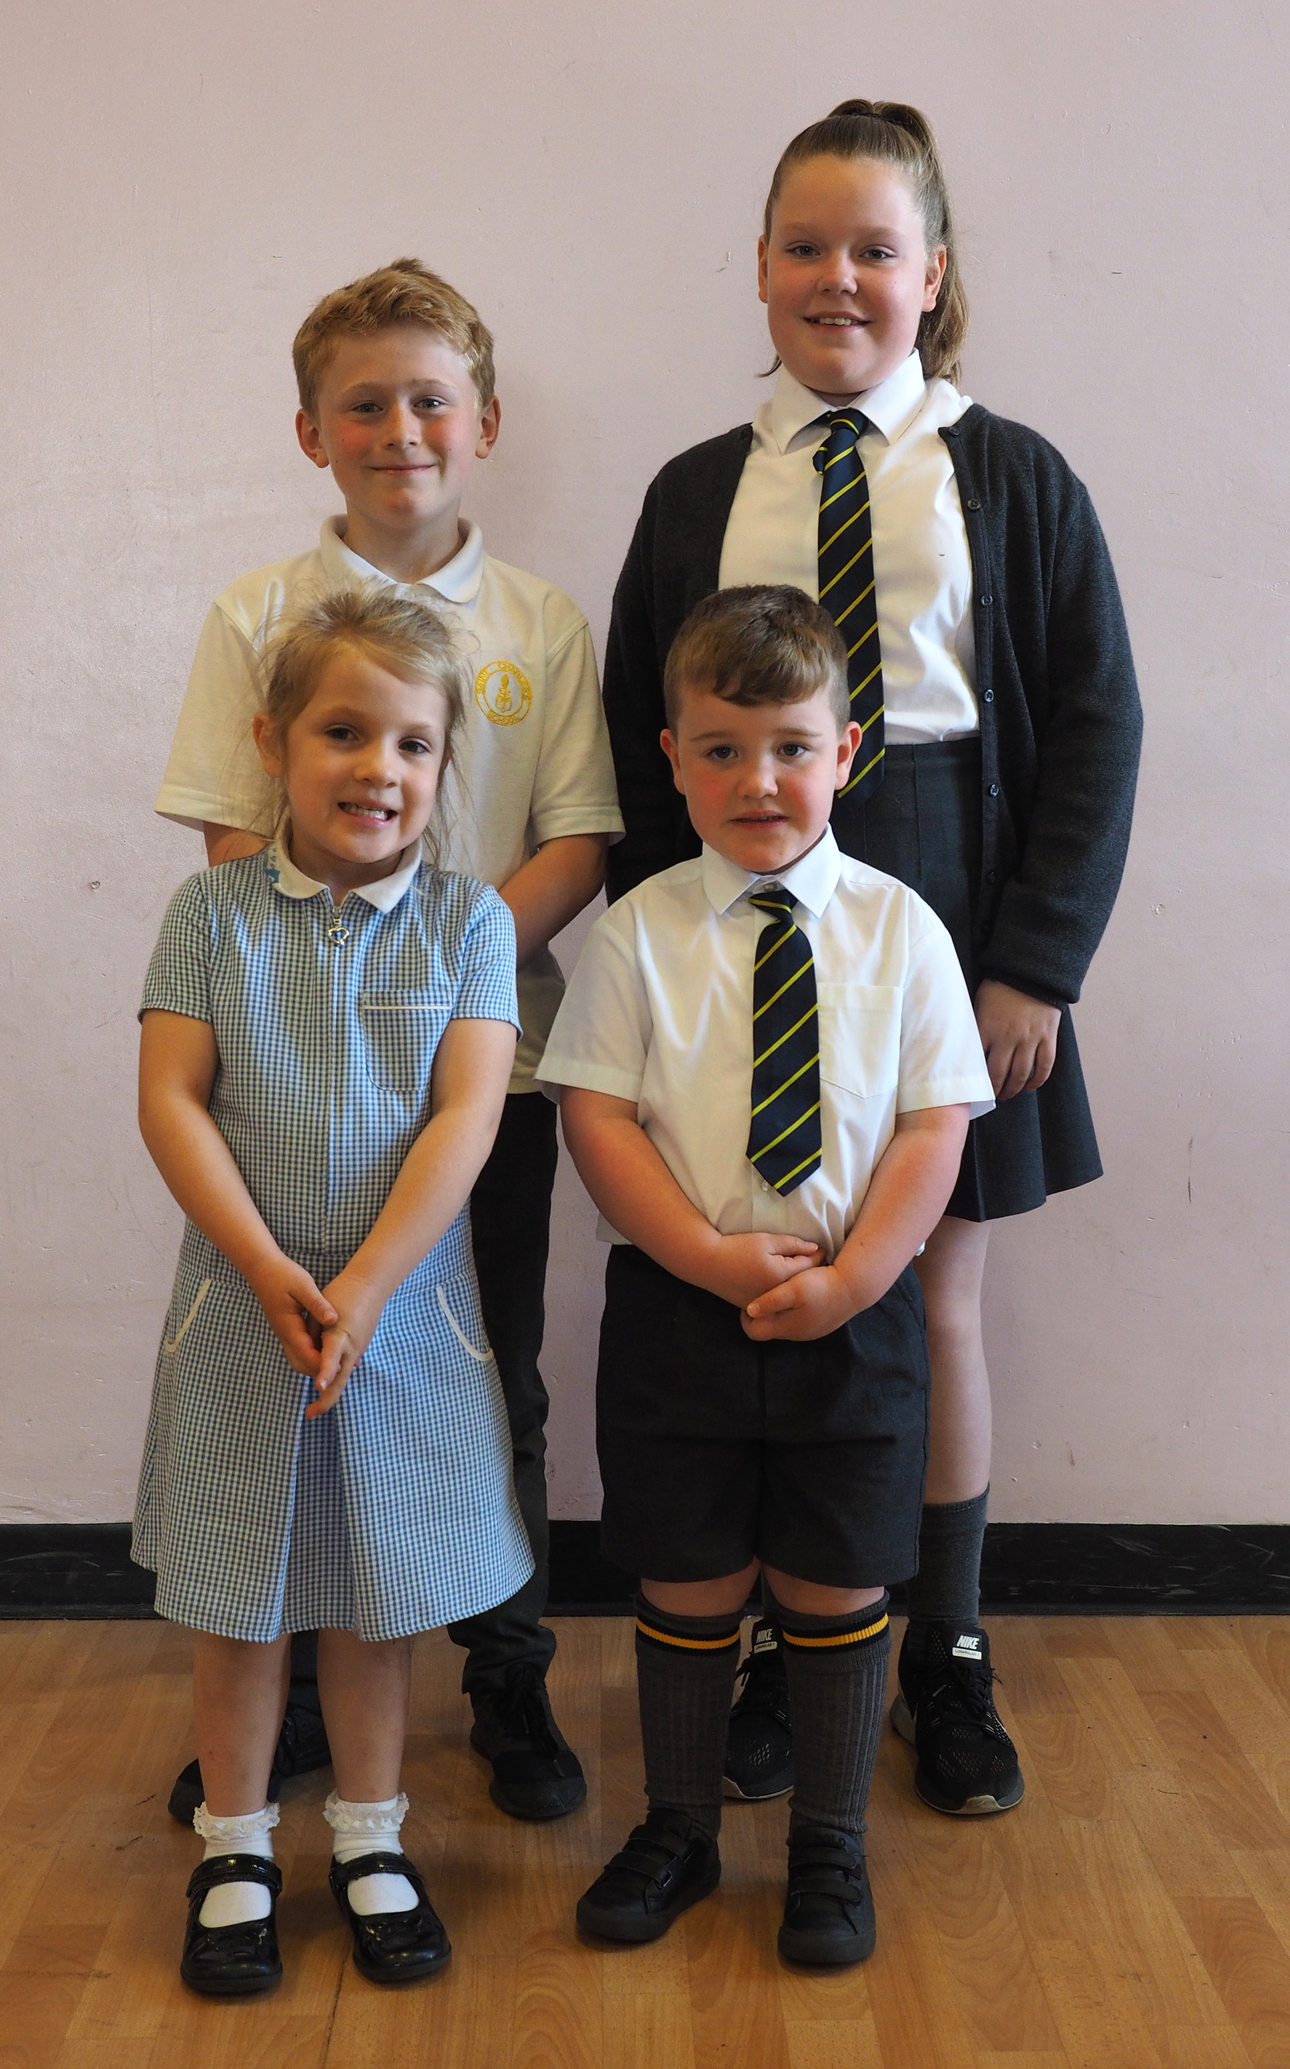
Summer Uniform

Between the beginning of May and the end of September, parents may dress their children in the summer uniform. This is optional and will depend on weather.
The summer uniform is:

Grey shorts, white polo shirt, blue & white gingham dress.

P.E. Uniform

Children should wear black shorts, white polo-shirt/tee-shirt and sandshoes or training shoes during Physical Education lessons.

In the interests of health and safety, of both individual and others present, all jewellery, including body jewellery, must be removed before taking part in physical education lessons or physical activities.
Grants for footwear and clothing for children are available to parents receiving certain benefits. Please see the council’s website: http://www.renfrewshire.gov.uk/Freeschoolmealsandclothinggrants
Information and application forms for free school meals are available from schools, registration offices and customer service centres. A form can be downloaded from the council's website: http://www.renfrewshire.gov.uk/Freeschoolmealsandclothinggrants
Please help the school and the education authority by making sure that pupils do not bring valuable or expensive items of clothing to school. The council has no insurance to cover the loss of valuable items.

Registration and Enrolment
The date for registration of new school entrants is advertised in all local nurseries, national and local press and on the council’s website www.renfrewshire.gov.uk. It is normally in January each year. Pupils should be registered in only one school for their catchment area. Parents will be provided with information about the school when they register their child.
Parents who want to send their child to a school other than the catchment school must make a placing request. Information on how to make a placing request is contained in the leaflet ‘Sending your child to school.’ The leaflet is available from any school, by phoning our customer contact centre on 0300 300 0300, or on our website www.renfrewshire.gov.uk. It is important to note that a successful placing request into a primary school does not guarantee a successful placing request when a child is transferring to secondary school.
Parents of pupils who have moved into the catchment area or, who wish their child to transfer to the school, should contact the school office for information.

Induction procedures for pupils starting school and their parents
Parents will be advised of parent meetings and pupil induction days during the spring and summer terms.

Class Organisation
St. Charles’ Primary School is a co-educational school, catering for both boys and girls. The school meets the needs of the Roman Catholic community of the south end of Paisley and the Hawkhead Estate. The Head Teacher organises classes and these are subject to annual review.
It is important to note that class structures are determined by the number of pupils enrolled at each stage.
Maximum class sizes are as follows
- Primary 1 - 25 pupils
- Primaries 2 & 3 - 30 pupils
- Primary 4 - 7 – 33 pupils

St. Charles’ Primary School has an established tradition of composite classes.
The maximum number of pupils in a composite class is 25.
The current school roll is 404 pupils organised across 15 classes.

Assessment and reporting
Assessment is an integral part of learning and teaching. It helps provide a picture of the learner’s progress and achievements, and identifies the next steps in learning. Assessment includes supporting learning, learner engagement and ensuring appropriate support. Information on learners’ progress is gathered through planned assessments and this information is recorded. This allows teachers to have a clear picture of how learners are progressing. It will also allow teachers to identify next steps in learning and inform reporting on progress and achievement.
Pupil progress reports to parents provide clear, positive and constructive information about their child’s learning and progress, reflecting on what has been achieved against standards and expectations. The school holds two formal parent evenings each year & provides an annual written progress report for each learner. There are many other opportunities each year for parents to share in their child’s progress and achievements.

Summary of the School Improvement Plan
As part of Children’s Services, St Charles’ Primary School & Nursery has developed an establishment improvement plan which provides a framework for how we intend to achieve Children’ Services’ vision of working together to get it right for children, families and communities – Protecting, learning, achieving and nurturing.
Children’s Services has an agreed set of priorities which we will work towards:
- We are reducing inequalities and delivering improved outcomes for children and young people;
- High quality learning and teaching and quality of care is taking place in all our schools and establishments;
- Self-evaluation and performance improvement are embedded throughout services;
- Levels of attainment and achievement are improving for all children and young people;
- High numbers of our young people are entering positive and sustainable post-school destinations; and
- Vulnerable children and adults live as safely as possible within local communities

We also have to take account of the Scottish Government’s national improvement framework which provides a vision for education in Scotland, namely to:
- improve attainment, particularly in literacy and numeracy;
- close the attainment gap between the most and least disadvantaged pupils;
- improve children’s health and wellbeing; and
- improve children and young people’s employability skills so that they move into positive and sustained destinations

This session the priorities within the plan (detailed below) take into account both national and local priorities and also the needs of our school.

School priority 1: Improve attainment in Literacy
School priority 2: Improve attainment in Numeracy
School priority 3: Improve attainment in Health & wellbeing
School priority 4: Developing Leadership Capacity

Further detail of the strategic actions & quality indicators linked to each priority can be found in St Charles’ Primary School & Nursery Improvement Plan 2018-19. This document is available from the school office, by request.

The Scottish Attainment Challenge
Attainment Challenge and Pupil Equity Funding (PEF)
The Scottish Attainment Challenge, launched in 2015, is about achieving equity in education. This can be achieved by ensuring every child has the same opportunity to succeed. Renfrewshire is one of nine ‘challenge authorities’ who have received funding to improve literacy and numeracy and health and wellbeing, with a particular focus on closing the poverty-related attainment gap.
The Pupil Equity Fund (PEF) is being provided as part of the £750 million Attainment Scotland Fund which will be invested over 2016-2021. The PEF is allocated directly to schools and targeted at closing the poverty related attainment gap. Every council area is benefitting from the fund and is based on the number of pupils in P1-S3 known to be eligible for free school meals. The funding is to be spent at the discretion of the head-teacher working in partnership with parents, pupils and staff to devise plans which focus on closing the poverty-related attainment gap.

Transfer to secondary school
Pupils normally transfer to secondary school between eleven and a half and twelve and a half years-of-age, so that they will have the opportunity to complete at least four years of secondary education. Parents will be informed of the arrangements no later than December of the year before the date of transfer.
Parents who want to send their child to a school other than the catchment school must make a placing request. Information on how to make a placing request is contained in the leaflet ‘Sending your child to school.’ It is important to note that a successful placing request into a primary school does not guarantee a successful placing request when a child is transferring to secondary school.
St Charles’ Primary School is an associated primary school of St Andrew’s Academy
Head teacher: Kevin Henry telephone: 0300 300 1440

Nursery class of St Charles’ Primary

Nursery Class Provision
The school's nursery class provides 50 full-time equivalent places for children aged 3 - 5 years as well as 10 full-time equivalent places for children aged 2-3 years.
Children are eligible for entry to the nursery after their third birthday (dependent on their month of birth). Starting dates for children born on or between 1 March to 31 August will start Autumn term (August). If your child was born outwith these dates then they would start the following month after their third birthday, e.g. child born on or between 1 to 30 September would start in October. Application forms for a nursery place are available from School office and should be returned there on completion.
A child from the age of 2 years can qualify for nursery if parent/s are in receipt of certain benefits. Please contact the school for further information.

Admission to Nursery
Nursery class provision is non-denominational. Placement in the nursery class does not guarantee a place in the primary school if a placing request is necessary. All Renfrewshire nursery classes adhere to the council’s admission policy and all applications are dealt with in line with its guidelines.
The Depute Headteacher is a member of the local admissions panel which is made up of other local nursery classes and partnership nurseries. All applications are discussed at a meeting of this panel and agreement about the allocation of places is made by the members. Parents will receive notification when their child is allocated a place and information will accompany this about starting dates and times.
Normally children will start at the appropriate time in the term after their third birthday. In some circumstances children may be eligible for a place after their second birthday.

Transfer from Nursery to Primary
Before leaving nursery, a transfer of information record for each child will be prepared by nursery staff to ensure a smooth transition and continuity of education for the child transferring to primary.
Your child will be supported in the transition from nursery to primary school in a variety of ways. This may include processes such as sharing of information on your child through the transfer of information document, joint curricular experiences with the primary school, and visits to the primary.

Car Parking
A dedicated parking space has been created in our car park to ease access for people with disabilities. Please do not use this space without authorisation.

Care and welfare
Your child’s welfare is central to the ethos of the school. Please contact the school to share any concerns you have about your child’s welfare or wellbeing. The staff will work with you as parents or carers of our pupils, to make sure they are safe, happy and able to benefit for the educational opportunities we offer. This handbook gives details of how we deal with bullying, homework, additional support needs and many other areas that may impact on your child’s wellbeing.

School security
Renfrewshire Council has introduced procedures to ensure the safety and security of pupils and staff when attending or working in a school. We use a number of security measures including a visitors’ book, badges and escorts, while visitors are within the school building. Normally, anyone calling at a school for any reason, will be asked to report to the school office. The school staff then can make the necessary arrangements for the visit.

Attendance and absence
It is the responsibility of parents of a child of school age to make sure that their child is educated. Most do this by sending their child to school regularly. Attendance is recorded twice a day, morning and afternoon.
Absence from school is recorded as authorised, that is approved by the education authority, or as unauthorised, that is unexplained by the parent (truancy).
If a child is absent from school, parents are required to phone or email the school office by 9.30 am on the first day. If no telephone call or email is received, parents will automatically receive a text message asking them to phone the school immediately.
Please make every effort to avoid family holidays during term time as this disrupts the child’s education and reduces learning time. The head teacher can approve absence from school for a family holiday in certain extreme situations, for example, in traumatic domestic circumstances where the holiday would improve the cohesion and wellbeing of the family. Please discuss your plans with the head teacher before the holiday. If the head teacher does not give permission before the holiday, it will be recorded as unauthorised absence. The head teacher may also exercise discretion when a parent can prove that work commitments make a family holiday impossible during school holiday times. Normally, your employer will need to provide evidence of your work commitments. Absence approved by the head teacher on this basis is regarded as authorised absence.
Parents from minority ethnic religious communities may request that their children be permitted to be absent from school to celebrate recognised religious events. Absence approved by the head teacher on this basis is regarded as authorised absence. Extended leave can also be granted on request for families returning to their country of origin for cultural or care reasons.
A supportive approach is taken to unexplained absence. However, the education authority has legal powers to write to, interview or prosecute parents, or refer pupils to the Reporter to the Children’s Panel, if necessary.
Please let the school know by letter or phone if your child is likely to be absent for some time, and give your child a note on his or her return to school, confirming the reason for absence. If there is no explanation from a child’s parents, the absence will be regarded as unauthorised.

Bullying
Renfrewshire Council has an anti-bullying policy which was developed in consultation with pupils, parents and staff. The policy provides guidance on the prevention, identification and management of bullying – both the bullying behaviour and the impact it has.
Our school also has its own anti-bullying policy which sets out our local approach to tackling bullying. You can request a copy of the Council’s policy and/or the school’s policy from the school office or access them online at http://www.renfrewshire.gov.uk/article/3469/Anti-bullying
If you have a specific concern about bullying, please report this to the school so that we can investigate and take any action that might be needed.

Safeguarding including Child protection
All children have a right to be protected from harm, abuse and neglect. The vision of the Renfrewshire Child Protection Committee is that “it’s everyone's job to make sure that children in Renfrewshire are safe."
Renfrewshire Council has a child protection policy and guidelines in place to make sure that all staff receive training each year and are confident in responding to any child protection or safeguarding issue, including e-safeguarding, child sexual exploitation and radicalisation. Staff ensure the wellbeing of children they come into contact with and work closely with other agencies to protect children and keep them safe. All school staff must report any concerns they have about the welfare of children.

Mobile phones
The benefits of mobile phones are recognised. Many young people and their parents regard them as an essential means of communication. Mobile phones can continue to be brought into schools, however the following limitations will apply in Renfrewshire schools and nursery establishments.
- All phones should be turned off and kept out of sight during the school day within the school campus.
- Photographing or recording of sound or images of staff, other pupils or visitors to the school is not allowed at any time within the school campus or on school transport.
- Mobile phones may be confiscated where these rules are broken.
- Any recordings made on school premises or school transport found on confiscated phones must be deleted on their return.
- Any photographs or recordings of staff in any situation, whether taken on school premises or elsewhere, found on confiscated phones must be deleted from phones on their return.
- Children’s Services expects that schools will, through normal collegiate procedures, develop or review existing policies on the use of mobiles phones that take account of the views of all staff, parents and pupils.
- Schools should ensure that pupils, parents and staff are aware that should a pupil breach the policy they will be disciplined in line with the school’s positive behaviour/discipline policy.
- Individual school policies should clearly state for the benefit of staff, pupils, parent and visitors any variations from the restrictions on use of mobile phones set out below.
- Pupils and parents should be notified that mobile phones will be confiscated where these limitations are breached.
- Smartphones introduce additional challenges for schools and parents. Pupils and parents should be aware that this also leaves pupils open to dangers such as cyber bullying, grooming and access to inappropriate material. Parents are encouraged to read anti-bullying policy for further guidance.
- Staff should not delete photographs or recordings from confiscated mobile phones.
- When staff confiscate mobile phones or other devices, they should ensure that these are retained in a safe place that cannot be accessed by others. This may be a lockable drawer or cupboard, a base area or a delegated area in the school office. Confiscated mobile phones should normally be passed to the school office or senior member of staff as soon as possible after confiscation.
Legal Aspects
- There are a number of aspects of the law that may apply to mobile phone misuse and the responses to that misuse. In the most serious cases there may be a crime involved – an incident that is being filmed might be an assault or breach of the peace. The misuse of a mobile phone might be an offence under the Communications Act 2003, if it involves a call or message that is grossly offensive or is of an indecent, obscene or menacing in character; and, the distribution of certain pornography might be an offence under the Civic Government (Scotland) Act 1982.
- In situations which are so serious that a school might call in the police, it is for the police and not the school to consider what, if any, criminal offence may apply.
These restrictions on use apply equally during any school activity that takes place off campus.
Pupils breaking the rules will be disciplined in line with the school’s positive behaviour or discipline policy.
In St Charles’ Primary School, any child bringing a mobile phone to school is asked to hand it into the class teacher at the beginning of each day. This ensures the owner and/or anyone else does not use the mobile phone inappropriately. Mobile phones are collected from the class teacher just before dismissal time each day.

School meals
All Primary 1 – Primary 3 children are automatically entitled to a free school meal.
Children of parents receiving certain benefits, are entitled to a free midday meal. Information and application forms for free school meals are available from schools, registration offices, customer service centres or may be downloaded from the council's website: http://www.renfrewshire.gov.uk/article/2303/School-meals
Children who are also entitled to free school meals are entitled to free milk at lunchtime. Milk may also be on sale in the school during the lunch period.

School transport
Renfrewshire Council’s current policy is to provide home to school transport to all primary school pupils who live more than 1.609 kilometres (1 mile) from their catchment school by the recognised shortest safe walking route. Parents who think they are eligible can get an application form from the school or Children’s Services in Renfrewshire House, Paisley or online at http://www.renfrewshire.gov.uk/article/3486/Home-to-school-transport. These forms should be completed and returned before the end of February for those pupils beginning school in August to allow appropriate arrangements to be made. However, parents may make an application at any time.
In special circumstances, the Director of Children’s Services has discretion to grant permission for pupils to travel in transport provided by the education authority, where spare places are available, at no additional cost to the authority.

Pick-up Points
Where home to school transport is provided, some pupils will require to walk a reasonable distance from home to the transport pick-up point, but this should not exceed the authority’s agreed limit of 1.6 kilometres (1 mile).
It is the parent's responsibility to make sure that their child arrives at the pick-up point on time and behaves in a safe and acceptable manner while boarding, travelling in and leaving the vehicle. Children who misbehave can lose their right to home to school transport.

Placing Requests
You should be aware that if we grant your placing request, we do not have to provide a school bus pass or any other help with transport.

Assisted support needs
Renfrewshire Council may provide home to school transport for children assessed to attend any school because of their Additional Support Needs. We also provide seat belt and wheelchair restraints needed to transport pupils.

Playground supervision
An adult presence is provided in playgrounds at break times, as required by law. In St Charles’ Primary School adult presence is provided by the janitor and members of support staff team.

Pupils leaving school premises at breaks
Schools have a duty to look after the welfare of their pupils. This means that the staff should take the same care of pupils as a sensible parent would take and includes taking reasonable care of pupils’ safety during intervals and lunchtimes, where they are engaged with them.
Renfrewshire Council recommends that pupils should not leave school grounds at intervals. Primary pupils should only leave at lunch times when they are going home for lunch, with their parents’ agreement. Parents should encourage their children to follow these rules in the interests of safety.

Equalities
Renfrewshire Council is committed to ensuring that all employees, customers and partners are treated fairly and with respect at all times. We are committed to promoting equality and tackling discrimination through the way services are planned, delivered and purchased. The council promotes and encourages a culture whereby equality of opportunity exists across all the protected characteristics of age, disability, race, gender reassignment, pregnancy and maternity; religion and belief; marriage and civil partnership, sex and sexual orientation.
School education is open to all pupils and all reasonable measures will be taken to make sure that the curriculum is available to every child. The Equality Act 2010 introduced a new public sector general equality duty which requires Scottish public authorities to pay 'due regard' to the need to:
- Eliminate discrimination, victimisation, harassment or other unlawful conduct that is prohibited under the Equality Act 2010;
- Advance equality of opportunity between people who share a characteristic and those who do not; and
- Foster good relations between people who share a relevant protected characteristic and those who do not.

The council supports the right of each citizen to a quality of life which is free from violence, discrimination and harassment. The council will take steps to ensure that all citizens, regardless of race, ethnic or national origin, religion, social background, marital status, gender, disability, age or sexuality have full access to its services, taking all possible measures to prevent discrimination in the way its services are delivered.
Parents can help to monitor our success in promoting equality of opportunity for all by providing equalities related information when asked.

Medical and health care
Medical examinations are carried out at various times during a child’s primary school years. As parents, you will be given notice of these and encouraged to attend, except for vision and hearing tests and dental examinations. Parents will be told about any recommended action or treatment. All examinations are carried out by NHS Greater Glasgow and Clyde.
Parents should notify the school of any medical requirements or allergies that their child may have. Wherever possible, where a child requires medication, it is better if this is provided outside of school hours. In cases where it is necessary that the child receives medication during school hours, parents should contact the school to make appropriate arrangements. School staff are under no obligation to give medicines to pupils and staff will advise parents of local arrangements. Where appropriate, schools will support parents in helping children and young people learn the life skills which allow them to manage their own healthcare needs.
Minor accidents are dealt with by the school’s qualified first aider. If a pupil takes ill or has an accident at school which requires that they be sent home or for treatment, the school will provide first aid and contact parents or carers. It is very important that the school has up to date contact details for all parents or carers and an additional contact person in case parents or carers can’t be reached. This information should be current, and the school notified of any changes. We will not send children home from school unaccompanied.
In the event of a serious illness or accident, a member of staff will accompany the child to a doctor or hospital and parents or carers will be notified immediately.

Religious Observance
Our school is fortunate to have a close link with the local church. Our parish priest, Father Jim Duggan, with the Christianity element of Religious and Moral Education and provides opportunities for religious observance. Parents have the right to withdraw their child from religious observance and should inform the school in writing.
In addition, parents and carers from religions other than Christianity may request that their children may be permitted to be absent from school in order to celebrate recognised religious events. Only written requests detailing the proposed arrangements will be considered.

Behaviour and discipline
A wide range of activities and educational experiences which include outings, visiting theatre groups and extra-curricular activities are undertaken to stimulate pupils and make school a place in which the children will be happy and want to attend. Teachers actively encourage positive behaviour and seek every opportunity to praise and reward pupils for it.
In St Charles’ Primary School various strategies are employed in this respect, however, the whole school emphasises the role of ‘Golden Time’ as a means of encouraging positive behaviour. Pupils have an entitlement to Golden Time once/week however this may be lost if their behaviour is not of a high enough standard.
Parents would be informed if this is happening on a regular basis.
The relationship between pupil and teacher is similar to that between child and his or her own parents, requiring mutual consideration on both sides. Minor acts of indiscipline are in the first instance always dealt with by the class teacher and Golden Time may or may not be removed.
Where a child is repeatedly disruptive in class, the teacher will refer his/her concerns to the appropriate senior member of staff. While a variety of incentives at class & school level will be used to encourage children to improve their behaviour, sanctions are deployed if required. Parents are always informed if their child’s behaviour is giving significant cause for concern and are involved in support planning, in an effort to affect change.
Serious mis-demeanours are always referred to the Senior Management Team.
The behaviours we expect from our learners are behaviours, which will ensure the wellbeing and safety of the children, and will foster attitudes of respect, care and concern for others, and, their property.

Wet weather arrangements

Our P1-3 children can come into school every morning from 8.45 as part of our relaxed entry procedures. Normally P4-P7 children line up at the rear of the building and are brought inside by classteachers & support staff at at 9am.
On days of inclement weather, we would hope to allow all pupils into the building at 8.45am this arrangement however is dependent on staff being available before the start of the school day & cannot be guaranteed.

During the school day, children stay inside the building only if the weather is particularly inclement at breaktimes.
Please ensure your child attends school each day with appropriate outdoor clothing and footwear to be comfortable & safe playing outside in cold and wet weather.

Curriculum matters

Curriculum for Excellence
Curriculum for Excellence (CfE) - Scotland's approach to learning and teaching - has been a very positive development in our schools. Scotland's children and young people are now much more confident, resilient and motivated to learn.
The National Improvement Framework, updated in 2018, sets out activity the Scottish Government and partners will take to drive improvement for children and young people.
Crucially, it sets out a clear vision for Scottish Education:
- Excellence through raising attainment: ensuring that every child achieves the highest standards in literacy and numeracy, set out within Curriculum for Excellence levels, and the right range of skills, qualifications and achievements to allow them to succeed; and
- Achieving equity: ensuring every child has the same opportunity to succeed, with a particular focus on closing the poverty-related attainment gap.
Moving forward schools will provide a more coherent, flexible and child-focused curriculum which ensures high-quality, interesting and engaging learning, to raise attainment, close the gap, and give all our young people the best chance of success in life.

School curriculum

The curriculum in Scotland is built on the values of wisdom, justice, compassion and integrity. It is recognised that all children and young people should develop skills for life, skills for learning and skills for work which will prepare them for a world that is changing very fast. The curriculum in our school will continue to develop over coming years to ensure that all our children become successful learners, confident individuals, responsible citizens and effective contributors.
The curriculum follows two phases – the broad general education (BGE) and the senior phase.

Broad General Education
One of the key entitlements of CfE is that all children should receive a rounded education, known as the broad general education (BGE), from early years to the end of S3, before moving to a senior phase in S4 to S6 which will include studying for qualifications. This BGE should provide young people with a wide range of knowledge, skills and experiences that they can draw on as their lives, careers and job opportunities continue to change.
The BGE phase of CfE is closely connected to the senior phase with the learning undertaken until the end of S3 providing a strong foundation for choosing and specialising in a range of subjects. In the senior phase, young people will have the opportunity to take qualifications and courses that suit their ability and interests.
The curricular areas which will be followed within the BGE are:
Literacy, numeracy and health and well-being – responsibility of all; and
English, mathematics, modern languages, sciences, social studies, expressive arts and religious and moral education/religious education in Roman Catholic schools.

The Learner’s Journey

Our approach to literacy, numeracy and health and well-being

Literacy Literacy across learning is one of the three areas, which are the responsibility of all staff.
All practitioners are in a position to make important contributions to developing and reinforcing young people’s literacy skills. Most learning opportunities provided in educational settings allow literacy skills to be applied, practised and developed.

Numeracy Numeracy across learning is another area which is the responsibility of all staff.
It provides opportunities for essential analytic, problem solving and decision making skills to be applied across all aspects of the curriculum.

Health & well-being Some aspects of the health and wellbeing framework are the responsibility of all adults, working together to support the learning and development of children and young people.
Learning in health and wellbeing ensures that children and young people develop the knowledge and understanding, skills, capabilities and attributes which they need for mental, emotional, social and physical wellbeing now and in the future. Learning through health and wellbeing enables children and young people to:
- make informed decisions in order to improve their mental, emotional, social and physical wellbeing
- experience challenge and enjoyment
- experience positive aspects of healthy living and activity for themselves
- apply their mental, emotional, social and physical skills to pursue a healthy lifestyle
- make a successful move to the next stage of education or work
- establish a pattern of health and wellbeing which will be sustained into adult life, and which will help to promote the health and wellbeing of the next generation of Scottish children
- and, for some, perform at high levels in sport or prepare for careers within the health and leisure industries.
Health and Wellbeing in schools covers:
- Mental, emotional, social and physical wellbeing
- Planning for choices and changes
- Physical education, physical activity and sport
- Food and health
- Substance misuse
- Relationships, sexual health and parenthood.
Health and wellbeing cannot exist in a vacuum. It requires exchange of information, mutual support and collaboration with community partners, schools and parents.

Our approach to relationships, sexual health From P1 to P7 all pupils are taught sex education through “God’s Loving Plan” materials approved by the Catholic Church. These materials are available to be viewed at any time by parents and annually an evening presentation is delivered to P6 & P7 parents.
Languages Knowing other languages and understanding other cultures is a 21st century skill set for students as they prepare to live and work in a global society .In St Charles’ Primary School our children learn Spanish language and culture P1-P7.
Mathematics Mathematics equips our learners with the skills they need to interpret and analyse information, simplify and solve problems, assess risk and make informed decisions.

Expressive Arts The inspiration and power of the arts play a vital role in enabling our children and young people to enhance their creative talent and develop their artistic skills.
Sciences Science and its practical application in healthcare and industry is central to our economic future, for our health and wellbeing as individuals and as a society.
Technologies Technologies form a central part of Scotland's heritage, identity and future. Their importance cannot be overstated whether as an economic necessity, a social influence or a vital educational experience.
Social Studies Through social studies, children and young people develop their understanding of the world by learning about other people, societies, their beliefs and values.
Religious Education Religious education includes learning about Christianity and other world religions, and supports the development of beliefs and values. In St Charles’ Primary School, the curriculum we offer will build on the openness of Roman Catholic schools to other young people regardless of denominations and faiths.

Assessment is for Learning
Assessment, as it relates to current curricular guidance, enables teachers to determine each child’s progress and to inform the next steps in learning appropriate to the individual. It is also used to profile each child as a learner. This information is communicated to parents & guardians at various times throughout the year.

In St Charles’ Primary School a digital application “See-Saw” is used to profile children’s learning P2-P7. In Primary 1 assessment observations are made and discussed by key staff.

Getting it right for every child (GIRFEC)
Getting it right for every child (GIRFEC) is the national approach in Scotland to improving outcomes and supporting the wellbeing of our children and young people by offering the right help at the right time from the right people. It supports them and their parent(s)/carers to work in partnership with the services that can help them.
All education staff have a statutory responsibility to promote and support the wellbeing of children and young people in their care. There are 8 wellbeing indicators and you can find out more about these here: https://www.gov.scot/Publications/2016/03/5084/1

Additional support for learning

Inclusion
Renfrewshire's inclusive approach affords all children and young people the opportunity to be part of a community, boosting their emotional wellbeing and aiding the development of social skills. This approach is based on the core inclusive value of providing education for children within their own community as much as possible. The child’s wellbeing plan is the core planning framework for individual support for each child and young person.

Support
All children and young people need support to help them learn and develop. The needs of the child or young person should always be central to the identification, planning and provision of support. Support should be appropriate, proportionate and timely.

Universal support
Universal support starts with the ethos, climate and relationships within every learning environment. It is the responsibility of all practitioners and partners.
An environment which is caring, inclusive, fair and focused on delivering learning to meet individual needs will encourage all children and young people to strive to meet their learning potential.
Personal learning planning is at the heart of supporting learning. The conversations about learning, reviewing progress and planning next steps are central to this process. Planned opportunities for achievement which focus on the learning and progress made through activities across the full range of contexts and settings in which the curriculum is experienced also contribute to the universal aspect of support.
In addition, all children and young people should have frequent and regular opportunities to discuss their learning and development with an adult who knows them well and with whom they have a mutually trusting relationship. This key member of staff has the holistic overview of the child or young person’s learning and personal development.

Targeted support
Children and young people can benefit from additional or targeted support, tailored to their individual circumstances. This could be at any points of their learning journey or throughout the journey.
Barriers to learning may arise from specific learning difficulties, disability, social, emotional or behavioural needs, bereavement or family issues.
Targeted support also encompasses children and young people requiring more choices and more chances to achieve positive, sustained post-school destinations.
This 'targeted' support is usually, but not exclusively, delivered by staff with additional training and expertise. In a secondary school, this support may be coordinated by guidance/pastoral care/pupil support staff through a staged intervention process.

Independent sources of information and advice nationally include -
Enquire – the Scottish advice service for additional support for learning
Telephone – 0345 123 2303
Email – info@enquire.org.uk
Scottish Independent Advocacy Alliance Ltd - a national organisation which promotes and supports advocacy
Telephone – 0131 556 6443
Email – enquiry@siaa.org.uk

Educational Psychology Service
Educational Psychologists (EPs) support equity, inclusion and attainment and deliver evidence-based intervention to support pupils’ wellbeing in Renfrewshire’s schools, nurseries and other learning centres.
EPs work with teachers, parents and support staff to help children and young people make the most of their lives and support schools, nurseries and other learning centres to improve and develop supportive healthy learning environments through the Renfrewshire Nurturing Relationships Approach, Mental Health in Schools, Attunement Coaching and Language and Communication-Friendly Environments.
Our school has a system in place for monitoring and reviewing the progress of all children and we have a link educational psychologist who visits on a regular basis and is part of the extended support team. When concerns are raised about a child or young person, the schools takes action to address these concerns and may involve a link EP. Parental permission will always be obtained before we request to involve the link EP.

Health and Wellbeing Education
Learning in health and wellbeing ensures that children and young people develop the knowledge and understanding, skills, capabilities and attributes which they need for positive mental, emotional, social and physical wellbeing now and in the future. Learning through health and wellbeing enables children and young people to:
- make informed decisions in order to improve their mental, emotional, social and physical wellbeing
- experience challenge and enjoyment
- experience positive aspects of healthy living and activity for themselves
- apply their mental, emotional, social and physical skills to pursue a healthy lifestyle
- make a successful move to the next stage of education or work
- establish a pattern of health and wellbeing which will be sustained into adult life, and which will help to promote the health and wellbeing of the next generation of Scottish children and young people
- and, for some, perform at high levels in sport or prepare for careers within the health and leisure industries.
Health and Wellbeing in schools covers:
- Mental, emotional, social and physical wellbeing
- Planning for choices and changes
- Physical education, physical activity and sport
- Food and health
- Substance misuse
- Relationships, sexual health and parenthood.
Health and wellbeing cannot exist in a vacuum. It requires exchange of information, mutual support and collaboration with community partners, schools and parents.

Specialist support service – teachers teaching in more than one school
We have a number of teachers who work in nurseries and schools to provide specialist support to children and young people who have a range of additional support needs. These teachers work with teachers within the nursery or school to plan and deliver an appropriate curriculum. The service also provides staff development and advice on resources.
The teams support the additional needs of:
- children with a significant hearing and or visual impairment;
- children with English as an additional language who are at the early stages of learning English;
- looked after and accommodated children and young people who are experiencing difficulties engaging with school;
- children at early stages of primary school who have a developmental coordination disorder along with attention difficulties;
- young people who attend the Flexible Learning provision; and
- nursery aged children who have been identified as having significant support needs.

Homework
Homework is an integral part of learning and teaching. It provides children and young people with the opportunity to develop self-reliance, self-discipline, self-confidence and be responsible for their own learning. It also strengthens the link between home and school by supporting parents and carers to share in the learning process. Homework can take many forms and will reflect the age, stage and area of learning currently being undertaken by your child. It will be issued on a regular basis and will be varied, meaningful and interesting.
St Charles’ Primary School has a homework policy based on Renfrewshire Council's policy and guidance. You can request a copy of this policy from the school office.
Pupils will be issued homework to be completed Monday to Thursday each week. No homework will be issued at weekends or holiday periods. Tasks set should take between ten minutes and thirty minutes to complete depending on a child’s age. Homework tasks will be simple enough for a child to undertake without parental assistance. Homework is mainly given as a discipline so that children at the later stages of education are able to settle down to homework unsupervised and unaided. The principle of personalisation & choice underpins our approach to homework however, it is assumed all children will complete homework set. Should a parent not wish their child to be issued with homework they should inform the school, in writing, of this fact.

Enterprise in education
Enterprise in Education [Determined to Succeed] is our strategy to develop the business and employability skills in young people.
It lies at the centre of curriculum for excellence and promotes a wide-range of opportunities for our children and young people aged 3-18 to become successful learners, confident individuals, responsible citizens and effective contributors.
The four main areas of Determined to Succeed are:
- Enterprising learning and teaching;
- Entrepreneurial learning;
- Work-based vocational learning; and
- Careers education.
Six inter-related themes are built around the main areas:
- Supporting the development of skills for life and skills for work;
- Engaging employers;
- Broadening the reach of the programme;
- Embedding enterprise in the curriculum;
- Building capacity; and
- Enhancing our international profile.
Enterprising activities will be organised to reflect the age and interests of our pupils.
The range of activities can include:
- Links and partnerships with businesses, colleges, and schools abroad;
- Fundraising events organised and run by pupils;
- Fairtrade activities;
- Joint school and community initiatives; and
- Work experience placements and speakers.

Extra curricular activities
It is of extreme importance that school life is not viewed as only a narrow set of academic subjects, and for this reason, we encourage the children as far as possible to take up extra-curricular activities during and outwith the school day.
A wide variety of activities are on offer at different times throughout the school year, including cookery, drama, football, netball, fitness clubs etc. There are opportunities for pupils to be involved in competitive games. Pupils also attend film or stage productions which are suitable for their age group. Whenever possible, visiting drama groups are invited to the school. The children themselves give concert and displays to which parents are invited.
Senior pupils have the opportunity to take part in an annual residential trip and pupils of other stages are taken on educational outings to places of interest connected with their class work throughout the year e.g. Transport Museum , Kelvingrove Art Galleries, Botanic Gardens, David Livingston Centre and various Glasgow Museums.

These activities would be impossible to organise without the willingness of staff to give of their own time and the active participation of parents. You are invited to assist us and your children whenever possible. However, it must be noted that only adults who have an up to date PVG (Protecting Vulnerable Groups) check carried out may get involved in school related activities. Normally voluntary involvement with the life of the school comes through the Parent Council and PVG checks are carried out via them where this is the case. The school’s Service Delivery Officer carries out the administration of these checks on behalf of the Parent Council. Where we are unable to provide appropriate adult cover some activities may not be able to take place.

Home school community links

Parental Involvement
By law, schools have a duty to promote parents’ involvement in their child’s education and our school encourages parents to:
- be involved with their child’s education and learning;
- be active participants in the life of the school; and
- express their views on school education generally and work in partnership with their child's schools.
Every parent who has a child attending our school is automatically a member of the Parent Forum. As a member of the Parent Forum, each parent can expect to:
- receive information about the school and its activities;
- hear about what partnership with parents means in our school;
- be invited to be involved in ways and times that suit you;
- identify issues you want the parent council to work on with the school;
- be asked your opinion by the parent council on issues relating to the school and the education it provides;
- work in partnership with staff; and
- enjoy taking part in the life of the school in whatever way possible.

The Parent Forum elects a smaller group of parents to form the Parent Council. Parent Councillors may be involved in:
- supporting the work of the school;
- gathering and representing parents’ views to the head teacher, education authority and Education Scotland;
- promoting contact between the school, parents, pupils, and the local community;
- fundraising;
- organising events;
- reporting to the parent forum;
- being involved in the appointment of senior promoted staff; and
- providing a representative to the National Parent Forum of Scotland.

Parent council chairs can attend the Parent Council Liaison Group, which gives parent councils an opportunity to speak with elected members and senior managers from the Council about issues relating to education in Renfrewshire. These meetings take place four times a year and details are sent to Parent council chairs at the start of each new academic year.
For more information on parental involvement or to find out about parents as partners in their child’s learning, please contact the school or visit the Parentzone website at:
https://education.gov.scot/parentzone
https://www.npfs.org.uk/
St Charles’ Primary School has a very active Parent Council, which represents the views of the wider parental community. Open meetings are held every month and all parents are invited and welcome to attend. The Parent Council is a group of parents, selected by the members of the Parent Forum, to represent all the parents of children at our school. Parent Councils are very flexible groups and the Parent Forum decides on the type of group it wants to represent their views. The Parent Council is involved in many fund raising activities, as well as being involved in the daily life of the school – e.g. Outings, presentations & hospitalities at meetings etc.
Parental Representation
Elected Parent Members | Elected Staff Members | Others
Mr Raymond Quinn – Chair | Mrs Pauline Kelly | Mrs Grace Hannigan - Advisor
Mrs Anji McAleer – Vice Chair  (Fundraising Sub Group- Chair) | Miss Katie Leck
Mrs Michelle McIlwaine– Treasurer
Mrs Frances Donnachie - Secretary

Home school links
The Home Link Service is one of the services that supports children and families in Renfrewshire. They are a multi-disciplinary team based in different areas across Renfrewshire and linked to school clusters.
The main aim of the service is to increase the educational attainment of children and young people. This is achieved by developing links between home and school to ensure pupils identified through the school’s Extended Support Framework as facing issues at home or in school that are barriers to learning are offered additional support.
Support offered to pupils can be given individually or in a group setting. Parents are fully involved, with an initial home visit to discuss the referral and updates on progress reviewed and evaluated on a regular basis.
Support is also offered to pupils who are identified as anxious during times of change, such as moving from nursery to primary, primary to secondary and secondary to further education or employment. These can be stressful times for both pupils and parents and a Home Link Worker with can support parents and the school to work together to ensure a smooth transition, and help children and young people learn how to cope with change.
Home Link is a non-statutory service and staff work in partnership with parents or carers, school staff and other agencies, including counselling and support services, health, social work and community learning and development, and other identified local voluntary and government agencies.

Pupil council
St Charles’ Primary School has very active pupil committees known as Citizenship Groups which were established to maximise pupil voice in our school. Committees meet on a regular basis throughout the year to represent the views of all pupils in the school. Children not only discuss issues or concerns raised at individual class level but take a view on matters which they feel are relevant to the pupils out with the immediate school environment e.g. environmental issues, fund raising priorities for each session. Some committees also discuss issues beyond the school community e.g. animal welfare. Committee members meet regularly with their peers to ensure any issues affecting our school community are presented and discussed at meetings. Each committee is facilitated by a member of school staff.
It is hoped that through giving the children a share in the responsibility for decision making within our school they will develop a degree of independence and maturity which will be of importance to them as individual members of society, whether within school or in the wider community.
Each year all children (P3-P7) choose a committee and are involved in the related work for an academic year. Some examples of committees established are- Fairtrade, Fundraising, Animal Welfare, Travel Group, International Education and Social Skills Promotion. Children share their work and learning in these groups during school assemblies and planned events.
Pupils in P1 & P2 use this time to work with staff on themed activities relating to citizenship, which focus on the teaching of the necessary skills for future engagement in the Citizenship Groups.

Community links

School lets
The sale and/or consumption of alcohol on school premises is prohibited. No applications for occasional licences by the school, Parent Council or other party hiring or using the school premises should be made to allow for the sale of alcohol on school premises.
To apply to use school facilities, contact the Community Facilities Section. Contact details are in the important contacts section at the end of this handbook.

Other useful information

Listening to learn - complaints, comments and suggestions
Renfrewshire Council encourages feedback on its services from parents and pupils as part of our overall commitment to giving the best possible service and to working in partnership. We are interested in feedback of all kinds, whether it be compliments, suggestions or complaints.
If you want to register a comment of any type about the school you can do this by writing, telephoning or making an appointment to see someone. All feedback is welcome and keeps us in touch.
If, in particular, you have a complaint about the school, please let us know. It is better that these things are shared openly and resolved fairly, rather than being allowed to damage the relationship between the family and the school. There will be no negative consequences from making a complaint and we will deal with the issue https://www.npfs.org.uk/confidentially. If we have made a mistake, we will apologise quickly and clearly and try to put things right.
There are some things which you should be aware of when making a complaint:
- Complaints about the school should be made first to the head teacher.
- It is helpful if you can give some details of the issue and ask for an early appointment to discuss it.
- We want to resolve complaints as quickly as possible. You will get a decision on your complaint in five working days or less, unless there are exceptional circumstances. If it is going to take longer than five working days, we will let you know.
- If you are not happy with the response to your complaint, you have the right to take it further. You can fill in a complaints form (available from the school or any council office), fill in the online form, write to us, email us at complaints@renfrewshire.gov.uk, or call us on 0300 300 0170. At this stage, we will carry out an in-depth investigation. We will acknowledge receipt of your complaint within three working days and give you a full response within twenty working days. If the investigation is going to take longer than this, we will contact you to discuss timescales.
- If you are still unhappy after the further investigation and our reply, you can take the matter up with the Scottish Public Services Ombudsman. Our reply will include the contact details.
- You should also note that you have the right to raise unresolved concerns with your local councillor, MSP or MP.

Data protection
Information on pupils, parents and guardians is stored on a computer system and may be used for teaching, registration, assessment and other administrative purposes. The information is protected by the EU General Data Protection Requirement and can only be shared or disclosed in accordance with the law.
Pupils attending any type of school have a right of access to their own information. This is known as the right of subject access. When a child cannot act for themselves or the child gives permission, parents will be able to access this information on their behalf.
For more information on data protection, please contact the school.

Information in Emergencies
We make every effort to maintain a full educational service, but on some occasions, circumstances arise which lead to disruption. Schools may be affected by severe weather, traffic and transport disruption, power failures or fuel shortages. In such cases, we will do all we can to let you know when we are closing and reopening the school or nursery.
We use a variety of methods to keep you updated in emergency situations including: e-mails, our schools digital newsletter, text messages, the school and council websites and Renfrewshire Council's social media channels (Facebook - renfrewshirecouncil and Twitter - @RenCouncilNews).
Further information may also be provided through letters, announcements in the local press, local radio, or notices in local shops, churches and community centres.
Please ensure we have the most up-to-date emergency contact information for your family and you are following the council's social media channels. You can sign up for the school’s digital newsletter via www.renfrewshire.gov.uk/e-alerts.

Important Contacts

Director of Children’s Services

Peter Macleod | Renfrewshire House  Cotton Street  Paisley  PA1 1LE | Email  sw@renfrewshire.gov.uk  Phone: 0141 618 6839
Homelink Service Senior Home Link Workers

 | c/o West Primary School  Newton Street  Paisley  PA1 2RL | Email  morag.mcguire@renfrewshire.gov.uk  margaret.mcmanus@renfrewshire.gov.uk  Phone: 0300 300 1415
Community Learning & Development

Community Facilities Section | Renfrewshire Leisure  3rd Floor  Renfrewshire House  Cotton Street  Paisley  PA1 1LE | Email  comfac.els@renfrewshire.gov.uk  Phone: 0300 300 1430
Adult Learning Services | West Johnstone Shared Campus  Beith Road  Johnstone  PA5 0BB | Email  als.els@renfrewshire.gov.uk  Phone: 01505 382863
Youth Services | West Primary School  Newton Street  Paisley  PA1 2RL | Email  youth@renfrewshire.gov.uk  Phone: 0141 889 1110
Customer Service Centre

Customer Service Centre | Renfrewshire House  Cotton Street  Paisley  PA1 1AN | Email  registrar.cs@renfrewshire.gov.uk  Phone: 0300 300 0300

Websites
You may find the following websites useful.
- https://education.gov.scot/parentzone/ - parents can find out about everything from school term dates to exam results. This site also offers information for nursery aged children and young people who have left school. It also lists relevant publications for parents and provides hyperlinks to other useful organisations.
- https://education.gov.scot/what-we-do/inspection-and-review/reports - parents can access school and local authority inspection reports and find out more about the work of Education Scotland.
- https://education.gov.scot/parentzone/find-a-school - parents can find out about individual schools. They can choose a school and select what type of information they need such as Education Scotland reports, exam results, stay on rates and free school meal entitlement.
- http://www.renfrewshire.gov.uk/ - contains information for parents and information on Renfrewshire schools.
- http://www.childline.org.uk/Explore/Bullying/Pages/Bullyinginfo.aspx - contains information for parents and children on varying forms of bullying and provides help for parents and children who are affected by bullying.
- http://www.respectme.org.uk/ - Scotland’s anti-bullying service. Contains information for parents and children on varying forms of bullying and provides help for parents and children who are affected by bullying
- https://education.gov.scot/ - provides information and advice for parents as well as support and resources for education in Scotland
- http://www.equalityhumanrights.com/ - contains information for everyone on equality laws within the government and local authorities.

Glossary
ASL – Additional Support for Learning
ASN – Additional Support Needs
CFE - Curriculum for Excellence
CLAD – Community Learning and Development
FOI – Freedom of Information
GIRFEC – Getting it Right for Every Child
HT/PT/GT – Head Teacher/Principal Teacher/Guidance Teacher
LTS – Learning and Teaching Scotland
SIP – Service Improvement Plan

Although this information is correct at time of printing, there could be changes affecting any of the contents before or during the course of the school year or in future school years.

Parent feedback
Please take a few minutes to fill in and return the questionnaire on the next page. Your feedback will help us improve the hand book next year.

Tell us what you think
Your feedback will help us to improve our handbook.
Did you find Please tick
1. the handbook useful? ◻Yes ◻No
2. the information you expected? ◻Yes ◻No
3. the handbook easy to use? ◻Yes ◻No
Please tell us how we can improve the handbook next year.

Name of school:______________________________________
Thank you for filling in the questionnaire. Your views are appreciated. Please return this questionnaire to:
Policy & Commissioning Team
Children’s Services, Renfrewshire Council
Renfrewshire House
Cotton Street
Paisley
PA1 1LE
email address: csdatapolicy@renfrewshire.gov.uk

