

l

Renfrewshire Coucil

St. Catherine’s Early Education and Learning Class

*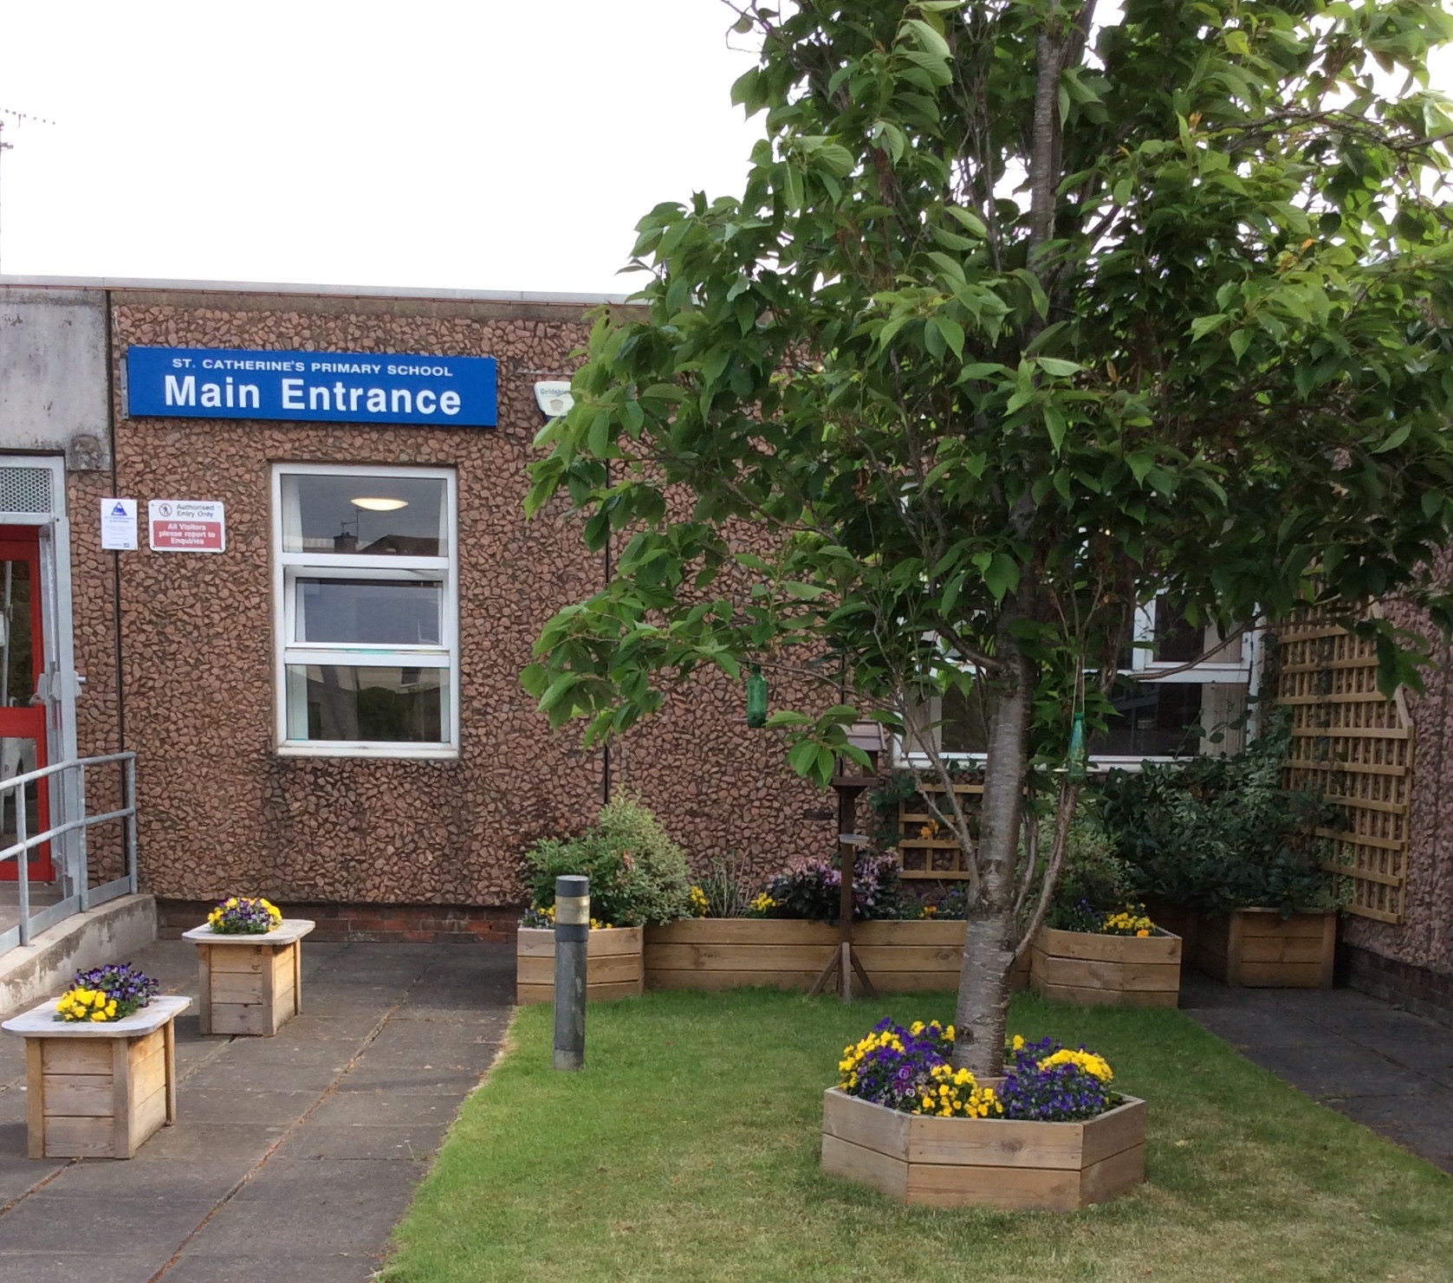n,*

*Achieve,*

*Aspire!*

**To find out more about St Catherine’s Early Education and Learning Class visit our school website.**

**Here you will also find full details of the school’s improvement priorities and actions. Alternatively, you can request a copy from the school office.**

https://blogs.glowscotland.org.uk/re/stcatherines

STANDARDS AND QUALITY REPORT

June 2018

This report will inform you of the school’s progress and achievements in the last session and let you know about our plans for 2018-2019. I hope that you find it helpful and informative.

E Henry

EMMA HENRY

Head Teacher

**SUCCESSES AND ACHIEVEMENTS**

Rights Respecting School Level 1 Sporting achievements including:

Fairtrade School -Renfrew and Erskine Hockey Festival

ECO School -Renfrew and Erskine Basketball Festival

Participation in Gallowhill Community Clean Up -Renfrew and Erskine Badminton Quaich

Participation in Digital Tapestry Event -Sportshall Athletics Event

Partnership working with West College Scotland -Renfrewshire Primary Track and Field

Participation in UWS Summer STEM Academy

**St Catherine’s Early Education and Learning Class**

**OUR AIMS**

* **A place that is known for its high standards and caring atmosphere**
* **A place where learners, staff and parents have a feeling of community, loyalty and are motivated to learn because of this**
* **A place where there is respect for all – in our own and in other communities**
* **A place where our curriculum meets the needs and abilities of all of our children**
* **A place where the love of children shines through everything that we do**

**OUR SCHOOL**

St Catherine’s Primary School is a denominational school in Paisley. **The school provides good facilities including a nursery room for two year olds, a nurture room and an outdoor classroom. T**he current school role is **175, organised into 8 classes. We also have a 15/15 two year old room and a 24/24 three to five year old room in our nursery.**

Our school community is vibrant and seeks to engage and involve learners and their families in all areas of school life. At every level, an ethos of excellence and ambition for all our learners is encouraged and attainment, achievement and participation are recognised and celebrated.

**HOW SUCCESSFUL HAVE WE BEEN IN IMPROVING OUR SCHOOL?**

**School Leadership**

* All staff have taken on leadership roles linked to their skills, interests and the priorities in our school improvement plan. This ensures that we all work collaboratively to improve our school.
* All children are encouraged to contribute to the school community at every stage, where they have opportunities to lead their own learning and be instrumental in bringing about change and improvement.

**Teacher Professionalism**

* The development of our tracking systems within literacy and numeracy to reflect national guidance has increased staff confidence and knowledge in evidencing progression using the Benchmarks.
* There is a focus on continually supporting the professional development of our staff in the field of learning and teaching. Improvement Plan Priorities including participation in the Local Authority Literacy Development Programme and the introduction of the SEAL Programme to support the development of learner numerical knowledge and skills have led to improvements in the quality of learning experiences for all children.
* Our commitment to a respectful, equitable and inclusive culture and ethos has been enhanced further through the development of an Anti Bullying Policy.

**Assessment of Children’s Progress**

* A well-developed approach to shared standards and expectations is in place with the Moderation Cycle used as the basis of this process. Moderation at school, cluster and with the addition of family level has ensured consistency of staff’s professional judgement, both locally and nationally.

**School Improvement**

* We have worked in partnership with our local authority Education Manager to self-evaluate leadership, learning, teaching, assessment, children’s wellbeing and attainment and achievement. This has helped us to showcase our strengths and identify areas for improvement.

**Parental Engagement**

* The extension of our Family Learning Programme to include a walking group, weekly Bookbug sessions and Homelink library bags has created positive connections between home and school.
* The school has created excellent partnerships with West College Scotland and has raised awareness of the training opportunities available to our parents/carers.

**Performance Information**

* Participation in Data Analysis for school leaders has ensured that we continue to improve the reach and effectiveness of planning meetings through successful data analysis strategies.
* Clear connections can be seen between tracking, profiling, planning and pupil targets. This has allowed staff to gain a holistic overview of each individual child ensuring tailor made pathways are created for all learners.

**KEY STRENGTHS OF THE SCHOOL**

* Warm and welcoming environment for learning.
* Very respectful relationships evident at all levels.
* Happy, confident children who actively engage with their school and benefit from being involved in helping to make improvements.
* Consistently high quality learning and teaching across the primary and early years classes. This is enriched through worthwhile partnerships with families, partners and the wider community.
* High quality team working and the opportunities for all staff to lead developments.
* The impact of the Renfrewshire Skills Progression Programme, which creates connections between achievements and the world of work and promotes positive, aspirational attitudes towards further education.
* Strong leadership at all levels which has resulted in high expectations and high standards across the school.

**OUR NEXT STEPS – PRIORITIES FOR 2018-19**

*We believe that we have made very good progress during session 2017-18 and we will use the improvement priorities listed below to build on this progress moving forward.*

**To enrich the quality of learning experiences and raise attainment in Numeracy.**

* Continue to make improvements to the Playroom environment to ensure numeracy embedded across various zones/ activities
* Embed SEAL into the 3-5 room
* Continue to Improve profiling and target setting
* Continue Curricular transition programme: Number Buddies
* Continue to improve the Family Learning focus on Numeracy, through events and home learning bags
* Newsletters/Website will have a ‘Numeracy’ section to provide parents/carers with ideas for supporting their child’s Numeracy at home

**To enrich the quality of learning experiences and raise attainment in Literacy.**

* Continue to make improvements to the Playroom environment to ensure literacy is embedded across various zones/ activities
* Introduce aspects of the Primary Literacy Coaching programme
* Continue to make improvements to profiling and setting targets
* Continue Curricular transition programme: Reading Buddies
* Continue to improve the Family Learning focus on Literacy, through events and home learning bags

**To improve the Social and Emotional Wellbeing of our families.**

* Introduce Place 2Be Counselling service and to devise a cohesive programme of Health and Wellbeing
* Extension of Family Learning to include weekly themed drop in sessions for parents/carers
* To align our behaviour policy with our skills progression framework to promote good decision making and restorative practice
* Maximise opportunities for outdoor learning by creating outdoor zones to maximise and utilise space for outdoor learning
* To track the health and wellbeing of children using the Leuven Scale

**Improvement in employability skills and sustained, positive school leaver destinations for all young people**.

* Enhance partnership with West College Scotland to promote further awareness of career/employment opportunities and skills development

Include local employability/training opportunities for parent/carers on school website/newsletter

. . . . . .

To refresh behaviour policy to consider a more restorative approach and to promote good decision-making. Identify pupils to take part in pupil restorative leader training.

. . . . . .

Extension of Family Learning to include weekly drop in sessions which focus on helping parents to access training and information about specific aspects of health and wellbeing, for example promoting self-confidence, resilience and coping skills and to provide family-based support, in particular to help young parents improve their own health and wellbeing.

. . . . . .

Further develop curriculum planning to maximise opportunities for outdoor learning initially within Physical Education.

Create outdoor zones to maximise and utilise space for outdoor learning.

St Catherine’s Primary School

Brabloch Crescent, Paisley PA3 4RG.

Tel: 0141 887 6085

School Website: [www.st-catherines.renfrewshire.sch.uk](http://www.st-catherines.renfrewshire.sch.uk)

E-Mail: stcatherinesenquiries@renfrewshire.gov.uk

***HAVE YOUR SAY!***

Please take the opportunity to share your thoughts with us as we use feedback to help us make improvements to the school.

You can do this by speaking to staff, participating in Parent Council meetings, responding to questionnaires/surveys and by completing evaluations at school events.