Diary Dates

November  4  5  11  13  16  19  19  22 | P4-P7 Cinema Trip  All Saints/All Souls Mass  School Photographs  Paisley Fire Service Assembly  P1-P3 Cinema Trip  Flu Vaccination Programme  P7 Parents Sacramental Meeting  P7 Mass of Commitment
26  29  30  December  15  16  18  22 | P4 Parents Sacramental Meeting  P4 Mass of Commitment  Holiday  Whole School Christmas Show 1:30p.m.  Whole School Christmas Show 10:00a.m.  P1-P7 Christmas Parties  Non Uniform Day  Advent Service  Pantomime: production of Peter Pan here in St Catherine’s  2:30p.m. finish

St. Catherine’s Primary School
Newsletter
November 2015

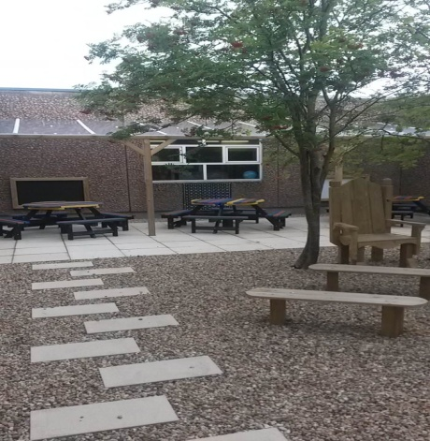
St. Catherine’s Primary School
Brabloch Crescent
Paisley
PA3 4RG
Head Teacher – Mrs. Teresa Brown
0141 887 6085
email – enquiries@st-catherines.renfrewshire.sch.uk
Website - www.st-catherines.renfrewshire.sch.uk

Although we encourage children to tell us about their achievements out with school we are sure that we don’t know about lots of things however big or small, for this reason we would like your help. If you feel that your child has accomplished something for the first time, improved in something, or has achieved an award (yellow belt in Judo, a badges at Scouts/Brownies/Boys Brigade etc) please let us know by completing the tear off slip below. This will then be shared at assembly and added to our achievements records

Recognition of Achievement

I’d like (name) _________________________________

(class) _________________________________

to be recognised for his/her achievement in

_________________________________________________

He/she __________________________________________________

__________________________________________________

__________________________________________________

Parent’s Signature _________________________________

Date _________________________________

School Christmas Show
This year our Christmas Show will be a whole school performance of ‘Children of the World’, a delightful Christmas musical that takes a look at how Christmas is celebrated around the world. To ensure an equitable distribution of tickets these will be restricted to two per family. The Show will be performed on the afternoon of 15th December and the morning of 16th December. Letters will be sent home in the near future inviting parents/carers to indicate which show they would like two free tickets for.

School Holiday
St Andrew’s Day, Monday 30th November is a school holiday. School will re-open on Tuesday 1st December.

School Dinners
Prices for school lunches are:
Grab and Go Days (Tuesday, Wednesday & Friday) £1.85
Dine in Days (Monday & Thursday) £2.05

School Photographs
Tempest Photography will be in the school on Wednesday 11th November to take individual and family photographs. Children should wear their full school uniform, i.e. Shirts and ties, if possible.

Drama Group
Well done to our Senior Drama Group who took part in the Paisley Halloween Festival. The children performed exceptionally well and were stunning in their spectacular costumes.

You are welcome to provide feedback on any items contained in our newsletter. Please do not hesitate to contact me if there is ever anything you wish to discuss.
Mrs Teresa Brown
Head Teacher

