Diary Dates

December  10  15  16  18  22  January  7  13 | Christmas lunch  Parent Council Christmas Discos  Whole School Christmas Show 1:30p.m.  Whole School Christmas Show 10:00a.m.  P1-P7 Christmas Parties  Non Uniform Day  Advent Service  Pantomime: production of Peter Pan here in St Catherine’s  School re-opens for the new term 9a.m.  Mass (New Term)

St. Catherine’s Primary School
Newsletter
December 2015

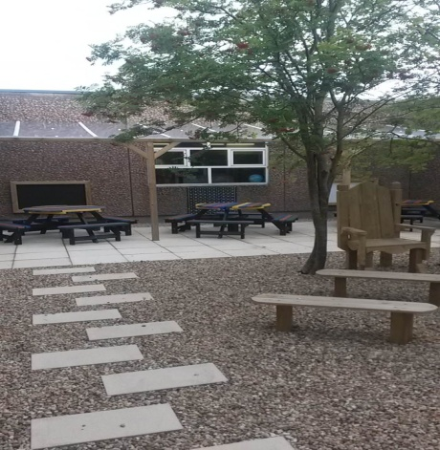
St. Catherine’s Primary School
Brabloch Crescent
Paisley
PA3 4RG
Head Teacher – Mrs. Teresa Brown
0141 887 6085
email – enquiries@st-catherines.renfrewshire.sch.uk
Website - www.st-catherines.renfrewshire.sch.uk

Although we encourage children to tell us about their achievements out with school we are sure that we don’t know about lots of things however big or small, for this reason we would like your help. If you feel that your child has accomplished something for the first time, improved in something, or has achieved an award (yellow belt in Judo, a badges at Scouts/Brownies/Boys Brigade etc) please let us know by completing the tear off slip below. This will then be shared at assembly and added to our achievements records

Recognition of Achievement

I’d like (name) _________________________________

(class) _________________________________

to be recognised for his/her achievement in

_________________________________________________

He/she __________________________________________________

__________________________________________________

__________________________________________________

Parent’s Signature _________________________________

Date _________________________________

Mary’s Meals
Well done to Primary 7 who raised £64.20 for Mary’s Meals during their World Porridge Day fundraising event. As the Local Authority is currently doubling every donation made to charities by schools a cheque for £128.40 has been sent to Mary’s Meals.

Parent Council Christmas Fayre
The Parent Council Christmas Fayre was a huge success and raised £1600 for Parent Council Funds. Well done and sincere thanks to the members of our Parent Council for their hard work and commitment in organising such a marvellous event. Thank you also to the parents, pupils and members of staff who came along to support the school at this event.

Parent Council Christmas Discos
The Parent Council Christmas Discos will take place on Thursday 10th December at 6:30p.m -7:30p.m for Primary 1 to Primary 3 and 7:30p.m - 8:45p.m for Primary 4 to Primary 7. More information about these events will be sent out by the Parent Council.

Christmas holidays
School will close at 2:30p.m on Tuesday 22nd December for the Christmas holidays and will reopen at 9:00a.m on Thursday 7th January 2016.

You are welcome to provide feedback on any items contained in our newsletter. Please do not hesitate to contact me if there is ever anything you wish to discuss.
Mrs Teresa Brown
Head Teacher

