Finding a Fraction of a Quantity
Let’s recap how to find a fraction of a quantity P7!
For example, if we want to find out what 4/5 (4 fifths) of 15 is, we first need to divide 15 equally into 5 groups, see below.
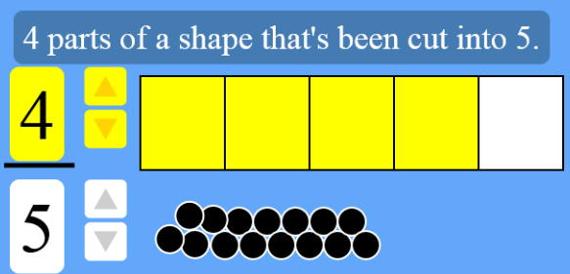

We can see that 15 divided into 5 groups is 3. We then need to find out what 4 of those groups is worth P7! We can figure that out by doing repeated addition (3 + 3 + 3 + 3), or by doing a times table calculation (4 x 3).
So 4/5 of 15 = 12.

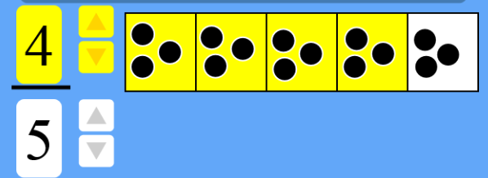

Let’s have a look at one more example to help us P7!
For this next question, we want to find out 5/6 (5 sixths) of 24. So firstly 24 has be shared equally into 6 groups.
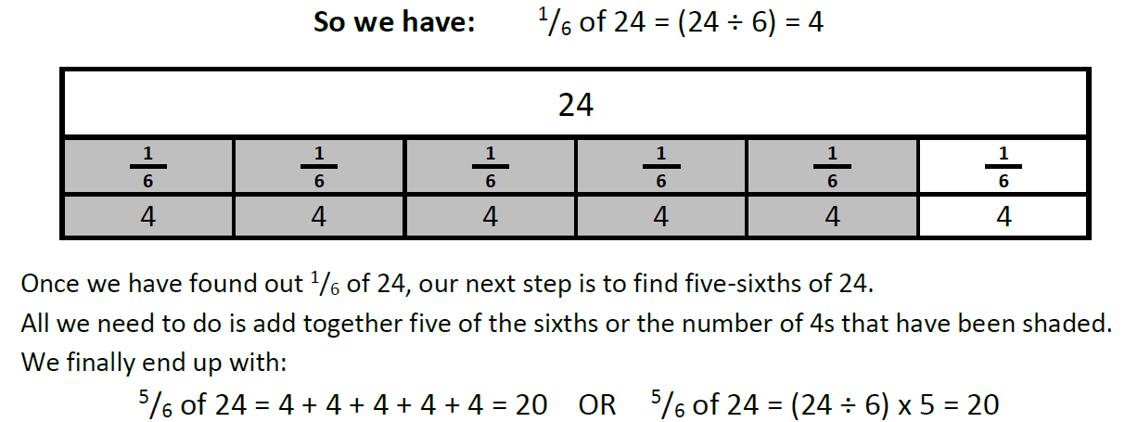
Task 1
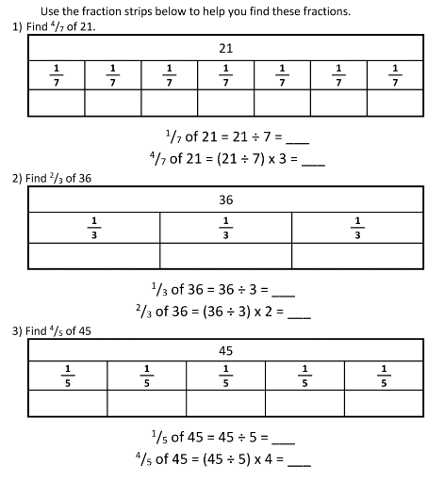

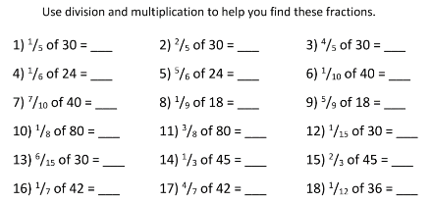
Task 2

See the next page for task 3.

Task 3
Have you felt reasonably confident with the questions so far?
If so have a bash at these!

