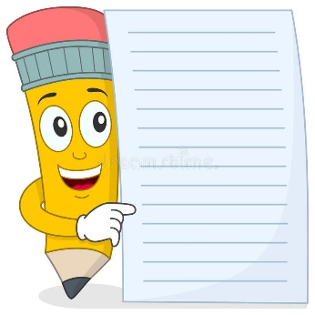
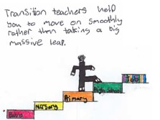
Early Writing Skills

Why is art important?
Here are some of the reasons encouraging you child to draw is important:
- Drawing forms, the base for other creative arts such as painting, sculpture and calligraphy.
- It is directly connected with important skills such as reading and writing
- Drawing is possibly the most accessible art form for kids – a sheet of paper (any kind) and a pencil is all you need.
- Early exposure to any form of art – visual or performance – has been known to boost brain activity.
- Your child is better prepared to understand other subjects when drawing activities are part of the curriculum.
- Learning to draw enables children to express themselves in different creative ways.
- Drawing activities for kids not only let your youngster have fun but also help develop their fine motor skills and imagination.
Encouraging your child through fun drawing activities is a good idea but remember, it is important to let them draw whatever they want whenever they feel like it.

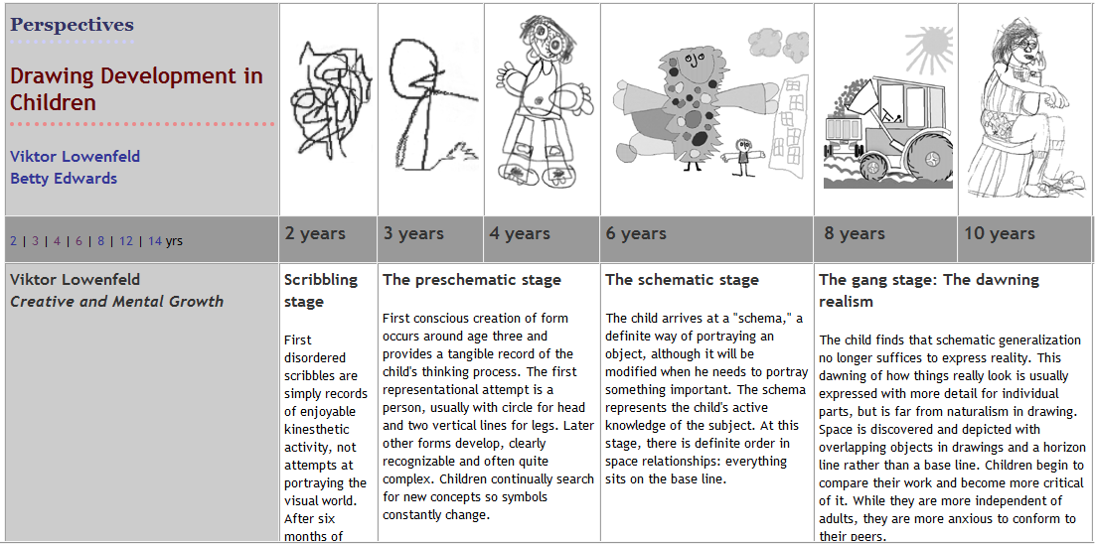
Stages of drawing:

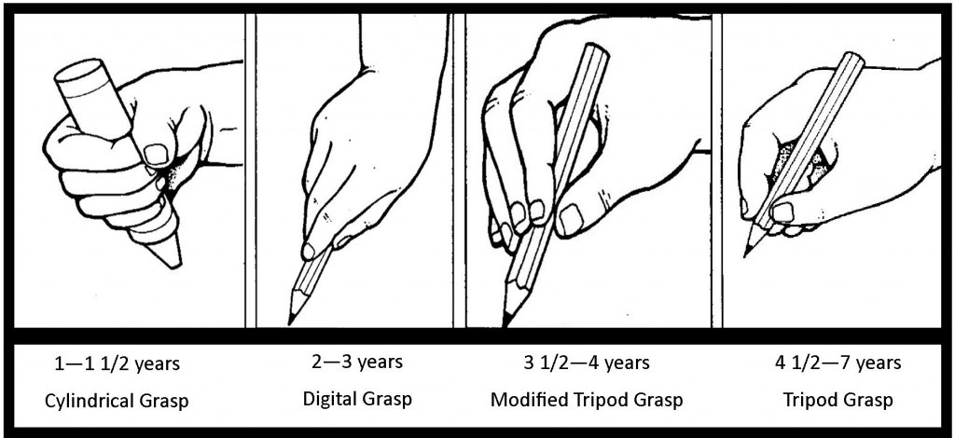
Pencil grip:

Children learn to draw and hold their pencil in different stages. It is however it important to understand that children develop at different paces, so there for the ages and stages of development are just guidelines.

Activity ideas:
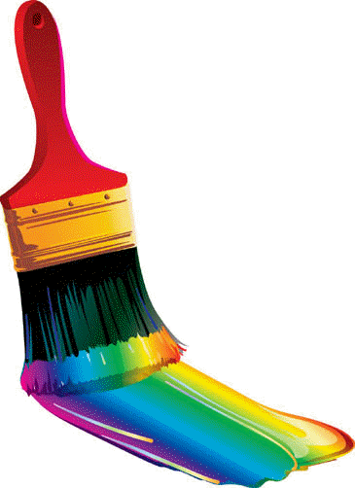
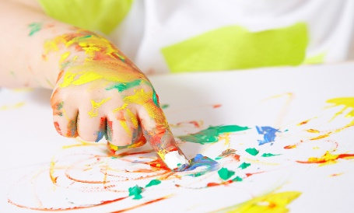
Painting with different materials i.e. paint brushes, fingers, sponges

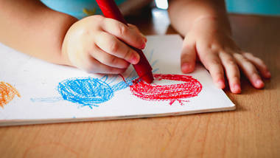
Drawing on different surfaces using different writing materials i.e. garden fence, ground, paper, white board using chalk, pens, pencils, charcoal.

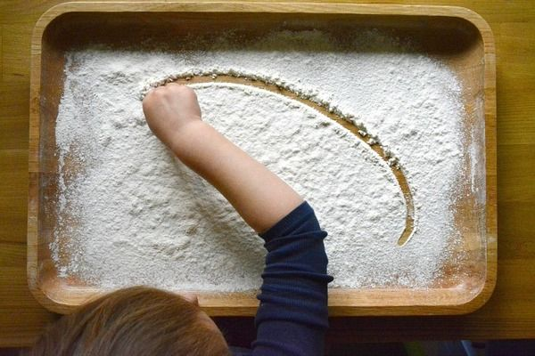
Drawing and writing in different malleable resources using fingers or other writing tools i.e. flour, glitter and lentils

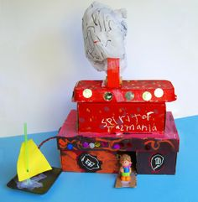
Making models using play dough, clay or household junk i.e. boxes, bottle lids and bottles

Questions you can ask?

Can you tell me about your drawing?
What did you use to make your picture?
Where did you get your ideas?
What is your favourite part of your picture?
How did you ………. (Make these lines or shapes, decide on the colours to use)?
What else are you going to add to your picture?

