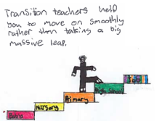
Stop the Bus!

Before you start:

Players: at least 2.

Need: paper and pencil/pen each.

Record: your categories
e.g. Girl’s name, Boy’s name, country, city, animal,
colour, you choose!

Girl’s name | Boy’s name | Country | Animal | Colour

To start:
Player 1 thinks through the alphabet. Player 2 says, “stop.”
The letter Player 1 has stopped on, has to be the first letter of each of your chosen categories.

To win:
The first player to complete their row says, “stop the bus!”

You can create your own rules for how to win this game!
You can make it easier or harder for the whole family by:
- having/not having a time limit
- work in teams
- your choice of categories – go with what you know!

Go on be creative and have fun!

