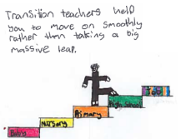
A to Z

There are so many family games we can play, using our alphabet!

A B C D E F G H I J K L M N O P Q R S T U V W X Y Z

a b c d e f g h i j k l m n o p q r s t u v w x y z

Before you play:
Players: 1 or more
Need: Paper and pen/pencil (if writing them down)

How to play:
Choose a category e.g. animals.

- Player who starts has to say an animal beginning with the letter ‘A’. The next player has to say an animal beginning with the letter ‘B’ and so on.
When you get to ‘Z’, you choose a new category.

- Have each letter on a bit of paper laid out in front of everyone. When Player One says, “go” everyone can call out their animal as they collect the paper letter. The winner is the player with most paper letters at the end.

Possible categories:
animals, food/drink, cities/towns, countries, sports, emotions, girl’s names, boy’s names, football teams, items in your house, things you might find in a school, … The list is endless!

Go on, be creative and have fun!

