Activities to support STEM
Sensory bottles

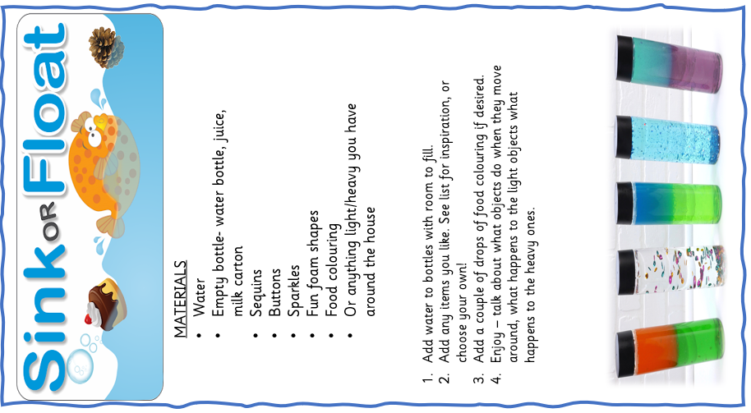
A great way to explore weight and forces is through sensory bottles. Here are some ideas of how to make them

