Activities to support STEM
Marshmallow and spaghetti experiment

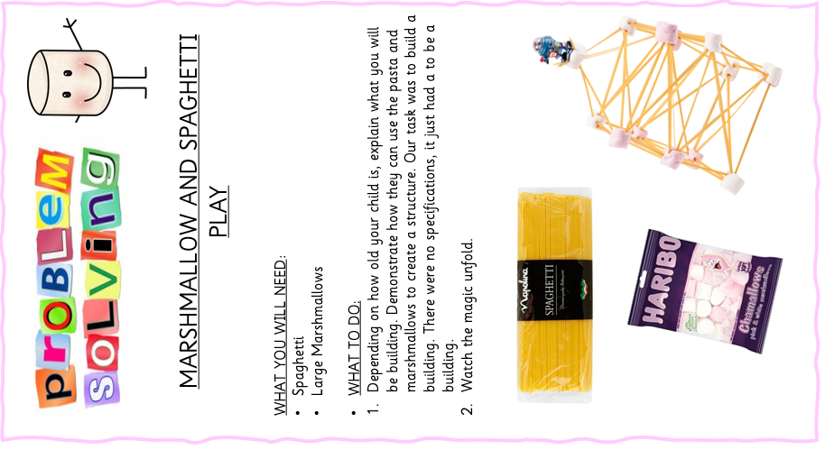
A great way to explore engineering small scale- allows for opportunities to problem solve and find ways to make a more solid structure with a mix of soft and hard materials.

