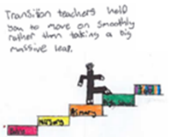 Numeracy at home 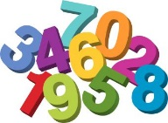

Activities at home with family:
- Walks in your local area with family – When out walking with family, you will be able to spot numbers on the doors of houses, numbers on passing buses and numbers on car registration plates. You might also be able to count how many buses you see or how many red cars you pass etc…

- Going on an indoor number hunt – You can all become number detectives around your house and try to find as many numbers as possible! You might find them on clocks, remote controls, microwave etc…

- Counting songs/Finger counting – We all know lots of number songs we like to sing every day like, 1,2,3,4,5 once I caught a fish alive and ten green bottles and many others. Remember when singing number songs and counting to use your fingers to show how many you are counting and singing about!

- Counting steps backwards and forwards – Try counting how many steps it is from one side of a room to the other, and then walk back again counting backwards from the number you stopped at.

- Dice games – if you have a dice from any board games you may have at home, you could play a physical game with your family. You could roll the dice and then you need to jump, hop or starjump the amount it lands on.

- Counting amounts and sharing – Help your parents/carers at meal and snack times by helping to cut up fruit or vegetables and then count how many pieces you have of each to share amongst your family.
Have fun!

