**Secondary Pupils**

**Home Learning Advice for Young People**

During the current health crisis and the need for home working, the following information is designed to help you manage the change to working from home and to give you hints and tips on how best to keep your learning progressing at home.

1. **Managing change**

Before doing anything else, you first need to give yourself time to deal with the change that is happening in your life.

Change is an inevitable, necessary and often positive part of life. However, sometimes major changes can become overwhelming and make you feel understandably anxious and worried. Dealing with the current situation, as well as trying to create a new routine from learning at school to learning at home can be stressful. Therefore, it is important that you treat this time as a time of transition and deal with it as you would any other period of transition.

Allowing yourself time to transition and adjust to change is important. There are many things that you can do to manage change and minimise stress and uncertainty. Focusing on understanding the change, what it means for you and why it is so stressful is an important first step. Another useful step is to focus on the potential positives of the change.

Try the following:

* Take time to think everything through
* Ask questions and develop an understanding of what is happening based on the facts (fear is often based on the unknown)
* Think about and focus on the things you can control rather than the things you can’t
* Accept that there are things out with your control
* Manage stress and anxiety by doing activities which make you feel good and relaxed a couple of times a day (this could be using mindfulness, relaxation or meditation techniques)
* Celebrate the positives and opportunities that have come out of the current situation (more time to spend with family, more time to practice hobbies etc)
* Seek support – use digital resources and tools to stay connected to friends and family. Remember your teachers are still there for you. Ask them questions, let them know your concerns and seek their support with your learning
* Set and stick to a routine

**The following websites may give you more support around this issue of managing change and coping with the current situation:**

<https://schools.au.reachout.com/articles/life-stage-transitions>

[www.voicesofyouth.org/campaign/studying-home-due-to-coronavirus-how-young-people-around-world-are-keeping-their-mood](http://www.voicesofyouth.org/campaign/studying-home-due-to-coronavirus-how-young-people-around-world-are-keeping-their-mood)

1. **Developing a routine**

Developing a daily routine is important, especially to help us manage a time of crisis. Developing a routine creates structure in our lives which we may not have at the moment.

A daily routine:

* Gives structure to our lives
* Allows us to plan our rest time without over working or feeling guilty (frees up our time)
* Allows us to make the most of our time
* Instils good habits and breaks bad ones
* Helps us to prioritise
* Reduces the need for willpower
* Helps to reduce stress
* Helps us to keep on track and reach our goals

1. **Make learning a part of your routine**

Making learning a natural part of your routine at home helps you to balance your time between work and rest/relaxation. It ensures that you work hard whilst still setting aside enough time to relax, exercise and have fun. Making learning a part of your daily routine, helps to support your mental and physical wellbeing.

So rather than developing a timetable for learning or study, develop a timetable for your WHOLE day. Sometimes it is good to split your day into 3 parts; morning, afternoon and evening. It is recommended that you only learn or study during 2 of those parts. You could therefore decide to do your learning in the morning and afternoon and rest in the evening. Or you may prefer to do work in the morning, relax in the afternoon and work in the evening.

To help you to do this, it is good to create a timetable which encompasses your WHOLE day. This means that you will stick strictly not just to learning BUT also to your deserved relaxation time.

**Your daily routine timetable** could be hand written, developed on word or by using one of the free online sites below. It is good to colour code your routine, giving different colours to breaks and relaxation and different subjects.

**Remember, when learning, don’t spend all day studying one subject and allocate MORE time to subjects you are less confident in.**

Printable timetable templates are available online. Some websites to support the creating daily schedules are listed below:

There are also several apps available on Android and Smart phones via Google Play and App Store, respectively.

* [Office 365 Daily Schedules](https://templates.office.com/en-us/daily-schedule-tm10000103)
* [Free Online Schedule Builder](https://schedulebuilder.org/)
* [Timetable Maker](https://timetablemaker.com/)

**Daily Routine Timetable Example**

This is an example of how you could organise each day. Days could look the same or change depending on what else is happening

|  |  |  |  |  |  |  |  |  |
| --- | --- | --- | --- | --- | --- | --- | --- | --- |
|  | **Wake up till break**  Things you could do | **Break till Lunch**  Things you could do | **Lunch** | **Lunch till mid afternoon**  Things you could do | **Mid afternoon till dinner**  Things you could do | **Dinner** | **Evening**  Things you could do | **Hour before bed**  Things you could do |
| **Monday** | Exercise  Breakfast  Chores | Learning for  2 hours |  | Learning for  2 hours | Help make dinner  Help with garden  Take dog out |  | Talk to friends  Hobby, listen to music, read a book, watch TV | Mindfulness/  relaxation |
| **Tuesday** | Exercise  Breakfast  Chores | Learning for  2 hours |  | Talk to friends  Hobby, listen to music, read a book, watch TV | Help make dinner  Help with garden  Take dog out |  | Learning for  2 hours | Mindfulness/  relaxation |
| **Wednesday** | Breakfast  Learning for  2 hours | Exercise  Chores |  | Talk to friends  Hobby, listen to music, read a book, watch TV | Help make dinner  Help with garden  Take dog out |  | Learning for  2 hours | Mindfulness/  relaxation |
| **Thursday** | Breakfast  Learning for  2 hours | Learning for  2 hours |  | Exercise  Chores | Help make dinner  Help with garden  Take dog out |  | Talk to friends  Hobby, listen to music, read a book, watch TV | Mindfulness/  relaxation |
| **Friday** | Exercise  Breakfast  Chores | Talk to friends  Hobby, listen to music, read a book, watch TV |  | Learning for  2 hours | Help make dinner  Help with garden  Take dog out |  | Learning for  2 hours | Mindfulness/  relaxation |

**Learning - remember your teachers are still there for you if you get stuck.**

**Where study is over 2 hours remember that you should also be having 10 minute breaks after every 50 minutes.**

1. **Know your learning style**

Knowing your learning style will help you to be more effective at learning while you are at home.

For example, if you are a visual learner, you will need images, videos, graphs etc to help you understand the work you are doing. If you don’t have access to resources which support visual learners, then this is something to ask your teacher.

Most people will move between different learning styles, but you will definitely have one which is more dominant than the others. Think about which one this is and make sure you can get help to access appropriate resources to help you learn more effectively and efficiently at home.

These are the main learning styles:

1. If you are a **visual learner**, you will understand things best by looking at images etc – you will need access to visual resources
2. Should you be an **aural learner**, you pick up things by hearing and listening closely – you should at times talk through what you are learning with others in your home, or with friends through online platforms – are you part of an online study group?
3. If you are a **physical learner** you’ll prefer using your body, touching things with your hands, and are focused on the feelings you get while doing whatever you’re trying to learn – you will need access to concrete resources and real life examples

**Knowing what your dominant learning style is will help you to make the correct decisions when it comes to home learning.**

Knowing your learning style will also help you to know whether you are social or solitary learner:

* Social learners need to work with others or talk through what they have learned with others. This helps to clarify things in your mind and deepen your understanding. As such, you may want to join or even set up an online study forum
* Solitary learners prefer to work alone. In which case you need to find a quiet place to learn, get rid of distractions, set up clear timetables and SMART targets

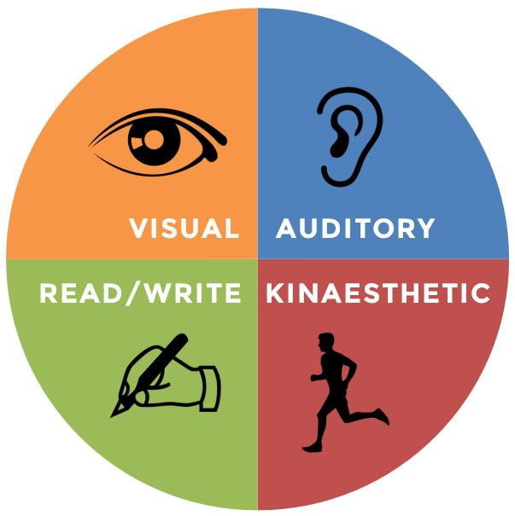

1. **Setting SMART targets**

A **SMART target** is used to help guide **goal** setting. **SMART** is an acronym that stands for Specific, Measurable, Achievable, Realistic, and Timely. Therefore, a **SMART target** incorporates all of these criteria to help focus your efforts and increase the chances of achieving your goal.

Make sure that when you are setting yourself targets for your learning, that you always make them SMART. If you don’t then you risk never reaching an end point, getting stressed, over working, not working hard enough or giving up.

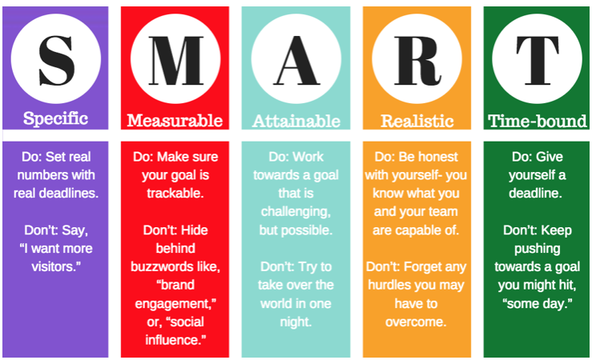

1. **Handy Hints and Tips for Studying or Completing Class or Coursework**
2. Spilt your day into thirds – morning/ afternoon/ evening – only complete class or course work during two thirds
3. Don’t work on one subject all day – timetable 1-2 hours per subject
4. Allocate more study time to subjects you are LESS confident in
5. Only do focused study for 50 mins, having 10 minutes rest in between to relax your brain and let it absorb the learning
6. Know your learning style
7. Set SMART Targets

**Best websites on how to study at home:**

<https://www.bbc.co.uk/bitesize/articles/zn3497h>

<https://education.gov.scot/parentzone/learning-at-home-supporting-study/>

[www.youthcentral.vic.gov.au/study-and-training/help-with-study/how-to-study-better](http://www.youthcentral.vic.gov.au/study-and-training/help-with-study/how-to-study-better)