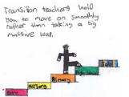

Induction tips and websites for parents and carers to help prepare for primary school.

|  |  |  |
| --- | --- | --- |
| Website/resource | level | Notes |
| See the source image  <https://www.pacey.org.uk/working-in-childcare/spotlight-on/being-school-ready/#readyforschool> | Early | Whether you're a parent whose child is about to start at school, or a childcare professional, supporting a family to take this next big step, this site has information, support and reassurance to share. |
| See the source image  <https://www.pacey.org.uk/Pacey/media/Website-files/PACEY%20general/Steps-to-starting-school.pdf> | Early | A printable poster to share with the child and chat about the skills parents can help develop. |

Great tips and practical support to child get ready for the move to school. It's not all about the reading writing and number skills- these help- it is more about helping children be curious, confident and ready to learn. There are some great factsheets for parents on the above website!

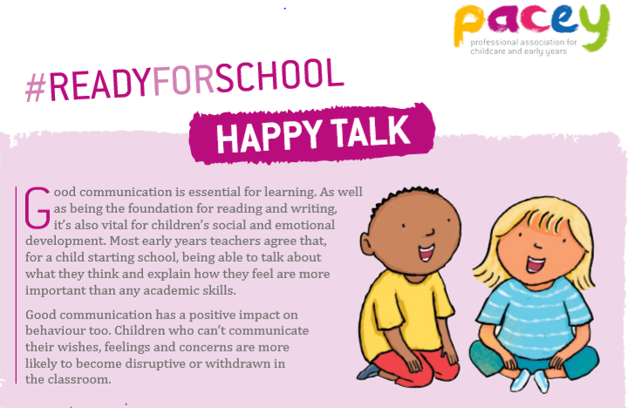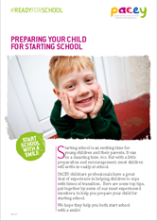



|  |  |  |
| --- | --- | --- |
| Website/resources | Level | Notes |
| https://childmind.org/article/how-can-we-help-kids-with-transitions/ | All | This site offers tools that may be useful to help children of all ages with transitions. There are points that cover, [ADHD](https://childmind.org/guide/guide-to-attention-deficit-hyperactivity-disorder/), [anxiety](https://childmind.org/guide/anxiety-basics/), [autism](https://childmind.org/guide/guide-to-austism-spectrum-disorder/), or [sensory processing](https://childmind.org/topics/concerns/sensory-processing/), that could offer advice and support that could make the difference between a good day and a bad one. |
| <https://www.firstdiscoverers.co.uk/support-children-preparing-for-school/> | Early | Offering support and tips for staff and parents to help with the transition from nursery to school. |
| https://www.theschoolrun.com/how-to-prepare-your-child-for-primary-school | Early | What do parents and children really need to know. Top tips for life long skills &learning. |

**A few ideas of what would be beneficial to your child starting school.**

**Physical skills**

Encourage your child to **get dressed independently**; this makes PE more enjoyable and saves time Also, teach her to fasten her own coat: if the teacher has to help all children, playtime is over before it’s begun.

It’s important for your child to **learn to eat with other people**, for example, using cutlery and staying at the table until she has finished. Eating as a family on a regular basis will help her to master these skills.

**Encourage your child to use the toilet independently – but don’t panic about accidents.** As children adapt to the new environment, the odd accident is inevitable. Most schools expect this in Primary 1 and will manage accidents with an accepting approach.

**Encourage lots of outdoor play**: jumping, swinging, running and playing on climbing apparatus. Big physical play helps the brain develop and builds the smaller muscles ready for writing later.

**Social & emotional skills**

One of the most important social skills for your child to learn before starting school is to **share and take turns**. You can encourage this through activities like family board games and giving your child opportunities to play with other children.

**Socialise with other children** encourage confidence to initiate play and conversation with family and friends.

Try to give your child some **experience of being away from you and in the company of others**, whether that’s at pre-school or nursery, or by spending time with friends and family and their children, so she’s more secure about being left at school.

Talk to your child **talking as a family helps children become more confident communicators**. ‘Conversation at home is vital to the future success of children and will help them gain the skills they need for a successful and happy life.’  
Jonathan Douglas, director of the [National Literacy Trust](http://www.wordsforlife.org.uk/)

**Be positive about starting school**. Walk past it regularly, talk about what the children do there, and make a big deal of how much fun your child will have. And try not to let your child hear you talking about your own anxieties about her starting school to other adults.

**Academic skills**

**Encourage a love of books** by sharing cuddly story times, discussing favourite characters and parts of the story. Go to the library and choose books based on your child's interests. By reading together, she will begin to learn that text runs from left to right and top to bottom, and that text carries a meaning.

It’s helpful if your child can **recognise her own name** so she can find her own peg and drawer.

To build early numeracy, **have fun counting everything**: buttons on coats, stairs, how many steps it takes to reach the kitchen. Point out favourite numbers, such as your child’s age, on the calendar, house numbers and number plates on cars.

Remember, it’s all about the fun you have sharing skills and knowledge with your child, these life-long skills will be used forever!