Early Level Life skills
to support organisation skills
Paper resources
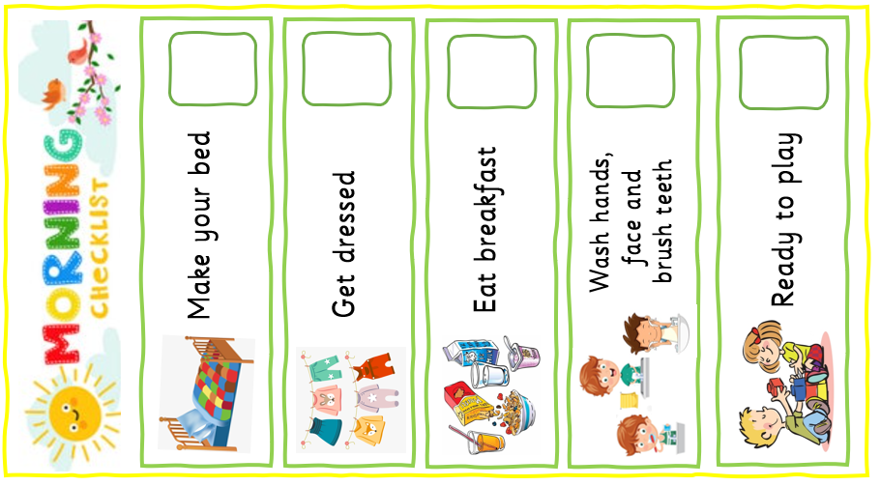
Organisation is a key skill that children need to develop in order to follow instructions and day to day routines. This morning checklist supports the introduction of basic- complex instructions for children to try and follow with very little adult prompt, this will further support their learning when organising their belongings in the mornings at school.

