Early Level Life skills
to support emotional regulation
Paper resources
Life skills are the skills that are nurtured over time, they are developed with practice and through everyday experiences and they are the key skills that children need support in developing in order to achieve more in life. Within the Early level for children to blossom in other curricular levels there is great importance in nurturing their Health and Wellbeing.
Using the emotion cards to help guide chat and give a visual idea
- Talk about situations when you would feel-
- What could make you feel like that?
- How could you make them feel better?
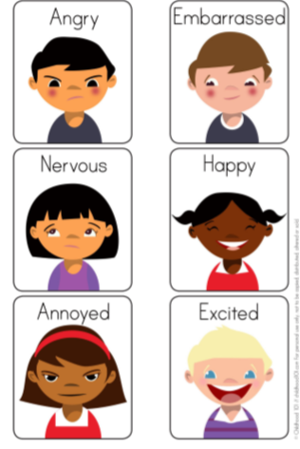
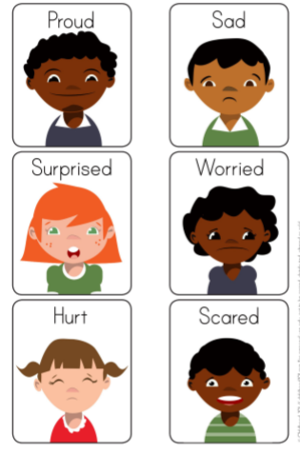
Early Level Life skills
to support emotional regulation
Paper resources

If finding a situation challenging, you can use breathing strategies to support self-regulation and calmness
